Compare View
The BridgePoint Model Compare feature integrates tightly with the built-in compare facilities provided by Eclipse.
The Compare View shows a textual comparison (diff) between two UML models. The comparison can be made between two different models, two different versions of the model, or with the model’s local history. The Compare View is the same regardless of the source of the models.
The Compare View is shown below comparing the Microwave Oven model to local history over a time span of a few changes. It is currently showing the difference between the Microwave Oven model in the workspace and the state of the model at 5:18:09pm.
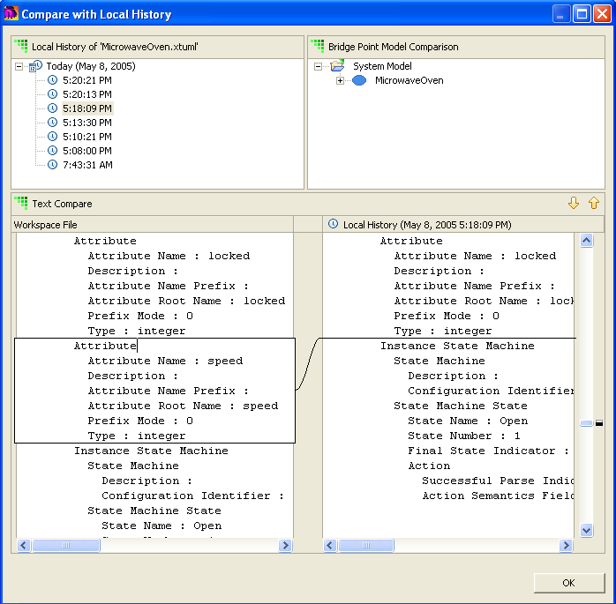
Several panes comprise the Compare View.

Context Pane
The left-most pane is specific to the kind of comparison being performed and provides context for the compare. Sometimes this pane contains timestamps, as when comparing with local history, sometimes revisions, as when comparing the workspace model against revisions in the repository.

Overview Pane
The right-most top pane provides and overview of the differences between the two models. The model elements are shown in a hierarchical view very similar to that of the Model Explorer. Model elements in this pane are adorned or not:
No adornment – The model element has changed between the two models being compared.
Plus (+) sign – The model element has been added relative to the workspace model (the model in the left-hand bottom pane).
Minus (-) sign – The model element has been deleted relative to the workspace model (the model in the right-hand bottom pane).
The overview pane for the example above:
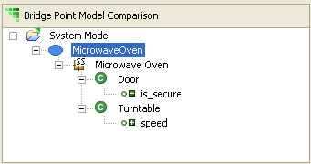
can be interpreted as follows:
- The class Oven has changed between the two models
- The attribute is_secure of class Door has been removed
- The attribute speed of class Turntable has been added
The textual comparison may be restricted by selecting a model element in the Overview Pane. Once selected, the compare is recalculated starting at the selected model element.

Text Compare Pane
The bottom-most pane is broken up into two sides, one for each of the models being compared. Each of the sides contains a textual representation of the models being compared. The model is shown hierarchically, from top to bottom, starting with the system, moving down through the packages, finally down to the states and events that make up the state machines.
The Text Compare Pane allows navigation up and down the hierarchy using two buttons, or by selecting the indicators in the right-hand margin. The former provides a quick way to move up and down through the changes, the latter a fast way to position at a specific change.

