System Browser

Opening and Closing
The System Browser Window can be opened in variety of ways; using the View menu, by double clicking on an event in the Event Window and, by clicking on a hotlink in the Execution Trace Window. It can be closed using the View menu or by using the system menus or buttons on the window.
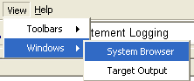

Opening the System Browser using the View Menu
Select View > Windows > System Browser. A check box appears next to the menu entry to indicate that the window is open somewhere on the desktop. Select View > Windows > System Browser again to close the window and remove the checkbox.

Opening the System Browser by clicking in the Event and Execution Trace Windows
In the Event Window, double clicking on an event opens the System Browser Window at the event. In the Execution Trace Window, clicking on a hotlink such as an instance handle or attribute reference opens the System Browser Window at that instance or attribute value.

Tree View
The System Browser Window shows your model in a hierarchical form, with the system at the root of the hierarchy. The system encloses the domains of the system, which in turn enclose their functions and subsystems. Subsystems enclose their classes, which enclose their attributes, state charts and instance populations and so on down to individual states, event data items etc. This enables you to browse a running system and discover what instances exist, what states they are in and what values their attributes have.
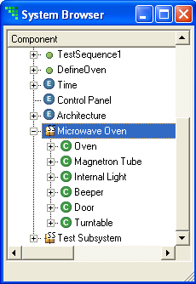
To see what a given tree item is enclosing, click on the + icon next to the tree entry, or double click the entry. Hitting the right arrow key on the keyboard while the tree item is selected also opens the tree. To close a given part of a tree, select the - icon next to the tree item you wish to close or again double click it. Alternatively, use the left arrow key on a selected tree branch.

Breakpoints
Right clicking many tree entries shows a context sensitive menu that allows you to set a comprehensive range of breakpoints on your target executable. Breakpoints can be set on state entry, event generation and dequeue, function and operation invocation and many more. One unique feature of Model Debugger is that it allows you to set breakpoints at instance scope.
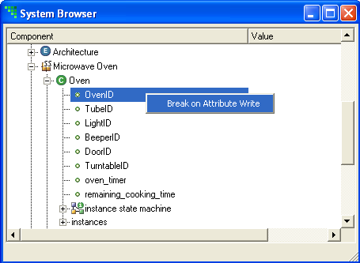
For example, if you browse to an instance and on examining it you decide you would like to know when a particular attribute is next written, you simply right click on the attribute and select Break on Attribute Write. The breakpoint trips only when the particular attribute value is written in that particular instance. To get the same effect in a conventional debugger, you would have to obtain the address of the attribute in memory and set a low level break on memory address write. You have instance scope facilities on state entry and events too.
To set a general scope breakpoint on an attribute (i.e. one that trips when the attribute is written in any instance), set a Break on Attribute Write at the level of the class, as opposed to the instance.
When a breakpoint is set on an item in the tree, a red spot is shown against the tree item to give a visual cue. You can disable a breakpoint using the same context sensitive menu used to set it. When a breakpoint is disabled, the red spot has a white center.
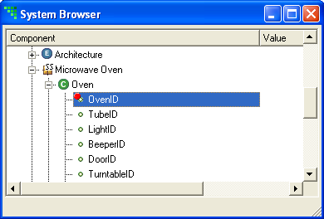
You can use this feature to remind you of the location of a breakpoint you may want to reset in the future. Clearing a breakpoint is also achieved from the same context sensitive menu.
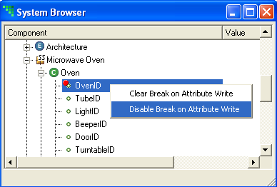

Function Invocation
It is possible to invoke functions defined as part of your model. To do this, right click on the chosen function and choose Invoke Function from the context sensitive menu.
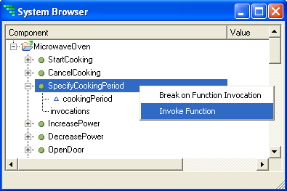
Many functions take parameters. To see the function parameters, you open the System Browser Window tree for the function. You can set the values of these parameters by double clicking on the parameter. An editing field appears allowing you to enter a new value (the starting value is un-initialized).
Parameters with the following data types:
- inst<Event>
- inst_ref<Mapping>
- inst_ref<Object>
- inst_ref<Timer>
- inst_ref_set<Object>
- state<State_Model>
cannot be set from the Model Debugger at this release. Functions with these parameter types can still be invoked, but dummy default values will be sent to the targets for parameters with these types.

