xtUML Project
An xtUML Project provides a place to organize xtUML models.
The xtUML Project wizard creates a new xtUML project in the current workspace. The new xtUML project wizard is accessed by selecting New > xtUML Project from either the File menu, or the Model Explorer View context menu.
The wizard is shown below.

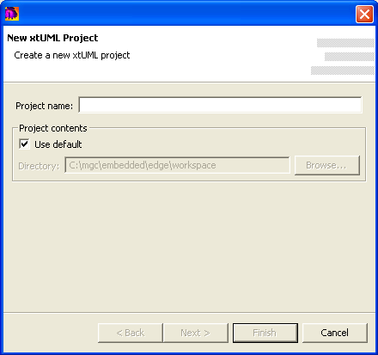
Project name should adhere to the file naming conventions of the underlying operating system.
Project contents allows you to specify the location of the project on the file system. To use the default, which is in the current workspace, leave Use default checked. To choose a location other than the default, deselect the checkbox and navigate to the desired folder using the Browse… button.
Note: Selecting a Project contents location of an existing project may cause data corruption and should be used judiciously.

