CONTENTS
1 Prerequisites: 2
1.1 iUML install 2
1.2 cmake install 2
1.3 boost install 2
1.4 Visual Studio 2010 install 3
2 Design History 3
3 Compiling and Linking Source Code 4
4 Running the dumper 10
5 Source Code Storage 10

Prerequisites:
The pre-requisites for this process are:
- iUML install
- cmake install
- boost install
- MicroSoft Visual Studio 2010 install.

iUML install
See local processes.

cmake install
www.cmake.org. Just get the version required from the internet. We have previously used v 3.13.4. Install instructions are in index.

boost install
Note that a fully installed and built version of boost requires 5.3Gb of storage.
www.boost.org. For the Solaris version, there was no need to build boost however we found that it is necessary for the Windows version. The latest version should be ok. We used version boost_1_69_0:
Install instructions (from (https://stackoverflow.com/questions/13042561/fatal-error-lnk1104-cannot-open-file-libboost-system-vc110-mt-gd-1-51-lib)):
First Unzip the boost library to any directory of your choice. I recommend c:\directory.
1.Open your visual C++.
2.Create a new project.
3.Right click on the project.
4.Click on property.
5.Click on C/C++.
6.Click on general.
7.Select additional include library.
8.Include the library destination. e.g. c:\boost_1_57_0.
9.Click on pre-compiler header.
10.Click on create/use pre-compiled header.
11.Select not using pre-compiled header.
12.Go to were the extracted file was c:\boost_1_57_0.
13.Click on booststrap.bat (don't bother to type on the command window just wait and don't close the window that is the place I had my problem that took me two weeks to solve. After a while the booststrap will run and produce the same file, but now with two different names: b2, and bjam.
14.Click on b2 and wait it to run.
15.Click on bjam and wait it to run. Then a folder will be produce called stage.
Then go over to the iUML Dumper Project.
1.Right click on the project.
2.Click on property.
3.Click on linker.
4.Click on general.
5.Click on include additional library directory.
6.Select the part of the library e.g. c:\boost_1_57_0\stage\lib.
And you are good to go!

Visual Studio 2010 install
This is standard. Other versions will almost certainly work too.

Design History
Original design notes:
The code is split into three main areas
- The API Generator - this is an executable which parses the output from the iUML generated domain model of the OOAofOOA in the iuml-dumper\iumlapi\gen-src directory, (with some edits and handcrafted extra files) to generate a C++ wrapper around the C API.
- The C++ API - this is mostly generated by the above, but with a few 'extras' thrown in.
- The actual Dumper, which uses the C++ API to run around the model and write out the MASL.

There are a few gotchas to look out for...

The Rogue Wave version of the C++ standard library that comes with our compiler thinks that the compiler doesn't support member templates, but it actually does, so there is a stdcomp.h file in the include directory to force this. You may not need this if you are using a better compiler.
It doesn't seem to run properly if built in cmake Release mode (ie with the optimizer on) - it Seg Faults somewhere in the standard library. This doesn't happen on our production version in clearcase, so I can only assume there is some subtlety with link orders or something, but I can't seem to find it - everything looks identical to me! Everything works fine with the cmake default build type, and with Debug.
The iUML library libC.so defines and uses a clog symbol, which is also defined (differently) in libm.so, so to force the linker to use the correct (libC) version we have to force libC into the link line first. It will Seg Fault if this is not done.

If you are looking to write other tools to extract info from iUML, then you probably want to build on top of the C++ iUMLAPI library. The UMLDumpModel and UMLUpdateModel are the most extensive examples, but there are a few other tools in the utils directory which show how to do other bits and pieces.

Compiling and Linking Source Code
Download the source code from repository github.com/xtuml/iuml-dumper. There are directories for the unix original application, and 2 further directories, winmods and winmods2 containing 2 phases of development of the Windows version.
There is a script “\winmods2\ prepare_for_build.bat” that will copy all 3 directories and create the dumper project read to start building at location D:\iUML_dumper. It is suggested that you run this script as the first stage in the process.
Three batch files exist at the top level:
runAll.bat – This runs the other two
setupenv.bat: This must point to a valid location for cmake and also a valid location for your iUML install area
run-cmake.bat – This should point to a valid location for the boost libraries.

In a command window, type runAll.bat:
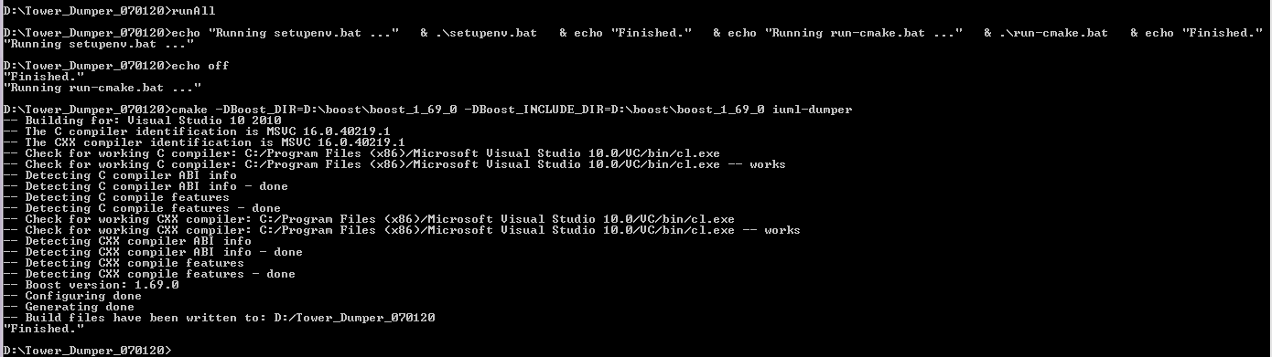

This will create the Visual Studio project.

Open the project by double-clicking iUML.sln
Execute build->build solution (the process should take about 10 – 15 mins.

When complete, there will be some errors:

error LNK1104 cannot open file api.lib
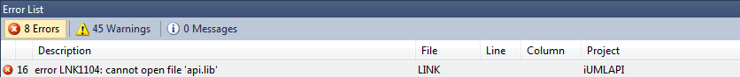
You need to open the properties for iUMLAPI. To do that, open any source file in that solution to put VS into the right context. Then do Project -> iUMLAPI Properties. Select Configuration Properties -> Linker -> Input.
Edit the “Additional Dependencies” (1st item in list)
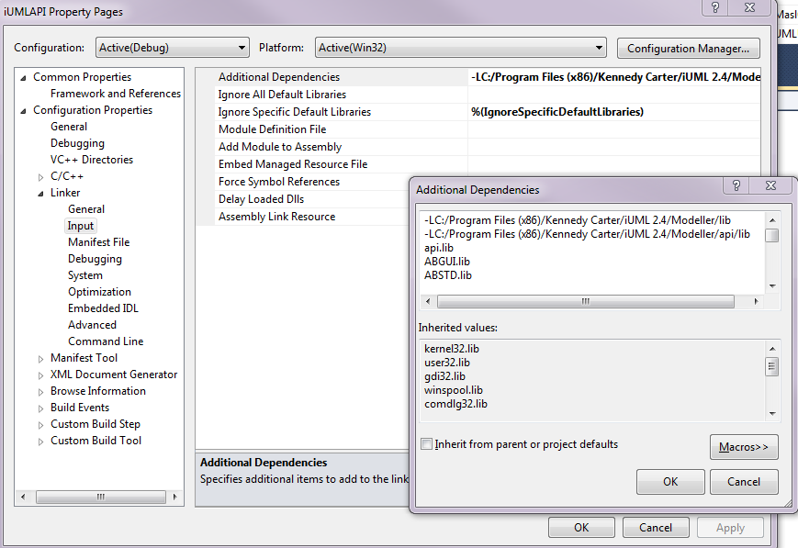
You can see in the above, there are some .lib files with no paths. The path to the KC libraries needs adding and is C:\Program Files (x86)\Kennedy Carter\iUML 2.4\Modeller\api\lib in the standard KC install. Note also that some files are not quite the same due to Solaris/Windows differences and will need changing. Note also that this step could possibly be eradicated by changes to iUMLAPI\cmakelists.txt.
Copy all the text below to replace what’s there:

C:/Program Files (x86)/Kennedy Carter/iUML 2.4/Modeller/api/lib/api.lib
C:/Program Files (x86)/Kennedy Carter/iUML 2.4/Modeller/api/lib/libABGUI344.lib
C:/Program Files (x86)/Kennedy Carter/iUML 2.4/Modeller/api/lib/libABSTD344.lib
C:/Program Files (x86)/Kennedy Carter/iUML 2.4/Modeller/perl/lib/auto/B/C/C.lib
C:/Program Files (x86)/Kennedy Carter/iUML 2.4/Modeller/api/lib/libDBG344.lib
C:/Program Files (x86)/Kennedy Carter/iUML 2.4/Modeller/api/lib/libDBI344.lib
C:/Program Files (x86)/Kennedy Carter/iUML 2.4/Modeller/api/lib/libDEASEL344.lib
C:/Program Files (x86)/Kennedy Carter/iUML 2.4/Modeller/api/lib/libEASEL344.lib
C:/Program Files (x86)/Kennedy Carter/iUML 2.4/Modeller/api/lib/libFRAMEWORKS344.lib
C:/Program Files (x86)/Kennedy Carter/iUML 2.4/Modeller/api/lib/libLOGIC344.lib
C:/Program Files (x86)/Kennedy Carter/iUML 2.4/Modeller/api/lib/libMI344.lib
C:/Program Files (x86)/Kennedy Carter/iUML 2.4/Modeller/api/lib/libOM344.lib
C:/Program Files (x86)/Kennedy Carter/iUML 2.4/Modeller/api/lib/libPRINT344.lib
C:/Program Files (x86)/Kennedy Carter/iUML 2.4/Modeller/api/lib/libSE344.lib
C:/Program Files (x86)/Kennedy Carter/iUML 2.4/Modeller/api/lib/libTBK344.lib
C:/Program Files (x86)/Kennedy Carter/iUML 2.4/Modeller/api/lib/libTBK1344.lib
C:/Program Files (x86)/Kennedy Carter/iUML 2.4/Modeller/api/lib/libTEBAS344.lib
C:/Program Files (x86)/Kennedy Carter/iUML 2.4/Modeller/api/lib/libTM344.lib
kernel32.lib
user32.lib
gdi32.lib
winspool.lib
shell32.lib
ole32.lib
oleaut32.lib
uuid.lib
comdlg32.lib
advapi32.lib

error LNK1104 cannot open file ‘..\iumlapi\Debug\iUMLAPI.lib’
error LNK1104 cannot open file ‘Debug\MaslGen.lib’

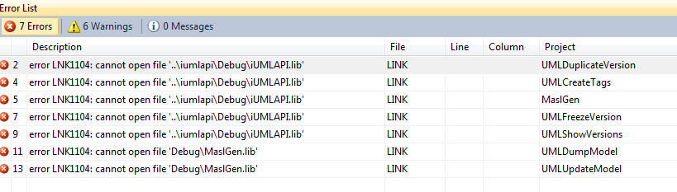
These files (iUMLAPI.lib and MaslGen.lib) are produced by the VS Build process, but the properties of the iUMLAPI and MaslGen project needs to change the name and type of these libraries from dynamic DLL to static.lib as below:
Note that doing this step removes the Configuration Properties -> Linker option in the previous step, therefore this step must be reverted if you wish to go back.
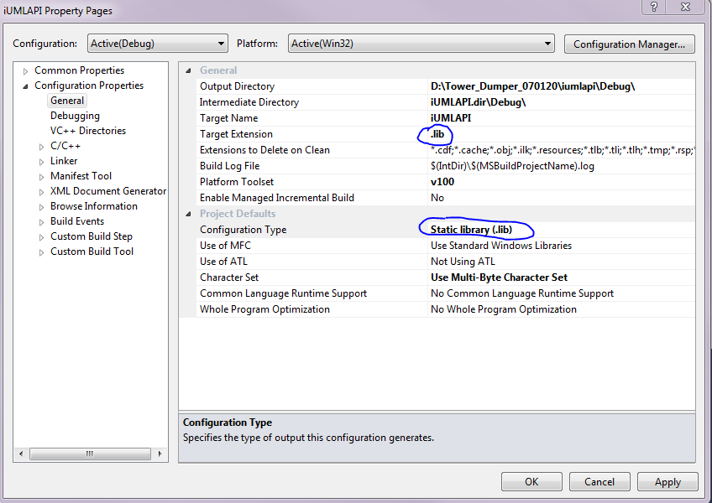
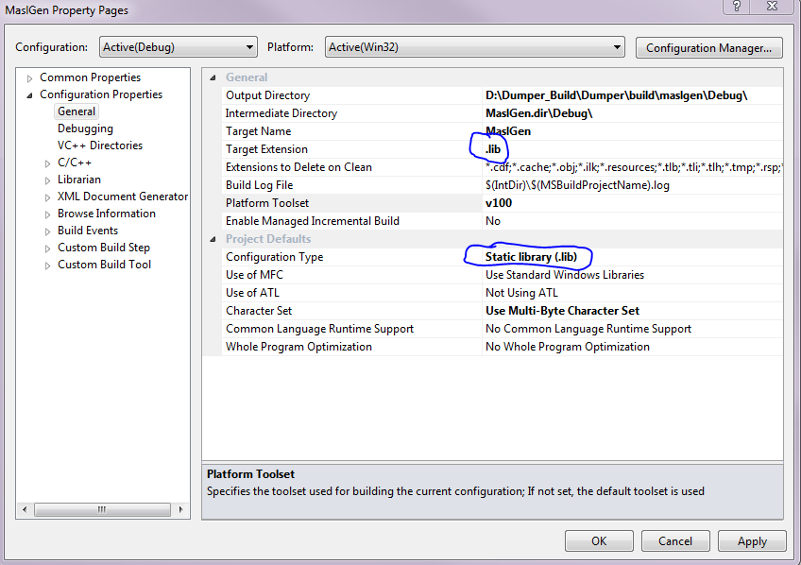

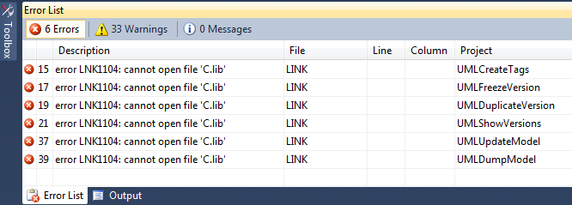
To correct the above, you need to do into the properties for all 6 projects mentioned above, remove c.lib and replace with C:/Program Files (x86)/Kennedy Carter/iUML 2.4/Modeller/api/lib/api.lib
Note – Only one of the 6 project changes shown below but do the same for all of them:
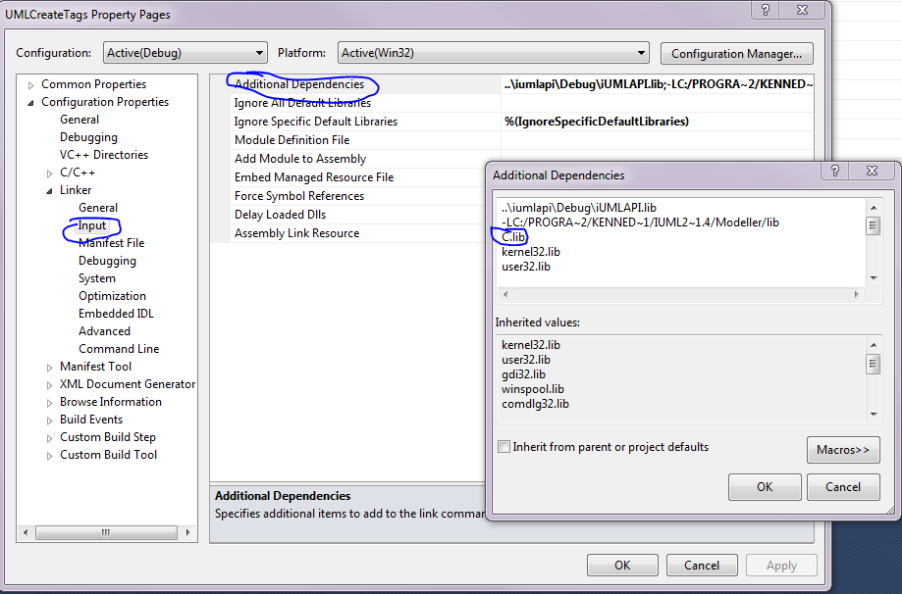
replace with:
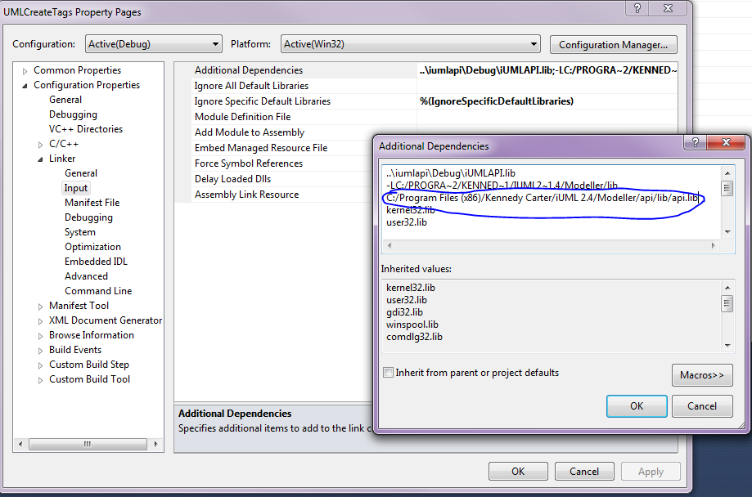
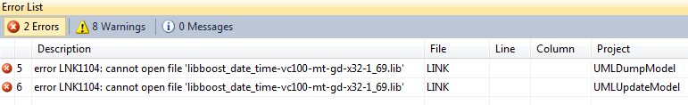
To fix the above; just add the path to the boost library asked for in both projects where the error occurs (Only one project shown here):
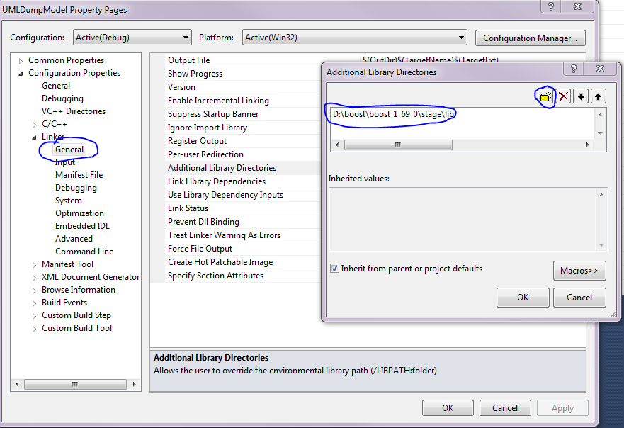
The build should then complete. You should see something resembling:
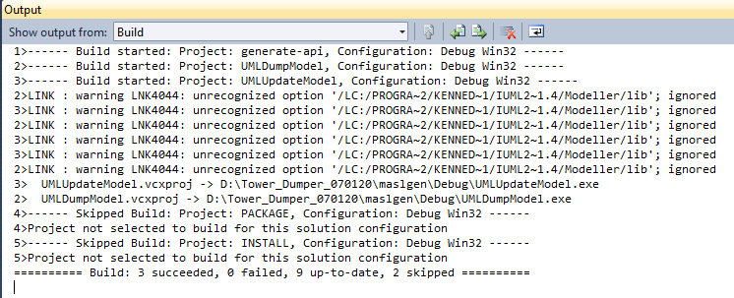

Running the dumper
In directory iUML_dumper_run there are some scripts to run the dumper on the iUML models.

Source Code Storage
The source code is updated in github here: https://github.com/xtuml/iuml-dumper

