Data Services Products: EMC-NACraton-FWANT-Vs2025
3-D shear-wave velocity model for the North American midcontinent from full-wave ambient noise tomography

Summary
NACraton-FWANT-Vs2025 (Yang et al., in press) is a 3-D shear-wave velocity model for the North American midcontinent from full-wave ambient noise tomography, with the best resolvable depth from 20 km down to 200 km.

Description
Name | NACraton-FWANT-Vs2025
Title | 3-D shear-wave velocity model for the North American midcontinent from full-wave ambient noise tomography
Type | 3-D Tomography Earth Model
Sub Type | Shear-wave velocity (km/s)
Year | 2025
Short Description | NACraton-FWANT-Vs2025 is a 3-D shear-wave velocity model for the North American midcontinent from full-wave ambient noise tomography (FWANT). The model is provided from 0 to 300 km, though the best resolvable depth for Vs is from 20 km down to 200 km. Since the model was constructed using Rayleigh waves from ambient noise cross-correlations, the velocity is for the vertically polarized shear-wave. FWANT also revolves P-wave velocity for the top 20 km. The tomography method involves 3-D wave propagation simulation. The travel-time different between the synthetics and the observed empirical Green’s functions are inverted for finite-frequency sensitivity kernels to get velocity perturbations. The velocity model here is achieved after 7 iterations.
Authors:
Authors: | Xiaotao Yang^{∗1}, Lihang Peng², Andrea Stevens Goddard³, Lijun Liu^{∗4}
Authors: | ¹ Department of Earth, Atmospheric, and Planetary Sciences, Purdue University. West Lafayette, IN, USA  ² Department of Earth Science & Environmental Change, University of Illinois Urbana-Champaign. Urbana, IL, USA  ³ Department of Earth and Atmospheric Sciences, Indiana University Bloomington. Bloomington, IN, USA  ⁴ State Key Laboratory of Lithospheric and Environmental Coevolution, Beijing, China
Previous Model | None
Reference Model | The reference velocity model consists of two parts: a global shear-velocity model for the top 400 km (Shapiro and Ritzwoller, 2002) and the IASP91 1-D Earth model from 400 km down to 1006 km (Kennett and Engdahl, 1991).
Model Download
Model Download | netCDF binary file for the above isotropic shear velocity model: NACraton-FWANT-Vs2025.nc.
Depth Coverage | From 0 km to 300 km (best resolution at 20-200 km).
Areal Coverage | North American midcontinent (United States) (latitude: 35° to 48°, longitude: -97° to -79°)
Data Set Description | The data set includes the shear velocity model on an inversion grid of longitude and latitude with spacing of 0.05° in both directions. No smoothing or interpolation applied in the uploaded model. Vertical grid spacing increases with depth.
Model Resolution | As tested and validated by previous applications of full-wave tomographic imaging (e.g., Gao, 2018; Zhang and Shen, 2008), Rayleigh waves are most sensitive to P-wave velocity at shallow depths (< 15-20 km) and to S-wave velocity at greater depths. Although P-wave velocity model is also provided for all depth, interpretation of P velocities deeper than 20 km is discouraged. The model provided here (Figure 1) is from the inversion result of the 7th iteration with a box smoothing at the size of 17 grids (or about 93.5 km). When interpreting the velocity model, it is recommended that the user smooth the model based on the best resolution at the corresponding depth, as shown in Yang et al. (in press) and Figure 2 on this page.

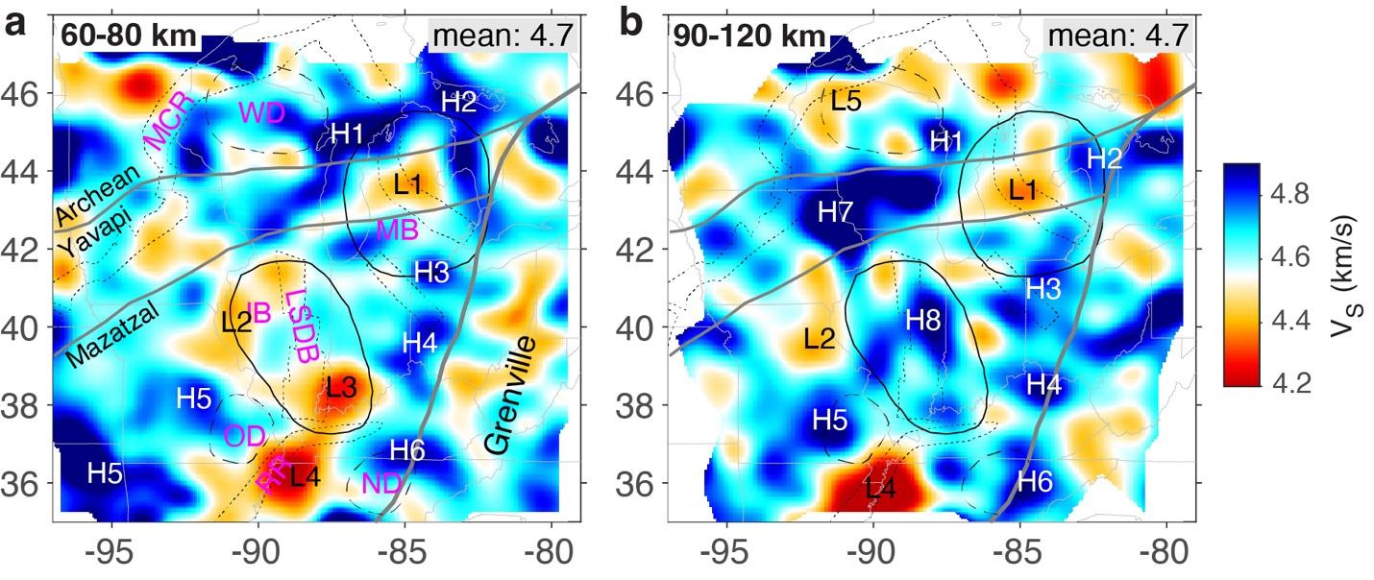
Figure 1. Average shear-wave velocities at the depth ranges of (a) 60-80 km and (b) 90-120 km, from full-wave ambient noise tomography model: NACraton-FWANT-Vs2025.

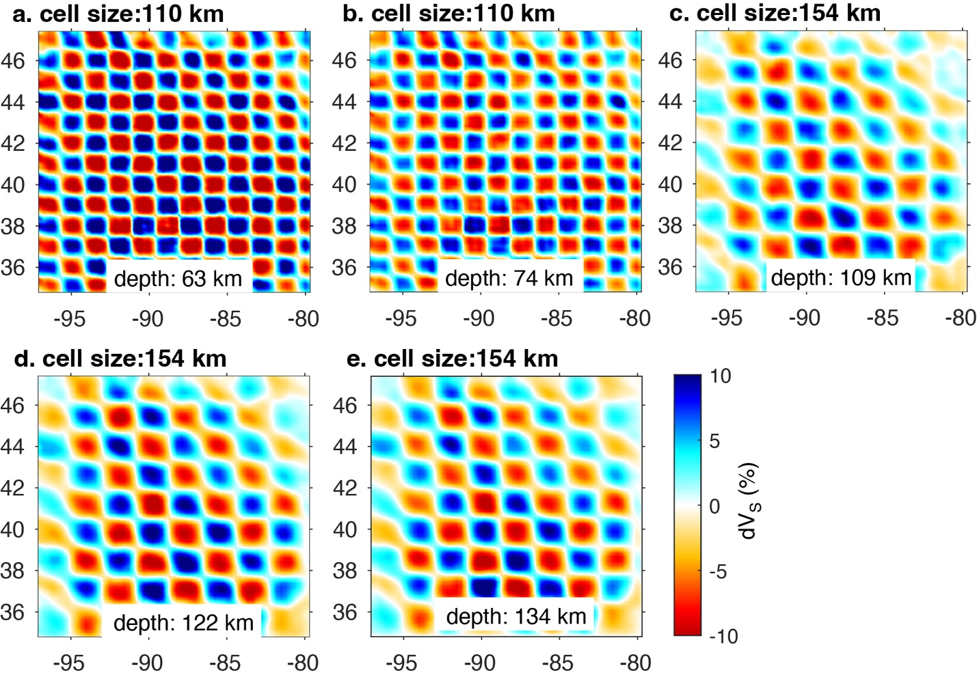
Figure 2. 3D checkerboard resolution tests for the velocity model. The velocity perturbation varies within ±10% in the input models.

References
This model:
- Yang, X., Peng, L., Stevens Goddard, A., Liu, L., Fischer, K. (in press). Lithospheric delamination below the North American midcontinent ceased subsidence in cratonic basins, AGU Advances
Other cited work:
- Gao, H. (2018). Three-dimensional variations of the slab geometry correlate with earthquake distributions at the Cascadia subduction system. Nature Communications, 9(1), 1–8. https://doi.org/10.1038/s41467-018-03655-5
- Kennett, B. L. N., Engdahl, E. R. Traveltimes for global earthquake location and phase identification. Geophys. J. Int., 105: 429-465 (1991)
- Shapiro, N. M., and M. H. Ritzwoller (2002), Monte-Carlo inversion for a global shear-velocity model of the crust and upper mantle, Geophys. J. Int., 151(1), 88-105, doi:10.1046/j.1365-246X.2002.01742.x
- Zhang, Z., & Shen, Y. (2008). Cross-dependence of finite-frequency compressional waveforms to shear seismic wave speeds. Geophysical Journal International, 174(3), 941–948. https://doi.org/10.1111/j.1365-246X.2008.03840.x

