Data Services Products: EMC-WNACraton-FWANT-Vs2026
3-D shear-wave velocity model for the western North American craton margin from full-wave ambient noise tomography

Summary
WNACraton-FWANT-Vs2026 (Yang et al., in revision) is a 3-D shear-wave velocity model for the western North American craton margin from full-wave ambient noise tomography, with the best resolvable depth from 10 km down to 200 km.

Description
Name | WNACraton-FWANT-Vs2026
Title | 3-D shear-wave velocity model for the western North American craton margin from full-wave ambient noise tomography
Type | 3-D Tomography Earth Model
Sub Type | Shear-wave velocity (km/s)
Year | 2026
Short Description | WNACraton-FWANT-Vs2026 is a 3-D shear-wave velocity model for the western North American craton margin from full-wave ambient noise tomography (FWANT). The model is provided from 0 to 200 km, though the best resolvable depth for Vs is from 10 km down to 170 km. Since the model was constructed using Rayleigh waves from ambient noise cross-correlations, the velocity is for the vertically polarized shear-wave. FWANT also revolves P-wave velocity for the top 15 km. The tomography method involves 3-D wave propagation simulation. The travel-time different between the synthetics and the observed empirical Green’s functions are inverted for finite-frequency sensitivity kernels to get velocity perturbations. The velocity model here is achieved after 4 iterations.
Authors:
 | Xiaotao Yang^{∗1}, Lijun Liu^{∗2}, Zebin Cao²
¹ Department of Earth, Atmospheric, and Planetary Sciences, Purdue University. West Lafayette, IN, USA
² State Key Laboratory of Lithospheric and Environmental Coevolution, Institute of Geology and Geophysics, Chinese Academy of Sciences. Beijing, China
Previous Model | None
Reference Model | The reference velocity model consists of two parts: a global AK135 1-D Earth model from 0 km down to 1006 km (Kennett et al., 1995).
Model Download
 | netCDF binary file for the above isotropic shear velocity model: WNACraton-FWANT-Vs2026.nc.
Depth Coverage | From 0 km to 200 km.
Areal Coverage | Western North American craton margin (United States) (latitude: 32° to 49°, longitude: -118° to -98.5°)
Data Set Description | The data set includes the shear velocity model on an inversion grid of longitude and latitude with spacing of 0.05° in both directions. No smoothing or interpolation applied in the uploaded model. Vertical grid spacing increases with depth.
Model Resolution | As tested and validated by previous applications of full-wave tomographic imaging (e.g., Gao, 2018; Zhang and Shen, 2008), Rayleigh waves are most sensitive to P-wave velocity at shallow depths (< 15-20 km) and to S-wave velocity at greater depths. Although P-wave velocity model is also provided for all depth, interpretation of P velocities deeper than 15 km in this model is discouraged. Figure 1 shows examples of the shear-wave velocity model at 74 and 97 km depths. When interpreting the velocity model, it is recommended that the user smooth the model based on the best resolution at the corresponding depth, as shown in Yang et al. (in revision) and Figure 2 on this page.

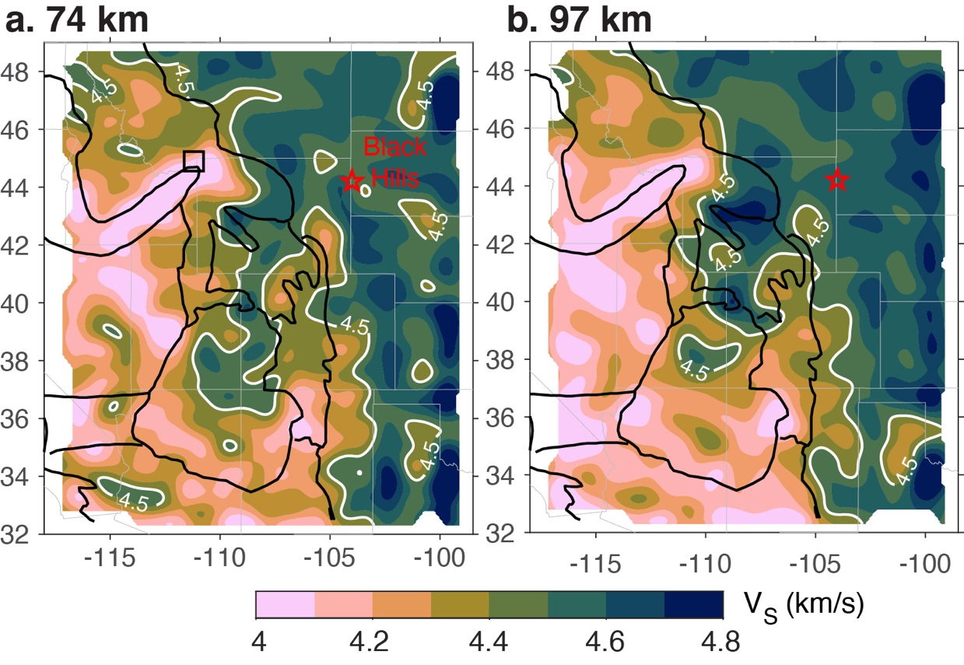
Figure 1. Shear-wave velocities at the depths of (a) 74 km and (b) 97 km, from full-wave ambient noise tomography model: WNACraton-FWANT-Vs2026.

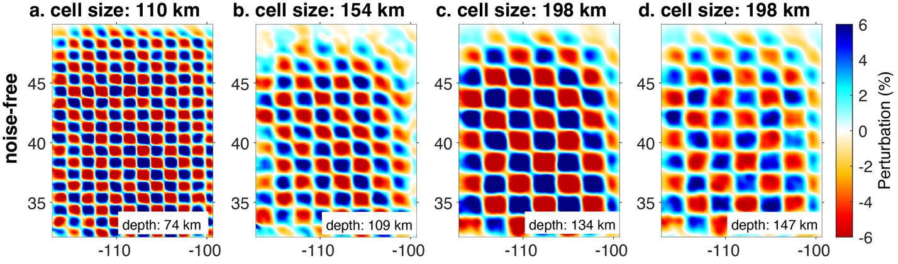
Figure 2. 3D checkerboard resolution tests for the velocity model. The velocity perturbation varies within ±10% in the input models.

References
This model:
- Yang, X., Liu, L., & Cao, Z. (in revision). Channelized lithospheric erosion shapes the western North American craton margin, Nature Communications
Other cited work:
- Gao, H. (2018). Three-dimensional variations of the slab geometry correlate with earthquake distributions at the Cascadia subduction system. Nature Communications, 9(1), 1–8. https://doi.org/10.1038/s41467-018-03655-5
- Kennett, B. L., Engdahl. R., & Buland, R. (1995), Constraints on seismic velocities in the earth from travel times, Geophys. J. Int, 122(1), 108-124.
- Zhang, Z., & Shen, Y. (2008). Cross-dependence of finite-frequency compressional waveforms to shear seismic wave speeds. Geophysical Journal International, 174(3), 941–948. https://doi.org/10.1111/j.1365-246X.2008.03840.x

