Table S1, Summary of study subjects by smoking status
 | Nonsmoker (n=20) | Smoker (n=23) | P value
Age (years) | 34(28-50) | 45(33-49) | 0.55
Gender (M/F) | 10/10 | 13/10 | 0.77
Race (black/white) | 9/11 | 11/12 | 1
Cigarettes per day (number) | NA | 15(10-20) | NA
Total years smoking (years) | NA | 15(11-29) | NA
Alcohol drink (rarely/weekly) | 17/3 | 20/3 | 1
PSR score | 4.5 (4.0 -6.0) | 6.0 (5.0 -8.0) | 0.03

Note: Note: Median(interquartile range) or counts are shown. P values were based on Wilcoxon test for continuous variables, Fisher's exact test for counts.

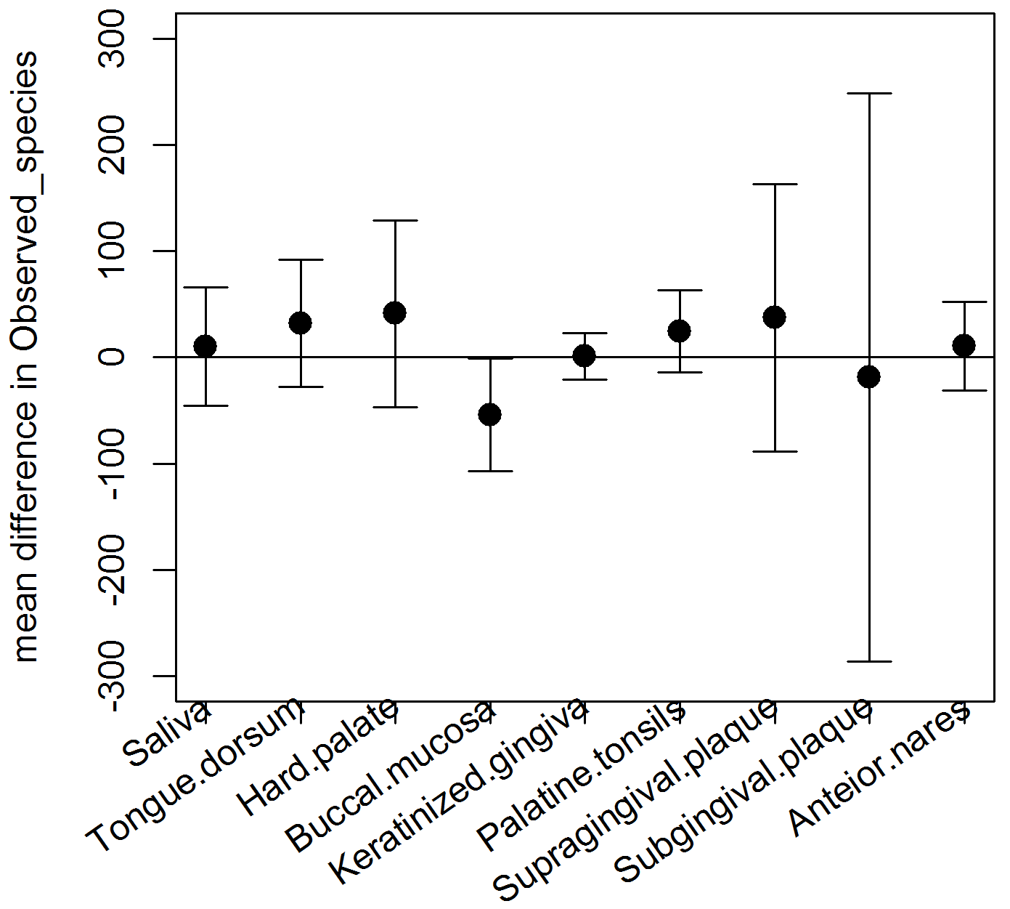
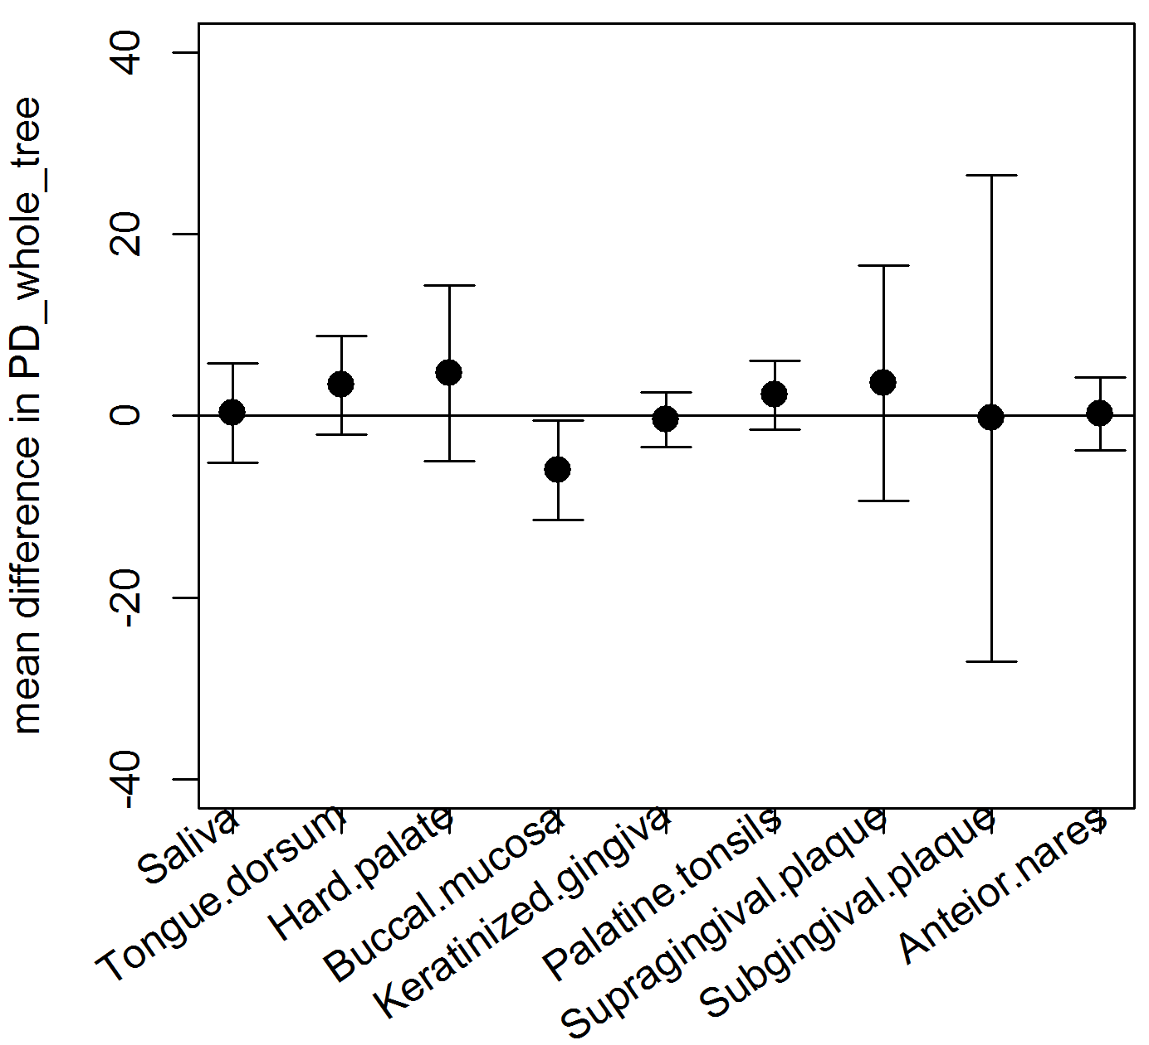
a
b

Figure S1, Mean difference between smoker and nonsmokers in observed species (a) and PD_whole_tree (b) with 95% confidence interval based on t-distribution. The black dots are mean difference between smokers and nonsmokers (smokers - nonsmokers).

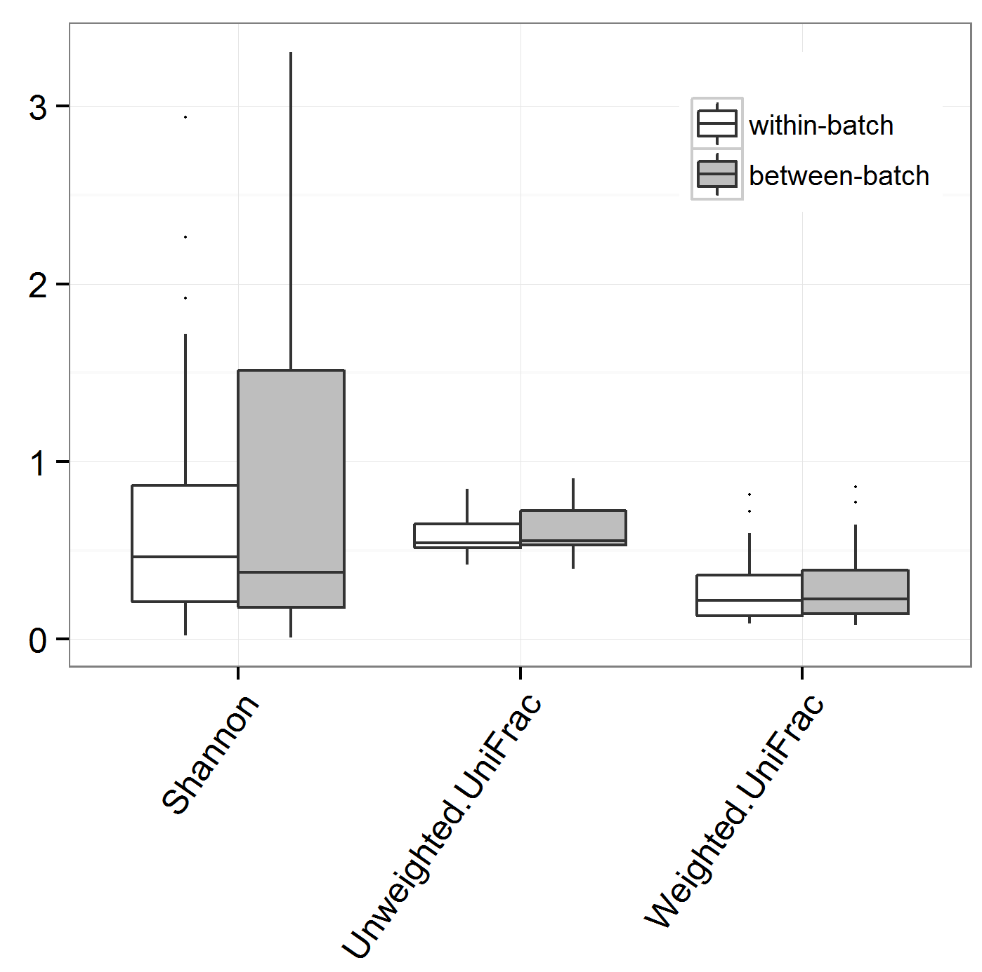
Figure S2, Box plot showing no difference of within- and between-plate/batch variation in alpha diversity (Shannon) and beta diversity (unweighted and weighted UniFrac). Boxes are interquartile range (IQR); median values are bands within the boxes; lines outside the boxes are 1.5-times IQR; dots are outliers.

