The phylogenic and functional compositions of the supragingival microbiome are different between caries-affected and caries-free hosts
Jinzhi He^{1◄}, Qichao Tu^{2,3◄}, Yichen Ge¹, Yujia Qin², Bomiao Cui¹, Xiaoyu Hu¹, Yuxia Wang¹, Ye Deng³, Kun Wang¹, Joy D. Van Nostrand³, Jiyao Li¹, Jizhong Zhou^{1, 3,*}, Yan Li^{1, *}, Xuedong Zhou^{1, *}
1. State Key Laboratory of Oral Diseases, Department of Endodontics, West China Hospital of Stomatology, Sichuan University, Chengdu 610041, China
2. Department of Marine Sciences, Ocean College, Zhejiang University, Zhejiang, 361000, China
3. Institute for Environmental Genomics, Department of Microbiology and Plant Biology, University of Oklahoma, Norman, OK 73019, USA.

◄ These two authors contributed equally to this study.
* Corresponding author: Xuedong Zhou, State Key Laboratory of Oral Diseases, West China Hospital of Stomatology, Sichuan University, Chengdu 610041, China; e-mail: zhouxd@scu.edu.cn or Yan Li, State Key Laboratory of Oral Diseases, West China Hospital of Stomatology, Sichuan University, Chengdu 610041, China; e-mail: feifeiliyan@163.com or Jizhong Zhou, Institute for Environmental Genomics, Department of Microbiology and Plant Biology University of Oklahoma, Norman, OK 73019, USA, e-mail: jzhou@rccc.ou.edu

Supplementary materials

Fig S1. Rarefaction curves of healthy (H), moderate caries (MC) and severe caries (SC) samples.
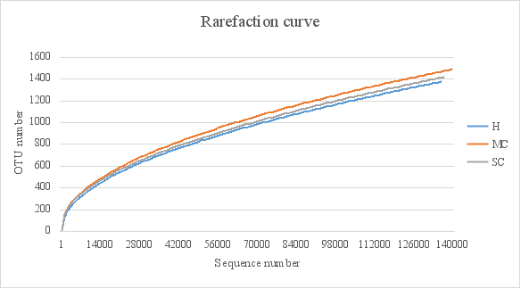

Fig S2. Microbial structure comparison by DCA between healthy and caries controls
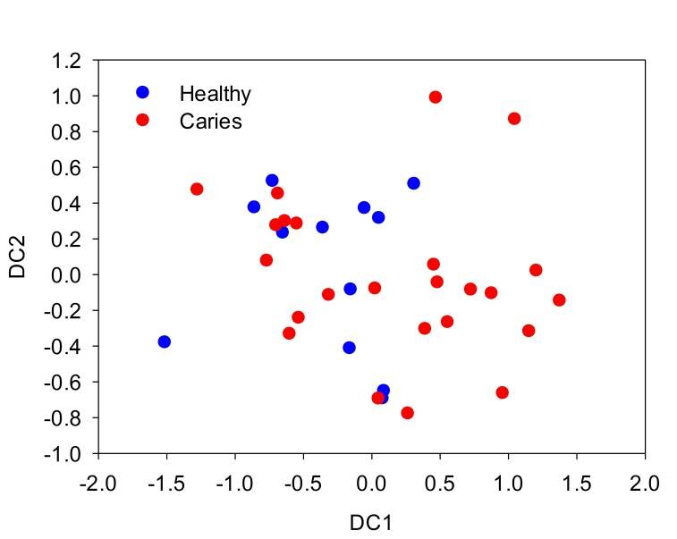

Fig S3. UniFrac distance comparison between healthy and caries controls
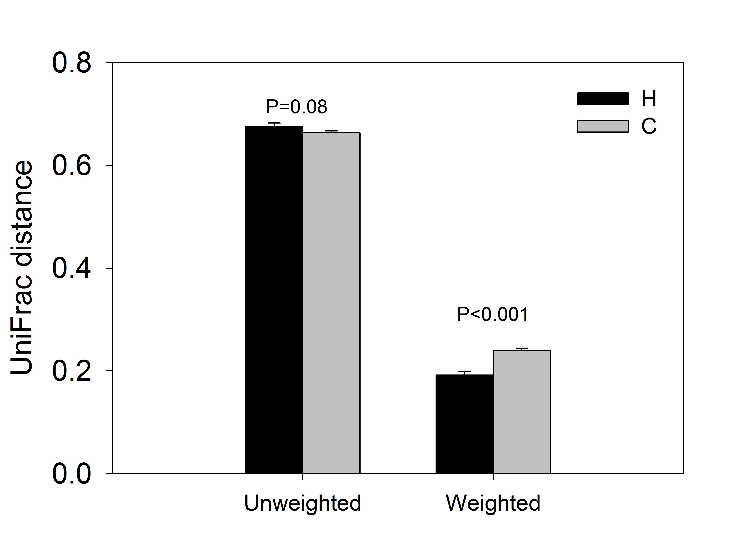

Fig S4. Functional structure comparison between healthy and caries controls
