Supplementary document for
The effects of removing dead bacteria by propidium monoazide on the profile of salivary microbiome
Qidi Ren^{#, a}, Fangqiao Wei^{#, a}, Chao Yuanª, Ce Zhu^{a, b}, Qian Zhang^{c}, Junkang Quanª, Xiangyu Sun^{*, a}, Shuguo Zheng^{*, a}

Table S1. Information of participants and samples
Sample ID | Sex | Age | Subgroup
C_M11 | Male | 6 | C1 (4~6y)
C_M12 | Male | 6 | C1 (4~6y)
C_M13 | Male | 6 | C1 (4~6y)
C_F11 | Female | 6 | C1 (4~6y)
C_F12 | Female | 6 | C1 (4~6y)
C_F13 | Female | 6 | C1 (4~6y)
C_M21 | Male | 28 | C2 (18~30y)
C_M22 | Male | 24 | C2 (18~30y)
C_M23 | Male | 29 | C2 (18~30y)
C_F21 | Female | 23 | C2 (18~30y)
C_F22 | Female | 29 | C2 (18~30y)
C_F23 | Female | 26 | C2 (18~30y)
C_M31 | Male | 50 | C3 (50~60y)
C_M32 | Male | 50 | C3 (50~60y)
C_M33 | Male | 51 | C3 (50~60y)
C_F31 | Female | 50 | C3 (50~60y)
C_F32 | Female | 50 | C3 (50~60y)
C_F33 | Female | 50 | C3 (50~60y)
P_M11 | Male | 6 | P1 (4~6y)
P_M12 | Male | 6 | P1 (4~6y)
P_M13 | Male | 6 | P1 (4~6y)
P_F11 | Female | 6 | P1 (4~6y)
P_F12 | Female | 6 | P1 (4~6y)
P_F13 | Female | 6 | P1 (4~6y)
P_M21 | Male | 28 | P2 (18~30y)
P_M22 | Male | 24 | P2 (18~30y)
P_M23 | Male | 29 | P2 (18~30y)
P_F21 | Female | 23 | P2 (18~30y)
P_F22 | Female | 29 | P2 (18~30y)
P_F23 | Female | 26 | P2 (18~30y)
P_M31 | Male | 50 | P3 (50~60y)
P_M32 | Male | 50 | P3 (50~60y)
P_M33 | Male | 51 | P3 (50~60y)
P_F31 | Female | 50 | P3 (50~60y)
P_F32 | Female | 50 | P3 (50~60y)
P_F33 | Female | 50 | P3 (50~60y)

Table S2. Total number of reads per sample
sample ID | raw reads | after QC
C_M11 | 36937 | 33451
C_M12 | 37692 | 34470
C_M13 | 32574 | 30363
C_F11 | 33057 | 30098
C_F12 | 30971 | 27883
C_F13 | 39055 | 36309
C_M21 | 41981 | 38815
C_M22 | 30338 | 28110
C_M23 | 34338 | 30647
C_F21 | 33459 | 30697
C_F22 | 35664 | 33098
C_F23 | 37234 | 33078
C_M31 | 44875 | 40860
C_M32 | 32964 | 29862
C_M33 | 37396 | 34397
C_F31 | 35195 | 31888
C_F32 | 35928 | 32824
C_F33 | 39125 | 36404
P_M11 | 35640 | 33197
P_M12 | 31889 | 29281
P_M13 | 32143 | 30187
P_F11 | 35724 | 32653
P_F12 | 42793 | 39202
P_F13 | 36622 | 34192
P_M21 | 34484 | 32306
P_M22 | 32185 | 30611
P_M23 | 31427 | 29451
P_F21 | 35407 | 32563
P_F22 | 30520 | 28428
P_F23 | 40549 | 37329
P_M31 | 33792 | 31402
P_M32 | 38250 | 35247
P_M33 | 33480 | 30999
P_F31 | 34390 | 31828
P_F32 | 29044 | 26990
P_F33 | 25123 | 23721
Table S3. Comparison among the three age groups by OTUs present in Group C and absent in Group P
(A) Summary of specific OTUs in for each age group
OTU number | Name | Level
4~6y
OTU247 | pittmaniae | species
OTU235 | diminuta | species
OTU195 | gingivicola | species
OTU182 | artemidis | species
OTU173 | sp._HMT_315 | species
OTU171 | sp._HMT_308 | species
OTU175 | Bergeyella | genus
18~30y
OTU252 | sp._HMT_894 | species
OTU237 | sakazakii | species
OTU234 | sp._HMT_266 | species
OTU226 | curtum | species
OTU223 | ignava | species
OTU213 | vestrisii | species
OTU208 | sp._HMT_927 | species
OTU187 | sp._HMT_183 | species
OTU183 | sp._HMT_080 | species
OTU180 | dentalis | species
OTU176 | Treponema | species
OTU172 | massiliensis | species
OTU170 | [G-1]_bacterium_HMT_155 | species
OTU167 | pleuritidis | species
OTU160 | [G-5]_bacterium_HMT_505 | species
OTU137 | [XI][G-4]_bacterium_HMT_369 | species
OTU134 | coli | species
OTU123 | (TM7)_[G-1]_bacterium_HMT_346 | species
OTU102 | [XI][G-6]_nodatum | species
OTU86 | Fusobacterium | genus
OTU185 | Corynebacterium | genus
OTU169 | Selenomonas | genus
OTU101 | Sneathia | genus
50~60y
OTU109 | capitis | species
OTU236 | sp._HMT_166 | species
OTU242 | [G-2]_bacterium_HMT_088 | species
OTU255 | omnicolens | species
OTU202 | Coriobacteriaceae | family
(B) Summary of OTUs shared by ≥ 2 age groups
OTU number | Name | Level
4~6y
OTU61 | luteus | species
OTU262 | (GN02)_[G-1]_bacterium_HMT_871 | species
OTU250 | sp._HMT_847 | species
OTU239 | muelleri | species
OTU225 | [F-1][G-1]_bacterium_HMT_093 | species
OTU224 | sp._HMT_262 | species
OTU208 | sp._HMT_927 | species
OTU147 | sp._HMT_257 | species
OTU136 | (TM7)_[G-2]_bacterium_HMT_350 | species
OTU251 | Lachnospiraceae_[XIV] | family
OTU221 | OTU221 | OTU
OTU193 | OTU193 | OTU
OTU192 | OTU192 | OTU
18~30y
OTU262 | (GN02)_[G-1]_bacterium_HMT_871 | species
OTU250 | sp._HMT_847 | species
OTU239 | muelleri | species
OTU225 | [F-1][G-1]_bacterium_HMT_093 | species
OTU224 | sp._HMT_262 | species
OTU147 | sp._HMT_257 | species
OTU136 | (TM7)_[G-2]_bacterium_HMT_350 | species
OTU221 | OTU221 | OTU
OTU193 | OTU193 | OTU
50~60y
OTU208 | sp._HMT_927 | species
OTU225 | [F-1][G-1]_bacterium_HMT_093 | species
OTU61 | luteus | species
OTU251 | Lachnospiraceae_[XIV] | family
OTU192 | OTU192 | OTU

Table S4. Beta diversity analysis based on PERMANOVA
 | Df | SumsOfSqs | MeanSqs | F.Model | R2 | Pr(>F)
Sex | 1 | 0.07411 | 0.074108 | 1.732 | 0.05699 | 0.112
Age | 1 | 0.16756 | 0.167558 | 3.9161 | 0.12885 | 0.002**
Group | 1 | 0.04111 | 0.041108 | 0.9607 | 0.03161 | 0.435
Subgroup | 4 | 0.1546 | 0.03865 | 0.9033 | 0.11888 | 0.589
Sex:Age | 1 | 0.03241 | 0.032413 | 0.7575 | 0.02493 | 0.648
Sex:Group | 1 | 0.00647 | 0.006467 | 0.1511 | 0.00497 | 1
Age:Group | 1 | 0.00515 | 0.005154 | 0.1205 | 0.00396 | 1
Sex:Subgroup | 4 | 0.11874 | 0.029685 | 0.6938 | 0.09131 | 0.887
Age:Subgroup | 1 | 0.01567 | 0.01567 | 0.3662 | 0.01205 | 0.964
Residuals | 16 | 0.6846 | 0.042787 |  | 0.52645
Total | 31 | 1.30041 |  |  | 1

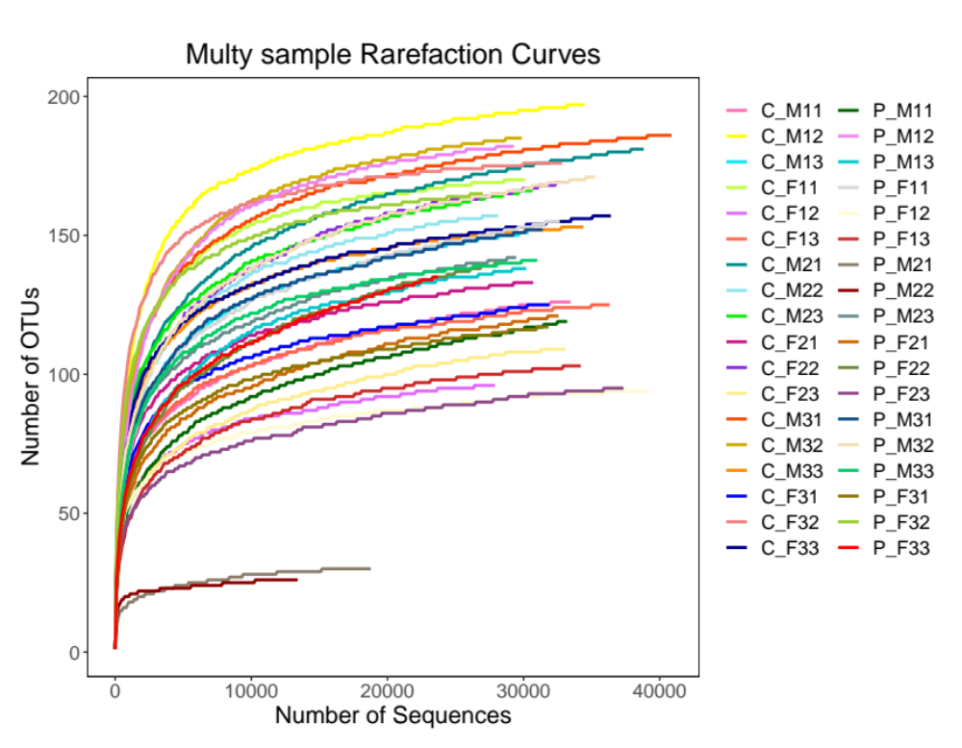
Figure S1. Rarefaction curves for each experimental sample

