110550133 劉安之
- How do you select features for your model input, and what preprocessing did you perform to review text?
I selected the title and text to be my input for 2 layesr lstm model. Then, I select vertified_purchase and helpful_vote to be my input for 1 layer of DNN. At last, I combine these features in another layer of DNN and use output layer to get the ratings. In addition, I first lowercase all the text and then split the text into individual tokens. Finally, I use a pre-trained embedding model GloVe to embed the text.

- Please describe how you tokenize your data, calculate the distribution of tokenized sequence length of the dataset and explain how you determine the padding size

I first lowercase all the text and then split the text into individual tokens. Finally, I use a pre-trained embedding model GloVe to embed the text with a dimension of 100. I calculate the distribution of tokenized sequence length of the dataset in the chart below, and I decide to choose padding size as 50 because most reviews will not exceed 50 words.
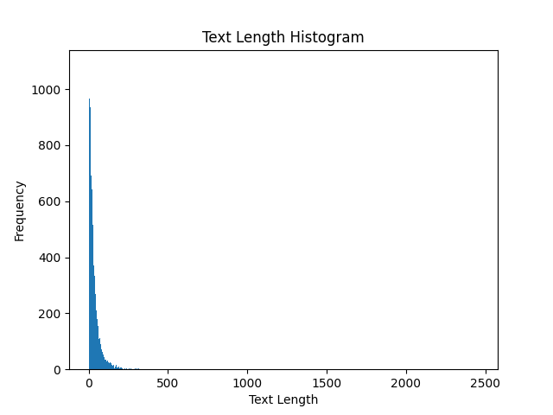

- Please compare the impact of using different methods to prepare data for different rating categories

If using imbalance dataset, like data having many 5 rating, will cause the accuracy low. In addition, ignoring vertified_purchase and helpful_vote will also lower the accuracy, because this is briefly that rating with more helpful vote and actually buying is more convincible.

