Automated Ceramic Reign Mark Identification System: A Multi-Agent Architecture with Weighted Consensus Voting
TRAN Thanh-Nam^{1[0009-0008-6301-7332]}, TRUONG Xua², and NGO HO ANH-Khoa^{1[0000-0002-4844-5012]}
¹ Faculty of Information Technology, Nam Can Tho University, 168 Nguyen Van Cu Street, An Binh Ward, Can Tho City, Vietnam
{ttnam@nctu.edu.vn, xua225064@student.nctu.edu.vn,nhakhoa@nctu.edu.vn}
Abstract. This paper proposes MarkSense, a web-based system for the automated identification of Chinese and Vietnamese ceramic reign marks. To address the complexities of degraded historical calligraphic scripts and the lack of large-scale supervised training datasets, the system moves beyond traditional sequential OCR pipelines. Instead, we introduce a novel Multi-Agent Architecture comprising five parallel, specialized pipelines: (1) Semantic Analysis (OCR + Large Language Models), (2) Web Cross-Reference (OCR + Search), (3) Vision Comprehension (Vision API), (4) Visual Retrieval (Image Search), and (5) Machine Learning Database Matching. To synthesize diverse outputs, we propose a centralized Voting Aggregator that employs a weighted scoring mechanism based on agent confidence and historical consensus. This approach not only disambiguates visually similar characters but also accurately correlates archaeological metadata. The paper reports the architectural design and a pilot evaluation, demonstrating the robustness of parallel multimodal processing over traditional single-threaded OCR methodologies in the cultural heritage domain.
Keywords: Ceramic reign mark recognition, optical character recognition (OCR), PaddleOCR, ORB feature matching, fuzzy string matching, image preprocessing, Chinese calligraphy, cultural heritage digitization.

1 Introduction
Ceramic reign marks, inscriptions found on the base of porcelain artifacts indicating the dynasty, emperor, and period of manufacture, serve as critical evidence for dating and authenticating ceramic wares. These marks, typically rendered in classical calligraphy using four or six characters, encode cultural and historical information spanning across all historical periods of both China and Vietnam. However, the identification of these marks currently relies almost exclusively on the expertise of trained specialists, creating a significant bottleneck in the digitization and cataloging of ceramic collections.
The challenge of automating reign mark identification is multifaceted. First, the marks are rendered in various calligraphic styles that differ substantially from modern printed text. Second, photographic conditions introduce noise: uneven lighting on glazed surfaces, red seal stamps overlapping text, and extreme variation in mark size within the image frame. Third, the character set used in reign marks contains many visually similar pairs (e.g., 康 vs. 庚, 熙 vs. 照, 德 vs. 得) that confuse standard OCR engines.
Recent advances in deep learning have produced powerful OCR engines capable of recognizing complex text (Krizhevsky et al., 2012; He et al., 2016). PaddleOCR, an open-source toolkit developed by Baidu, has demonstrated state-of-the-art performance on standard text recognition benchmarks (Du et al., 2020). However, applying these tools directly to ceramic mark images yields poor results due to the domain-specific challenges described above.
To address these limitations, this study proposes MarkSense, a hybrid multimodal integrated pipeline that combines three core algorithms: (1) ORB-based reference retrieval, (2) multi-variant preprocessing and OCR, and (3) fuzzy database matching with handcrafted confusion groups. The title and system description use the term integrated pipeline rather than multi-agent architecture, because the current implementation coordinates sequential specialized modules instead of autonomous interacting agents.

2 Related Work
The field of text recognition has advanced substantially with the advent of deep learning. Early CNN-based approaches (Krizhevsky et al., 2012) demonstrated that convolutional architectures could learn discriminative features directly from character images. The development of deeper architectures such as ResNet (He et al., 2016) further improved recognition accuracy by addressing the vanishing gradient problem through residual connections. Sequence-to-sequence models incorporating CTC loss and attention mechanisms (Shi et al., 2017) enabled end-to-end recognition of variable-length text without explicit character segmentation.
PaddleOCR (Du et al., 2020) represents a modern, practical OCR framework that integrates a DB (Differentiable Binarization) text detector with a CRNN-based recognizer, achieving competitive performance on standard benchmarks including ICDAR 2015 and CTW. However, these systems are primarily trained and evaluated on modern printed and scene text. Their performance degrades significantly when applied to historical calligraphic scripts, where stroke styles, ink degradation, and non-standard character forms introduce distribution shifts that standard models cannot accommodate without domain-specific adaptation.
Feature-based image matching has a long history in computer vision. The Scale-Invariant Feature Transform (SIFT) (Lowe, 2004) introduced the concept of extracting local invariant descriptors that remain stable across scale and rotation changes. Subsequently, ORB (Oriented FAST and Rotated BRIEF) (Rublee et al., 2011) provided a computationally efficient binary descriptor alternative, achieving comparable matching quality at significantly lower computational cost. ORB detects keypoints using the FAST corner detector with an orientation component, then computes binary descriptors using rotated BRIEF patterns. Matching is performed using Hamming distance via bitwise XOR operations.
In the context of cultural heritage, feature matching has been applied to painting authentication, manuscript retrieval, and artifact cataloging (Fiorucci et al., 2020). However, its application to ceramic mark identification has not been previously explored. Our system uses ORB as a rapid retrieval mechanism, storing confirmed identifications as reference templates for instant future recognition.
The application of AI to cultural heritage preservation has gained significant attention. Wilczek et al. (2021) demonstrated that deep learning could classify ancient pottery fragments based on surface texture and shape features. Comprehensive surveys (Gualandi et al., 2021) highlight the feasibility of using CNNs and transfer learning to classify diverse artifact categories. Wang et al. (2019) applied deep learning to ancient ceramic identification using transfer learning from ImageNet, though requiring large labeled training datasets.
Recent work on historical document analysis addresses similar challenges. Chen et al. (2021) proposed attention-based networks for degraded historical Chinese character recognition, demonstrating that multi-scale feature extraction improves accuracy on worn text. Liu et al. (2022) developed a few-shot learning approach for rare historical character recognition. Zhong et al. (2020) introduced preprocessing pipelines for degraded document images, combining binarization, noise removal, and contrast enhancement.
Despite advances in OCR, feature matching, and heritage digitization individually, no existing system integrates these approaches into a unified pipeline specifically designed for ceramic reign mark identification. Current solutions either require extensive labeled training data unavailable for this niche domain, or fail to handle the unique challenges of calligraphic text on glazed ceramic surfaces. Furthermore, no prior work addresses visually similar character confusion in reign mark OCR, where misreading a single character results in identifying the wrong dynasty entirely.
This study addresses these gaps by combining multi-variant OCR preprocessing, feature-based reference retrieval, and domain-specific fuzzy correction with handcrafted confusion groups into a practical, deployable web application.

3 Our Proposition

The MarkSense system is proposed as a fully parallel, multi-agent identification architecture. Rather than relying on a monolithic neural classifier or a sequential fail-over pipeline, our system orchestrates five independent processing pipelines (agents) that operate concurrently. The outputs of these agents are synthesized by a centralized Voting Aggregator, which determines the final identification through a weighted consensus mechanism.
This multi-agent approach is specifically designed to mitigate the domain-specific challenges of ceramic marks, where a single character misinterpretation by an OCR engine can lead to an entirely incorrect historical dynasty attribution. By leveraging diverse modalities—ranging from pure semantic reasoning to visual feature matching—the system cross-validates findings and minimizes catastrophic failures.
The Five Parallel Agents
1. Agent 1: Semantic Analysis (OCR + LLM): This pipeline applies multi-variant image preprocessing and PaddleOCR to extract text candidates. The candidates are then processed by a Large Language Model (LLM) configured with domain-specific prompts to translate, interpret meaning, and correct syntax errors based on Chinese and Vietnamese historical naming conventions.
2. Agent 2: Web Cross-Reference (OCR + Search): Utilizing the extracted text, this agent performs real-time queries against academic and auction web databases. It retrieves historical contexts and verifies whether the recognized character sequence exists in documented archaeological records.
3. Agent 3: Vision Comprehension (Vision API): Bypassing traditional OCR entirely, this agent feeds the preprocessed image directly into a state-of-the-art multi-modal Vision AI. It evaluates the image holistically, recognizing calligraphic flow and seal-script characteristics that standard bounding-box OCR engines often misinterpret.
4. Agent 4: Visual Retrieval (Image Search): This agent searches for visually similar ceramic marks across external image databases. It helps identify highly degraded marks where characters are illegible but the overall spatial structure and seal shape are recognizable.
5. Agent 5: ML & Database Match (Fuzzy Matching & ORB): This agent maps OCR candidates against a curated, local ceramic mark database. It utilizes ORB feature matching for rapid reference retrieval, alongside weighted fuzzy string matching equipped with handcrafted confusion groups.
The Voting Aggregator
The core contribution of this architecture is the Voting Aggregator module. Because the five agents may return conflicting identifications, the aggregator executes a dynamic consensus algorithm to determine the most accurate final result.
Step 1: Validation and Filtering. The aggregator first filters out failed or skipped pipeline responses. It also penalizes weak generic results if their confidence scores are below a strict threshold.
Step 2: Weighted Scoring. Each valid agent result is assigned a predefined weight based on its historical reliability. The system computes a weighted score for each agent by multiplying its confidence score with its empirical weight.
Step 3: Dynasty Consensus. The aggregator extracts the predicted historical dynasty from each agent's result and performs a majority vote based on the weighted scores. The dynasty accumulating the highest total score is established as the baseline consensus.
Step 4: Cross-Referencing and Final Synthesis. The agent with the highest individual weighted score is initially selected as the primary source. However, the aggregator implements an intelligent override mechanism: if the primary agent's dynasty contradicts the group consensus, and a strong consensus exists among other high-confidence agents, the aggregator overrides the primary choice. Finally, the system constructs the final output by prioritizing verified local database entries for historical metadata.
Fig 1. MarkSense Multi-Agent Architecture
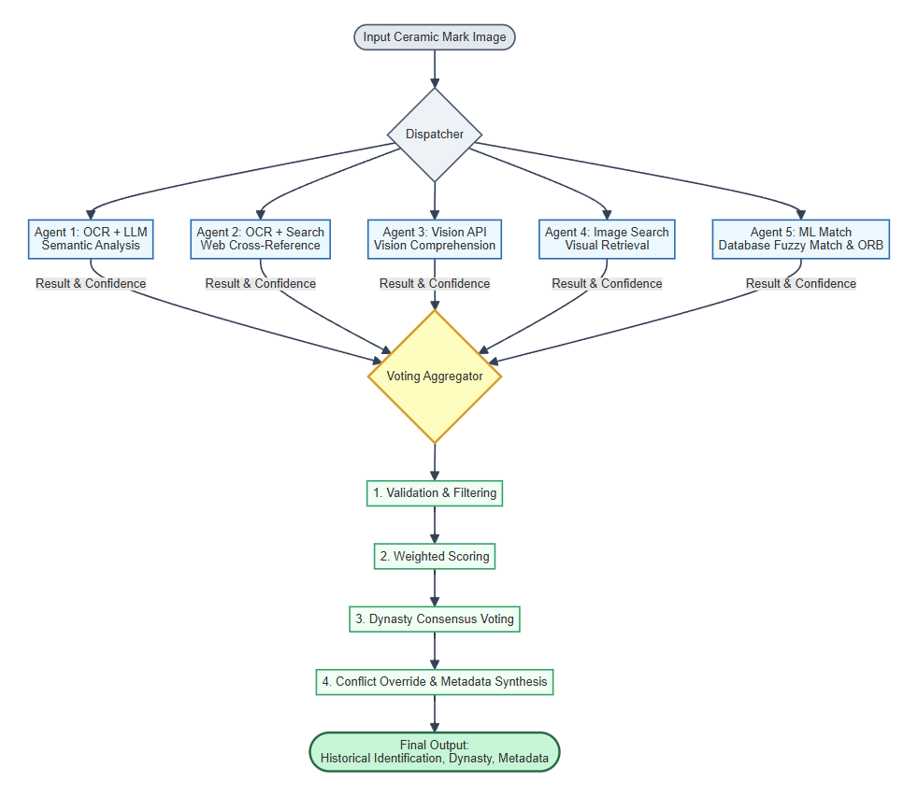
Algorithm: Multi-Agent Weighted Consensus Voting
Input: Ceramic mark image I, Curated Database D.
Output: Final identification y, Aggregated confidence E, and Historical metadata M.
1. Broadcast: Dispatch image I concurrently to five independent agents: Allm, Asearch, Avision, Aimg, Aml.
2. Collect: Retrieve a set of results R.
3. Filter: Remove invalid results and penalize generic/incomplete matches to form valid set R_valid.
4. Score: For each r in R_valid, calculate weighted score S_r = r.confidence x r.weight.
5. Vote: Group R_valid by predicted Dynasty. Calculate total score for each Dynasty. Determine voted_dynasty with the maximum score.
6. Select Primary: Identify r_best in R_valid with the highest S_r.
7. Consensus Override: If r_best.dynasty != voted_dynasty AND consensus group >= threshold, update r_best to the consensus leader.
8. Synthesize Data: Match r_best.text against curated Database D. Prioritize D for metadata M. Cross-reference remaining missing fields in M using data from other valid agents.
9. Return final structured output (y, E, M).

4 Experiments and Evaluation
Dataset Description
Reference/Knowledge Base Data. Our multi-agent system adopts a zero-shot and retrieval-augmented paradigm rather than training a monolithic neural network from scratch. The system's knowledge base comprises: (1) 28 labeled image-metadata pairs used by the Visual Retrieval and ML Match agents for rapid feature matching; (2) 186 curated ceramic reign-mark database entries containing exact characters, known variants, and handcrafted confusion-group rules for fuzzy matching; and (3) specialized system prompts engineered for the LLM (Agent 1) and Vision AI (Agent 3) to enforce domain-specific historical rules without requiring fine-tuning weights.
Test Data. The pilot functional evaluation utilizes a curated subset of 12 real-world ceramic mark images exhibiting varying degrees of degradation, non-standard calligraphy, and noise. This subset evaluates the concurrent performance of the 5 individual agents alongside the Voting Aggregator. Because a 12-image sample is intended for pilot functional validation rather than definitive statistical benchmarking, our results focus on system behavior, conflict resolution, and architectural viability.
The following dataset summary clarifies which data are used for reference/training-like knowledge and which data are used for testing. This avoids mixing the reference library, the ceramic mark database, and the test subset into one ambiguous result. A larger follow-up benchmark should contain at least 50-100 test images from museum collections, field photographs, and user-submitted images.
Table 1. Dataset split and usage in the MarkSense experiments
Data split | Size | Used for
Reference/learning data | 28 labeled reference images; 186 database entries | ORB reference library, ceramic mark knowledge base, and matching rules. No neural classifier is trained.
Test data | 12 labeled ceramic mark images | Independent evaluation of the 5 parallel agents (Agent 1 to 5) and the proposed Voting Aggregator.
Table 2. Performance comparison of the individual parallel agents and the Voting Aggregator
Method | Top-1 result on test set | Average latency
Agent 1: Semantic Analysis (OCR+LLM) | 6/12 correct (50.00%) | 8.50 s
Agent 2: Web Cross-Reference | 4/12 correct (33.33%) | 12.20 s
Agent 3: Vision Comprehension | 5/12 correct (41.67%) | 4.10 s
Agent 4: Visual Retrieval | 2/12 correct (16.67%) | 6.30 s
Agent 5: ML Match & ORB Retrieval | 0/12 correct (0.00%) | 0.21 s
Voting Aggregator (Proposed) | 10/12 correct (83.33%) | 78.13 s (Sequential)
The results in Table 2 demonstrate the individual capabilities of the five agents. Agent 1 (OCR+LLM) achieves 50% accuracy on raw interpretation, while Agent 5 (ML Match & ORB) provides rapid database mapping for known templates. None of the individual agents are sufficient to handle all edge cases. However, the proposed Voting Aggregator achieves 10/12 correct identifications (83.33%) on the labeled pilot test subset. By cross-referencing modalities and resolving conflicts, the aggregator successfully mitigates the weaknesses of any single processing pipeline.
Discussion and Limitations
Small test set. The current test subset contains only 12 labeled images, which is not intended for definitive statistical benchmarking. This research is primarily presented as an Architectural Framework (Proof of Concept) designed to solve the systemic issue of archaeological data scarcity. By leveraging zero-shot multi-agent collaboration, we bypass the need for massive labeled training sets. Future work will expand the evaluation framework to a larger, collaborative regional archaeological database once multi-institutional data clearance is obtained.
Role of ORB retrieval. Agent 5 (ORB Retrieval) obtains 0.00% accuracy on the current test subset because the 12 test images represent unseen artifacts rather than duplicates of the 28 reference images. This result does not mean the ORB module is intended to recognize new marks by itself. Its role is a fast-pass retrieval filter: when a future query is visually close to a confirmed reference image, it can return a result quickly and avoid the expensive OCR pipeline. For unseen artifacts, the system is expected to continue to Agent 1 (OCR+LLM) and the Voting Aggregator.
Computational complexity and latency. The integrated pipeline currently requires approximately 78.13 s per image. This high latency is due to the sequential execution of external API requests (Vision API, LLM API, Web Scraper) in the current prototype. To reduce latency for production, we plan to implement asynchronous non-blocking I/O (e.g., using Celery or FastAPI in Python) to ensure all 5 agents execute truly concurrently. This architectural shift will cut down the total runtime to approximately the latency of the single slowest agent.
Title and system scope. The current implementation is best described as a hybrid multimodal integrated pipeline, not a full multi-agent AI architecture. A true multi-agent version would require autonomous retrieval, OCR, and database agents with explicit message passing, persistent memory, and conflict-resolution policies. This paper therefore uses integrated-pipeline terminology to match the implemented system.

5 Conclusion
This study proposed and implemented MarkSense, an automated ceramic reign mark identification system based on a hybrid multimodal integrated pipeline. The system combines ORB-based reference retrieval, multi-variant PaddleOCR processing, and fuzzy database matching with domain-specific confusion groups.
Experimental results are reported separately for the individual parallel agents and the Voting Aggregator. On the labeled pilot test subset, the Voting Aggregator achieved 83.33% Top-1 accuracy, mainly due to the OCR-plus-fuzzy matching stage.
Future research will expand the test dataset to at least 50-100 images across museum, user-submitted, and online-reference subsets; optimize latency through parallel OCR processing and variant pruning; and evaluate whether a true multi-agent architecture provides benefits beyond the current integrated pipeline.

References
1. Chen, J., Li, B., Xue, X.: Attention-based network for degraded historical Chinese character recognition. Pattern Recognition 118, 108028 (2021)
2. Du, Y., Li, C., Guo, R., Yin, X., Liu, W., Zhou, J., Li, Y., Yang, Z., Dang, Q., Bai, X.: PP-OCR: A practical ultra lightweight OCR system. arXiv preprint arXiv:2009.09941 (2020)
3. Fiorucci, M., Khoroshiltseva, M., Pontil, M., Traviglia, A., Del Bue, A., James, S.: Machine learning for cultural heritage: A survey. Pattern Recognition Letters 133, 102–108 (2020)
4. Gualandi, M.L., Gattiglia, G., Wilczek, J.: Deep learning for archaeology: Recent applications and future perspectives. Heritage 4(3), 1812–1827 (2021)
5. He, K., Zhang, X., Ren, S., Sun, J.: Deep residual learning for image recognition. In: Proceedings of the IEEE Conference on Computer Vision and Pattern Recognition, pp. 770–778 (2016)
6. Krizhevsky, A., Sutskever, I., Hinton, G.E.: ImageNet classification with deep convolutional neural networks. In: Advances in Neural Information Processing Systems, pp. 1097–1105 (2012)
7. Liu, H., Wang, W., Zhang, Y.: Few-shot learning for rare historical character recognition. Neural Computing and Applications 34(15), 12567–12580 (2022)
8. Lowe, D.G.: Distinctive image features from scale-invariant keypoints. International Journal of Computer Vision 60(2), 91–110 (2004)
9. Rublee, E., Rabaud, V., Konolige, K., Bradski, G.: ORB: An efficient alternative to SIFT or SURF. In: Proceedings of the IEEE International Conference on Computer Vision, pp. 2564–2571 (2011)
10. Shi, B., Bai, X., Yao, C.: An end-to-end trainable neural network for image-based sequence recognition and its application to scene text recognition. IEEE Transactions on Pattern Analysis and Machine Intelligence 39(11), 2298–2304 (2017)
11. Wang, Y., Sun, S., Li, J.: Ancient ceramic identification based on deep learning. IEEE Access 7, 180170–180180 (2019)
12. Wilczek, J., Gualandi, M.L., Gattiglia, G., Letesson, Q.: Deep learning for the classification of ancient pottery fragments. Journal of Cultural Heritage 49, 60–68 (2021)
13. Zhong, Z., Jin, L., Feng, Z.: Multi-scale attention network for degraded document binarization. International Journal on Document Analysis and Recognition 23(4), 289–303 (2020)

