白盒测试

#### **伪代码：**

参数说明：work_task——[int 类型,工作完成情况的得分], work_capacity——[int 类型,工作能力的得分], work_attitude——[int 类型,工作态度的得分], work_total——[int 类型,员工总得分], work_bonus——[int 类型(也可为 float 类型),员工的年终奖], rate——[String 类型,员工等级]。

1. int work_total, work_bonus, Total=20000;
2. String rate;
3. if(work_task<0|| work_task>100)
4. return "工作完成情况的输入有误";
5. if(work_capacity<0|| work_capacity>20)
6. return "工作能力的输入有误";
7. if(work_attitude<0|| work_attitude>30)
8. return "工作态度的输入有误";
9. work_total=(int)(work_task*50%+ work_capacity+ work_attitude);
10. switch(work_total){
11. Case 1: 85 <= work_total <= 100:
12. work_bonus = Total*(1+10%);
13. rate="A";
14. break;
15. Case 2: 60 <= work_total < 85:
16. work_bonus = Total;
17. rate="B";
18. break;
19. Case 3: 40 <= work_total < 60:
20. work_bonus = Total*(1-20%);
21. rate="C";
22. break;
23. Case 4: 0 < work_total < 40:
24. work_bonus = 0;
25. rate="D";
26. break;
27. }
28. return "该员工等级为" + rate + ",年终奖为" + work_bonus;

#### **程序图：**

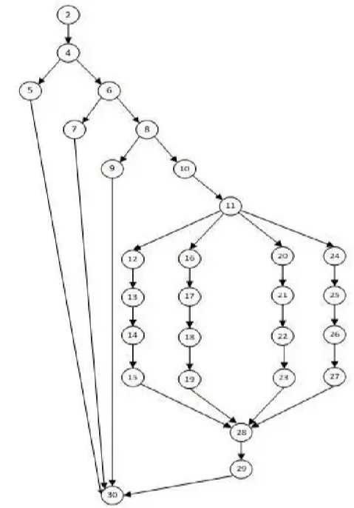

#### **年终奖程序的定义和使用节点**

|  |  |  |
| --- | --- | --- |
| **变量** | **定义节点** | **使用节点** |
| work_task | 1 | 4, 10 |
| work_capacity | 1 | 6, 10 |
| work_attitude | 1 | 8, 10 |
| Total | 1 | 13, 17, 21, 25 |
| work_total | 10 | 11, 12, 16, 20, 24 |
| work_bonus | 13, 17, 21, 25 | 29 |
| rate | 14, 18, 22, 26 | 29 |

#### **年终奖程序的定义-使用路径**

|  |  |  |  |  |
| --- | --- | --- | --- | --- |
| **编号** | **变量** | **路径（开始，结束节点）** | **定义-使用路径** | **是否定义-使用路径** |
| 1 | work_task | 1, 4 | 1, 2, 4 | 是 |
| 2 | work_task | 1, 10 | 1, 2, 4, 6, 8, 10 | 是 |
| 3 | work_capacity | 1, 6 | 1, 2, 6 | 是 |
| 4 | work_capacity | 1, 10 | 1, 2, 4, 6, 8, 10 | 是 |
| 5 | work_attitude | 1, 8 | 1, 2, 8 | 是 |
| 6 | work_attitude | 1, 10 | 1, 2, 4, 6, 8, 10 | 是 |
| 7 | Total | 2, 13 | 2, 4, 6, 8, 10, 11, 12, 13 | 是 |
| 8 | Total | 2, 17 | 2, 4, 6, 8, 10, 11, 16, 17 | 是 |
| 9 | Total | 2, 21 | 2, 4, 6, 8, 10, 11, 20, 21 | 是 |
| 10 | work_total | 10, 11 | 10, 11 | 是 |
| 11 | work_total | 10, 12 | 10, 11, 12 | 是 |
| 12 | work_total | 10, 16 | 10, 11, 16 | 是 |
| 13 | work_total | 10, 20 | 10, 11, 20 | 是 |
| 14 | work_total | 10, 24 | 10, 11, 24 | 是 |
| 15 | work_bonus | 13, 29 | 13, 14, 15, 28, 29 | 是 |
| 16 | work_bonus | 17, 29 | 17, 18, 19, 28, 29 | 是 |
| 17 | work_bonus | 21, 29 | 21, 22, 23, 28, 29 | 是 |
| 18 | work_bonus | 25, 29 | 25, 26, 27, 28, 29 | 是 |
| 19 | rate | 14, 29 | 14, 15, 28, 29 | 是 |
| 20 | rate | 18, 29 | 18, 19, 28, 29 | 是 |
| 21 | rate | 22, 29 | 22, 23, 28, 29 | 是 |
| 22 | rate | 26, 29 | 26, 27, 28, 29 | 是 |

#### **计算年终奖程序的全定义准则测试用例**

|  |  |  |  |  |
| --- | --- | --- | --- | --- |
| **编号** | **work_task** | **work_capacity** | **work_attitude** | **通过路径** |
| 1 | 95 | 20 | 15 | P4 |
| 2 | 80 | 15 | 10 | P5 |
| 3 | 60 | 15 | 5 | P6 |
| 4 | 40 | 10 | 5 | P7 |

#### **计算年终奖程序的全使用准则测试用例**

|  |  |  |  |  |
| --- | --- | --- | --- | --- |
| **编号** | **work_task** | **work_capacity** | **work_attitude** | **通过路径** |
| 1 | 95 | 20 | 15 | P4 |
| 2 | 80 | 15 | 10 | P5 |
| 3 | 60 | 15 | 5 | P6 |
| 4 | 40 | 10 | 5 | P7 |