Changes

At fist of all, I want to focus on the design part. In the process of making our website, we found that the original mobile interface design was not very good. Originally, we decided to display three icons side by side on the welcome page, but later found that this would make the structure too compact and unsightly, and the same leaf appeared in the same on the portal.

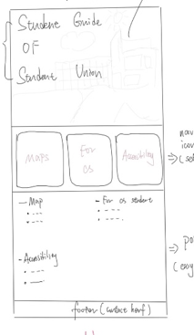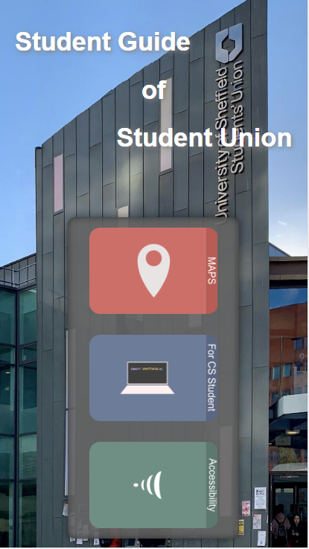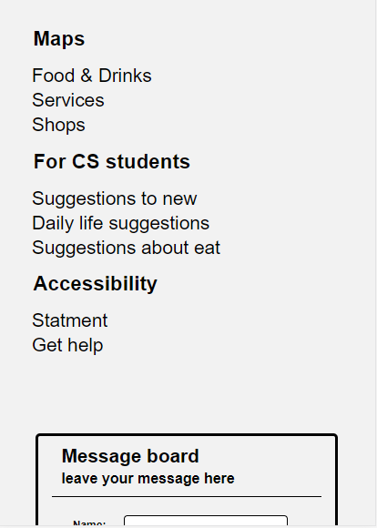

**Original Now**

Then we put the message board that was originally placed on the contact page on the welcome page (this is the thing in the picture) because we found the welcome page to be a bit monotonous and doing so helps us get more user messages.

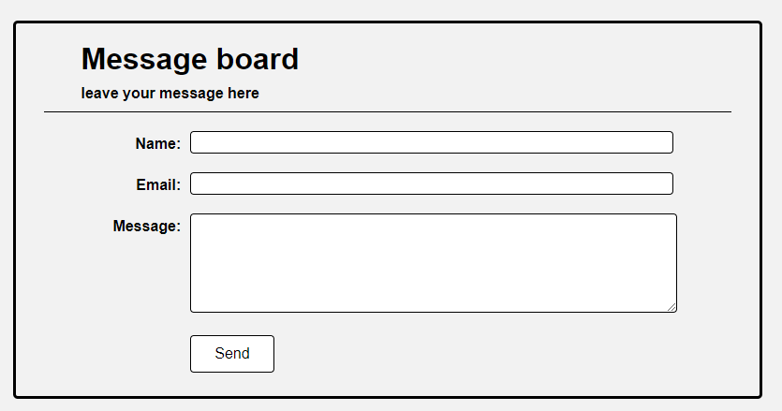

Organisation:

We create a HTML & CSS template of banner and aside for each page except the home page. These make it easier for users to jump between pages and within pages. And the template has reduced the amount of work we make on pages. We also make a template of Portal and Footer, and add them to the end of each page. For some pages, we made a content block template. We split our content into blocks, and make a template for all of the blocks to enhance our production efficiency.

We use normalization.css for each page, therefore the web page will show in a same style in different browsers.

We organize the file structure according to the relationship between pages. All the css files are in a subdirectory of the page called css, and all the images are in a subdirectory of the page called img.

We use “Sublime Text 3” as our code editor and use Chrome browser’s developer tool as our debugging tool, which shows every attribute of each element clearly.

We use a number of ways to show our menus, such us, the three rotatable buttons in the middle of the main page, portal area at the bottom of each page, banners and asides in some pages. Users can navigate to the paragraph they want by any of the above methods.

We did not use any JavaScript for adjust the layout of our web pages, so the pages can show correctly in every browser witch support html5 and css3 even the JavaScript is disabled.

Optimisation:

All the jpeg images in our web site are converted into progressive format and all of the png files are converted into interlaced format. This allows users to preview the image even when the image is not fully loaded to improve the user experience.

Initially, we designed a sidebar fixed on the screen for the user to click conveniently. Then we realize, if the viewport of the browser is not high enough, some content will be cut. Therefore, when the height of the viewport is too small, we design to change the properties of the sidebar to make it scroll with the page.

窗体顶端

Security:

The form in contact page contains a number of users’ personal details, we think it is important to keep it secure. However, if we add some encryption algorithms to JavaScript, it is easy for hackers to read the encryption algorithm and decrypt it, so we decide only convert the content into base64 coding before email them to make the content difficult to identify and also avoid the possibility of script injection. Maybe using https protocol is the best way to keep the security than using http protocol.

Testing:

We use Chrome, Safari and Edge to test our webpage, they all work fine. And we use device simulator in chrome to test it used on different devices. The test is successful.