

**Our shop**

Come and check out our Students' Union Shop - Our Shop is the only place you'll ever need to go! We have great offers across our ranges of food and drink, cards, toiletries & essentials.（source: https://su.sheffield.ac.uk/eat-drink-shop）

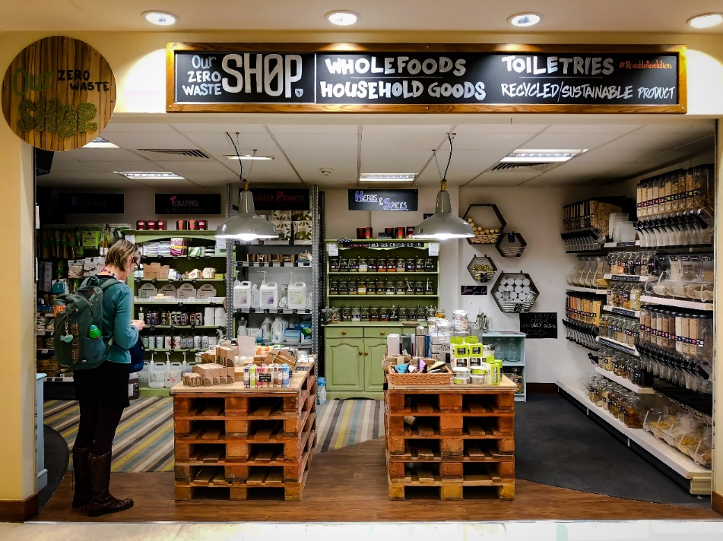

**Our Zero Waste Shop**

Our Zero Waste Shop sells a huge range of spices, herbs, grains, legumes, dried fruits and nuts all free from wasteful plastic packaging. Each product is sold by weight so you can buy as much or as little as you need. Just bring your own container, buy one from us, or use one of our recyclable paper bags.

We also have refill stations for your empty bottles of household products, with everything from laundry detergent, to liquid hand soap and multi-surface cleaner. There’s no need to buy a new bottles of product - it’s cheaper and less wasteful to refill! You can also pick up a range of recycled and sustainable products from recycled kitchen and toilet roll to sustainable bamboo cutlery and kitchenware. （source: https://su.sheffield.ac.uk/eat-drink-shop）



**SSUS**

The official University of Sheffield merchandise, sports wear & custom society clothing store. Visit us online at [sheffieldstore.com](https://sheffieldstore.com/)or in store at the Students' Union. The full range is ethically and sustainable sourced with many clothing items suitable for vegans. All stocked items are available for international shipping or click and collect for free! Join our [mailing list](https://us1.list-manage.com/subscribe?u=f5cc308dd0b3418797c759a5c&id=4ae3be1762) for exclusive discounts, free giveaways and 'see it first' product leaks. （source: https://su.sheffield.ac.uk/eat-drink-shop）