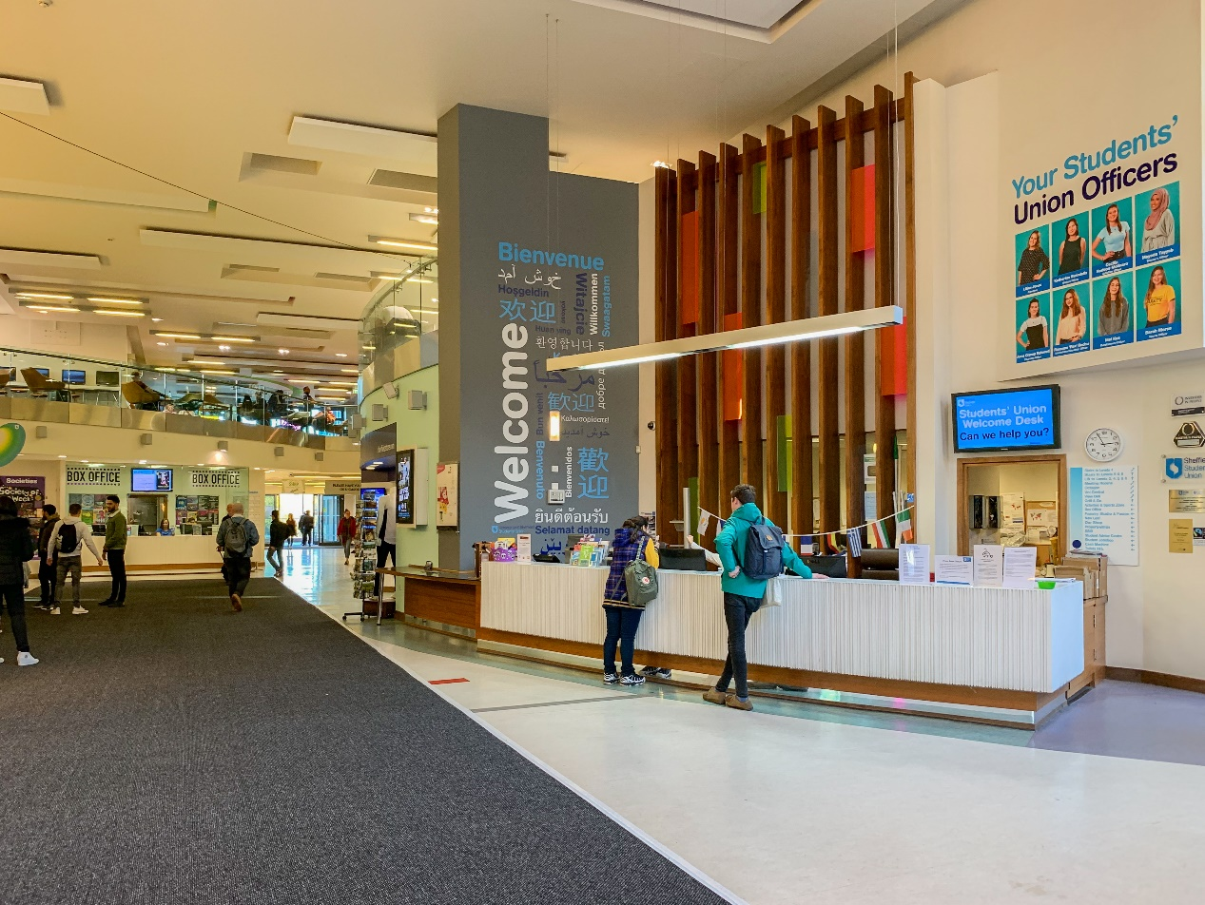

**Key Collection**

If you've booked a room in the Students' Union, collect the key from here.

**Lost Property**

Lost something? All lost/found property in and around the building is sent to the Welcome Desk.

**Travel tickets**

Pick up local discounted bus and tram tickets, University staff parking scratchcards, and National Express coach tickets. There is also a train ticket collection machine in the Plaza which you can pick up your train tickets from.

**Postal Service**

Ideal for International mailing, special delivery & recorded mail - we will weigh and post your letters/parcels for you (up to 2KG). You'll be charged however much postage is required to send your mail!

Tel: 0114 2228500  
Email: [welcome.desk@sheffield.ac.uk](mailto:welcome.desk@sheffield.ac.uk)

(source: https://su.sheffield.ac.uk/food-drink/outlets-services-pages/welcome-desk)

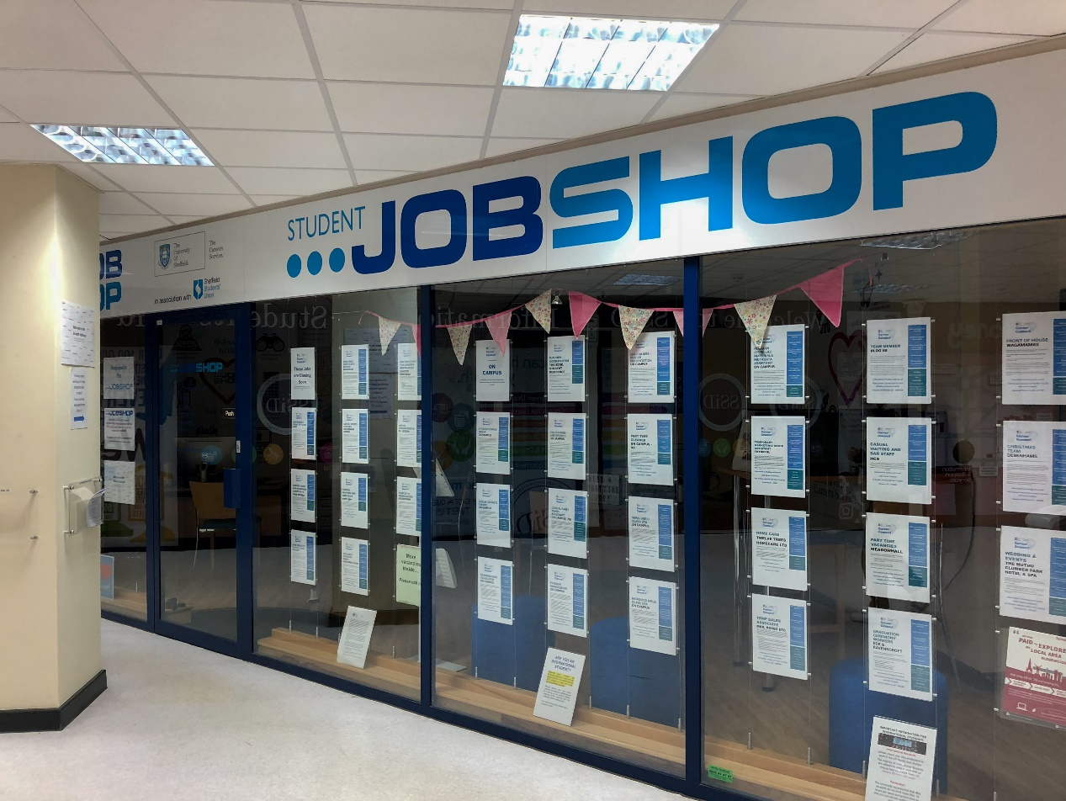

The Careers Service Student Jobshop works closely with local organisations to identify part-time work opportunities to fit around your studies

Opening hours: Mon-Fri 9.00 am - 5.00 pm; Tues 11.00 am - 5.00 pm

(source: <https://www.sheffield.ac.uk/careers/jobs/jobshop>)

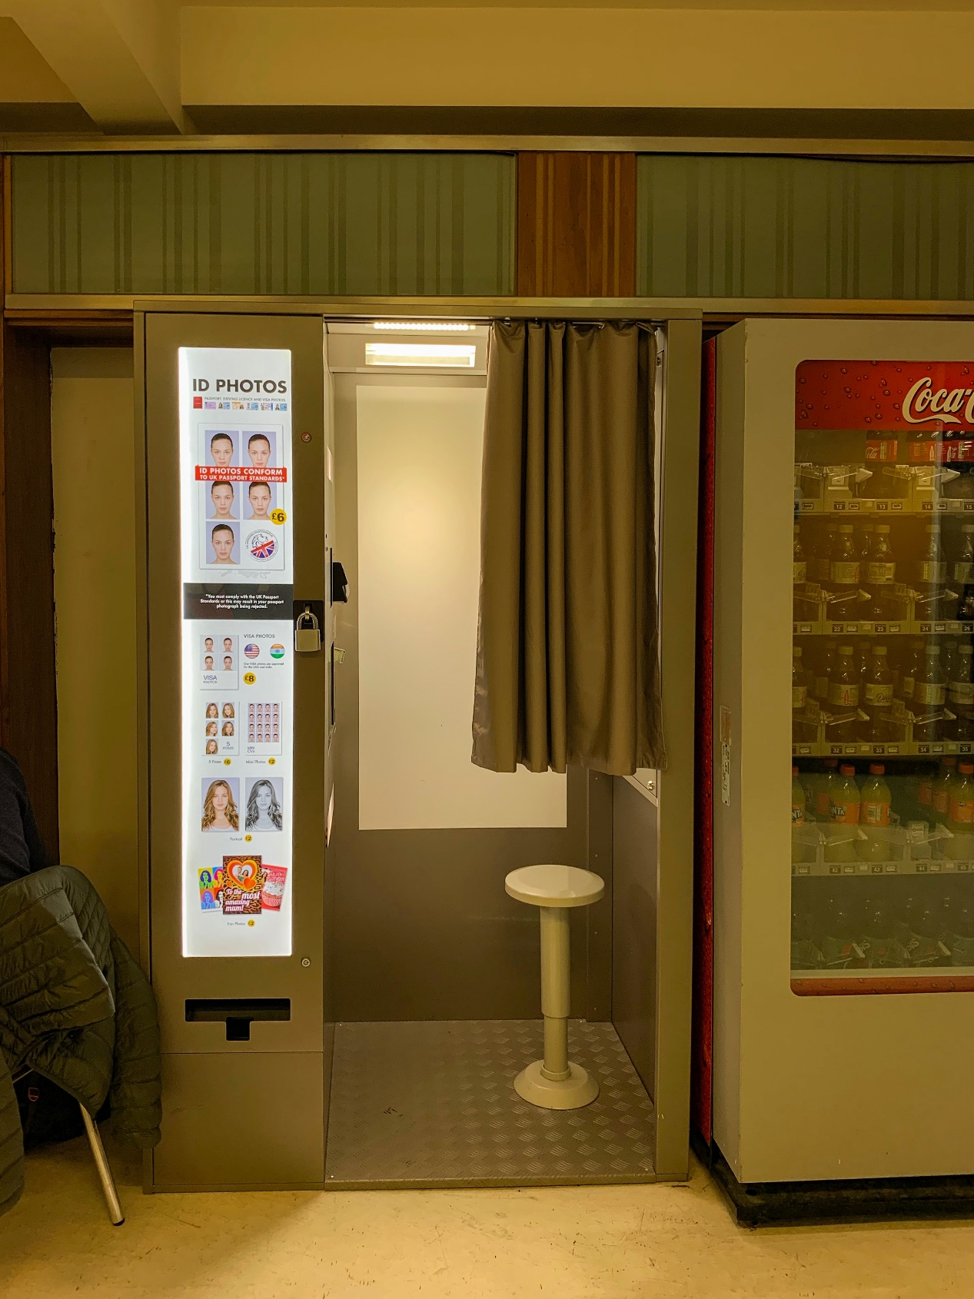

Passport Photo Booth

**Location:** Plaza, Level 3