In this part, we talk about the flag of the image edge. We deal with 2 neighbor pixels: p and q. We take a value called 'image local cost' to be this flag. If the flag is less, the 'energy' is less and the probability to be an edge is bigger.

The flag ILC includes 3 parts: Laplacian Zero-Crossing, Grasient Magnitude and Gradient Direction. We combine these 3 parts with 3 weights(0.43,0.43,0.14):

这里写图片描述

1. Laplacian Zero-Crossing

It's the second partial derivative of the image(${ ∇}^{2}f )$. If ${ ∇}^{2}f=0$, the color of image changes most quickly, so we set the 'energy' fz as 0, and in other situations it's 1.

2. Gradient Magnitude

Gradient Magnitude is bigger, the color of image changes most quickly, and the energy fD is smaller. So we give a function to change G(Gradient Magnitude) to fD:

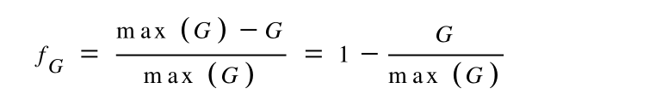

3. Gradient Direction.

This is a bit complex. It's a flag to show how much the directions of p and q is similar(if the 2 directions are same, the flag is 0; if they are opposite, it's 1). I use a picture to simplify the flag:

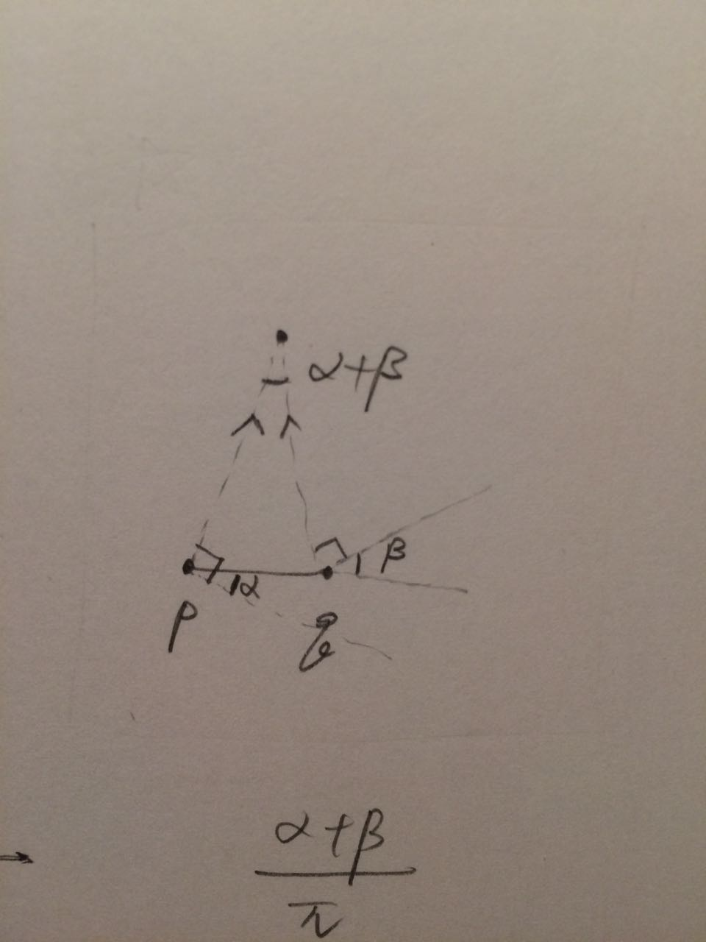

And fG is ($α+β)/π$. Because $α+β$ is from 0 to 1, it’s what we want here.

(The next part is to understand Live-Wire-2-D dynamic programming graph search and realize it in matlab.)