HO CHI MINH CITY UNIVERSITY OF TECHNOLOGY AND

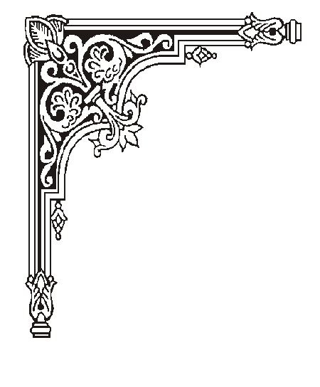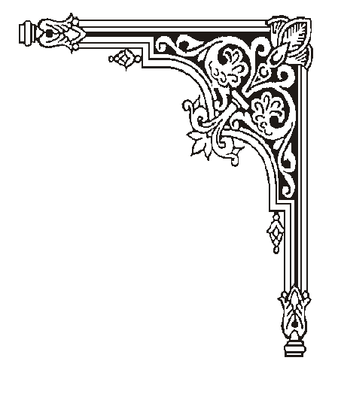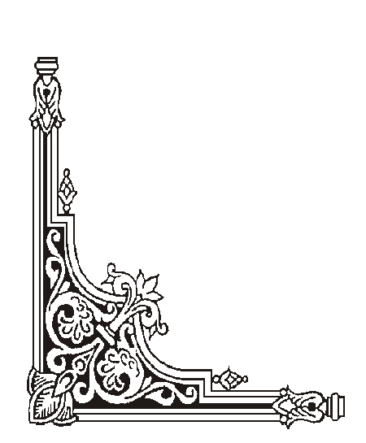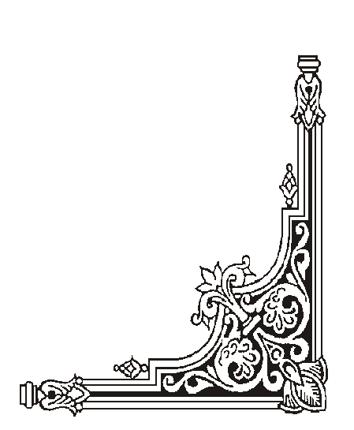

EDUCATION

FACULTY OF MECHANICAL ENGINEERING

# --------------🖎🕮✍--------------

# 

**Final essay**

**Subjects: Advance robot programming**

Students: Phạm Xuân Ái – 20134012

Hồ Văn Đằng - 20134013

Instructor: PGS.TS Nguyễn Trường Thịnh

**HO CHI MINH CITY – June/ 2022**

**Contents**

Chapter1 : OVERVIEW  2

1.1. Introduction to robot SCADA 2

1.2. Design tasks 4

Chapter 2 : CALCULATION MECHANICAL SYSTEM 5

## 2.1. Joints and links theory 5

#### 2.2 Foward Kinematics 6

2.3 Jacobian for velocity 9

2.4Inverse kinematics 9

2.5Dynamics 11

Chapter 3: DESIGN SYSTEM 14

3.1. System diagram 14

3.2. Function of elements 17

3.3 Control Algorthms 18

3.4 Result 18

Chapter4: CONCLUSION 14

## 4.1 Theoretically 19

4.2. Practically 19

4.1. Restrict 19

4.2. Direction to fix 19

REFERENCES

# 

# CHAPTER 1: OVERVIEW

### 1.1 Introduction to Robot SCARA

According to the development of society, the need to increase production and

Product quality increasingly requires the wide application of production automation facilities. The trend of creating highly flexible automatic lines and equipment has formed and developed strongly... Therefore, there is a rapidly increasing demand for the application of robots, automatic robotic arms (Robots) to create. flexible automated production systems. Robots are widely applied and play an important role in production as well as in life. A robot is a programmable multi-function device used to move materials, parts, and tools through pre-programmed drives. Robotic science is based mainly on matrix algebraic operations. The robot has arms with many degrees of freedom and can perform move like a human hand and can be controlled by a computer or can be controlled by a program that is pre-loaded in the chip on the controller board.

The acronym SCARA stands for Selective Compliance Assembly Robot Arm or Selective Compliance Articulated Robot Arm.

In 1981, Sankyo Seiki, Pentel and NEC presented a completely new concept of assembly robots. The robot was developed under the guidance of Hiroshi Makino, a professor at Yamanashi University. The robot is called the Selectively Compliant Assembly Robotic Arm, SCARA. Its swing arm is rigid in the Z axis and malleable in the XY axis, allowing it to accommodate holes in the XY axis.

Thanks to SCARA's parallel shaft joint layout, the arm is slightly XY-directed but stiff in the 'Z' direction, hence the term: Selective compliance. This is convenient for many types of assembly operations, i.e. fitting round pins into round holes without binding.

The second property of SCARA is that the two-joint joint arm layout is similar to that of a human arm, hence the commonly used term, Articulated. This feature allows the arm to extend into confined areas and then retract or "fold" back. This is advantageous for transferring parts from one cell to another or for enclosed loading/unloading processing stations.

SCARA is typically faster than comparable Cartesian robotic systems. Their single pedestal mount requires a small footprint and provides an easy, unobstructed mounting form. On the other hand, SCARA can be more expensive than equivalent Cartesian systems, and the control software requires inverse kinematics for linear interpolated motions. However, this software often comes bundled with SCARA and is often transparent to the end user.

Several types of SCARA Robots:

Robot SCARA Denso HM-G Robot SCARA Kuka

Robot SCARA Fanuc SR-6iA Robot SCARA Epson

*Figure 0.1. Typical SCARA robots*

**1.2. Design tasks**

Design a scada robot with 3 degrees of freedom to move the robot to a given coordinate to draw the characters x, o with a given 30x30 cm chessboard whose cells are 3x3, 5x5

,9x9, respectively to play tic tac toe

a, Main stitches

The robot arm has 3 degrees of freedom, mechanical design in the form of 2 rotary joints, 1 translational joint.

- Robot body: Is a fixed stitch, placed vertically to keep the robot fixed when working, attached to the dynamic stitch 1 through the rotary joint 1 with the vertical z axis.

➢- Stage 1: The horizontal driving stitch is perpendicular to the vertical axis during the working process of the robot, capable of rotating around the axis z through the rotary joint 1

➢- Stitch 2: Dynamic stitch capable of rotating in the vertical plane through rotary joint 2 connected to stitch 1

➢- Stitch 3: lead screw - ball nut (reciprocating screw, rotating nut).

b, Drive system

The kinematic structure of this manipulator belongs to the biomimetic system, with the axes of rotation, the joints are all vertical.

➢- Switch 1, 2: gear system (reducer box)

➢- Stitch 3: translational stitch servo motor

- Drive motor

# 

### 

### CHAPTER 2: CALCULATION MECHANICAL SYSTEM

## 2.1 Joints and links theory

### Links.

Each part of a machine, which moves relative to some other part, is known as a kinematic link (or simply link) or element. A link may consist of several parts, which are rigidly fastened together, so that they do not move relative to one another. In order to transmit motion, the driver and the follower may be connected by the following three types of links:

* Rigid link. A rigid link is one which does not undergo any deformation while transmitting motion. Strictly speaking, rigid links do not exist. However, as the deformation of a connecting rod, crank etc. of a reciprocating steam engine is not appreciable, they can be considered as rigid links.
* Flexible link. A flexible link is one which is partly deformed in a manner not to affect the transmission of motion. For example, belts, ropes, chains and wires are flexible links and transmit tensile forces only.
* Fluid link. A fluid link is one which is formed by having a fluid in a receptacle and the motion is transmitted through the fluid by pressure or compression only, as in the case of hydraulic presses, jacks and brakes.

For the robot demonstrated in this paper, there are two rigid, movable links included for plotting in 2D and one fixed link as the base of the robot.

### Pairs and joints.

The two links or elements of a machine, when in contact with each other, are said to form a pair. If the relative motion between them is completely or successfully constrained (i.e. in a definite direction), the pair is known as kinematic pair. Besides, joint is a term used to referred the point of connection between two links in a pair.

According to the type of contact between the elements, pairs can be classified as below:

* Lower pair: When the two elements of a pair have a surface contact when relative motion takes place and the surface of one element slides over the surface of the other, the pair formed is known as lower pair. It will be seen that sliding pairs, turning pairs and screw pairs form lower pairs.
* Higher pair: When the two elements of a pair have a line or point contact when relative motion takes place and the motion between the two elements is partly turning and partly sliding, then the pair is known as higher pair. A pair of friction discs, toothed gearing, belt and rope drives, ball and roller bearings and
* cam and follower are the examples of higher pairs.

In case of our robot, there are three joints included.

### Degree of freedom.

Degrees of freedom (DOF), in a mechanics context, are specific, defined modes in which a mechanical device or system can move. The number of DOF is equal to the total number of independent displacements or aspects of motion. In the field of automatic control, a system is designed so that every DOF is under control, which means the number of motors must be equal to the number of DOF required for exact manipulation.

For planar mechanism, the number of DOF $W$ is computed as below:

$$W=3n−\left(2p_{5}+p_{4}\right)$$

For spatial mechanism, the number of DOF $W$ is computed as below:

$$W=6n−\left(5p_{5}+4p_{4}+3p_{3}+2p_{2}+p_{1}\right)$$

* $n$: number of movable links.

#### $p_{i}$: number of type- $i$ pairs in the mechanism ( $i$ DOF restrained)

#### 2.2 Kinematics Robot

Set up the Denavit-Hartenberg coordinate system

Using the Denavit-Hartenberg method to solve the robot kinematics problem. Set up the Denavit-Hartenberg coordinate system:

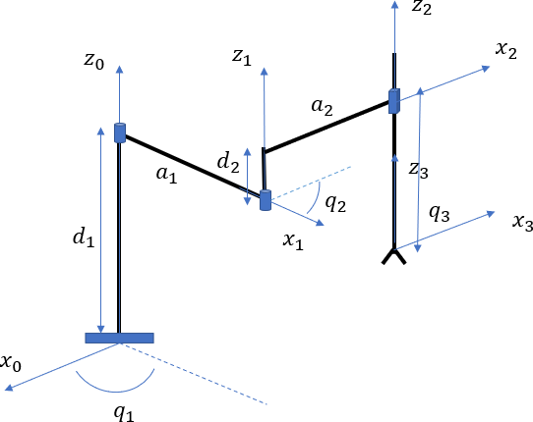

*Figure 0.2. Kinematic diagram of SCARA*

D-H table and homogeneous coordinate transformation matrices

Table D-H:

|  |  |  |  |  |
| --- | --- | --- | --- | --- |
| **link** | **θ** | **d** | **a** | **α** |
| **1** | θ1 | d1 | a1 | 0 |
| **2** | θ2 | d2 | a2 | 0 |
| **3** | 0 | d3 | 0 | 0 |

Where: θ1, θ2, d3 are joints variables.

Set θ1 = q1 , θ2 = q2 , d3 = q3

Joint parameters :

q1 $ϵ$ [ ${−180}^{o}$, ${180}^{o}$]

q2 $ϵ$ [ ${−180}^{o}$, ${180}^{o}$]

q3 $ϵ$ [0, 15 ]

The kinetic table becomes:

|  |  |  |  |  |
| --- | --- | --- | --- | --- |
| **link** | **θ** | **d** | **a** | **α** |
| **1** | *q*1 | *d*1 | *a*1 | 0 |
| **2** | *q*2 | *d*2 | *a*2 | 0 |
| **3** | 0 | *q*3 | 0 | 0 |

Homogeneous transformation matrices:

DH matrix converts from coordinate system 0 to coordinate system 1 :

$T_{1}^{0}$ = $\left[\begin{matrix}\begin{matrix}cos(q1) & −sin(q1) \\ sin(q1) & cos(q1)\end{matrix} & \begin{matrix}0 & a1cos(q1) \\ 0 & a1sin(q1)\end{matrix} \\ \begin{matrix}0 & 0 \\ 0 & 0\end{matrix} & \begin{matrix}1 & d1 \\ 0 & 1\end{matrix}\end{matrix}\right]$

DH matrix converts from coordinate system 1 to coordinate system 2:

$T_{2}^{1}$ = $\left[\begin{matrix}\begin{matrix}cos(q2) & −sin(q2) \\ sin(q2) & cos(q2)\end{matrix} & \begin{matrix}0 & a1cos(q2) \\ 0 & a1sin(q2)\end{matrix} \\ \begin{matrix}0 & 0 \\ 0 & 0\end{matrix} & \begin{matrix}1 & d2 \\ 0 & 1\end{matrix}\end{matrix}\right]$

DH matrix converts from coordinate system 2 to coordinate system 3:

$T_{3}^{2}$ = $\left[\begin{matrix}\begin{matrix}1 & 0 \\ 0 & 1\end{matrix} & \begin{matrix}0 & 0 \\ 0 & 0\end{matrix} \\ \begin{matrix}0 & 0 \\ 0 & 0\end{matrix} & \begin{matrix} 1 & q3 \\ 0 & 1\end{matrix}\end{matrix}\right]$

DH matrix converts from coordinate system 0 to coordinate system 3:

$T_{3}^{0}$ = $T_{1}^{0}$ $T_{2}^{1}$ $T_{3}^{2}$** = $\left[\begin{matrix}\begin{matrix}cos(q1+q2) & −sin(q1+q2) \\ sin(q1+q2) & cos(q1+q2)\end{matrix} & \begin{matrix} 0 & a2 cos(q1 + q2 ) + a1 cos(q1) \\ 0 & a2 sin(q1 + q2 ) + a1 sin(q1)\end{matrix} \\ \begin{matrix}0 & 0 \\ 0 & 0\end{matrix} & \begin{matrix}1 & d1+d2+q3 \\ 0 & 1\end{matrix}\end{matrix}\right]$

Solve the forward kinematics problem:

For the forward kinematics problem, the position, velocity, and acceleration of the

joint variables are considered as known, it is necessary to find the position, velocity,

and acceleration of the manipulation stage with respect to a fixed coordinate system.

Determine the coordinates to locate the end impact point:

The coordinates of the final impact point are determined by comparing the elements

On both sides of the system of kinetic equations in the form of a matrix , we get:

$\left\{\begin{matrix}xE = x(q) \\ yE = z(q) \\ zE = z(q)\end{matrix}\right.$ => $\left\{\begin{matrix}xE =a2 cos(q1 + q2 ) + a1 cos(q1) \\ yE =a2 sin(q1 + q2 ) + a1 sin(q1) \\ zE = q3+d2+d1\end{matrix}\right.$

## 2.3 Jacobian for velocity

Jacobian matrix is to deal with velocity analysis. The target is to compute angular velocity of the joints by knowing linear velocity of the end point.

$$\left\{\begin{aligned}x=a_{1}\cos\left(θ_{1}\right)+a_{2}\cos\left(θ_{1}+θ_{2}\right) \\ y=a_{1}\sin\left(θ_{1}\right)+a_{2}\sin\left(θ_{1}+θ_{2}\right)\end{aligned}\right.$$

Taking Jacobian, we then have:

$$J=\left[\begin{matrix}−a_{2}\sin\left(θ_{1}+θ_{2}\right)−a_{1}\sin\left(θ_{1}\right) & −a_{2}\sin\left(θ_{1}+θ_{2}\right) \\ a_{2}\cos{(θ_{1}+θ_{2}})+a_{1}\cos\left(θ_{1}\right) & a_{2}\cos\left(θ_{1}+θ_{2}\right)\end{matrix}\right]$$

It is generally known that:

$$\left[\begin{matrix}v_{x} \\ v_{y}\end{matrix}\right]=J\left[\begin{matrix}ω_{1} \\ ω_{2}\end{matrix}\right]→\left[\begin{matrix}ω_{1} \\ ω_{2}\end{matrix}\right]=J^{−1}\left[\begin{matrix}v_{x} \\ v_{y}\end{matrix}\right]$$

Therefore:

$$ω_{1}=\frac{v_{x}\cos\left(θ_{1}+θ_{2}\right)+ v_{y}\sin{(θ_{1}}+θ_{2}) }{l_{1}\sin\left(θ_{2}\right)}$$

$$ω_{2}=−\frac{a_{1}v_{y}\sin\left(θ_{1}\right)+ a_{2}v_{x}\cos\left(θ_{1}+θ_{2}\right)+ a_{2}v_{y}\sin\left(θ_{1}+θ_{2}\right)+ a_{1}v_{x}\cos\left(θ_{1}\right)}{a_{1}a_{2}\sin{(θ_{2}})}$$

**2.4 Inverse kinematics**

The problem of inverse kinematics is very important in programming and controlling the motion of robots. Because in practice, it is often necessary to control the robot so that the clamping arm (manipulator) moves to certain positions in the operating space according to a certain rule. For the inverse kinematics problem, the motion law of the manipulator (positioning coordinates) is known, it is necessary to determine the matching coordinates (matching variable). The inverse kinematics problem can be solved by many different methods. Here, I would like to present the Calculus method

With reverse-position kinematics for a 3-degree-of-freedom robot, in this case the Assembly Robot.

The input to be determined *is $\left[\begin{matrix}xE & yE & zE\end{matrix}\right]$*

*Analytical Method:*

From the kinematics equation (*), we have:

$\left\{\begin{matrix}xE =a2 cos(q1 + q2 ) + a1 cos(q1) \\ yE =a2 sin(q1 + q2 ) + a1 sin(q1) \\ zE = q3+d2+d1\end{matrix}\right.$ (*)

**Note**: From now on, to simplify the expressions, we use the convention sin = s, cos = c

For example : sin(*q*1 )  *s*1,cos(*q*1 )  *c*1,sin(*q*1  *q*2 )  *s*12 ,cos(*q*1  *q*2 )  *c*12…

(*) <=> $\left\{\begin{matrix}xE =a2 c12 + a1 c1 \\ yE =a2 s12 + a1 s1 \\ zE = q3+d2+d1\end{matrix}\right.$

Sum of the squares of both sides of the equation xE, yE, we get q2:

${xE}^{2}$ + ${yE}^{2 }$ = ${a1}^{2}$ + ${a2}^{2}$ + 2a1a2s2

=> s2 = $\frac{{xE}^{2}+{yE}^{2 }−{a1}^{2} − {a2}^{2}}{2a1a2}$

=> s1 = $\sqrt{1 ∓ {s2}^{2} }$

=> $θ_{2}=\arctan\left(\frac{\sin\left(θ_{2}\right)}{\cos\left(θ_{2}\right)}\right)$

Putting p2 back (*) we get:

$\left[\begin{matrix}a2c2+a1 & −a2s2 \\ a2s2 & a2c2+a1\end{matrix}\right]\left[\begin{matrix}c1 \\ s1\end{matrix}\right]$ = $\left[\begin{matrix}xE \\ yE\end{matrix}\right]$

* Crammer’s rule:

$$\cos{θ_{1}}=\frac{\left|\begin{matrix}xE & −a_{2}\sin{θ_{2}} \\ yE & a_{1}+a_{2}\cos{θ_{2}}\end{matrix}\right|}{\left|\begin{matrix}a_{1}+a_{2}\cos{θ_{2}} & −a_{2}\sin{θ_{2}} \\ a_{2}\sin{θ_{2}} & a_{1}+a_{2}\cos{θ_{2}}\end{matrix}\right|}=\frac{xE\left(a_{1}+a_{2}\cos{θ_{2}}\right)+yE\left(a_{2}\sin{θ_{2}}\right)}{a_{1}^{2}+2a_{1}a_{2}\cos{θ_{2}}+a_{2}^{2}}$$

$$\sin{θ_{1}}=\frac{\left|\begin{matrix}a_{1}+a_{2}\cos{θ_{2}} & xE \\ a_{2}\sin{θ_{2}} & yE\end{matrix}\right|}{\left|\begin{matrix}a_{1}+a_{2}\cos{θ_{2}} & −a_{2}\sin{θ_{2}} \\ a_{2}\sin{θ_{2}} & a_{1}+a_{2}\cos{θ_{2}}\end{matrix}\right|}=\frac{yE\left(a_{1}+a_{2}\cos{θ_{2}}\right)−x\left(a_{2}\sin{θ_{2}}\right)}{a_{1}^{2}+2a_{1}a_{2}\cos{θ_{2}}+a_{2}^{2}}$$

=> c1 = $\frac{xE(a2c2+a1)+yEa2s2}{d}$

=> s1 = $\frac{yE(a2c2+a1)+xEa2s2}{d}$

Where d is the determinant of the linear system:

d = ${(a2c2+a1)}^{2}$ + ${(a2s2)}^{2}$

=> $θ_{1}=\arctan\left(\frac{\sin\left(θ_{1}\right)}{\cos\left(θ_{1}\right)}\right)$

=> q3 = zE - d2 -d1

**2.5 Dynamics**

The study of dynamics between the forces acting on the structure and the movement of the mechanism. Robot dynamics is a very complex issue. Specifically, the final actuator is transmitted through a link with the correct operating parameters

To calculate the robot dynamics, we will set up the differential equation of motion of the robot. The robot's motion differential equation is built according to the Lagrangian type equation with the following general form:

L= K - P

In the calculation and design of robots, people often use the matrix form of the Lagrange equation to facilitate the use of mathematical tools and conduct computer simulations. The differential equation of motion of the robot has the form:

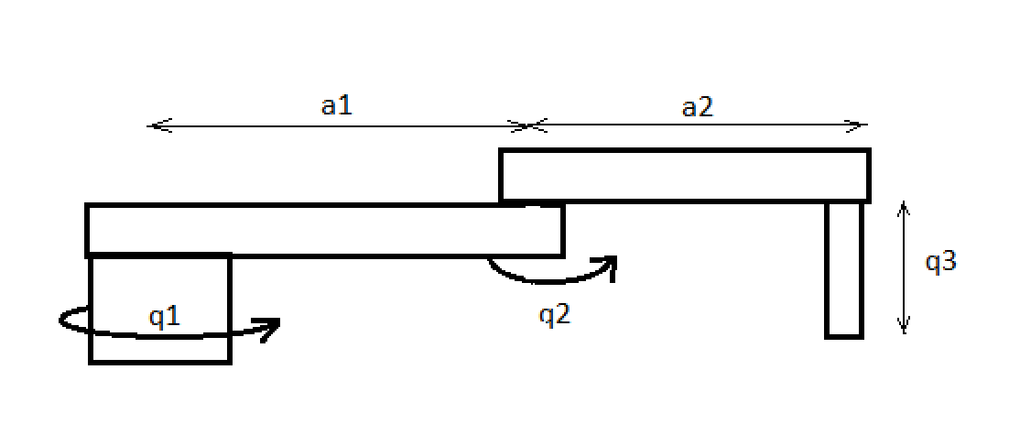

m2

m1

*Figure 0.3 Dynamics diagram*

Applying the Lagrange function, we have: L = K – P

where K is the total kinetic energy of the system.

P is the total potential energy.

Apply to Robot with two lengths a1 and a2 with respective weights of m1 and m2. Rotary variables work with variables θ1 and θ2. We calculate the forces F1 and F2.

For link 2:

$\left\{\begin{aligned}x2 = a1cos(p1) \\ y2 =a1sin(p1) \\ z2 = 0\end{aligned}\right.$ => $\left\{\begin{aligned}\dot{x2} = − a1sin(p1)\dot{p1} \\ \dot{y2} =a1cos(p1)\dot{p1} \\ \dot{z2} = 0\end{aligned}\right.$

=> ${v2}^{2}$ = ${\dot{x2} }^{2}$ + ${\dot{y2}}^{2}$ + ${\dot{z2}}^{2}$ = ${(a1p1)}^{2}$

=> k2 = 0.5 m2 ${\dot{p1}}^{2}{a1}^{2}$

=> p2 = m2 g a1 sin(p1)

For link 3:

$$\left\{\begin{aligned}x3 = a1cos(p1)+a2cos(p1+p2) \\ y3 =a1sin(p1)+a2sin(p1+p2) \\ z3 = 0\end{aligned}\right.$$

=> $\left\{\begin{aligned}\dot{x3} = − a1sin(p1)\dot{p1} − a2(\dot{p1}+\dot{p2})sin(p1+p2) \\ \dot{y3} =a1cos(p1)\dot{p1}+ a2(\dot{p1}+\dot{p2})cos(p1+p2) \\ \dot{z3} = 0\end{aligned}\right.$

=> ${v3}^{2}$ = ${\dot{x3} }^{2}$ + ${\dot{y3}}^{2}$ + ${z3}^{2}$ = ${(a1p1)}^{2}$ + ${a2 }^{2}$ ${\dot{(x2+}\dot{y2}) }^{2}$ + 2a1a2(${\dot{p1}}^{2}$ + $\dot{p1}\dot{p2}$)cos(p2)

K3 =

0.5m3 ${v3}^{2}$ = 0.5m3 ${(a1p1)}^{2}$ + 0.5m3 ${a2 }^{2}$ ${\dot{(x2+}\dot{y2}) }^{2}$ + m3a1a2(${\dot{p1}}^{2}$ + $\dot{p1}\dot{p2}$)cos(p2)

P3 = m3g( $a1sin(p1)+a2sin(p1+p2)$)

Applying the Lagrange function, we have: L= (K2+K3) – (P2+ P3)

= 0.5(m2+m3) ${(a1p1)}^{2}$ + 0.5m3 ${a2 }^{2}$ ${\dot{(x2+}\dot{y2}) }^{2}$ + m3a1a2(${\dot{p1}}^{2}$ + $\dot{p1}\dot{p2}$)cos(p2) -

(m2+m3)g a1 sin(p1) - m3 g a2 sin(p1+p2)

$\frac{∂L}{∂\dot{p1}}$ = (m2+m3) ${a1}^{2}\dot{p1}$ + m3 ${a2 }^{2}(\dot{p1}+\dot{p2})$ + m3 a1a2 (2 $\dot{p1}+\dot{p2}$)cos(p2)

$\frac{∂}{∂t}\frac{∂L}{∂\dot{p1}}$ = (m2+m3) ${a1}^{2}\ddot{p1}$ + m3 ${a2 }^{2}(\ddot{p1}+\ddot{p2})$

$\frac{∂L}{∂p1}$ = -(m2+m3)g a1 cos(p1) - m3g a2 $cos(p1+p2)$

$\frac{∂L}{∂\dot{p2}}$ = m3 ${a2 }^{2}(\dot{p1}+\dot{p2})$ + m3 a1a2 ($\dot{p1}$)cos(p2)

$\frac{∂}{∂t}\frac{∂L}{∂\dot{p2}}$ = m3 ${a2 }^{2}(\ddot{p1}+\ddot{p2})$ + m3 a1a2 $(\ddot{p1})$ cos(p2)

$\frac{∂L}{∂p2}$ = - m3a1a2(${\dot{p1}}^{2}$ + $\dot{p1}\dot{p2}$)sin(p2) - m3g a2 cos(p1+p2)

=> T1 = (m2+m3) ${a1}^{2}\ddot{p1}$ + m3 ${a2 }^{2}(\ddot{p1}+\ddot{p2})$ + (m2+m3)g a1 cos(p1) - m3g a2 $cos(p1+ p2)$

=> T2 = m3 ${a2 }^{2}(\ddot{p1}+\ddot{p2})$ + m3 a1a2 $(\ddot{p1})$ cos(p2) + m3a1a2(${\dot{p1}}^{2}$ + $\dot{p1}\dot{p2}$)sin(p2) - m3g a2 cos(p1+p2)

**Chapter 3: DESIGN OF ROBOT**

**3.1. System diagram**

In terms of transmission and control, the robot is made up of structural blocks

mechanics work by means of actuating mechanisms. These mechanisms of action can

working together to perform complex tasks under the supervision of control of a component with a structure like a computer, also known as components micro control

The robot is built from the following basic components:

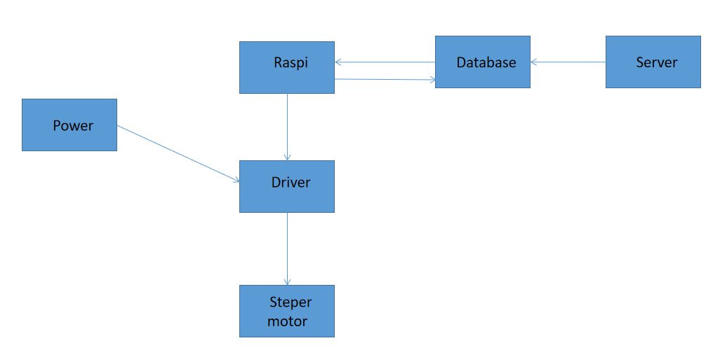

*Figure 0.4 System diagram*

**3.2. Function of elements**

a, Power

Pulse source is a power supply that transforms from AC power to DC by pulse oscillation mode created by electronic circuit combined with a pulse transformer. Classical linear source uses ferromagnetic transformer. to do low voltage duty and then use rectifier combined with ic linear source to create DC voltage levels as required

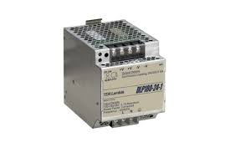

*Figure 0.5 Power*

The Robot use 24v power to provide to control 2 stepper motror before that the control signal is process in driver

b, Driver

To control a stepper motor, a driver is required. This is a pulse device for the motor to operate, for each type of motor there will be a corresponding driver.

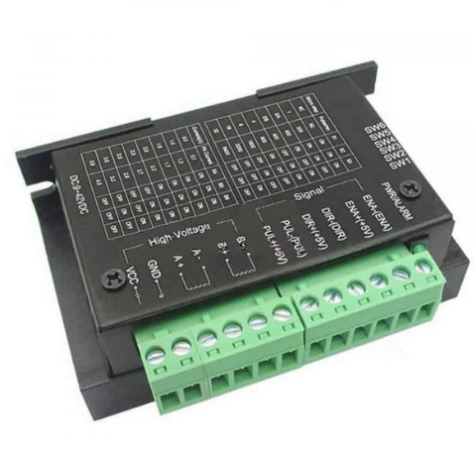

*Figure 0.6 Driver*

c, Stepper motor

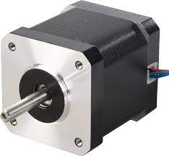

*Figure 0.7 Stepper motor*

Stepper motors are controlled as successive discrete electrical pulses that form angular motions or rotor movements. Stepper motors do not rotate by conventional mechanism, they rotate in lateral steps with very high cybernetic precision. They work thanks to electronic switches that feed the control signals into the stator in a certain order and frequency.

d, raspi

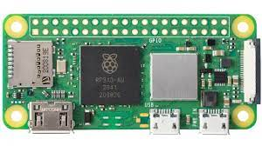

*Figure 0.8 Raspberry pi zero2*

When the user performs a control action on the browser, such as turning on and off a light bulb, that information is sent to the server. The server will forward that information to the Master via TCP/IP method. Web-server will now be the client of the Master. More information about this method can be found in the previous tutorial “Client-Server model”. After sending the information, the server will update the information in the database. Control information is also displayed right on the browser. The data collected in save in database. Then the raspi read it and do the function on coded. In the tic tac toe robot, users use a web page to control the robot by type the Decarses coordinates and the x,o string send to database.

**3.3 Control algorthms**

a, Position control

After having the formula to compute angular velocity from linear velocity, we now move to the part of trajectory and motors control.

For moving from one point to another, we will adjust the angle directly so that the pen can move to the desired position.

With drawing X/O sign, for convenience, the process will both start at the center of t he shape (also the center of the box) and the size of the drawing will both be defined with radius $R$:

* With X sign:

1. The pen will be moved to the top right corner of the shape
2. The pen is dimmed down to touch the paper and then start to draw along the line connecting
3. The pen is then lifted up and then move to the right with displacement $∆x$ with the function line
4. Finally, the pen is dimmed down again to touch the paper and then start to draw along the line connecting with change the pluse to driver to have the true function

* With O sign:

1. The pen is moved to top of the circle
2. The pen is then dimmed down to touch the paper and follow the trajectory:

$$x=x_{center}+R\cos{θ}$$

$$y=y_{center}+R\sin{θ}$$

where $θ$ in range $\left[0;2π\right]$ to plot a circle with radius $R$.

b, Fix control

After go to the beginning position of the setup, if the robot do not come with true position the algorithms is fixed it, there are two function :

1. The stepper motor is moved by add the length of pluse and direction to the database and the raspi control program read database and control the driver
2. The web server have GUI allowed uses to communicate the controller

**3.4 Results**

The application of this SCADA robot is play tic tac toe from the request of this content, we have to control the robot with a pen to write the x , o string in the 30x30 cm tablet 3x3, 5x5 ,9x9 box with the tic tac toe rule

After running robot with control program, we have the result:

good movement, stable direction change but the accuracy is not high, there is still vibration during movement.

did not control the robot automatically because it exist error after run write step

**Chapter 4: CONCLUSION**

## 4.1. Theoretically.

Basically, we have completed the selection of robot configuration, transmission mechanism, impact mechanism.  
Solve the problem of kinematics and inverse kinematics of the robots.  
Write code to control the robot moving to the desired position.

## 4.2. Practically

Completed machining parts and assembled the robot.  
Control the robot to move in the desired trajectory.  
Robots do not have the ability to play automatically but must be through communication with computer.

**4.3. Restrict**

■ The mechanical part has not been optimized, making the robot work unstable, photo

affect the programming cannot bring the robot speed to full speed.

■ The robot has not high flexibility and the mechanical structure is not sure to be able to fold bulk cargoes.

■ The robot works depending on the power supply so we can't tell when

when the robot stops working. The programming part still has some unstable issues like

The navigation program depends on the white lines on the stock, using encoder so the program turns and turns is not yet standard.

■ Transceiver signal part is not stable.

**4.4. Direction to fix**

■ Adjust the mechanical structure to be more suitable, flexible and distribute the force more appropriately.

■ Increase the capacity of the motors so that the robot can fold heavier loads

and works faster.

■ Design a power-out alarm circuit and an automatic power-up circuit for the robo. Source

The ground of the circuit will be designed to be larger and have a capacitor at the power supply

■ Use 2 encoders on 2 wheels to make the robot move and turn stably and accurately

corpse.

**References**

1 . Cameron Hughes (May 22, 2016), Tracey Hughes "Robot Programming: A Guide to Controlling Autonomous Robots, 1st Edition",Que Publishing.

2 .Peter Mckinnon (January 28, 2016),"Robotics: Everything You Need to Know About Robotics from Beginner to Expert", CreateSpace Independent Publishing Platform