Quantum HOI Project — Experiment Log and Route Map

0. Project goal
This document records the experimental route of the Quantum Higher-Order Information (Quantum HOI) project, including:
- what experiments have been performed,
- why each experiment was introduced,
- the parameter settings used in each experiment,
- what quantities were computed,
- what the main observations were,
- which figure(s) each experiment supports.
This document is intended to serve as a project roadmap + experiment registry, so that the entire workflow can be viewed in one place together with the figure outputs.

1. Global conceptual setup

1.1 Core question
The central question of the project is whether Jordan-associator-based diagnostics can reveal genuinely higher-order organization in quantum many-body systems, beyond what can be captured by pairwise correlations or conventional entanglement proxies.
The working idea is:
- the Jordan associator encodes algebraic non-associativity generated by incompatible edge interactions,
- the resulting state-resolved quantity should correlate with higher-order information measures,
- and this relation may evolve qualitatively as the interaction topology becomes richer.

1.2 Core observables
The project repeatedly uses the following observables.

Information-theoretic observables
For a 3-qubit reduced state $ρ_{ABC}$:
- Tripartite mutual information:
$$I_{3}\left(A:B:C\right)=S\left(A\right)+S\left(B\right)+S\left(C\right)-S\left(AB\right)-S\left(AC\right)-S\left(BC\right)+S\left(ABC\right)$$
- Positive higher-order synergy proxy:
$$I_{3-}=max\left(0,-I_{3}\right)$$
- Pairwise mutual-information baseline:
$$P_{pair}=I\left(A:B\right)+I\left(A:C\right)+I\left(B:C\right)$$

Associator diagnostics
For edge Hamiltonians $H_{AB},H_{BC},H_{AC}$ on a triangular face:
- Jordan product:
$$A∘B=1/2\left(AB+BA\right)$$
- Jordan associator:
$${\left[A,B,C\right]}_{∘}=\left(A∘B\right)∘C-A∘\left(B∘C\right)$$
- Face-resolved mediator scores:
$$j_{AB}=∥{\left[H_{BC},H_{AB},H_{AC}\right]}_{∘}∥_{F}, j_{BC}=∥{\left[H_{AB},H_{BC},H_{AC}\right]}_{∘}∥_{F}, j_{AC}=∥{\left[H_{AB},H_{AC},H_{BC}\right]}_{∘}∥_{F}$$
- Bare algebraic capacity:
$$J_{tot}=\sqrt{j_{AB}^{2}+j_{BC}^{2}+j_{AC}^{2}}$$
- State-resolved activation:
$$m_{AB}=Tr\left(ρ_{ABC}A_{AB}\right), m_{BC}=Tr\left(ρ_{ABC}A_{BC}\right), m_{AC}=Tr\left(ρ_{ABC}A_{AC}\right)$$
$$J_{ρ,exp}=\sqrt{{\left|m_{AB}\right|}^{2}+{\left|m_{BC}\right|}^{2}+{\left|m_{AC}\right|}^{2}}$$
- Activation efficiency:
$$η=\frac{J_{ρ,exp}}{J_{tot}}$$

Pairwise entanglement observables
- Pairwise negativity on a 2-qubit reduced state:
Nρ=λi<0​λiρTA
- Pairwise negativity sum on a triangular face:
$$N_{pair_sum}=N_{AB}+N_{AC}+N_{BC}$$

Defensive tripartite negativity proxies
These were retained in the project as diagnostic / defensive observables, not as the primary higher-order witness:
- $N_{A|BC}$, $N_{B|AC}$, $N_{C|AB}$
- $N_{tri_min}=min\left(N_{A|BC},N_{B|AC},N_{C|AB}\right)$
- $N_{tri_geom}={\left(N_{A|BC}N_{B|AC}N_{C|AB}\right)}^{1/3}$
These quantities are useful because their failure mode is itself informative.

2. Common Hamiltonian family design

2.1 Fixed-norm XYZ family
For each edge, the interaction is chosen from an XYZ form:
$$H_{ij}=J_{x}^{\left(ij\right)} σ_{x}^{\left(i\right)}σ_{x}^{\left(j\right)}+J_{y}^{\left(ij\right)} σ_{y}^{\left(i\right)}σ_{y}^{\left(j\right)}+J_{z}^{\left(ij\right)} σ_{z}^{\left(i\right)}σ_{z}^{\left(j\right)}$$
The coefficients are generated from an angular parameterization:
$$\vec{u}\left(θ,ϕ\right)=\left(\begin{matrix}sinθcosϕ \\ sinθsinϕ \\ cosθ\end{matrix}\right)$$
and then distorted by edge-specific shape vectors before being renormalized to a fixed total strength:
$$\sqrt{J_{x}^{2}+J_{y}^{2}+J_{z}^{2}}=R$$

2.2 Standard parameter choice
Unless otherwise specified:
- total edge strength: $R=\sqrt{3}$
- 4-qubit environment edge strength: $g_{D}=0.20$
- 5-qubit environment edge strength: varied; pilot values include $g_{E}=0.20$ and $g_{E}=1.50$

2.3 Scan ranges

4-qubit scans
- $θ∈\left[0.1,π/2\right]$
- $ϕ∈\left[0,π/2\right]$
- grid size: $20×20=400$ points

5-qubit scans
- $θ∈\left[0.1,π/2\right]$
- $ϕ∈\left[0,π/2\right]$
- pilot grid size: $12×12=144$ points

3. Initial-state design
Three families of initial conditions were tested.

3.1 Axis-biased product state
$$\left|+++⟩⊗\right|0⟩$$
Purpose:
- start from a completely unentangled state,
- probe early-time activation in a maximally $X$-biased product background,
- useful for identifying strong but potentially biased transient associator signals.

3.2 Fixed random product state
$$\left|ψ_{0}⟩=\right|{\vec{n}}_{1}⟩⊗\left|{\vec{n}}_{2}⟩⊗\right|{\vec{n}}_{3}⟩⊗|0⟩$$
or in the 5-qubit case,
$$\left|ψ_{0}⟩=\right|{\vec{n}}_{1}⟩⊗\left|{\vec{n}}_{2}⟩⊗\right|{\vec{n}}_{3}⟩⊗\left|{\vec{n}}_{4}⟩⊗\right|0⟩$$
Purpose:
- remove the strong $X$-axis preference of the $|+++⟩$ state,
- preserve a clean unentangled start,
- serve as the main benchmark initial condition.

3.3 Haar-random pure state
Purpose:
- act as a control / boundary-condition test,
- probe what happens when the system starts already close to volume-law saturation,
- test whether associator diagnostics remain discriminative in highly entangled initial states.

4. Experiment route overview
The project currently contains five major experimental routes:
- Route 0: symbolic derivation and toy-model mechanism analysis
- Route 1 / main 4-qubit closed-system scans: baseline associator–HOI relation in the triangle network
- Defensive / diagnostic branch: tripartite negativity proxies and competition metrics
- Route 3: 4-qubit open-system robustness under three noise channels
- 5-qubit tetrahedral extension: closed-system pilot, environment-coupling scan, open-system robustness, and time-resolved crossover
The following sections document each route separately.

5. Route 0 — Symbolic derivation and toy-model mechanism analysis

5.1 Objective
This route was introduced to clarify the formal algebraic role of the Jordan associator in short-time dynamics.
The purpose was not to generate the main numerical evidence, but to answer the question:
Why should a Jordan associator appear at all in the dynamical emergence of higher-order structure?

5.2 Main ingredients
Three symbolic derivations were carried out.

Route 0.1 — Third-order interference structure
Goal:
- expand $ρ\left(t\right)$ in powers of $t$,
- isolate the terms containing all three edges,
- compare these with the Jordan associator structure.
Main conclusion:
- the third-order cross-edge terms and the associator share the same non-associative algebraic kernel.

Route 0.2 — Short-time linear-entropy curvature
Goal:
- expand the reduced purity / reduced linear entropy at short times,
- identify the explicit cross-edge contributions in the $t^{2}$ coefficient.
Main conclusion:
- the short-time curvature of reduced mixedness contains explicit three-edge interference contributions, consistent with an associator-controlled mechanism.

Route 0.3 — Why $⟨A_{mediator}⟩\left(t\right)$ is natural
Goal:
- show that the state-activated associator is itself a natural dynamical observable,
- rather than merely a post hoc algebraic summary.
Main conclusion:
- the time dependence of the mediator associator expectation value provides a direct dynamical readout of higher-order algebraic conflict.

5.3 Toy-model figure
A toy-model short-time figure was generated using the reduced linear entropy and associator diagnostics.
Purpose:
- visualize how the earliest-stage mixedness generation relates to state activation,
- verify that the short-time approximation is meaningful in the small-$t$ regime.
Result placeholders:
Third-order cross terms in rho(t):
H_{AB}*H_{AC}*H_{BC}*rho_0 - 3*H_{AB}*H_{AC}*rho_0*H_{BC} + H_{AB}*H_{BC}*H_{AC}*rho_0 - 3*H_{AB}*H_{BC}*rho_0*H_{AC} + 3*H_{AB}*rho_0*H_{AC}*H_{BC} + 3*H_{AB}*rho_0*H_{BC}*H_{AC} + H_{AC}*H_{AB}*H_{BC}*rho_0 - 3*H_{AC}*H_{AB}*rho_0*H_{BC} + H_{AC}*H_{BC}*H_{AB}*rho_0 - 3*H_{AC}*H_{BC}*rho_0*H_{AB} + 3*H_{AC}*rho_0*H_{AB}*H_{BC} + 3*H_{AC}*rho_0*H_{BC}*H_{AB} + H_{BC}*H_{AB}*H_{AC}*rho_0 - 3*H_{BC}*H_{AB}*rho_0*H_{AC} + H_{BC}*H_{AC}*H_{AB}*rho_0 - 3*H_{BC}*H_{AC}*rho_0*H_{AB} + 3*H_{BC}*rho_0*H_{AB}*H_{AC} + 3*H_{BC}*rho_0*H_{AC}*H_{AB} - rho_0*H_{AB}*H_{AC}*H_{BC} - rho_0*H_{AB}*H_{BC}*H_{AC} - rho_0*H_{AC}*H_{AB}*H_{BC} - rho_0*H_{AC}*H_{BC}*H_{AB} - rho_0*H_{BC}*H_{AB}*H_{AC} - rho_0*H_{BC}*H_{AC}*H_{AB}
Nested commutators (= 4 × Jordan associator):
[H_AB, [H_BC, H_AC]] =
-H_{AB}*H_{AC}*H_{BC} + H_{AB}*H_{BC}*H_{AC} + H_{AC}*H_{BC}*H_{AB} - H_{BC}*H_{AC}*H_{AB}
[H_BC, [H_AB, H_AC]] =
-H_{AB}*H_{AC}*H_{BC} + H_{AC}*H_{AB}*H_{BC} + H_{BC}*H_{AB}*H_{AC} - H_{BC}*H_{AC}*H_{AB}
[H_AC, [H_AB, H_BC]] =
-H_{AB}*H_{BC}*H_{AC} + H_{AC}*H_{AB}*H_{BC} - H_{AC}*H_{BC}*H_{AB} + H_{BC}*H_{AB}*H_{AC}

Interpretation:
At short times, the curvature of reduced mixedness contains explicit
three-edge cross terms, consistent with an associator-controlled mechanism.
Mediator associator:
A_BC = 1/4 [H_BC, [H_AB, H_AC]]
(-H_{AB}*H_{AC}*H_{BC} + H_{AC}*H_{AB}*H_{BC} + H_{BC}*H_{AB}*H_{AC} - H_{BC}*H_{AC}*H_{AB})/4

For <A_BC>(t) = Tr[rho(t) A_BC], the first derivative involves:
[A_BC, H]

Total number of terms in [A_BC, H]: 22
Number of three-edge cross terms: 22

Three-edge cross terms in [A_BC, H]:
-H_{AB}*H_{AC}*H_{AB}*H_{BC}/4 - H_{AB}*H_{AC}*H_{BC}*H_{AB}/4 - H_{AB}*H_{AC}*H_{BC}*H_{AC}/4 - H_{AB}*H_{AC}*H_{BC}**2/4 - H_{AB}*H_{BC}*H_{AB}*H_{AC}/4 + H_{AB}*H_{BC}*H_{AC}*H_{AB}/4 + H_{AB}**2*H_{AC}*H_{BC}/4 + H_{AC}*H_{AB}*H_{AC}*H_{BC}/4 + H_{AC}*H_{AB}*H_{BC}*H_{AB}/4 + H_{AC}*H_{AB}*H_{BC}*H_{AC}/4 + H_{AC}*H_{AB}*H_{BC}**2/4 - H_{AC}*H_{BC}*H_{AB}*H_{AC}/4 + H_{AC}*H_{BC}*H_{AC}*H_{AB}/4 - H_{AC}**2*H_{AB}*H_{BC}/4 + H_{BC}*H_{AB}*H_{AC}*H_{AB}/4 + H_{BC}*H_{AB}*H_{AC}*H_{BC}/2 + H_{BC}*H_{AB}*H_{AC}**2/4 - H_{BC}*H_{AC}*H_{AB}*H_{AC}/4 - H_{BC}*H_{AC}*H_{AB}*H_{BC}/2 - H_{BC}*H_{AC}*H_{AB}**2/4 - H_{BC}**2*H_{AB}*H_{AC}/4 + H_{BC}**2*H_{AC}*H_{AB}/4

Interpretation:
This confirms that the state-activated associator is itself a natural
short-time dynamical observable, rather than merely a post hoc algebraic quantity.

6. Main 4-qubit closed-system experiments — Triangle network

6.1 Physical setup
System:
- internal triangle: $A,B,C$
- environment-like auxiliary node: $D$
- weak coupling only on the $CD$ edge
Total Hamiltonian:
$$H_{tot}=H_{AB}+H_{BC}+H_{AC}+H_{CD}$$
After unitary evolution, $D$ is traced out and all higher-order observables are computed on $ρ_{ABC}$.

6.2 Objective
The main goal of the 4-qubit closed-system route was to test whether:
- $I_{3-}$ can be generated from initially unentangled states,
- the generated higher-order signal correlates more strongly with associator-based diagnostics than with pairwise baselines,
- the relation changes with time.

6.3 Baseline parameter settings
- grid size: $20×20=400$
- default weak environment coupling: $g_{D}=0.20$
- initial states tested:
  - $\left|+++⟩⊗\right|0⟩$
  - fixed random product state
  - Haar-random control

6.4 Experiment 4Q-A — Short-time scan with $\left|+++⟩⊗\right|0⟩$

Purpose
- test whether a completely unentangled but axis-biased state can generate a visible associator signal,
- serve as the earliest proof-of-concept.

Main observables
- $I_{3-}$
- $J_{ρ,exp}$
- $J_{tot}$
- $η$
- $P_{pair}$
- $N_{pair_sum}$
- defensive tripartite negativity proxies

Key result
The $|+++⟩$ state yields a strong but axis-biased transient signal. This makes it useful for diagnosing the onset of the mechanism, but not ideal as the final unbiased benchmark.
Result placeholders:
- 4-qubit main experiment A: plus, short-time
- ----- Main summary: target = I3_minus -----

- === Scan summary (target = I3_minus) ===
- N = 400
- Pearson corr(J_rho_exp, I3_minus) = 0.808442
- Pearson corr(J_tot, I3_minus) = 0.021477
- Pearson corr(eta, I3_minus) = 0.774692
- Pearson corr(P_pair, I3_minus) = 0.217473
- Pearson corr(N_pair_sum,I3_minus) = 0.263021

- Top 8 points by I3_minus:
- theta=1.261, phi=1.571, I3_minus=0.003507, J_rho_exp=2.793624, J_tot=14.363786, eta=0.194491, P_pair=0.537814, N_pair_sum=0.272958
- theta=1.184, phi=1.571, I3_minus=0.003487, J_rho_exp=3.022546, J_tot=16.651461, eta=0.181518, P_pair=0.486946, N_pair_sum=0.254177
- theta=1.261, phi=1.488, I3_minus=0.003430, J_rho_exp=2.809099, J_tot=14.546059, eta=0.193118, P_pair=0.534703, N_pair_sum=0.272039
- theta=1.184, phi=1.488, I3_minus=0.003422, J_rho_exp=3.036369, J_tot=16.711357, eta=0.181695, P_pair=0.483793, N_pair_sum=0.253252
- theta=1.184, phi=1.405, I3_minus=0.003270, J_rho_exp=2.992101, J_tot=17.006858, eta=0.175935, P_pair=0.472623, N_pair_sum=0.250087
- theta=1.261, phi=1.405, I3_minus=0.003270, J_rho_exp=2.769735, J_tot=15.224359, eta=0.181928, P_pair=0.522633, N_pair_sum=0.268313
- theta=1.339, phi=1.571, I3_minus=0.003233, J_rho_exp=2.389832, J_tot=11.523562, eta=0.207387, P_pair=0.609133, N_pair_sum=0.305333
- theta=1.106, phi=1.571, I3_minus=0.003214, J_rho_exp=3.108613, J_tot=18.471540, eta=0.168292, P_pair=0.449955, N_pair_sum=0.252917

- ----- Defensive summary: tripartite negativity proxies -----

- === Scan summary (target = N_tri_geom) ===
- N = 400
- Pearson corr(J_rho_exp, N_tri_geom) = 0.275202
- Pearson corr(J_tot, N_tri_geom) = -0.215134
- Pearson corr(eta, N_tri_geom) = 0.473947
- Pearson corr(P_pair, N_tri_geom) = 0.981725
- Pearson corr(N_pair_sum,N_tri_geom) = 0.997280

- Top 8 points by N_tri_geom:
- theta=1.571, phi=1.571, N_tri_geom=0.232490, J_rho_exp=0.000000, J_tot=0.000000, eta=nan, P_pair=0.943229, N_pair_sum=0.398854
- theta=1.571, phi=1.488, N_tri_geom=0.231719, J_rho_exp=0.038637, J_tot=4.090354, eta=0.009446, P_pair=0.938492, N_pair_sum=0.397924
- theta=0.100, phi=0.000, N_tri_geom=0.229048, J_rho_exp=0.159369, J_tot=7.867995, eta=0.020255, P_pair=0.928578, N_pair_sum=0.395310
- theta=1.571, phi=1.405, N_tri_geom=0.228554, J_rho_exp=0.063827, J_tot=8.491443, eta=0.007517, P_pair=0.918777, N_pair_sum=0.394030
- theta=0.100, phi=0.083, N_tri_geom=0.226339, J_rho_exp=0.235895, J_tot=7.856053, eta=0.030027, P_pair=0.911561, N_pair_sum=0.391883
- theta=0.100, phi=0.165, N_tri_geom=0.223657, J_rho_exp=0.314651, J_tot=7.821192, eta=0.040231, P_pair=0.894829, N_pair_sum=0.388439
- theta=1.571, phi=1.323, N_tri_geom=0.223165, J_rho_exp=0.082098, J_tot=12.831163, eta=0.006398, P_pair=0.885447, N_pair_sum=0.387242
- theta=0.100, phi=0.248, N_tri_geom=0.221020, J_rho_exp=0.391243, J_tot=7.765353, eta=0.050383, P_pair=0.878487, N_pair_sum=0.385003

- === Scan summary (target = N_tri_min) ===
- N = 400
- Pearson corr(J_rho_exp, N_tri_min) = 0.326856
- Pearson corr(J_tot, N_tri_min) = -0.293062
- Pearson corr(eta, N_tri_min) = 0.520317
- Pearson corr(P_pair, N_tri_min) = 0.937218
- Pearson corr(N_pair_sum,N_tri_min) = 0.963357

- Top 8 points by N_tri_min:
- theta=1.571, phi=1.571, N_tri_min=0.232179, J_rho_exp=0.000000, J_tot=0.000000, eta=nan, P_pair=0.943229, N_pair_sum=0.398854
- theta=1.571, phi=1.488, N_tri_min=0.231519, J_rho_exp=0.038637, J_tot=4.090354, eta=0.009446, P_pair=0.938492, N_pair_sum=0.397924
- theta=1.571, phi=1.405, N_tri_min=0.227492, J_rho_exp=0.063827, J_tot=8.491443, eta=0.007517, P_pair=0.918777, N_pair_sum=0.394030
- theta=0.100, phi=0.000, N_tri_min=0.227233, J_rho_exp=0.159369, J_tot=7.867995, eta=0.020255, P_pair=0.928578, N_pair_sum=0.395310
- theta=0.100, phi=0.083, N_tri_min=0.223505, J_rho_exp=0.235895, J_tot=7.856053, eta=0.030027, P_pair=0.911561, N_pair_sum=0.391883
- theta=1.571, phi=1.323, N_tri_min=0.220556, J_rho_exp=0.082098, J_tot=12.831163, eta=0.006398, P_pair=0.885447, N_pair_sum=0.387242
- theta=0.100, phi=0.165, N_tri_min=0.219807, J_rho_exp=0.314651, J_tot=7.821192, eta=0.040231, P_pair=0.894829, N_pair_sum=0.388439
- theta=0.100, phi=0.248, N_tri_min=0.216163, J_rho_exp=0.391243, J_tot=7.765353, eta=0.050383, P_pair=0.878487, N_pair_sum=0.385003

6.5 Experiment 4Q-B — Short-time scan with fixed random product state

Purpose
- remove the axis bias of the plus state,
- keep a clean unentangled start,
- test whether the associator–HOI relation survives in a more generic product state.

Main conclusion
This becomes the main benchmark regime. The fixed random product initial condition preserves the clean onset logic while avoiding the strongest basis bias.
Result placeholders:
- 4-qubit main experiment B: fixed random product, short-time
- ----- Main summary: target = I3_minus -----

- === Scan summary (target = I3_minus) ===
- N = 400
- Pearson corr(J_rho_exp, I3_minus) = 0.382886
- Pearson corr(J_tot, I3_minus) = 0.079847
- Pearson corr(eta, I3_minus) = 0.424907
- Pearson corr(P_pair, I3_minus) = -0.685991
- Pearson corr(N_pair_sum,I3_minus) = -0.741941

- Top 8 points by I3_minus:
- theta=1.261, phi=0.992, I3_minus=0.001915, J_rho_exp=1.474184, J_tot=21.862061, eta=0.067431, P_pair=0.226706, N_pair_sum=0.158521
- theta=1.261, phi=0.909, I3_minus=0.001905, J_rho_exp=1.631689, J_tot=22.383821, eta=0.072896, P_pair=0.217338, N_pair_sum=0.158690
- theta=1.339, phi=1.075, I3_minus=0.001884, J_rho_exp=1.246268, J_tot=21.401521, eta=0.058233, P_pair=0.259436, N_pair_sum=0.179986
- theta=1.339, phi=1.157, I3_minus=0.001856, J_rho_exp=1.105127, J_tot=19.610705, eta=0.056353, P_pair=0.267426, N_pair_sum=0.178590
- theta=1.261, phi=1.075, I3_minus=0.001844, J_rho_exp=1.306284, J_tot=20.870975, eta=0.062589, P_pair=0.238097, N_pair_sum=0.162587
- theta=1.261, phi=0.827, I3_minus=0.001843, J_rho_exp=1.775707, J_tot=22.404506, eta=0.079257, P_pair=0.208976, N_pair_sum=0.160164
- theta=1.184, phi=0.744, I3_minus=0.001837, J_rho_exp=2.050096, J_tot=21.254539, eta=0.096454, P_pair=0.174823, N_pair_sum=0.139450
- theta=1.184, phi=0.827, I3_minus=0.001829, J_rho_exp=1.880282, J_tot=21.594650, eta=0.087072, P_pair=0.186449, N_pair_sum=0.143059

- ----- Defensive summary: tripartite negativity proxies -----

- === Scan summary (target = N_tri_geom) ===
- N = 400
- Pearson corr(J_rho_exp, N_tri_geom) = -0.683272
- Pearson corr(J_tot, N_tri_geom) = -0.424722
- Pearson corr(eta, N_tri_geom) = -0.596575
- Pearson corr(P_pair, N_tri_geom) = 0.996532
- Pearson corr(N_pair_sum,N_tri_geom) = 0.996362

- Top 8 points by N_tri_geom:
- theta=0.100, phi=0.000, N_tri_geom=0.189298, J_rho_exp=0.325927, J_tot=7.867995, eta=0.041424, P_pair=0.688749, N_pair_sum=0.340571
- theta=0.100, phi=0.083, N_tri_geom=0.188319, J_rho_exp=0.266606, J_tot=7.856053, eta=0.033936, P_pair=0.683007, N_pair_sum=0.339209
- theta=0.100, phi=0.165, N_tri_geom=0.187391, J_rho_exp=0.205285, J_tot=7.821192, eta=0.026247, P_pair=0.677581, N_pair_sum=0.337906
- theta=0.100, phi=0.248, N_tri_geom=0.186518, J_rho_exp=0.144079, J_tot=7.765353, eta=0.018554, P_pair=0.672496, N_pair_sum=0.336666
- theta=0.100, phi=0.331, N_tri_geom=0.185703, J_rho_exp=0.089856, J_tot=7.691095, eta=0.011683, P_pair=0.667772, N_pair_sum=0.335493
- theta=0.100, phi=0.413, N_tri_geom=0.184952, J_rho_exp=0.070413, J_tot=7.601513, eta=0.009263, P_pair=0.663427, N_pair_sum=0.334391
- theta=0.100, phi=0.496, N_tri_geom=0.184265, J_rho_exp=0.109257, J_tot=7.500148, eta=0.014567, P_pair=0.659478, N_pair_sum=0.333364
- theta=0.100, phi=0.579, N_tri_geom=0.183647, J_rho_exp=0.170694, J_tot=7.390853, eta=0.023095, P_pair=0.655938, N_pair_sum=0.332416

- === Scan summary (target = N_tri_min) ===
- N = 400
- Pearson corr(J_rho_exp, N_tri_min) = -0.616257
- Pearson corr(J_tot, N_tri_min) = -0.444096
- Pearson corr(eta, N_tri_min) = -0.519362
- Pearson corr(P_pair, N_tri_min) = 0.977338
- Pearson corr(N_pair_sum,N_tri_min) = 0.980617

- Top 8 points by N_tri_min:
- theta=0.100, phi=0.000, N_tri_min=0.181712, J_rho_exp=0.325927, J_tot=7.867995, eta=0.041424, P_pair=0.688749, N_pair_sum=0.340571
- theta=0.100, phi=0.083, N_tri_min=0.181426, J_rho_exp=0.266606, J_tot=7.856053, eta=0.033936, P_pair=0.683007, N_pair_sum=0.339209
- theta=0.100, phi=0.165, N_tri_min=0.181202, J_rho_exp=0.205285, J_tot=7.821192, eta=0.026247, P_pair=0.677581, N_pair_sum=0.337906
- theta=0.100, phi=0.248, N_tri_min=0.181038, J_rho_exp=0.144079, J_tot=7.765353, eta=0.018554, P_pair=0.672496, N_pair_sum=0.336666
- theta=0.100, phi=0.579, N_tri_min=0.180938, J_rho_exp=0.170694, J_tot=7.390853, eta=0.023095, P_pair=0.655938, N_pair_sum=0.332416
- theta=0.100, phi=0.331, N_tri_min=0.180932, J_rho_exp=0.089856, J_tot=7.691095, eta=0.011683, P_pair=0.667772, N_pair_sum=0.335493
- theta=0.100, phi=0.496, N_tri_min=0.180885, J_rho_exp=0.109257, J_tot=7.500148, eta=0.014567, P_pair=0.659478, N_pair_sum=0.333364
- theta=0.100, phi=0.413, N_tri_min=0.180882, J_rho_exp=0.070413, J_tot=7.601513, eta=0.009263, P_pair=0.663427, N_pair_sum=0.334391

6.6 Experiment 4Q-C — Haar-random control

Purpose
- probe whether the associator remains discriminative when the initial state is already highly entangled.

Main conclusion
The Haar-random initial state destroys the clean signal structure: the system is effectively already too saturated for the associator to serve as a selective onset diagnostic.
Result placeholders:
----- Main summary: target = I3_minus -----

=== Scan summary (target = I3_minus) ===
N = 400
Pearson corr(J_rho_exp, I3_minus) = -0.091665
Pearson corr(J_tot, I3_minus) = 0.084456
Pearson corr(eta, I3_minus) = -0.180550
Pearson corr(P_pair, I3_minus) = -0.641887
Pearson corr(N_pair_sum,I3_minus) = -0.539068

Top 8 points by I3_minus:
theta=1.571, phi=1.157, I3_minus=0.698101, J_rho_exp=1.739839, J_tot=20.063373, eta=0.086717, P_pair=1.139625, N_pair_sum=0.141562
theta=1.571, phi=1.240, I3_minus=0.698063, J_rho_exp=1.507859, J_tot=16.773089, eta=0.089897, P_pair=1.137729, N_pair_sum=0.140453
theta=1.571, phi=1.075, I3_minus=0.696102, J_rho_exp=1.885885, J_tot=22.547061, eta=0.083642, P_pair=1.141907, N_pair_sum=0.143069
theta=1.571, phi=1.323, I3_minus=0.695637, J_rho_exp=1.195196, J_tot=12.831163, eta=0.093148, P_pair=1.136013, N_pair_sum=0.139773
theta=1.571, phi=0.992, I3_minus=0.692526, J_rho_exp=1.949155, J_tot=24.159642, eta=0.080678, P_pair=1.144669, N_pair_sum=0.144896
theta=0.255, phi=0.000, I3_minus=0.692004, J_rho_exp=1.171109, J_tot=17.204892, eta=0.068068, P_pair=1.099491, N_pair_sum=0.131861
theta=1.571, phi=1.405, I3_minus=0.690713, J_rho_exp=0.818553, J_tot=8.491443, eta=0.096397, P_pair=1.134133, N_pair_sum=0.139486
theta=0.177, phi=0.000, I3_minus=0.689815, J_rho_exp=0.899953, J_tot=13.165790, eta=0.068355, P_pair=1.103010, N_pair_sum=0.140216

----- Defensive summary: tripartite negativity proxies -----

=== Scan summary (target = N_tri_geom) ===
N = 400
Pearson corr(J_rho_exp, N_tri_geom) = -0.369529
Pearson corr(J_tot, N_tri_geom) = -0.145105
Pearson corr(eta, N_tri_geom) = -0.461303
Pearson corr(P_pair, N_tri_geom) = 0.059379
Pearson corr(N_pair_sum,N_tri_geom) = -0.176230

Top 8 points by N_tri_geom:
theta=1.571, phi=1.157, N_tri_geom=0.320509, J_rho_exp=1.739839, J_tot=20.063373, eta=0.086717, P_pair=1.139625, N_pair_sum=0.141562
theta=1.571, phi=1.075, N_tri_geom=0.320422, J_rho_exp=1.885885, J_tot=22.547061, eta=0.083642, P_pair=1.141907, N_pair_sum=0.143069
theta=1.571, phi=1.240, N_tri_geom=0.320240, J_rho_exp=1.507859, J_tot=16.773089, eta=0.089897, P_pair=1.137729, N_pair_sum=0.140453
theta=1.571, phi=0.992, N_tri_geom=0.320071, J_rho_exp=1.949155, J_tot=24.159642, eta=0.080678, P_pair=1.144669, N_pair_sum=0.144896
theta=1.571, phi=0.909, N_tri_geom=0.319547, J_rho_exp=1.937909, J_tot=24.905814, eta=0.077809, P_pair=1.147940, N_pair_sum=0.146941
theta=1.571, phi=1.323, N_tri_geom=0.319535, J_rho_exp=1.195196, J_tot=12.831163, eta=0.093148, P_pair=1.136013, N_pair_sum=0.139773
theta=1.571, phi=0.827, N_tri_geom=0.318930, J_rho_exp=1.862888, J_tot=24.836132, eta=0.075007, P_pair=1.151709, N_pair_sum=0.149089
theta=1.571, phi=1.405, N_tri_geom=0.318345, J_rho_exp=0.818553, J_tot=8.491443, eta=0.096397, P_pair=1.134133, N_pair_sum=0.139486

=== Scan summary (target = N_tri_min) ===
N = 400
Pearson corr(J_rho_exp, N_tri_min) = -0.276173
Pearson corr(J_tot, N_tri_min) = 0.083073
Pearson corr(eta, N_tri_min) = -0.649503
Pearson corr(P_pair, N_tri_min) = 0.310127
Pearson corr(N_pair_sum,N_tri_min) = -0.252476

Top 8 points by N_tri_min:
theta=1.571, phi=0.661, N_tri_min=0.284291, J_rho_exp=1.567656, J_tot=22.571630, eta=0.069452, P_pair=1.160641, N_pair_sum=0.153266
theta=1.571, phi=0.579, N_tri_min=0.284221, J_rho_exp=1.370042, J_tot=20.564959, eta=0.066620, P_pair=1.165737, N_pair_sum=0.155100
theta=1.571, phi=0.744, N_tri_min=0.284188, J_rho_exp=1.735641, J_tot=24.027790, eta=0.072235, P_pair=1.155953, N_pair_sum=0.151231
theta=1.571, phi=0.827, N_tri_min=0.283945, J_rho_exp=1.862888, J_tot=24.836132, eta=0.075007, P_pair=1.151709, N_pair_sum=0.149089
theta=1.571, phi=0.496, N_tri_min=0.283939, J_rho_exp=1.153500, J_tot=18.108663, eta=0.063699, P_pair=1.171196, N_pair_sum=0.156653
theta=1.571, phi=0.909, N_tri_min=0.283586, J_rho_exp=1.937909, J_tot=24.905814, eta=0.077809, P_pair=1.147940, N_pair_sum=0.146941
theta=1.571, phi=0.413, N_tri_min=0.283405, J_rho_exp=0.928377, J_tot=15.306870, eta=0.060651, P_pair=1.176962, N_pair_sum=0.157851
theta=1.571, phi=0.992, N_tri_min=0.283122, J_rho_exp=1.949155, J_tot=24.159642, eta=0.080678, P_pair=1.144669, N_pair_sum=0.144896

7. Time-resolved 4-qubit crossover experiments

7.1 Objective
This route was designed to determine whether the relation between associator diagnostics and $I_{3-}$ changes as the system evolves.

7.2 Quantities tracked over time
At each time point, a full $\left(θ,ϕ\right)$ scan was performed, and the following were recorded:
- $corr\left(J_{ρ,exp},I_{3-}\right)$
- $corr\left(J_{tot},I_{3-}\right)$
- $corr\left(S_{L},I_{3-}\right)$
- $max\left(I_{3-}\right)$

7.3 Updated interpretation
The revised figure logic no longer defines the two regimes by the crossing of $J_{ρ,exp}$ and $J_{tot}$, but by the peak time of $J_{ρ,exp}$.

Regime definition
- State-activated regime: $t<t_{peak}$
- Capacity-dominant regime: $t>t_{peak}$

Figure title
Time-resolved associator diagnostics in the triangle network (4-qubit)

Main interpretation
- Early times: the system is increasingly aligned with the state-activated associator, which reaches a clear peak.
- Later times: higher-order signal persists, but the interpretation becomes increasingly dominated by the structural capacity encoded by $J_{tot}$.
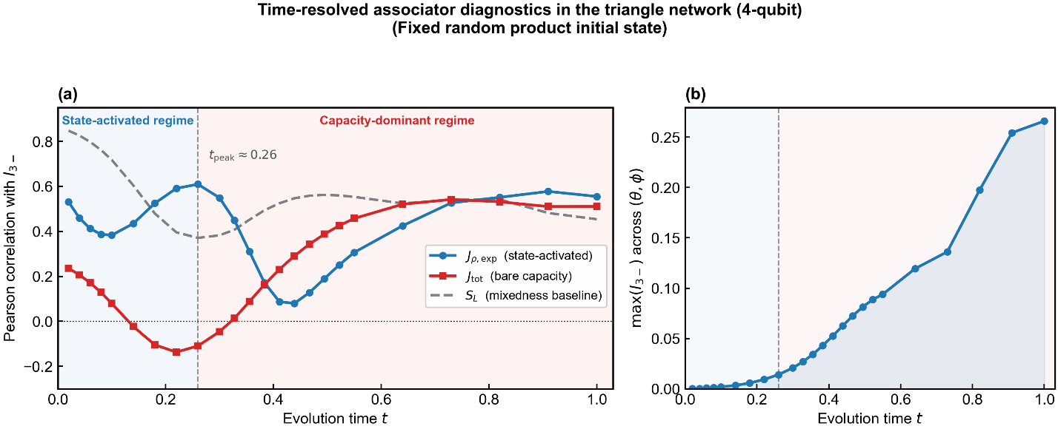
Figure mapping: Figure 1.
Result placeholders:
4-qubit time scan: plus
t=0.05 | corr(J_rho_exp, I3-)=0.8027 | corr(J_tot, I3-)=0.0191 | corr(eta, I3-)=0.7612 | corr(P_pair, I3-)=0.2056 | corr(N_pair_sum, I3-)=0.2384 | max(I3-)=0.0008
t=0.10 | corr(J_rho_exp, I3-)=0.8084 | corr(J_tot, I3-)=0.0215 | corr(eta, I3-)=0.7747 | corr(P_pair, I3-)=0.2175 | corr(N_pair_sum, I3-)=0.2630 | max(I3-)=0.0035
t=0.15 | corr(J_rho_exp, I3-)=0.7764 | corr(J_tot, I3-)=0.0202 | corr(eta, I3-)=0.7733 | corr(P_pair, I3-)=0.2333 | corr(N_pair_sum, I3-)=0.2958 | max(I3-)=0.0089
t=0.20 | corr(J_rho_exp, I3-)=0.6689 | corr(J_tot, I3-)=0.0134 | corr(eta, I3-)=0.7177 | corr(P_pair, I3-)=0.2505 | corr(N_pair_sum, I3-)=0.3293 | max(I3-)=0.0183
t=0.30 | corr(J_rho_exp, I3-)=0.3458 | corr(J_tot, I3-)=-0.0096 | corr(eta, I3-)=0.3925 | corr(P_pair, I3-)=0.2774 | corr(N_pair_sum, I3-)=0.2899 | max(I3-)=0.0556
t=0.50 | corr(J_rho_exp, I3-)=0.2593 | corr(J_tot, I3-)=-0.0063 | corr(eta, I3-)=0.2159 | corr(P_pair, I3-)=0.2767 | corr(N_pair_sum, I3-)=-0.1558 | max(I3-)=0.1913
t=1.00 | corr(J_rho_exp, I3-)=0.0966 | corr(J_tot, I3-)=0.5571 | corr(eta, I3-)=-0.0609 | corr(P_pair, I3-)=0.5055 | corr(N_pair_sum, I3-)=0.2931 | max(I3-)=0.1997
4-qubit time scan: fixed random product
t=0.05 | corr(J_rho_exp, I3-)=0.4328 | corr(J_tot, I3-)=0.1899 | corr(eta, I3-)=0.4075 | corr(P_pair, I3-)=-0.5755 | corr(N_pair_sum, I3-)=-0.6023 | max(I3-)=0.0005
t=0.10 | corr(J_rho_exp, I3-)=0.3829 | corr(J_tot, I3-)=0.0798 | corr(eta, I3-)=0.4249 | corr(P_pair, I3-)=-0.6860 | corr(N_pair_sum, I3-)=-0.7419 | max(I3-)=0.0019
t=0.15 | corr(J_rho_exp, I3-)=0.4569 | corr(J_tot, I3-)=-0.0464 | corr(eta, I3-)=0.5475 | corr(P_pair, I3-)=-0.6867 | corr(N_pair_sum, I3-)=-0.7694 | max(I3-)=0.0039
t=0.20 | corr(J_rho_exp, I3-)=0.5624 | corr(J_tot, I3-)=-0.1283 | corr(eta, I3-)=0.6677 | corr(P_pair, I3-)=-0.6011 | corr(N_pair_sum, I3-)=-0.7001 | max(I3-)=0.0073
t=0.30 | corr(J_rho_exp, I3-)=0.5492 | corr(J_tot, I3-)=-0.0461 | corr(eta, I3-)=0.5923 | corr(P_pair, I3-)=-0.5049 | corr(N_pair_sum, I3-)=-0.6203 | max(I3-)=0.0208
t=0.50 | corr(J_rho_exp, I3-)=0.2018 | corr(J_tot, I3-)=0.3955 | corr(eta, I3-)=0.0497 | corr(P_pair, I3-)=-0.3039 | corr(N_pair_sum, I3-)=0.2144 | max(I3-)=0.0830
t=1.00 | corr(J_rho_exp, I3-)=0.5552 | corr(J_tot, I3-)=0.5106 | corr(eta, I3-)=0.3981 | corr(P_pair, I3-)=0.4199 | corr(N_pair_sum, I3-)=0.2793 | max(I3-)=0.2660

8. Figure 3 — Applicability across initial states and boundary conditions

8.1 Objective
Figure 3 was used to characterize the applicability range of the associator diagnostic.

8.2 Panel (a): axis-biased product state
This panel now shows only the three time-resolved curves:
- $J_{ρ,exp}$
- $J_{tot}$
- $S_{L}$
without any regime shading.
Purpose:
- show that the plus state produces a strong but transient signal,
- illustrate that the mechanism is visible but basis-biased.

8.3 Panel (b): Haar-random control
Purpose:
- show that in a volume-law-like initial state, the associator readout becomes indiscriminative.

Main message
The associator is not claimed to be universally sharp in all initial conditions; rather, it is most informative in clean low-entanglement starts where the onset of higher-order structure is dynamically generated.
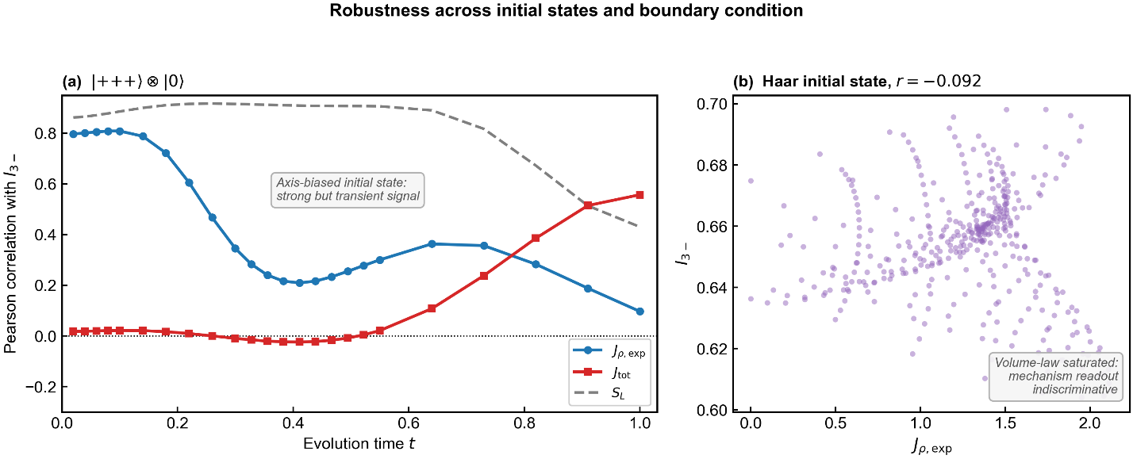
Figure mapping: Figure 3.

9. Defensive diagnostic branch — Tripartite negativity proxies

9.1 Objective
These experiments were retained to document what standard tripartite-entanglement-style proxies do not capture in the current regime.

9.2 Quantities computed
- $N_{A|BC}$, $N_{B|AC}$, $N_{C|AB}$
- $N_{tri_min}$
- $N_{tri_geom}$

9.3 Purpose
- test whether a more conventional tripartite negativity language can substitute for $I_{3-}$,
- determine whether the associator is merely tracking ordinary inseparability.

9.4 Main conclusion
In the 4-qubit regime studied here, these proxies are highly collinear with pairwise baselines and pairwise negativity sums. Their failure is itself important:
- they track overall inseparability,
- they do not selectively isolate the irreducible higher-order structure of interest.

Why this branch was retained
This negative result is valuable for two reasons:
- it clarifies why $I_{3-}$ remains the primary higher-order indicator in the current framework,
- it may behave differently in the 5-qubit extension, so it remains worth keeping in the main notebook.
Result placeholders:
----- Original Phase-1 summary (I3_minus) -----

=== Scan summary ===
N = 400
Pearson corr(J_rho_exp, I3_minus) = 0.382886
Pearson corr(J_tot, I3_minus) = 0.079847
Pearson corr(eta, I3_minus) = 0.424907
Pearson corr(P_pair, I3_minus) = -0.685991

Top 8 points by I3_minus:
theta=1.261, phi=0.992, I3_minus=0.001915, J_rho_exp=1.474184, J_tot=21.862061, eta=0.067431, P_pair=0.226706
theta=1.261, phi=0.909, I3_minus=0.001905, J_rho_exp=1.631689, J_tot=22.383821, eta=0.072896, P_pair=0.217338
theta=1.339, phi=1.075, I3_minus=0.001884, J_rho_exp=1.246268, J_tot=21.401521, eta=0.058233, P_pair=0.259436
theta=1.339, phi=1.157, I3_minus=0.001856, J_rho_exp=1.105127, J_tot=19.610705, eta=0.056353, P_pair=0.267426
theta=1.261, phi=1.075, I3_minus=0.001844, J_rho_exp=1.306284, J_tot=20.870975, eta=0.062589, P_pair=0.238097
theta=1.261, phi=0.827, I3_minus=0.001843, J_rho_exp=1.775707, J_tot=22.404506, eta=0.079257, P_pair=0.208976
theta=1.184, phi=0.744, I3_minus=0.001837, J_rho_exp=2.050096, J_tot=21.254539, eta=0.096454, P_pair=0.174823
theta=1.184, phi=0.827, I3_minus=0.001829, J_rho_exp=1.880282, J_tot=21.594650, eta=0.087072, P_pair=0.186449

----- Tripartite entanglement proxy: N_tri_geom -----

=== Entanglement summary (N_tri_geom) ===
Pearson corr(J_rho_exp, N_tri_geom) = -0.683272
Pearson corr(J_tot, N_tri_geom) = -0.424722
Pearson corr(eta, N_tri_geom) = -0.596575
Pearson corr(I3_minus, N_tri_geom) = -0.705934
Pearson corr(P_pair, N_tri_geom) = 0.996532
Pearson corr(N_pair_sum,N_tri_geom) = 0.996362

Top 8 points by N_tri_geom:
theta=0.100, phi=0.000, N_tri_geom=0.189298, I3_minus=0.000019, J_rho_exp=0.325927, eta=0.041424, P_pair=0.688749, N_pair_sum=0.340571
theta=0.100, phi=0.083, N_tri_geom=0.188319, I3_minus=0.000019, J_rho_exp=0.266606, eta=0.033936, P_pair=0.683007, N_pair_sum=0.339209
theta=0.100, phi=0.165, N_tri_geom=0.187391, I3_minus=0.000019, J_rho_exp=0.205285, eta=0.026247, P_pair=0.677581, N_pair_sum=0.337906
theta=0.100, phi=0.248, N_tri_geom=0.186518, I3_minus=0.000019, J_rho_exp=0.144079, eta=0.018554, P_pair=0.672496, N_pair_sum=0.336666
theta=0.100, phi=0.331, N_tri_geom=0.185703, I3_minus=0.000019, J_rho_exp=0.089856, eta=0.011683, P_pair=0.667772, N_pair_sum=0.335493
theta=0.100, phi=0.413, N_tri_geom=0.184952, I3_minus=0.000018, J_rho_exp=0.070413, eta=0.009263, P_pair=0.663427, N_pair_sum=0.334391
theta=0.100, phi=0.496, N_tri_geom=0.184265, I3_minus=0.000018, J_rho_exp=0.109257, eta=0.014567, P_pair=0.659478, N_pair_sum=0.333364
theta=0.100, phi=0.579, N_tri_geom=0.183647, I3_minus=0.000017, J_rho_exp=0.170694, eta=0.023095, P_pair=0.655938, N_pair_sum=0.332416

----- Tripartite entanglement proxy: N_tri_min -----

=== Entanglement summary (N_tri_min) ===
Pearson corr(J_rho_exp, N_tri_min) = -0.616257
Pearson corr(J_tot, N_tri_min) = -0.444096
Pearson corr(eta, N_tri_min) = -0.519362
Pearson corr(I3_minus, N_tri_min) = -0.689167
Pearson corr(P_pair, N_tri_min) = 0.977338
Pearson corr(N_pair_sum,N_tri_min) = 0.980617

Top 8 points by N_tri_min:
theta=0.100, phi=0.000, N_tri_min=0.181712, I3_minus=0.000019, J_rho_exp=0.325927, eta=0.041424, P_pair=0.688749, N_pair_sum=0.340571
theta=0.100, phi=0.083, N_tri_min=0.181426, I3_minus=0.000019, J_rho_exp=0.266606, eta=0.033936, P_pair=0.683007, N_pair_sum=0.339209
theta=0.100, phi=0.165, N_tri_min=0.181202, I3_minus=0.000019, J_rho_exp=0.205285, eta=0.026247, P_pair=0.677581, N_pair_sum=0.337906
theta=0.100, phi=0.248, N_tri_min=0.181038, I3_minus=0.000019, J_rho_exp=0.144079, eta=0.018554, P_pair=0.672496, N_pair_sum=0.336666
theta=0.100, phi=0.579, N_tri_min=0.180938, I3_minus=0.000017, J_rho_exp=0.170694, eta=0.023095, P_pair=0.655938, N_pair_sum=0.332416
theta=0.100, phi=0.331, N_tri_min=0.180932, I3_minus=0.000019, J_rho_exp=0.089856, eta=0.011683, P_pair=0.667772, N_pair_sum=0.335493
theta=0.100, phi=0.496, N_tri_min=0.180885, I3_minus=0.000018, J_rho_exp=0.109257, eta=0.014567, P_pair=0.659478, N_pair_sum=0.333364
theta=0.100, phi=0.413, N_tri_min=0.180882, I3_minus=0.000018, J_rho_exp=0.070413, eta=0.009263, P_pair=0.663427, N_pair_sum=0.334391

10. Supplementary competition table

10.1 Objective
A time-resolved competition table was produced to compare the main associator diagnostics against a broader set of candidate indicators.

10.2 Candidate metrics compared
- $J_{ρ,exp}$
- $J_{tot}$
- $η$
- $P_{pair}$
- $N_{sum}$
- GHZ witness proxy
- $S_{L}$

10.3 Purpose
- show that the project did not cherry-pick only favorable metrics,
- provide a broader methodological context for the main choices.
Figure mapping: Supplementary competition heatmap.
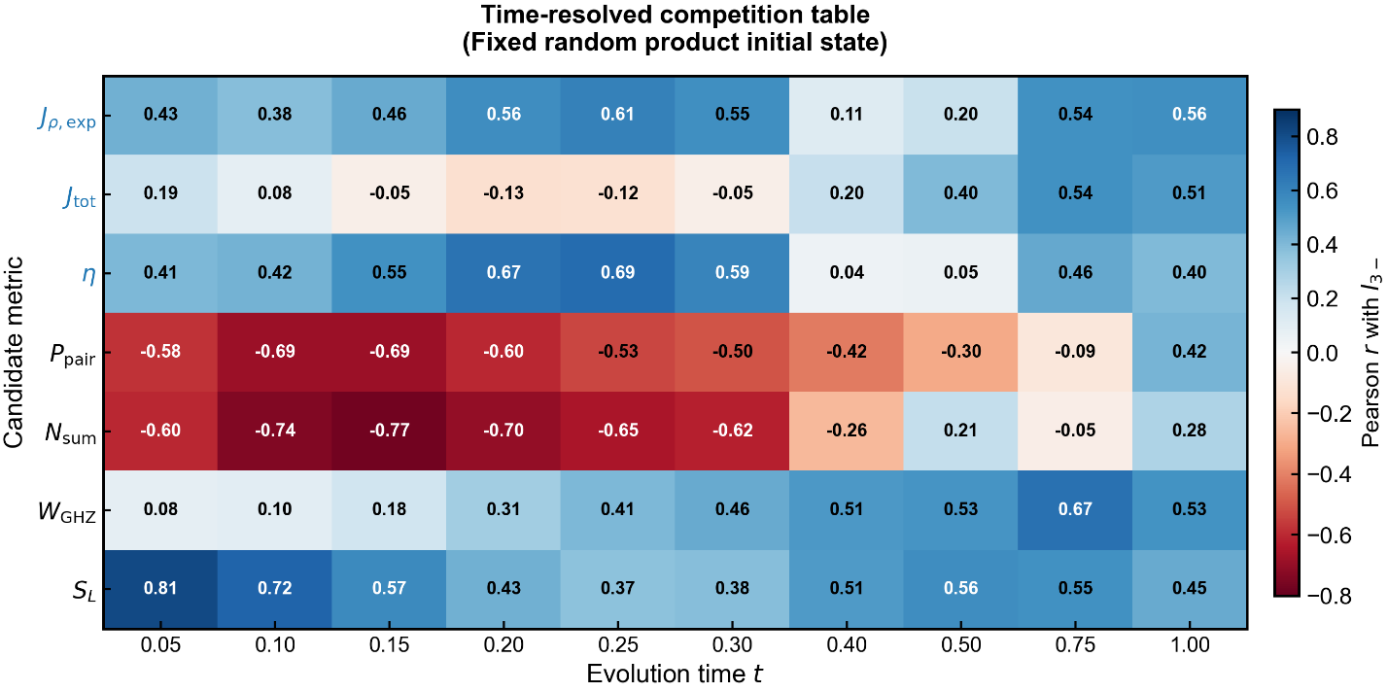
Result placeholders:
See in figure.

11. Route 3 — 4-qubit open-system robustness under noise

11.1 Objective
The 4-qubit open-system route tests whether higher-order structure is more robust than dyadic baselines under realistic decoherence.

11.2 Noise model
After a unitary preparation stage, noise is turned on for nodes $A,B,C$ only.
Three channels were compared:
- amplitude damping
- dephasing
- depolarizing

11.3 Standard parameter settings
- candidate pool: num_pool = 80
- selected families: top_k = 12
- unitary preparation time: t_prep = 0.80
- noisy evolution duration: t_open = 1.20
- time steps:
  - steps_prep = 50
  - steps_open = 60
- noise strength: gamma = 0.20
- weak environment coupling: g_D = 0.20
- initial state: fixed random product state

11.4 Family selection logic
Prepared families were ranked using:
$$\text{score}=I_{3-}⋅\left(N_{pair}+ε\right)$$
Purpose:
- keep families with visible tripartite synergy and visible pairwise entanglement baseline at preparation time,
- avoid trivial or nearly featureless trajectories.

11.5 Main plotted quantities

Updated 4-qubit definition
To make the 4-qubit and 5-qubit figures directly comparable, the dyadic baselines were rewritten as means over internal edges, not totals.
For the triangle:
$${\overline{I_{2}}}^{△}=\frac{P_{pair}}{3}$$
$${\overline{N_{2}}}^{△}=\frac{N_{pair_sum}}{3}$$
The main 4-qubit open-system figure therefore contains:
- blue: $I_{3-}$
- red: ${\overline{I_{2}}}^{△}$
- orange: ${\overline{N_{2}}}^{△}$
and a ratio panel:
$$\frac{I_{3-}}{{\overline{I_{2}}}^{△}}$$

11.6 Main conclusion
The 4-qubit open-system route supports the claim that higher-order structure remains relatively persistent compared with pairwise entanglement, and its weight relative to the dyadic information background increases after noise onset.
Figure mapping: Figure 4.
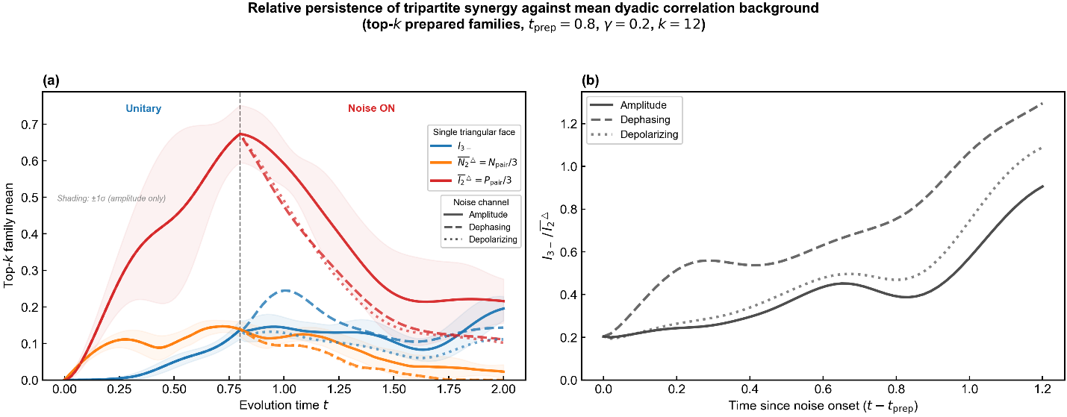
Result placeholders:
Selected top-k = 12 families
1. theta=0.916, phi=0.100, I3_minus=0.167263, N_pair_sum=0.369901, P_pair=2.137333, score=6.187070e-02
2. theta=0.791, phi=0.298, I3_minus=0.137743, N_pair_sum=0.435800, P_pair=1.904222, score=6.002834e-02
3. theta=0.770, phi=0.318, I3_minus=0.129049, N_pair_sum=0.453880, P_pair=1.867781, score=5.857256e-02
4. theta=0.786, phi=0.069, I3_minus=0.179642, N_pair_sum=0.323187, P_pair=2.346065, score=5.805809e-02
5. theta=0.632, phi=0.138, I3_minus=0.136714, N_pair_sum=0.415458, P_pair=2.192538, score=5.679887e-02
6. theta=0.969, phi=0.036, I3_minus=0.153260, N_pair_sum=0.369336, P_pair=2.058884, score=5.660450e-02
7. theta=0.743, phi=1.308, I3_minus=0.103770, N_pair_sum=0.520263, P_pair=2.157955, score=5.398794e-02
8. theta=0.752, phi=0.357, I3_minus=0.114697, N_pair_sum=0.469224, P_pair=1.781695, score=5.381841e-02

12. 5-qubit tetrahedral extension — Closed-system pilot

12.1 Physical setup
System:
- internal tetrahedron: $A,B,C,D$
- external node: $E$
- environment coupling only on the edge $DE$
Total Hamiltonian:
$$H_{tot}=H_{AB}+H_{AC}+H_{AD}+H_{BC}+H_{BD}+H_{CD}+H_{DE}$$
After unitary evolution, node $E$ is traced out to obtain $ρ_{ABCD}$.
From this 4-qubit reduced state, all four triangular faces are extracted:
- $ABC$
- $ABD$
- $ACD$
- $BCD$
Higher-order observables are computed separately on each face.

12.2 Objective
The 5-qubit extension was introduced to test whether the project’s central mechanism survives and changes in a genuine 3-simplex topology.
Key questions:
- Does the higher-order signal strengthen or weaken in the tetrahedral geometry?
- Do different triangular faces behave differently?
- Does the environment coupling generate face-resolved topological differentiation?

12.3 Standard pilot settings
- grid size: $12×12=144$
- initial state: fixed random product state on $A,B,C,D$ tensored with $|0⟩_{E}$
- pilot time: typically $t=0.20$
- environment coupling values tested: at least $g_{E}=0.20$ and $g_{E}=1.50$

12.4 Data structure saved for each point
For every parameter point, the following are saved:

Facewise raw results
For each face $f∈\{ABC,ABD,ACD,BCD\}$:
- $I_{3-}^{\left(f\right)}$
- $J_{ρ,exp}^{\left(f\right)}$
- $J_{tot}^{\left(f\right)}$
- $η^{\left(f\right)}$
- $P_{pair}^{\left(f\right)}$
- $N_{pair_sum}^{\left(f\right)}$
- defensive tripartite negativity proxies

Aggregated results
- face mean and std of the main observables
- distal-face value:
$$I_{3-}^{distal}=I_{3-}^{\left(ABC\right)}$$
- adjacent-face mean:
$$I_{3-}^{adj}=\frac{I_{3-}^{\left(ABD\right)}+I_{3-}^{\left(ACD\right)}+I_{3-}^{\left(BCD\right)}}{3}$$

Environment edge observables
From the full 5-qubit state $ρ_{5}$, the $DE$ edge is reduced:
$$ρ_{DE}={Tr}_{ABC}\left(ρ_{5}\right)$$
and the following are stored:
- $I_{DE}$
- $N_{DE}$

12.5 Main pilot observations

Weak environment coupling ($g_{E}=0.20$)
Main qualitative result:
- face-averaged higher-order signal becomes stronger than in the 4-qubit case,
- all four faces show very similar $I_{3-}$ values,
- the tetrahedron behaves almost like a volume-wide higher-order reservoir.

Stronger environment coupling ($g_{E}=1.50$)
Main qualitative result:
- the distal face $ABC$ becomes more protected than the adjacent faces,
- topological differentiation emerges,
- environment-edge entanglement $N_{DE}$ increases, but does not directly support the internal higher-order signal.
Result placeholders:
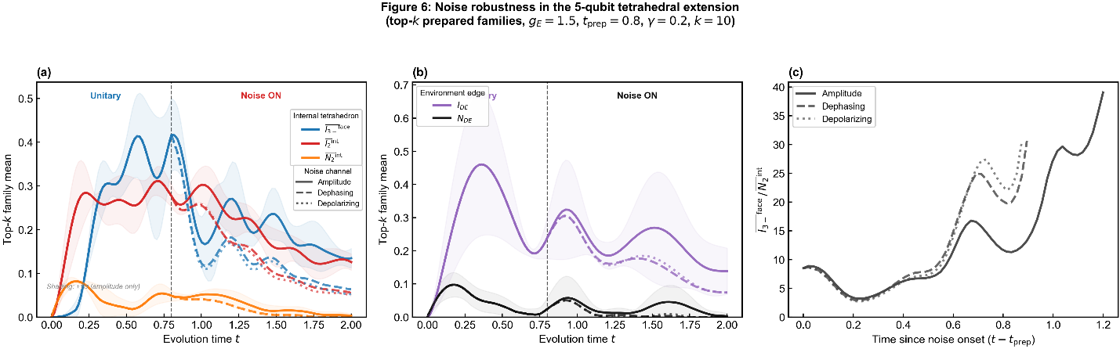

13. 5-qubit environment-coupling scan

13.1 Objective
This experiment was introduced to determine how the tetrahedral higher-order structure changes as the external coupling $g_{E}$ is varied.

13.2 Procedure
A representative high-signal point was selected from the pilot scan, and then the following were tracked as functions of $g_{E}$:
- face-mean $I_{3-}$
- distal-face $I_{3-}$
- adjacent-face mean $I_{3-}$
- $I_{DE}$
- $N_{DE}$
- $Δ_{topo}=I_{3-}^{distal}-I_{3-}^{adj}$
- $J_{ρ,exp}^{mean}$

13.3 Main qualitative observations

Environment edge
- $I_{DE}$ tends to keep growing with stronger coupling,
- $N_{DE}$ does not grow monotonically; it reaches a peak at intermediate coupling and then decreases.
Interpretation:
- edge-local total correlation and edge-local entanglement are not the same thing,
- very strong coupling may redistribute the correlation into more delocalized or more classical channels.

Topological differentiation
- the distal face continues to strengthen even after the face-mean and adjacent-face curves have begun to turn over,
- the topological gap $Δ_{topo}$ becomes a useful measure of environment-induced face differentiation.
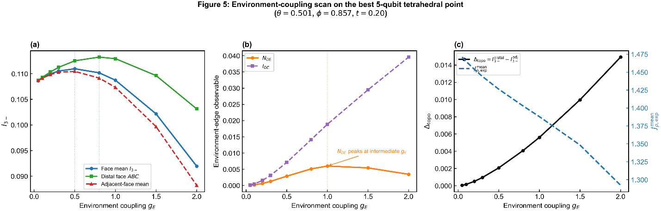
Figure mapping: Figure 5.
Result placeholders:
See in figure and gE_scan.csv

14. 5-qubit open-system robustness

14.1 Objective
This route asks whether the 5-qubit tetrahedral system shows the same or even stronger robustness advantage of higher-order structure under decoherence.

14.2 Noise model
The same three channels were reused:
- amplitude damping
- dephasing
- depolarizing
Noise is applied to the tetrahedron nodes $A,B,C,D$ only. Node $E$ is retained as the coherent environment-coupling node.

14.3 Standard parameter settings
- candidate pool: num_pool = 60
- selected families: top_k = 10
- unitary preparation time: t_prep = 0.80
- noisy evolution duration: t_open = 1.20
- steps_prep = 50
- steps_open = 60
- gamma = 0.20
- environment coupling in the current main run: g_E = 1.50
- initial state: fixed random product state

14.4 Selection logic
Prepared families were scored by:
$$\text{score}=I_{3-}^{mean} \left(N_{2}^{int}+ε\right)$$
Purpose:
- retain families with visible higher-order signal,
- while ensuring a nontrivial internal dyadic entanglement baseline at preparation time.

14.5 Updated internal observables for plotting
The 5-qubit open-system figure uses explicit means over the six internal tetrahedron edges, not face-summed proxies.

Internal dyadic mutual-information mean
I2int=16ij∈K4​Ii:j
where
$$K_{4}=\{AB,AC,AD,BC,BD,CD\}$$

Internal dyadic negativity mean
N2int=16ij∈K4​Nij

Main higher-order observable
I3-face=14f​I3-f

14.6 Main figure structure

Main-text figure
- blue: ${\overline{I_{3-}}}^{face}$
- red: ${\overline{I_{2}}}^{int}$
- orange: ${\overline{N_{2}}}^{int}$
ratio panel:
$$\frac{{\overline{I_{3-}}}^{face}}{{\overline{I_{2}}}^{int}}$$

Supplementary environment-edge figure
- $I_{DE}$
- $N_{DE}$

14.7 Main qualitative conclusion
The 5-qubit open-system results suggest that:
- the face-averaged higher-order signal remains remarkably persistent,
- internal dyadic entanglement is more fragile,
- environment-edge diagnostics do not straightforwardly mirror the internal higher-order behavior.
This strengthens the interpretation that higher-order organization in the tetrahedral geometry is not reducible to edge-local entanglement.
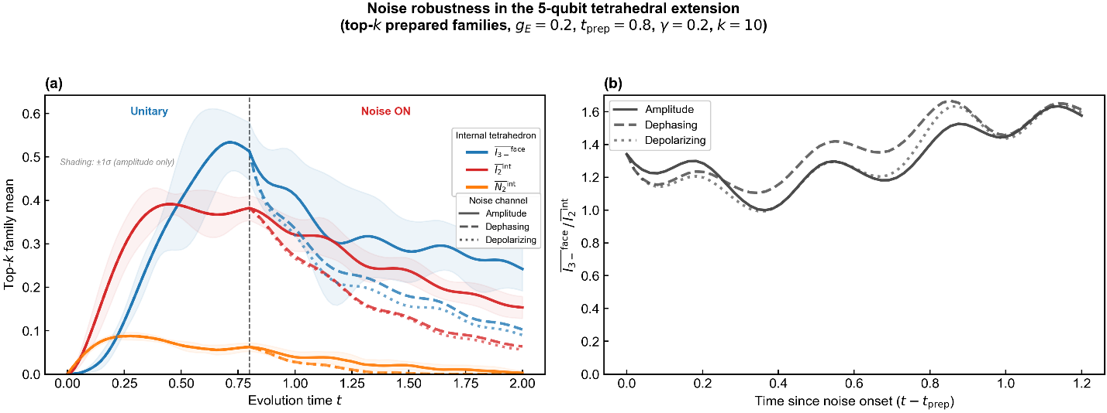
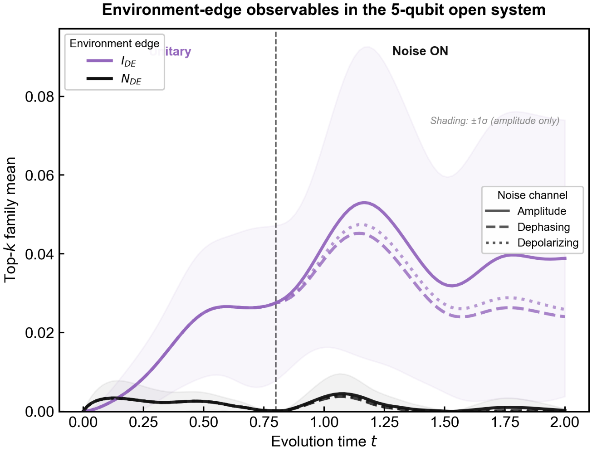
Figure mapping: Figure 6 + supplementary environment-edge figure.
Result placeholders:
=== Route-5 open system: selecting top-k prepared families ===

Selected top-k = 10 families
1. theta=0.302, phi=0.667, I3_mean=0.469857, N2_int_mean=0.074329, I2_int_mean=0.419456, N_DE=0.000000, score=3.492400e-02
2. theta=0.630, phi=1.006, I3_mean=0.444146, N2_int_mean=0.076858, I2_int_mean=0.428710, N_DE=0.000058, score=3.413616e-02
3. theta=0.540, phi=0.828, I3_mean=0.458334, N2_int_mean=0.073238, I2_int_mean=0.408324, N_DE=0.000759, score=3.356748e-02
4. theta=0.450, phi=1.202, I3_mean=0.526879, N2_int_mean=0.061502, I2_int_mean=0.355836, N_DE=0.000506, score=3.240406e-02
5. theta=0.683, phi=0.035, I3_mean=0.623103, N2_int_mean=0.051572, I2_int_mean=0.365119, N_DE=0.000000, score=3.213457e-02
6. theta=1.328, phi=0.968, I3_mean=0.471391, N2_int_mean=0.065961, I2_int_mean=0.405616, N_DE=0.000000, score=3.109323e-02
7. theta=0.793, phi=1.144, I3_mean=0.521129, N2_int_mean=0.055601, I2_int_mean=0.355550, N_DE=0.000000, score=2.897539e-02
8. theta=1.191, phi=0.990, I3_mean=0.449130, N2_int_mean=0.064288, I2_int_mean=0.371622, N_DE=0.000000, score=2.887349e-02

15. Time-resolved 5-qubit crossover experiments

15.1 Objective
This route generalizes the 4-qubit crossover logic to the tetrahedral network.

15.2 Updated target and diagnostics
At each time point, a full $\left(θ,ϕ\right)$ scan is performed and the following are recorded:
- $corr\left(J_{ρ,exp}^{mean},{\overline{I_{3-}}}^{face}\right)$
- $corr\left(J_{tot}^{mean},{\overline{I_{3-}}}^{face}\right)$
- $corr\left({\overline{S_{L}}}^{face},{\overline{I_{3-}}}^{face}\right)$
- $max\left({\overline{I_{3-}}}^{face}\right)$

15.3 Revised stage definition
The two regimes are now split by the peak time of $J_{ρ,exp}^{mean}$, not by the crossing of $J_{ρ,exp}^{mean}$ and $J_{tot}^{mean}$.

Regime definition
- State-activated regime: $t<t_{peak}$
- Capacity-dominant regime: $t>t_{peak}$

15.4 Main interpretation
Unlike the earlier 4-qubit story, the 5-qubit tetrahedral network shows a more subtle structure:
- bare capacity is already relevant very early,
- state activation rises later and has a clear peak,
- the higher-order signal continues to grow over a broader interval.
This suggests that the tetrahedral network behaves as a richer capacity-bearing topology, in which activation still matters, but its role is embedded in a broader structural reservoir. This behavior can be understood as a self-averaging effect: in the triangle network, $J_{\text{tot}}$is a single scalar encoding the algebraic capacity of one face, and its early-time predictive power is limited by the lack of structural diversity. In the tetrahedral network, $J_{\text{tot}}^{\text{mean}}$averages over four faces whose individual capacities vary with the Hamiltonian parametrisation. This averaging suppresses statistical fluctuations and allows the bare capacity to become informative at earlier times — analogous to how mean-field descriptions become increasingly accurate as the number of interacting subsystems grows. The state-activated component $J_{ρ,\text{exp}}$therefore transitions from a dominant early-time predictor in the triangle to an incremental finite-size correction in the tetrahedron, while retaining a well-defined peak that marks the optimal window of state-resolved diagnostics.

Figure title
Time-resolved associator diagnostics in the tetrahedral network (5-qubit)
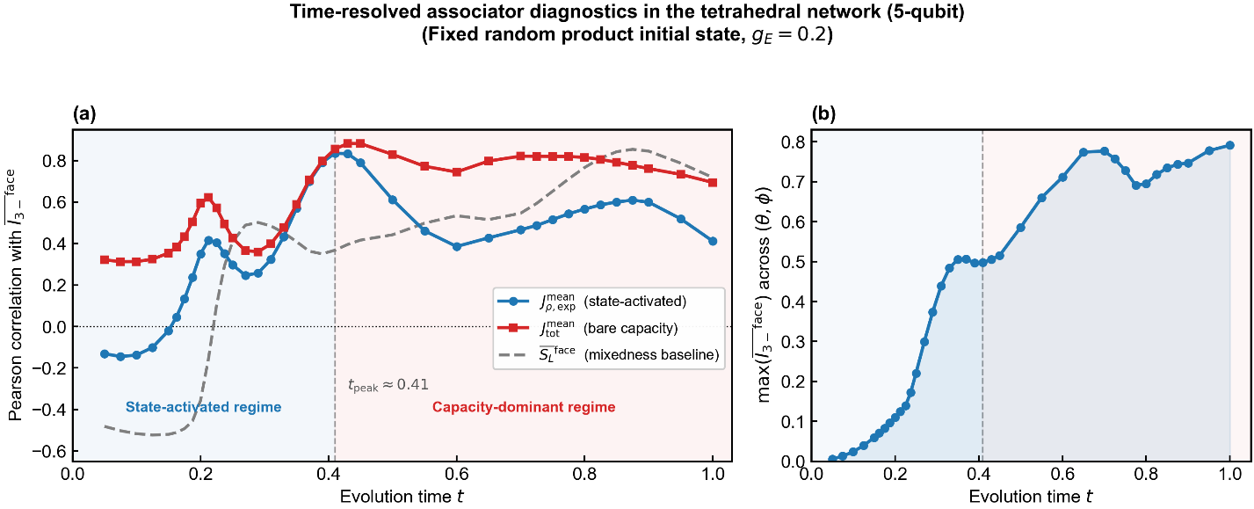
Figure mapping: Figure 7.
Result placeholders:
See time_scan_5q.csv

16. Current figure list

Main-text figures
- Figure 1 — Time-resolved associator diagnostics in the triangle network (4-qubit)
- Figure 2 — Mechanism snapshot in the generative / early state-activated regime
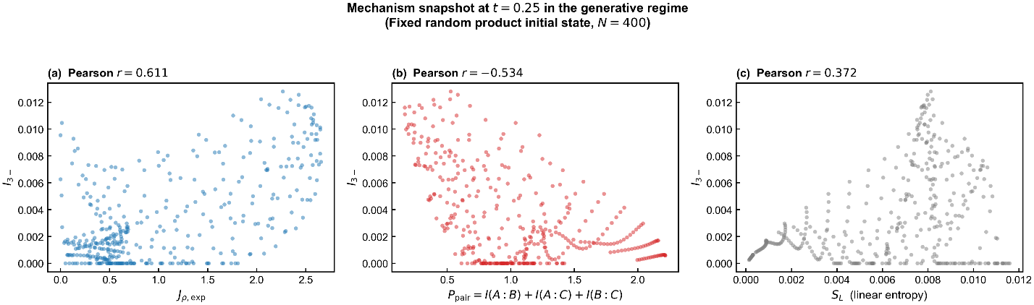
- Figure 3 — Robustness across initial states and boundary condition
- Figure 4 — 4-qubit open-system robustness against mean dyadic correlation background
- Figure 5 — 5-qubit environment-coupling scan at a representative point
- Figure 6 — 5-qubit open-system robustness in the tetrahedral extension
- Figure 7 — Time-resolved associator diagnostics in the tetrahedral network (5-qubit)

Supplementary figures
- Competition heatmap of candidate metrics vs $I_{3-}$
- 5-qubit environment-edge observables in the open system

17. What this document is for next
The next step is story design:
- What is the central discovery?
- Which result is the strongest headline?
- How should the 4-qubit and 5-qubit stories be layered together?
- Which claim should be emphasized in the abstract / title / introduction?

17. Story design decisions
Central discovery. The Jordan associator, decomposed into a state-activated component ($J_{ρ,\text{exp}}$) and a bare algebraic capacity ($J_{\text{tot}}$), provides a two-layer diagnostic framework for the dynamical generation of irreducible tripartite quantum correlations. The state-activated signal peaks at an intermediate time and then decays as the quantum state thermalises; the bare capacity provides a time-robust structural predictor whose early-time relevance increases with network size through self-averaging.
Strongest headline result. The time-resolved crossover between state-activated and capacity-dominant regimes (Figure 1), together with its scale-dependent evolution in the tetrahedral extension (Figure 7), constitutes the primary novel finding. This is supported by the complete absence of pairwise entanglement ($N_{\text{sum}}≡0$) during active synergy generation (Figure 2), and by the noise-channel-independent persistence of higher-order structure relative to dyadic baselines (Figures 4 and 6).
Layering strategy. The 4-qubit triangle network serves as the primary proof-of-concept where the crossover is cleanest and the competition analysis is most thorough. The 5-qubit tetrahedral extension serves a dual role: (i) validating that the associator framework generalises beyond the minimal topology, and (ii) revealing the self-averaging mechanism through which bare capacity acquires early-time predictive power in richer networks. The environment-coupling scan (Figure 5) provides a third layer demonstrating topology-sensitive face differentiation — a result that connects the microscopic associator framework to network-level structure.
Abstract / title emphasis. The title should foreground the mechanistic discovery (non-associativity as a generative engine) rather than the technical tool (Jordan associator). A candidate framing: the generation and persistence of irreducible higher-order quantum correlations are governed by the non-associative algebraic structure of the interaction Hamiltonian, with the state-activated and bare-capacity components playing complementary roles across dynamical regimes and network scales.

18. Exact-null ablation and two-layer recovery route

18.1 Objective
A new route was added after the original log to convert the associator story from a correlation-based mechanism claim into a counterfactual control experiment. The purpose of this route is to construct an exact non-associative null manifold, verify that higher-order synergy collapses on that manifold even though pairwise dynamics remains active, and then track how the state-activated and bare-capacity channels recover as the system is moved continuously away from the null manifold.

18.2 Exact associator-null control family
The control family is built by forcing all triangle-edge interactions onto a common spin axis. In operator form, the null manifold is
H^(0)_ij = J_ij τ_i τ_j, with τ = n · σ.
so that all edge Hamiltonians on the triangle commute pairwise. In the current implementation the common-axis direction is chosen to be the z axis, which makes the control family an aligned-axis ZZ manifold. The external weak edge keeps the same norm scale as in the main 4-qubit setup. By construction, all mediator associators on the internal face vanish exactly at alpha = 0, while alpha = 1 recovers the original fixed-norm XYZ family.
The interpolation path is norm-preserving edge by edge. This prevents the ablation experiment from being reinterpreted as a simple change in total interaction strength. The control parameter alpha is therefore best read as the non-associativity strength along a continuous path connecting the exact null manifold to the original model family.

18.3 Representative-point sanity check
The first validation step was performed at a representative high-signal point from the main 4-qubit benchmark, with theta = 1.261, phi = 0.992, fixed random product initial state, and t = 0.10.
At alpha = 0.00: J_tot = 0, J_rho,exp = 0, comm_max = 0, I3_minus = 5.55e-17, P_pair = 0.7425, N_pair_sum = 0.3534.
At alpha = 1.00: J_tot = 2.186e+01, J_rho,exp = 1.474, I3_minus = 1.915e-03, P_pair = 0.2267, N_pair_sum = 0.1585.
This single-point check already established the key logical fact required for the ablation route: exact removal of the associator channel does not freeze the dynamics. Instead, pairwise mutual-information and pairwise-negativity backgrounds remain strongly active, while the higher-order signal collapses essentially to machine precision.

18.4 Early-time trajectory check
The same representative point was then followed over a short-time window for alpha = 0.00, 0.50, and 1.00. The resulting trajectories show that the alpha = 0 curve keeps visible pairwise evolution throughout the early-time regime, but the I3_minus curve stays pinned near zero. As alpha increases, J_rho,exp and I3_minus recover together, while pairwise observables remain nonzero across the whole path.
This stage confirms that the null family is not merely a low-signal or weak-coupling limit. Rather, it is a dynamically active control family in which the non-associative three-edge channel is removed exactly.

18.5 Global interpolation scan across the 4-qubit family
After the representative sanity checks, the ablation route was promoted to a full family scan on the same 20 x 20 (theta, phi) grid used in the main 4-qubit study. The scan uses fixed random product initial state, alpha values from 0.0 to 1.0 in steps of 0.1, and early-time evaluation points t = 0.10, 0.15, and 0.25.
The central normalized diagnostics are I3_minus(alpha) / I3_minus(1), P_pair(alpha) / P_pair(1), and N_pair_sum(alpha) / N_pair_sum(1), evaluated pointwise and then summarized across the family. Median-plus-IQR summaries were used for the main figure because the ratio distributions are visibly skewed.
The full interpolation scan confirms the representative-point picture globally. At alpha = 0, the relative HOI signal sits essentially at the machine-floor baseline, while the pairwise backgrounds remain substantially retained and in median are larger than their alpha = 1 baselines. As alpha increases, the higher-order signal turns on continuously, whereas the pairwise channels do not show any analogous collapse at the null point.
A second global summary was computed in fraction form: for each alpha and time, the scan records the fraction of (theta, phi) points with strong HOI suppression (defined by I3_minus(alpha) < 0.1 I3_minus(1)) and the fraction of points that simultaneously retain pairwise activity while remaining HOI-suppressed. At alpha = 0 these fractions are near unity across the tested early-time window, and they decrease progressively as non-associativity is restored.
See ablation_scan_4q.csv

18.6 Two-layer recovery from the null manifold
A second figure was then built from the same interpolation scan by tracking the normalized recovery of bare algebraic capacity J_tot, state-activated non-associativity J_rho,exp, and the tripartite synergy signal I3_minus.
This recovery analysis reveals a hierarchical bottleneck. The family-level median of J_tot(alpha) / J_tot(1) rises rapidly as alpha is increased away from the null manifold, whereas I3_minus(alpha) / I3_minus(1) recovers more slowly. The state-activated component J_rho,exp lies between the two and tracks the HOI recovery much more closely than J_tot does.
The physical interpretation is that bare non-associative capacity is necessary but not sufficient. The algebraic structure can allow a large amount of non-associativity before the quantum state is sufficiently aligned to activate it as an observable higher-order signal. This directly supports the two-layer framework developed elsewhere in the project: capacity and activation are distinct, and the latter acts as the practical bottleneck for early-time HOI generation.
The recovery hierarchy also provides a natural interpretation of the time-resolved crossover in the original 4-qubit analysis. The early regime is activation-limited, while later times increasingly reveal the predictive role of the bare capacity channel once the dynamical bottleneck has been opened by time evolution.

18.7 Main conclusion of the new route
Taken together, the exact-null ablation and the recovery analysis upgrade the original associator story in two decisive ways.
First, the exact-null control provides a counterfactual necessity test: when the non-associative three-edge channel is removed exactly, the early-time higher-order signal collapses even though pairwise dynamics remains active.
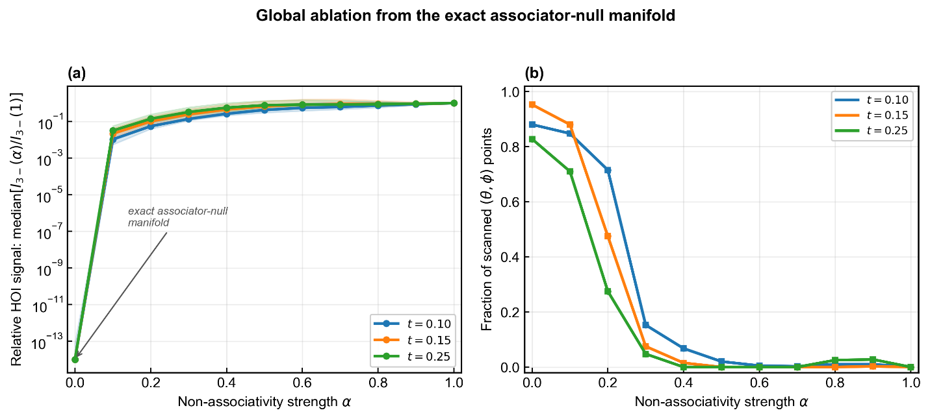
Second, the recovery curves expose a hierarchical mechanism: restoring bare non-associative capacity does not immediately restore tripartite synergy, because state activation remains the gating bottleneck.
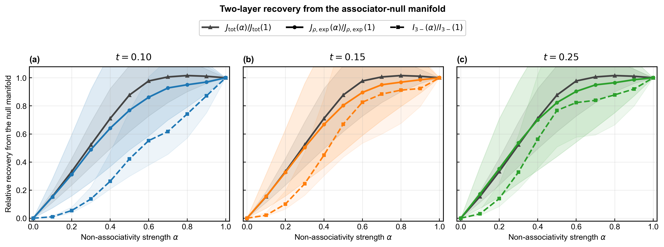
The evidence chain after this update can therefore be summarized as: algebraic identity -> dynamical correlation -> counterfactual necessity -> hierarchical recovery mechanism.

19. Revised figure priorities after the latest round

Main-text figures (PRL-facing order)
Figure 1 — Time-resolved associator diagnostics in the triangle network (4-qubit).
Figure 2 — Mechanism snapshot in the generative / early state-activated regime.
Figure 3 — Global ablation from the exact associator-null manifold (two-panel version: relative HOI signal and family-level suppression fractions).
Figure 4 — Two-layer recovery from the associator-null manifold.
Figure 5 — Time-resolved associator diagnostics in the tetrahedral network (5-qubit).

Supplementary / lower-priority figures
Applicability across initial states and boundary conditions.
Competition heatmap of candidate metrics vs I3_minus.
5-qubit environment-coupling scan at a representative point.
4-qubit and 5-qubit open-system robustness figures.
5-qubit environment-edge observables in the open system.

20. Updated story design decisions

20.1 Central discovery
The project now supports a stronger central claim than in the original draft stage. The non-associative algebraic structure of the Hamiltonian is not merely correlated with higher-order quantum organization; it defines the generative channel for early-time tripartite synergy. That channel operates through a two-layer hierarchy consisting of bare algebraic capacity and state-activated access to that capacity.

20.2 Strongest headline result
The strongest headline is now the combination of the 4-qubit crossover, the exact-null ablation, and the two-layer recovery analysis. Together they establish that higher-order synergy is activation-limited at early times, that the signal collapses when the non-associative channel is removed exactly, and that bare capacity recovers earlier than the observable synergy signal itself.

20.3 Role of the 5-qubit extension
The 5-qubit tetrahedral extension continues to serve as the scale/topology generalization layer. Its main role is no longer to carry the whole paper by itself, but to show that the two-layer picture is not restricted to the minimal triangle and that self-averaging increases the early usefulness of the bare-capacity channel in richer simplicial structures.

20.4 Title / abstract emphasis
The title and abstract should foreground the mechanistic claim: non-associative three-edge interference acts as the microscopic channel for higher-order synergy generation, while the observable emergence of that synergy is controlled by a capacity-versus-activation hierarchy. The paper should not be framed as introducing a new indicator for its own sake.

