**E-Shopper: System Architecture**

**Team members:**

*Hoang Long Nguyen - 615661*

*Xuan Giap Nguyen - 615643*

*Thi Thu Hang Nguyen - 615716*

*Hira Sadaf – 615700*

**GitHub Repository:**

[*https://github.com/xuangiap10/E-Shopper*](https://github.com/xuangiap10/E-Shopper)

Middle Tier

HTML

HTTPS

Browser



Server

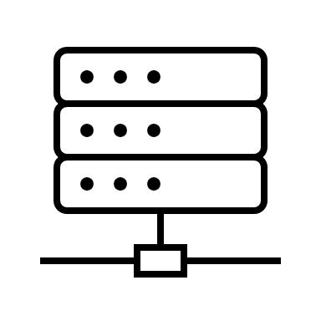

Data



URL

**User Interface**

- Angular JS

- Javascript, CSS, HTML, Images, etc



E-Shopper Database

Rich HTML

(Angular JS)

Dynamic HTML

Client Tier

Express Middleware

**Business service layer**

Database communication

**Data Access layer**

Request for data

JSON

**Web container**

Express

Node.js (RESTful requests)

**Web service layer**

**Web Services**

Data Tier