**CS32 Homework 5**

Xuanhe Zhang UID:706078980

1.

a.

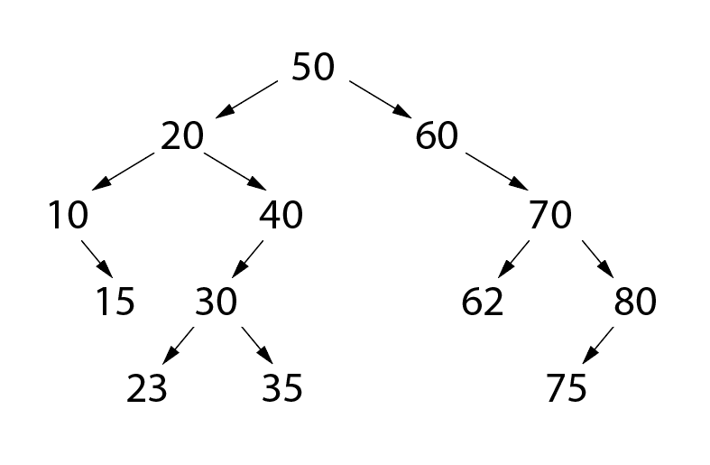

b.

inorder: 10, 15, 20, 23, 30, 35, 40, 50, 60, 62, 70, 75, 80

preorder: 50, 20, 10, 15, 40, 30, 23, 35, 60, 70, 62, 80, 75

postorder: 15, 10, 23, 35, 30, 40, 20, 62, 75, 80, 70, 60, 50

c.

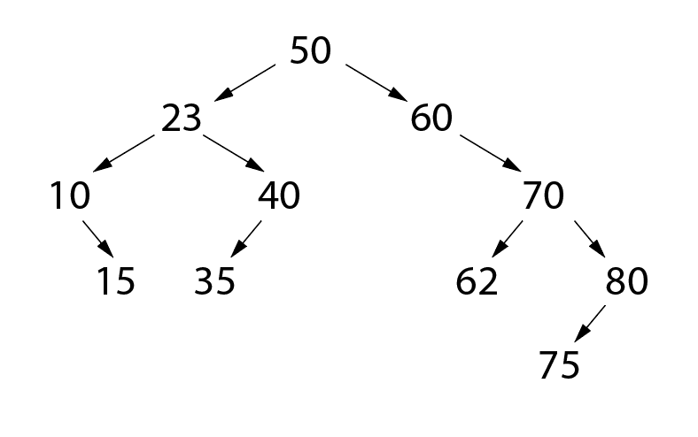

2.

a.

struct Node {

public:

Node* parent;

Node* left;

Node* right;

int data;

}

b.

insert(Node node, Node root){

if node’s data strictly greater than root’s:

if root has right child:

insert(node, root.right);

else

point node’s parent to root;

point root’s right child to node;

else if node’s data strictly less than root’s:

if root has left child:

insert(node, root.left);

else

point node’s parent to root;

point root’s right child to node;

else return;

}

3.

a.

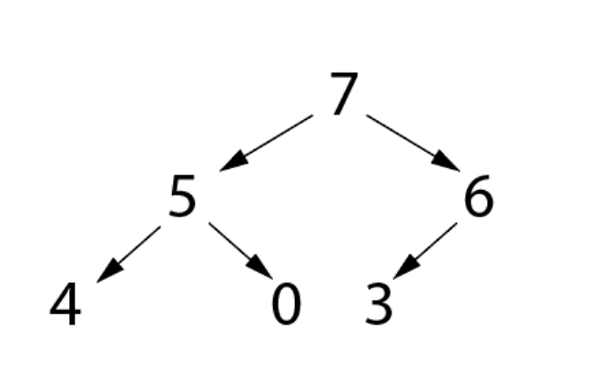

b. [7, 5, 6, 4, 0, 3]

c. [6, 5, 3, 4, 0]

4.

a. O(C+S)

b. O(log(C)+S)

c. O(log(C)+log(S))

d. O(log(S))

e. O(1)

f. O(log(C)+S)

g. O(S*log(S))

h. O(C*log(S))