1. **Stable Matching**

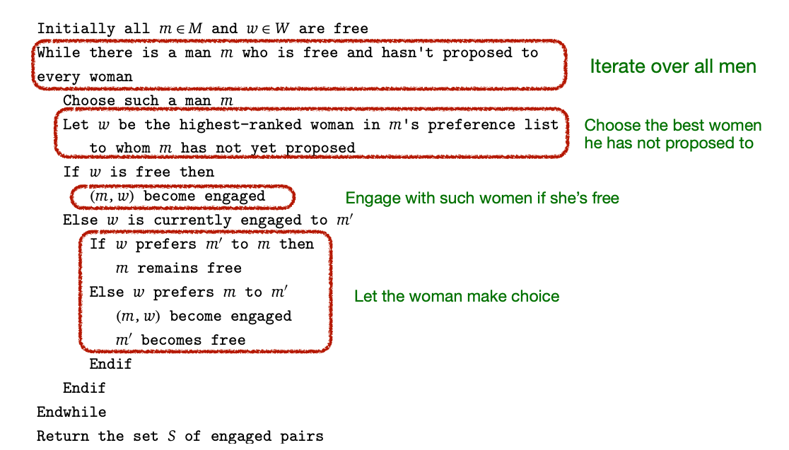

1. Preference list
2. Perfect matching: not singles
3. Instability: exists mutual consensus for rematch
4. Stable matching:
5. Perfect match
6. No instability (Every pair in S is Stable)
7. Valid Candidate:
8. (m, w) pair exists in some stable matching S
9. Remark:
10. Any match that satisfies the above definition is a stable matching.
11. G-S algorithm produces a stable matching, but it is not the only way to determine a stable matching.
12. A stable matching existing regardless of whether it can be found by G-S or not.
13. **Comparing Complexity**

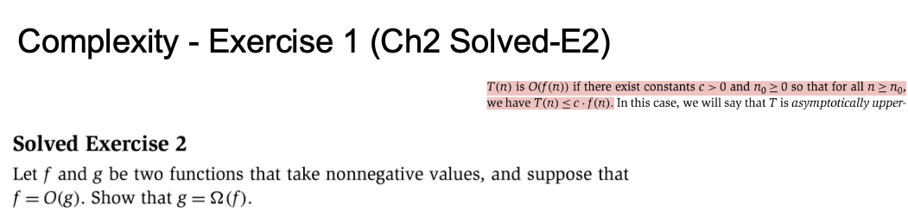

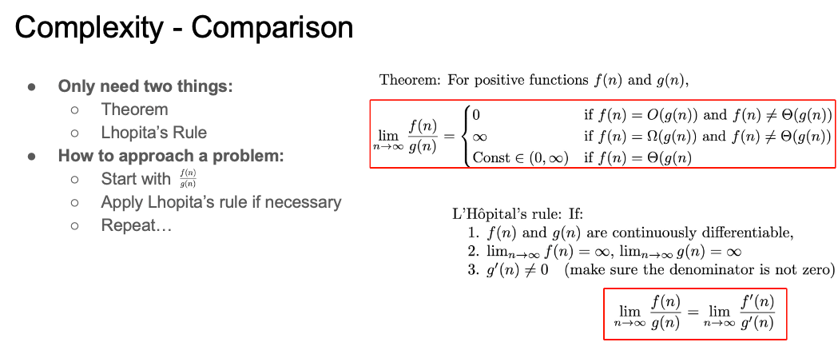

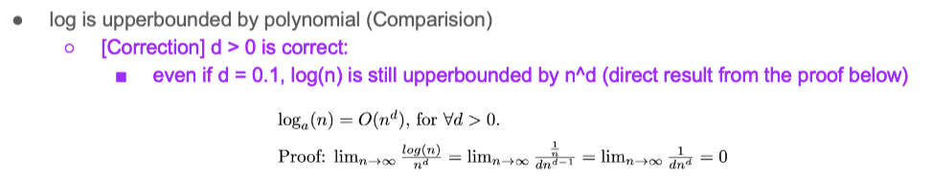

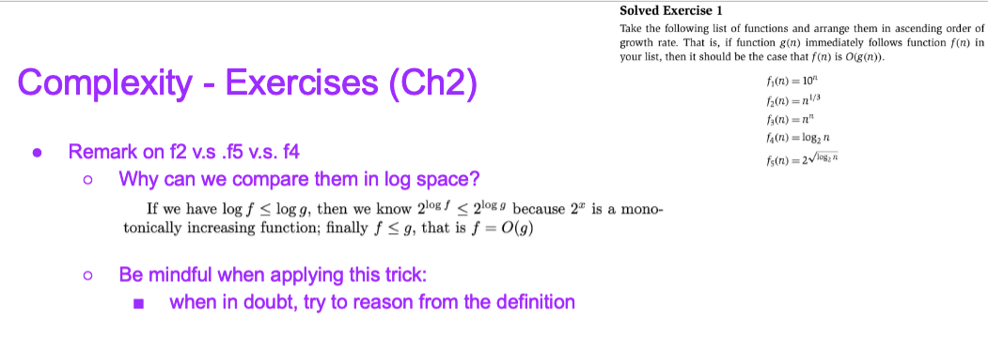

Stable match

Binary Search

Sorted List

O(logn)

2Sum

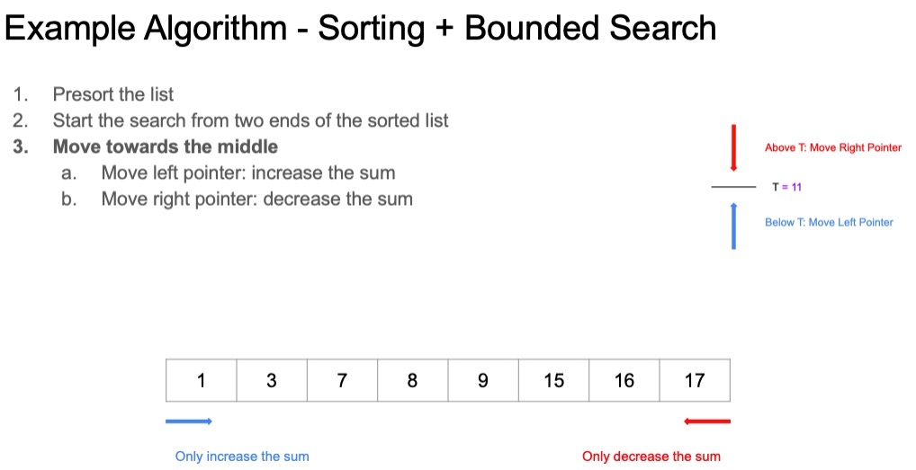

1. **Containers**

**Array, Linked List**

**Stack**

**Queue**

**Priority Queue (Heap)**

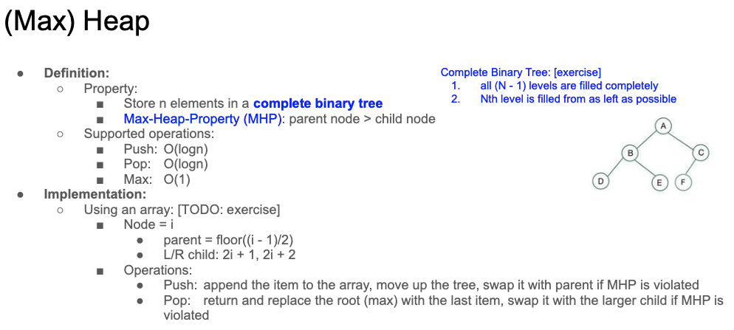

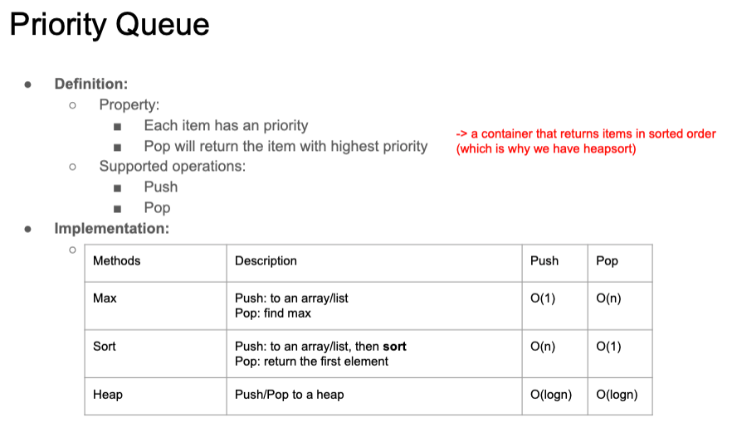

1. **Graphs & Trees**

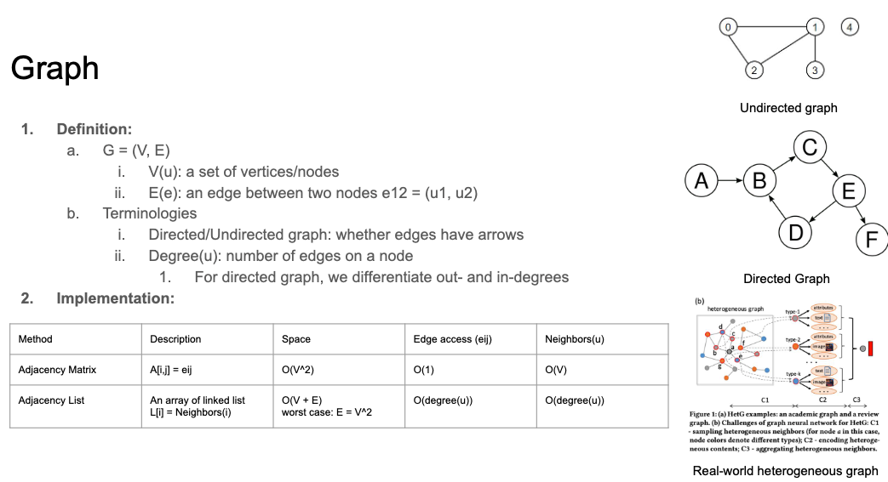

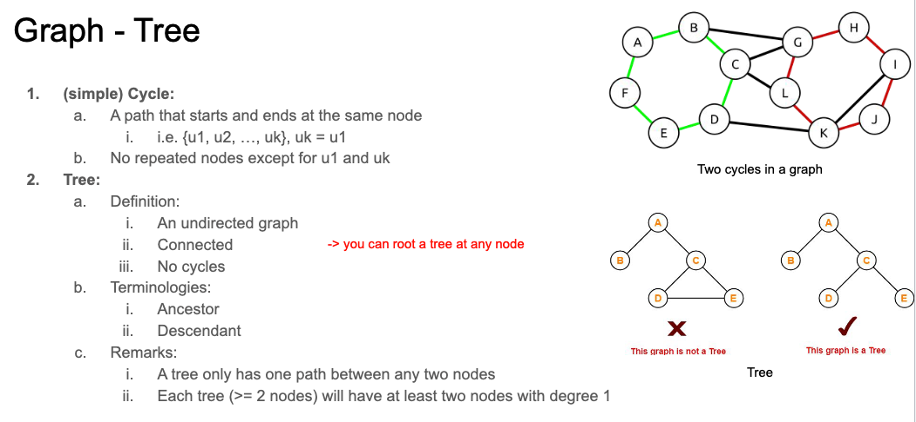

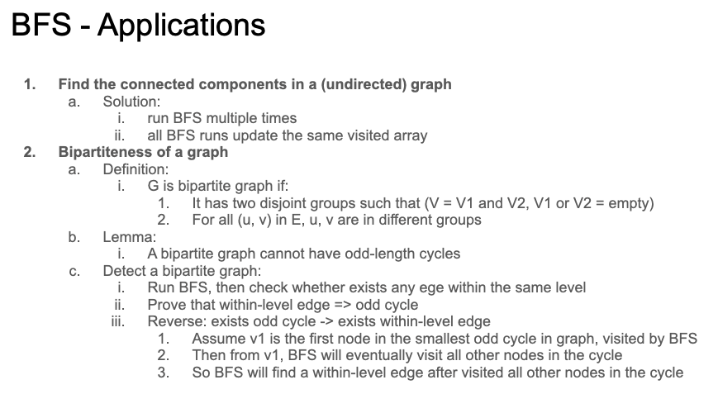

**Bipartite Graph**

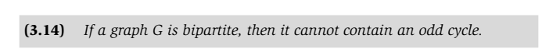

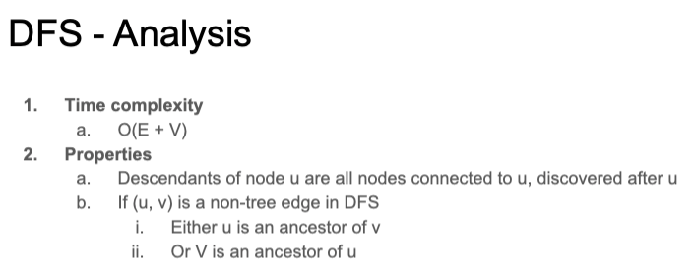

**Directed Graph**

**强连通性**

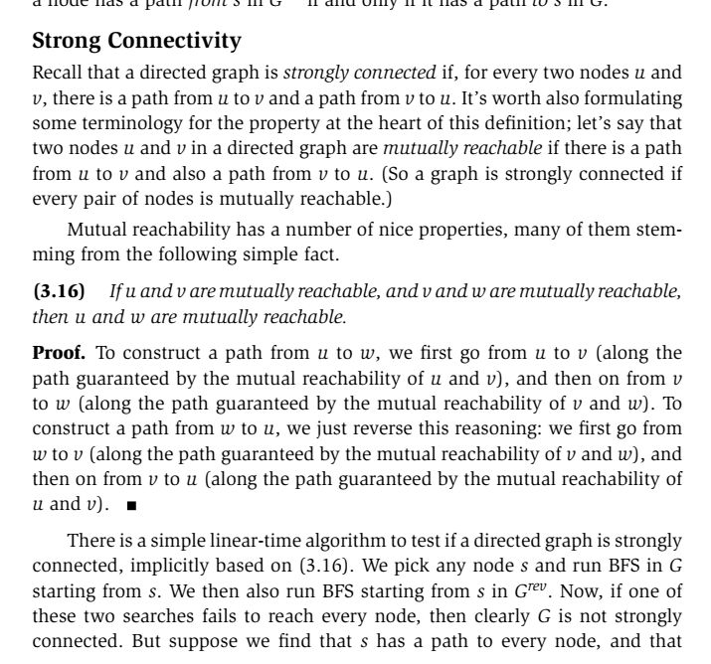

**Topological ordering**

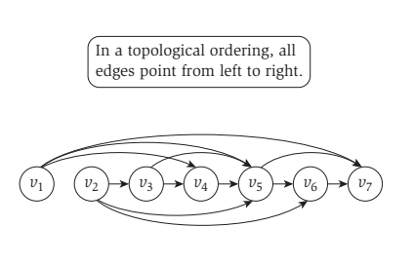

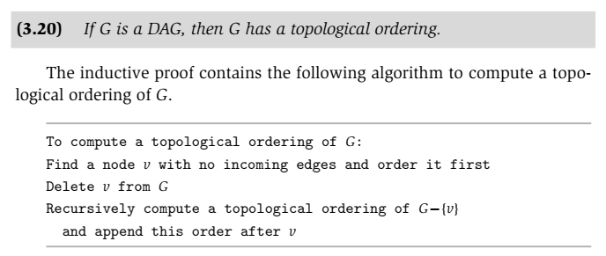

1. **General Methods for proofs**

Proof by contradiction

Proof by induction

Proof by giving a (counter) exmaple

区间调度问题：按照end升序排序，贪心取end最早，删除掉所有重复区间。循环

435. 无重叠区间

452.用最少数量的箭引爆气球