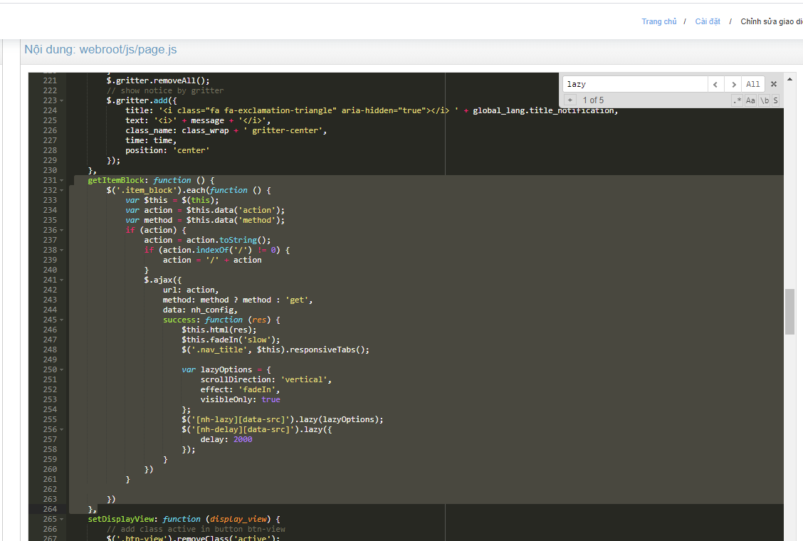

getItemBlock: function () {

$('.item_block').each(function () {

var $this = $(this);

var action = $this.data('action');

var method = $this.data('method');

if (action) {

action = action.toString();

if (action.indexOf('/') != 0) {

action = '/' + action

}

$.ajax({

url: action,

method: method ? method : 'get',

data: nh_config,

success: function (res) {

$this.html(res);

$this.fadeIn('slow');

$('.nav_title', $this).responsiveTabs();

var lazyOptions = {

scrollDirection: 'vertical',

effect: 'fadeIn',

visibleOnly: true

};

$('[nh-lazy][data-src]').lazy(lazyOptions);

$('[nh-delay][data-src]').lazy({

delay: 2000

});

}

})

}

})

},

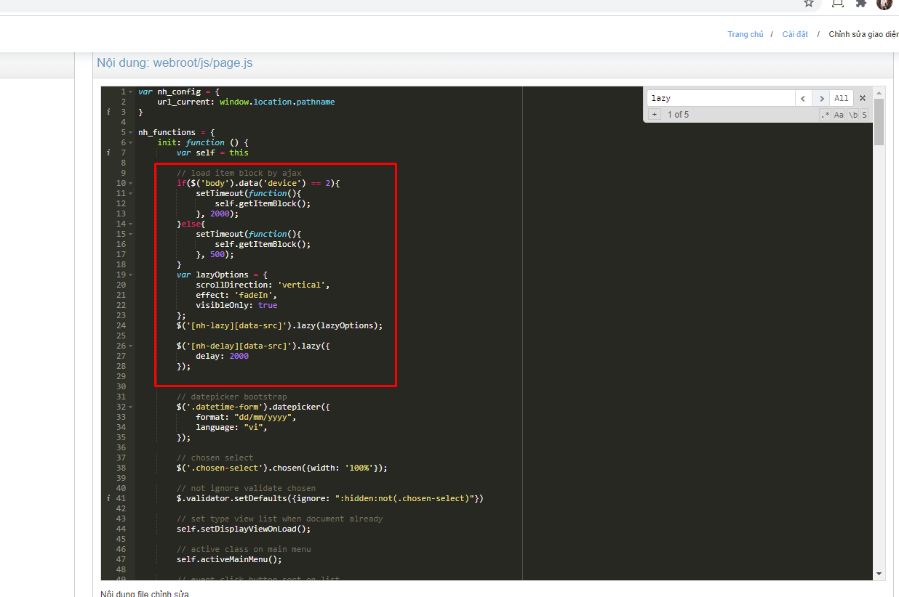

// load item block by ajax

if($('body').data('device') == 2){

setTimeout(function(){

self.getItemBlock();

}, 2000);

}else{

setTimeout(function(){

self.getItemBlock();

}, 500);

}

var lazyOptions = {

scrollDirection: 'vertical',

effect: 'fadeIn',

visibleOnly: true

};

$('[nh-lazy][data-src]').lazy(lazyOptions);

$('[nh-delay][data-src]').lazy({

delay: 2000

});