- a sequence diagram showing all calls between the different services for the following scenario where we start up the different microservices
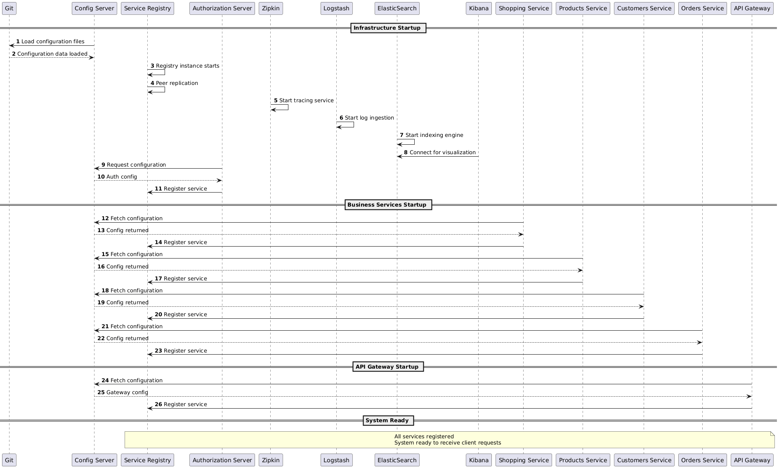
- a sequence diagram showing all calls between the different services for the following scenario: • The client application call the method placeOrder() on the Orders service. • The Orders service calls the Products service to update the available products on stock amount.
