Lab 13: Financial Risk System - Architecture Design

a. Architectural characteristics

Based on the requirements, the key architectural characteristics are:
- Scalability:
- Justification: Trade volume grows daily and must be supported for at least 5 years without redesign.
- Priority: High
- Requirement: The system must scale to process increasing trade volumes (initial ~5,000 trades, +10/day) within the nightly batch window.
- Availability:
- Justification: Business users across time zones depend on reports daily before trading begins.
- Priority: High
- Requirement: Risk reports must be accessible 24x7 with less than 30 minutes of downtime per day.
- Performance: All processing must complete between 5pm New York and 9am Singapore.
- Justification: Reports must be generated between 5pm New York and 9am Singapore.
- Priority: High
- Requirement: The system must complete import, enrichment, calculation, and report generation within the overnight processing window.
- Security: Authenticated and authorized access only. Role-based access (read-only users vs parameter editors).
- Justification: Financial risk data is highly sensitive and access is restricted by bank policy.
- Priority: High
- Requirement: All access must be authenticated and authorized, with role-based permissions for viewing reports and modifying parameters.
- Auditability & Traceability: Must track report generation, parameter changes, and input data.
- Justification: The bank must explain how risk values were calculated for compliance and investigation.
- Priority: High
- Requirement: The system must record report generation, parameter changes, and retain input data for traceability.
- Reliability & Fault Tolerance: System should recover from errors when possible and log all errors.
- Justification: Batch failures must not silently block business operations.
- Priority: Medium
- Requirement: Errors must be logged, partial recovery attempted, and critical failures reported via SNMP.
- Maintainability & Extensibility: Reference Data System will be replaced in ~3 months.
- Justification: The Reference Data System will be replaced within 3 months.
- Priority: Medium
- Requirement: The architecture must allow reference data sources to be replaced with minimal impact.
- Operability & Monitoring: SNMP alerts for fatal errors and missed report deadlines.
- Justification: Operations teams require visibility into failures and SLA breaches.
- Priority: Medium
- Requirement: SNMP traps must be sent for fatal errors or missed report deadlines.
- Data Retention: Input files must be retained for 1 year.

b. Detailed scenarios (quality attribute scenarios)

Scenario 1 – Availability
Source: Business user in Singapore
Stimulus: User attempts to access risk report at 8:30am Singapore time
Environment: Normal operations, after batch processing completes
Artifact: Risk Report Web Portal
Response: System authenticates the user and displays the latest completed risk report
Measure: Report is displayed within acceptable response time and before 9am

Scenario 1 – Availability
Source: Business user in Singapore
Stimulus: User attempts to access risk report at 8:30am Singapore time
Environment: Normal operations, after batch processing completes
Artifact: Risk Report Web Portal
Response: System authenticates the user and displays the latest completed risk report
Measure: Report is displayed within acceptable response time and before 9am

Scenario 2 – Performance
Source: Trade Data System
Stimulus: Large trade XML file arrives at 5pm New York
Environment: Nightly batch processing window
Artifact: Trade Import and Risk Calculation Engine
Response: System imports, enriches, calculates, and generates reports
Measure: All reports generated before 9am Singapore time

Scenario 3 – Security
Source: Unauthorized business user
Stimulus: User attempts to modify risk calculation parameters
Environment: Normal system operation
Artifact: Configuration Management UI
Response: System denies access and logs the attempt
Measure: No parameter change occurs and audit log entry is recorded

Scenario 4 – Auditability
Source: Compliance officer
Stimulus: Requests explanation of a counterparty’s risk value
Environment: Post-report generation
Artifact: Audit Log and Data Retention Store
Response: System provides input files, parameters, and timestamps used
Measure: Full traceability without manual reconstruction

Scenario 5 – Reliability
Source: Reference Data Importer
Stimulus: Corrupted counterparty XML file
Environment: Nightly batch processing
Artifact: Import Module
Response: System logs error, skips invalid records, continues processing valid data
Measure: Report still generated with warning logged

c. Architecture diagrams (PlantUML)

1. Overall System Architecture

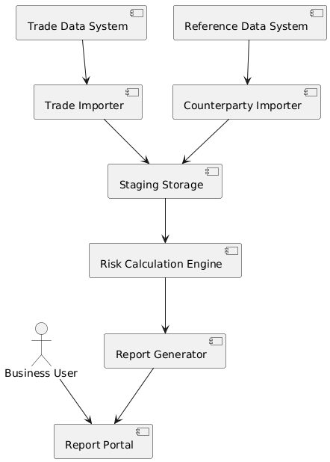

2. Security & Authorization Architecture
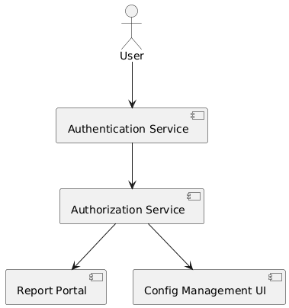

3. Audit & Monitoring Architecture

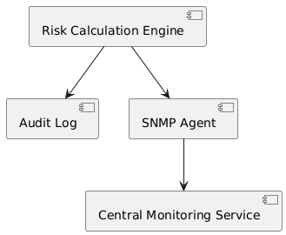
Presentation Layer
- Web Framework: Spring Boot with Thymeleaf or React.js
- Web Server: Apache Tomcat or Nginx
- Load Balancer: HAProxy or AWS ELB
Application Layer
- Application Server: Spring Boot (embedded Tomcat)
- Batch Processing: Spring Batch
- Scheduler: Spring Scheduler or Quartz
- Authentication: Spring Security with LDAP integration
Integration Layer
- XML Parsing: JAXB or Jackson XML
- SNMP Client: SNMP4J library
- File Monitoring: Apache Commons VFS or Spring Integration
Data Layer
- Primary Database: PostgreSQL or Oracle Database
- Caching: Redis for session management
- File Storage: NFS or Amazon S3 for archives
- ORM: JPA/Hibernate
Cross-Cutting
- Logging: SLF4J with Logback
- Monitoring: Spring Boot Actuator + Prometheus + Grafana

d. Risks of the proposed architecture (detailed)

Risk 1: Batch processing may not complete before 9am Singapore deadline
Description:
Batch processing may not complete within the available processing window (5pm New York to 9am Singapore).
Impact:
High – Business users cannot access risk data before the trading day starts.
Probability:
Medium
Factors:
- Data quality issues causing reprocessing or retries
- Unexpected increase in trade volume
- System performance degradation over time
- Network latency during file transfers
- Increasing complexity of risk calculations
Consequences:
- Traders operate without current risk visibility
- Potential regulatory compliance issues
- Loss of business confidence in the system
- Manual workarounds required by operations teams

Risk 2: Single batch job failure blocks report generation
Description:
Failure in one batch component (import, enrichment, or calculation) may halt the entire report generation process.
Impact:
High – No risk reports are produced for all users.
Probability:
Medium
Factors:
- Tight coupling between batch steps
- Lack of automatic retry or recovery mechanisms
- Corrupted input files
- Insufficient error isolation
Consequences:
- Complete loss of daily risk report
- Increased operational support workload
- Delayed business decisions
- Emergency manual calculations

Risk 3: Incorrect or incomplete input data affects risk accuracy
Description:
Invalid, missing, or inconsistent trade or counterparty data may lead to incorrect risk calculations.
Impact:
High – Incorrect risk exposure may lead to poor trading decisions.
Probability:
Medium
Factors:
- File-based data transfer without real-time validation
- Inconsistent reference data
- Partial or corrupted XML files
- Late arrival of input files
Consequences:
- Incorrect exposure calculations
- Regulatory audit findings
- Financial losses
- Reduced trust in reported figures

Risk 4: Security misconfiguration exposes sensitive data
Description:
Incorrect access control configuration may allow unauthorized users to view or modify sensitive risk data.
Impact:
High – Confidential financial data exposure.
Probability:
Low to Medium
Factors:
- Misconfigured roles and permissions
- Human error during user provisioning
- Lack of periodic access reviews
- Overly broad authorization rules
Consequences:
- Data confidentiality breach
- Regulatory penalties
- Reputational damage
- Mandatory security investigations

Risk 5: Tight coupling to current Reference Data System
Description:
Strong dependency on the existing Reference Data System may complicate migration to the new system.
Impact:
Medium – Increased effort and risk during system transition.
Probability:
High
Factors:
- Hard-coded file formats or schemas
- Limited abstraction of reference data access
- Insufficient interface boundaries
Consequences:
- Delayed integration with new reference system
- Increased development and testing effort
- Risk of production outages during migration

Risk 6: Insufficient monitoring and delayed failure detection
Description:
Failures may not be detected immediately, delaying corrective action.
Impact:
Medium – Problems escalate before being addressed.
Probability:
Medium
Factors:
- Limited real-time monitoring
- Dependence on manual checks
- Insufficient alert coverage
Consequences:
- Late awareness of missed deadlines
- Increased downtime
- SLA breaches
- Operational inefficiency

e. Risk mitigation strategies

Mitigation for Risk 1: Batch processing may not complete before 9am Singapore deadline
Strategy:
Improve batch performance, resiliency, and predictability.
Actions:
- Parallelize trade processing by counterparty or trade batches
- Optimize database indexing and calculation logic
- Introduce performance monitoring for each batch phase
- Pre-validate input files to fail fast on bad data
- Allow partial reprocessing instead of full reruns
Residual Risk:
Low to Medium – Dependent on unexpected spikes in data volume.

Mitigation for Risk 2: Single batch job failure blocks report generation
Strategy:
Increase fault tolerance and isolation between batch steps.
Actions:
- Split batch processing into independent, restartable stages
- Persist intermediate results after each stage
- Implement automatic retries with limits
- Allow last successful report to remain available if batch fails
- Add manual restart capability for failed steps
Residual Risk:
Low – Failures become localized and recoverable.

Mitigation for Risk 3: Incorrect or incomplete input data affects risk accuracy
Strategy:
Strengthen data validation and traceability.
Actions:
- Enforce XML schema validation on import
- Quarantine invalid records instead of aborting entire batch
- Log data quality warnings in audit logs
- Include data completeness indicators in reports
- Retain raw input files for investigation
Residual Risk:
Medium – External data sources remain a dependency.

Mitigation for Risk 4: Security misconfiguration exposes sensitive data
Strategy:
Apply strict access control and governance.
Actions:
- Enforce role-based access control (RBAC)
- Separate read-only users from parameter administrators
- Apply principle of least privilege
- Log all access attempts and configuration changes
- Perform periodic access reviews
Residual Risk:
Low – Human error still possible but detectable.

Mitigation for Risk 5: Tight coupling to current Reference Data System
Strategy:
Decouple reference data access through abstraction.
Actions:
- Introduce adapter or interface layer for reference data
- Isolate file parsing logic from business logic
- Support multiple reference data formats in parallel
- Test new reference system in shadow mode before cutover
Residual Risk:
Low – Migration risk reduced to adapter changes.

Mitigation for Risk 6: Insufficient monitoring and delayed failure detection
Strategy:
Improve observability and alerting.
Actions:
- Configure SNMP traps for batch failures and missed deadlines
- Add health checks for batch components
- Track batch execution times and trends
- Provide operational dashboards for overnight processing
- Alert operations teams before SLA breaches occur
Residual Risk:
Low – Issues detected early and acted upon.

