1. Draw the tables including data that you need to store this order in a relational database.

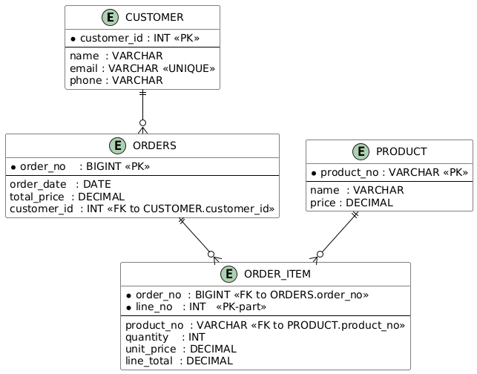

2. Draw the collections including data that you need to store this order in a mongo database.

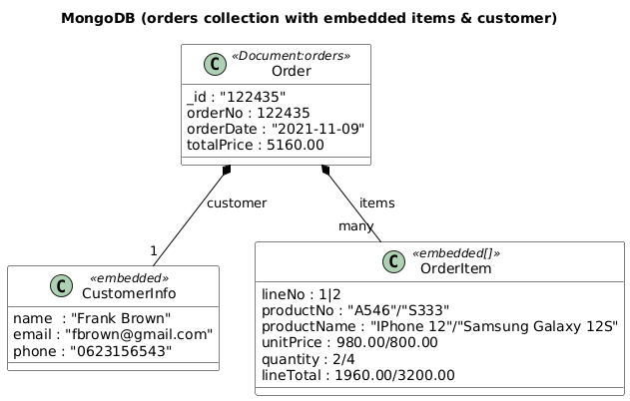

3. Draw the tables including data that you need to store this order in a cassandra database.

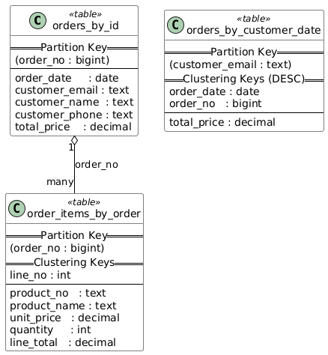

4. Draw the database structure including data that you need to store this order in a neo4j
database.
