# transition

1. 简介：transition CSS 属性是一个简写属性，用于 transition-property, transition-duration, transition-timing-function, transition-delay.。
   1. transition-property : * //指定过渡的性质，比如transition-property:backgrond 就是指backgound参与这个过渡
   2. transition-duration: *//指定这个过渡的持续时间
   3. transition-delay: * //延迟过渡时间
   4. transition-timing-function: *//指定过渡类型，有ease | linear | ease-in | ease-out | ease-in-out | cubic-bezier
      1. 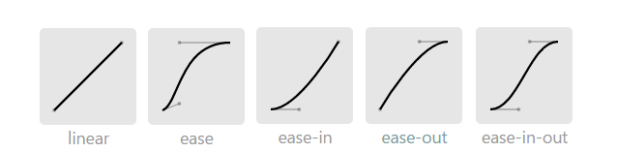
2. 只对block元素生效
3. padding，margin，border之类的属性，用transitionend事件会有多次捕捉的情况发生
4. padding:2em;，如果font-size被改变了，此时padding的“书面值”不变，仍旧是2em，但“实际值”将会发生变化并触发transition过渡。这被称作“隐式过渡”。多数浏览器会实现隐式过渡，但传闻IE很特别
5. 开关过渡和永久过渡
   1. 开关过渡就是过渡后恢复到原始状态。
   2. 永久过渡就是过渡后不恢复到原始状态。
6. auto过渡是瞬间完成过渡，没有动画
7. 用js实现auto过渡

window.onload = function(){

var box = document.getElementById("box2"),

originWidth = box.clientWidth,

width2AutoLater = null,

width2OriginLater = null;

var width2Auto = function(element, time) {

if (typeof window.getComputedStyle == "undefined") return;

var width = window.getComputedStyle(element).width;

element.style.width = "auto";

var targetWidth = window.getComputedStyle(element).width;

element.style.width = width;

setTimeout(function() {

element.style.transition = "width "+ time +"ms linear";

element.style.width = targetWidth;

}, 10);

};

var width2Origin = function(element, time) {

setTimeout(function() {

element.style.transition = "width 0s linear";

element.style.width = originWidth + "px";

}, 10);

};

function callLater(func, paramA, paramB){

return function(){

func.call(this, paramA, paramB);

};

}

width2AutoLater = callLater(width2Auto, box, 1000);

width2OriginLater = callLater(width2Origin, box, 1000);

box.addEventListener("mouseenter", width2AutoLater);

box.addEventListener("mouseleave", width2OriginLater);

}

<div id="box2" class="div1"></div>