# canvas

1. 使用：<canvas id = "canvas" width = "宽度" height = "高度">您的浏览器不支持canvas元素（此消息在浏览器不支持canvas元素时显示）</canvas>
2. 通过js去绘制图形。
   1. 画一条斜线

var c= document.querySelector('#myCanvas');

var ctx = c.getContext("2d");

ctx.moveTo(0,0);

ctx.lineTo(400,200);

ctx.stroke();

* 1. 画一个圆

var c = document.getElementById('myCanvas');

var ctx = c.getContext("2d");

ctx.beginPath();

ctx.arc(95,50,40,0,2*Math.PI);

ctx.stroke();

* 1. 实线字

var c = document.querySelector("#myCanvas");

var ctx = c.getContext("2d");

ctx.font = ("30px Arial");

ctx.fillText("Hello World", 10, 50);

* 1. 双线字

var c = document.getElementById('myCanvas');

var ctx = c.getContext("2d");

ctx.font = "30px Arial";

ctx.strokeText("xuanmiao",10, 50);

* 1. 渐变矩形

var c = document.getElementById("myCanvas");

var ctx = c.getContext("2d");

//create gradient

var grd = ctx.createLinearGradient(0,0,150,0);

grd.addColorStop(0,"red");

grd.addColorStop(1,"white");

//Fill with gradient

ctx.fillStyle = grd;

ctx.fillRect(10,10,150,80);

* 1. 创建从中心到四周渐变

var c = document.getElementById("myCanvas");

var ctx = c.getContext("2d");

var grd = ctx.createRadialGradient(75,50,5,90,60,100);

grd.addColorStop(0,"red");

grd.addColorStop(1,"white");

//Fill with gradient

ctx.fillStyle = grd;

ctx.fillRect(10,10,150,80);

* 1. canvas划图像

var c = document.getElementById("myCanvas");

var ctx = c.getContext("2d");

var img = document.getElementById("scream");

ctx.drawImage(img,10,10);

1. 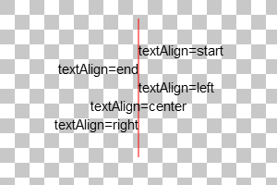
2. 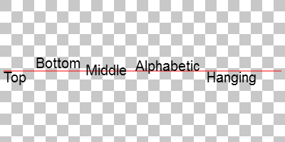
3. ctx.measureText(txt).width //测量文本txt的宽度。
4. ctx.drawImage(img, 10, 10); //绘制图像
5. ctx.globalAlpha=0.2; //设置透明度
6. 所有globalCompositeOperation的值：
   1. 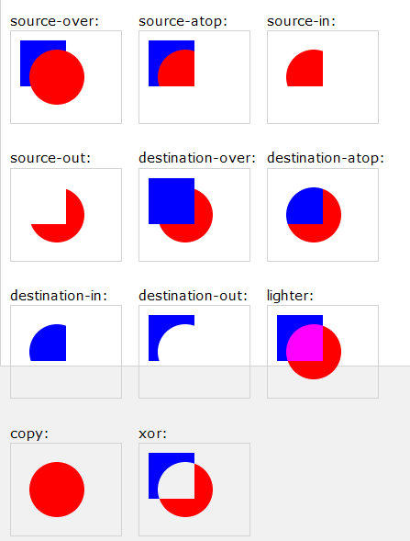
7. 用法：ctx.globalCompositeOperation="source-over";