### Screen Navigation Options

#### Static configuration

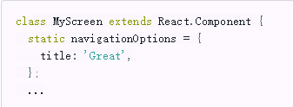

#### Dynamic Configuration