FER202_TRIAL_PE
Subject: FER202
Duration: 85 minutes

INSTRUCTIONS
Please read the instructions carefully before doing the questions.
- You are Not allowed to use any device to share data with others.
- You must use IDE as Visual Studio Code, for your development tools.
- Your work will be considered invalid (0 points) if your code inserts stuff that is unrelated to the test.
- Your work will be considered invalid (0 points) if your code does not use the .env file to store the API URL.
- You are required to use either Bootstrap or React-Bootstrap for UI styling. Applications that do not use one of these libraries will be considered invalid (0 points).

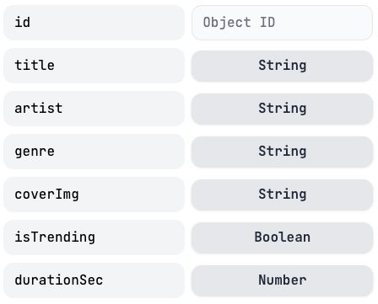
Project Setup
Create a new React application using either:
- npx create-react-app or
- npm create vite@latest
Name your project using your roll number (e.g., se123456).
Task 1. Create Data Resource
- Create a new resource on mockapi.io and name it with your roll number (e.g., se123456). Then, define an appropriate schema for this resource.
- Replace the resource data by copying the content from the music_library.json file into it.
Task 2. Music Library
- Create a Navbar for navigating routes in your application, including:
  - Music Library
  - Music Management.
(npm install react-router)
- At the Music Library route (URL must be /rollnumber/music-library, e.g., /se123456/music-library):
  - Display all music songs from the data source.
  - Sort songs in ascending order by title (A–Z).
  - Use a grid layout with card views for each music song. Each song must include the following: coverImg, title, artist, genre, isTrending and durationSec. Display durationSec (represents the duration of the song in seconds) information in minute format mm:ss (e.g., durationSec: 78 => 1:18).
  - If isTrending is true, display the label “Trending”.
Task 3. Music Management
- At the Music Management route (URL must be /rollnumber/music-management, e.g., /se123456/music-management):
  - Display all songs in a data-table format.
  - Sort data by id in descending order.
  - Each row must include: id, title, artist, genre and a coverImg (displayed as a thumbnail 60x60 pixels).
  - Each row must also include links or icons for the following actions: Edit and Delete.
- At the Music Management route, implement the delete function: Clicking the Delete button must display a confirmation prompt before deleting any song. After a successful deletion, show a notification (alert, toast, etc.). Finally, reload the songs list.
- Create an Add Song route (URL must be /rollnumber/add-song, e.g., /se123456/add-song) with the requirements:
- The form must validate all inputs.
- All fields are required.
- title must have at least 2 characters or more.
- artist must contain more than 1 word (e.g., "Alex Chen").
- coverImg must be a valid URL.
- durationSec must be a number formatted with a maximum of 3 digits..
- isTrending is a switch control, set to false by default.
- genre is a select box with these 5 options: Pop, Rock, Jazz, Instrumental, Acoustic. By default, no option should be selected. Users must actively choose a value when creating or editing an song.
- At the Music Management route, implement the update function: Clicking the Edit button must navigate to the update form (URL must be /rollnumber/update-song/:id, e.g., /se123456/update-song/:id). The form must follow the same validation rules as the Add Song form in Task 3.3.

-The end of test-

