FER202_SU26_PE
Subject: FER202
Duration: 85 minutes

INSTRUCTIONS
Please read the instructions carefully before doing the questions.
- You are Not allowed to use any device to share data with others.
- You must use IDE as Visual Studio Code, for your development tools.
- Your work will be considered invalid (0 points) if your code inserts stuff that is unrelated to the test.
- Your work will be considered invalid (0 points) if your code does not use the .env file to store the API URL.
- You are required to use either Bootstrap or React-Bootstrap for UI styling. Applications that do not use one of these libraries will be considered invalid (0 points).

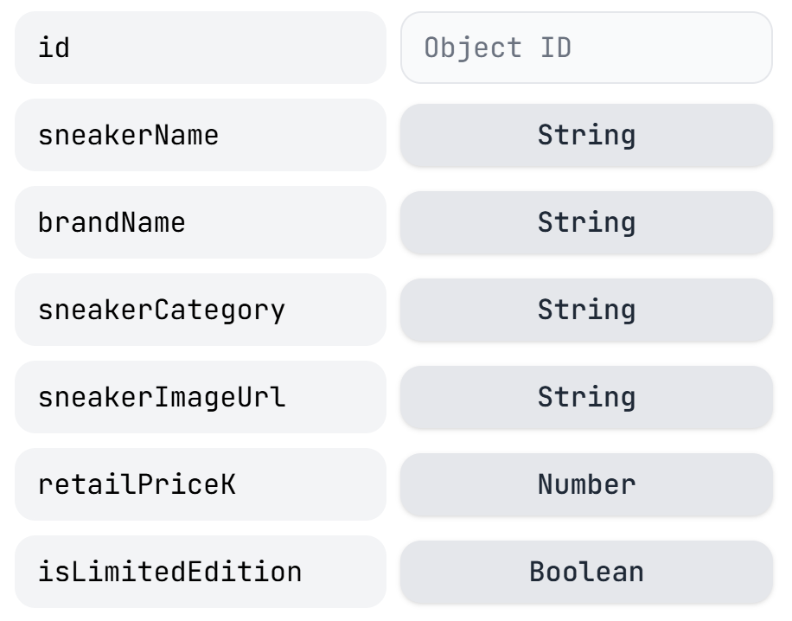
Project Setup
Create a new React project with one of these commands:
- npx create-react-app or
- npm create vite@latest
Use your roll number as the project name (for example, se123456).
Task 1. Create the Data Resource (0.5 point)
- On mockapi.io, create a resource with your roll number as its name (for example, se123456). Create a schema that matches the sneaker data.
- Copy all data from sneaker_collection.json to the resource.
Task 2. Create the Sneaker Collection Page (4 points)
- Create a Navbar with links to these routes:
  - Sneaker Collection
  - Sneaker Management
(Install react-router if needed)
- Create the Sneaker Collection page at /rollnumber/sneaker-collection (for example, /se123456/sneaker-collection). The page must meet these requirements:
  - Get and display all sneakers from the API.
  - Sort the list of sneakers in descending alphabetical order based on the sneakerName property.
  - Display the sneakers in a grid of cards. Each card must show sneakerImageUrl, sneakerName, brandName, sneakerCategory, isLimitedEdition, and retailPriceK.
  - retailPriceK stores the price in thousands of VND. Display it in VND format (for example, retailPriceK: 189 => 189,000 VND).
  - If isLimitedEdition is true, show the label “Limited Edition”.

Task 3. Implement Sneaker Management (5.5 points)
- Create the Sneaker Management page at /rollnumber/sneaker-management (for example, /se123456/sneaker-management). The page must meet these requirements:
  - Display all sneaker records in a data table.
  - Sort the list of records in descending order based on their id.
  - Each row must show id, sneakerName, brandName, sneakerCategory, and sneakerImageUrl. Display sneakerImageUrl as a 70 x 70 pixel thumbnail.
  - Add an Edit link or icon and a Delete link or icon to each row.
- When the user clicks Delete, show a confirmation message before deleting the sneaker. After the delete request is successful, show a notification and reload the list.
- On the Sneaker Management page, provide an Add Sneaker button/link that navigates to /rollnumber/add-sneaker (for example, /se123456/add-sneaker). The form must meet these requirements:
- Validate all form inputs.
- All fields are required.
- sneakerName must have at least 2 characters.
- brandName must have at least 2 words.
- sneakerImageUrl must be a valid URL.
- retailPriceK must be a positive integer with no more than 3 digits.
- isLimitedEdition must use a switch control. Its default value must be false.
- sneakerCategory must use a select box with these 5 options: Running, Basketball, Lifestyle, Skateboarding, and Training. The default value must be empty, so the user has to select an option.
- Add the update feature to the Sneaker Management page:
- When the user clicks Edit, go to /rollnumber/edit-sneaker/:id (for example, /se123456/edit-sneaker/:id).
- Load the selected sneaker's current data into the edit form.
- Use the same validation rules as the Add Sneaker form.
- After the update request is successful, show the updated data in the Sneaker Management table.

-The end of test-

