project
Xuan Phung
2026-04-29
library(readxl)
## Warning: package 'readxl' was built under R version 4.5.3
library(ggplot2)
workout_dataset<- read_excel("C:/Users/amorn/Downloads/workout_dataset.xlsx")
ggplot(workout_dataset, aes(x=`Time(minutes)`, y=CaloriesBurned)) +
geom_point(size=3) + geom_smooth(method = "lm", se = TRUE)+
labs(
title="Calories Burned Per Workout",
x="Workout Time (Minutes)",
y="Calories Burned"
)+theme_minimal()
## `geom_smooth()` using formula = 'y ~ x'
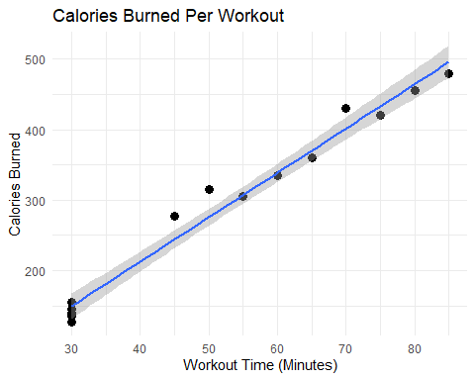
$μ:$mean calories burend $H_{0}:μ=200$ vs $H_{a}:μ≠200$
t.test(
x = workout_dataset$CaloriesBurned,
mu = 200,
alternative = "greater"
)
##
## One Sample t-test
##
## data: workout_dataset$CaloriesBurned
## t = 2.6271, df = 13, p-value = 0.01045
## alternative hypothesis: true mean is greater than 200
## 95 percent confidence interval:
## 229.7737 Inf
## sample estimates:
## mean of x
## 291.3571

