Work - Flow

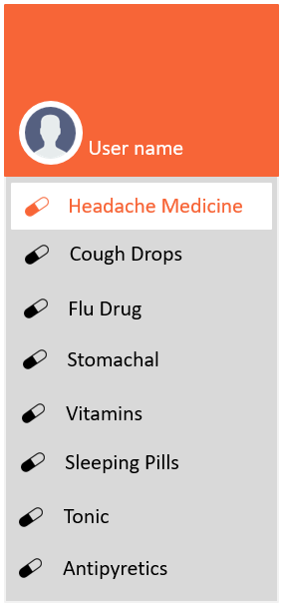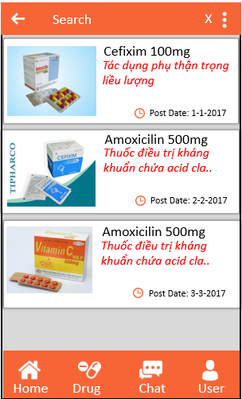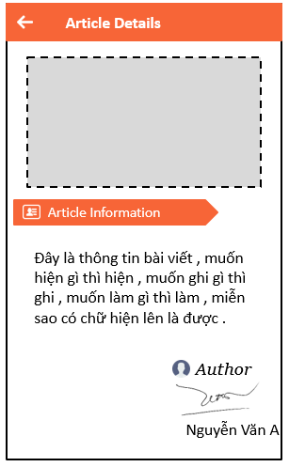

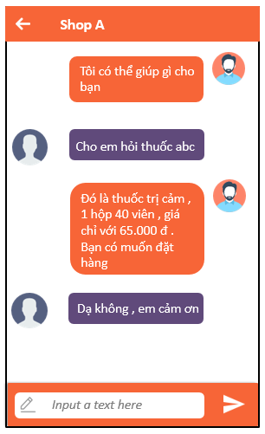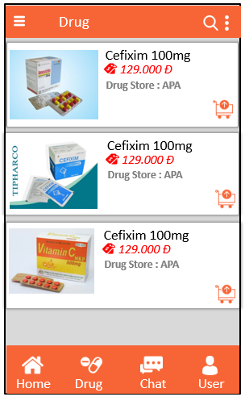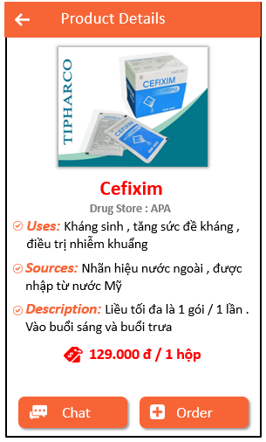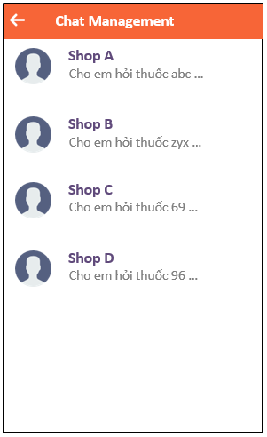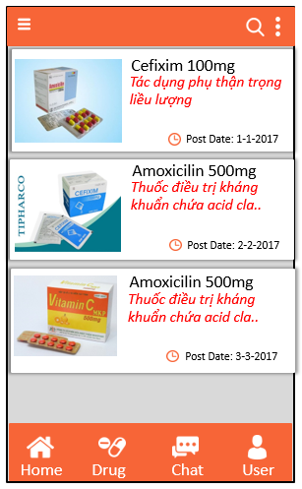

#MH6

#MH5

Chưa có tài khoản

#MH3

#MH6

#MH2

#MH7

#MH9

#MH3

#2

#MH4

#1

#MH1

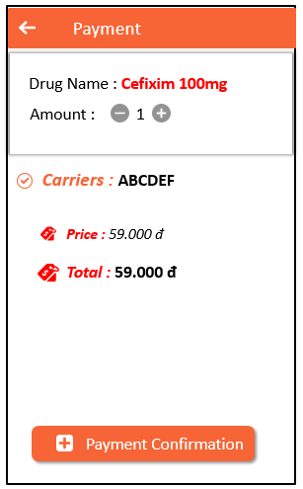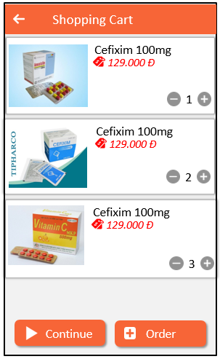

#MH2

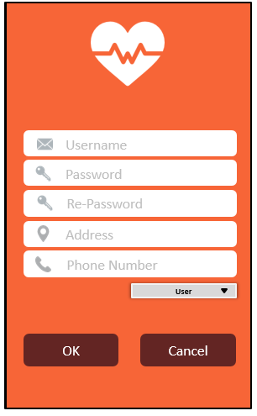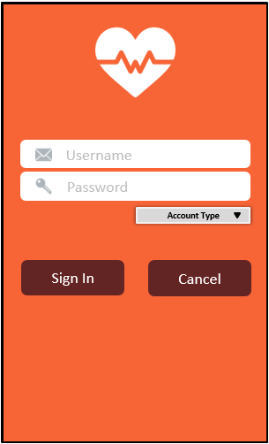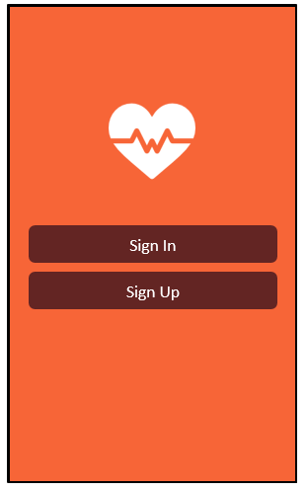

#MH1

Đăng kí thành công

#MH1

#MH11

#MH10

#MH9

Chưa có tài khoản

#MH8

#MH7

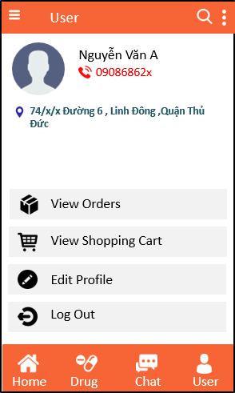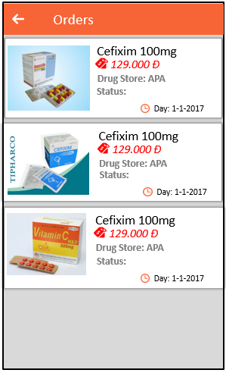

Loại user

#MH1

#MH2

#MH3

#MH12

#MH13

Loại hãng vận chuyển

#MH7

Loại seller

#MH17

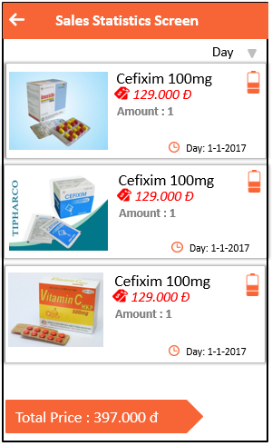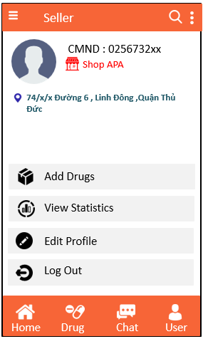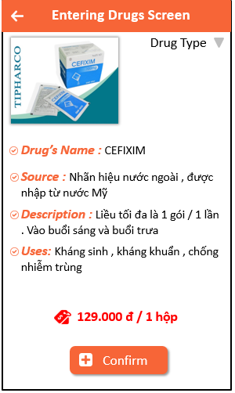

#MH15

#MH14

#MH3

#MH2

#MH16

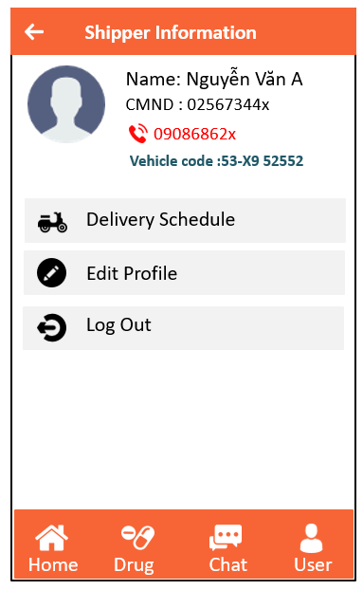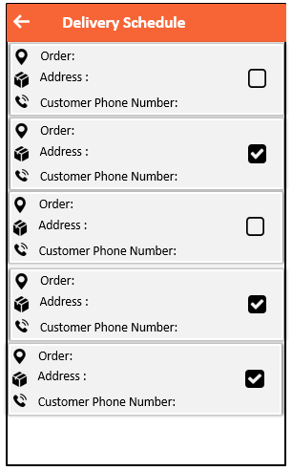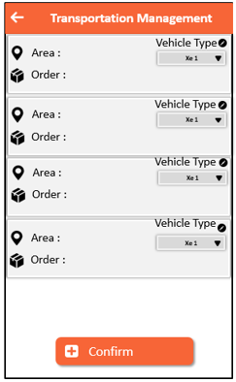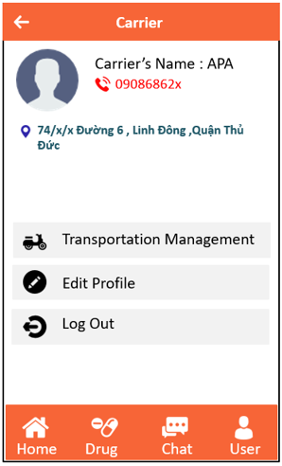

#MH19

#MH18

#MH3

#MH2

#MH17

#MH3

#MH2

#MH1

#MH3

#MH2

Loại ship

#MH20

|  |  |  |
| --- | --- | --- |
| Key | Name Screen | Description |
| #MH1 | Home | The screen starts is this screen, the screen contains a list of posts |
| #MH2 | Drug List | The screen contains a list of different drugs |
| #MH3 | Chat Management | The screen manages the chat list |
| #MH4 | Article Detail | The screen contains details of the article |
| #MH5 | Drug Detail | Show the information of drug |
| #MH6 | Chat Screen | Show the conversation chat directly to the seller |
| #MH7 | Shopping Cart | Contains drugs that have been added to the cart |
| #MH8 | Payment Confirmation | Confirmation will order the order from the cart |
| #MH9 | Login or Register | Can choose to sign in or sign up |
| #MH10 | Login | Sign in to your account |
| #MH11 | Register | Account registration |
| #MH12 | User Account | Details and management of the user account |
| #MH13 | View Order | View cart details |
| #MH14 | Seller Account | Details and management of the seller account |
| #MH15 | Entering Drugs | Input the information of the drug for sale |
| #MH16 | Sales Statistics | View inventory statistics |
| #MH17 | Carrier Account | Details and management of the carrier account |
| #MH18 | Transportation Management | management of transport vehicles |
| #MH19 | Shipper Account | Details and management of the shipper account |
| #MH20 | Delivery Schedules | Displays all transportation schedules of the vehicle |
| #1 | List of drug filters | Classify the drugs by topic |
| #2 | Sort list of articles | Sort articles by order by date |