TRƯỜNG CAO ĐẲNG CÔNG NGHỆ THỦ ĐỨC

KHOA CÔNG NGHỆ THÔNG TIN

--------------------------------

**BÁO CÁO KẾT THÚC MÔN HỌC**

**Chuyên đề phát triển ứng dụng trên di động 1**

**TÊN ĐỀ TÀI**

SELL DRUG ONLINE(SDO)

Giảng viên hướng dẫn: Tiêu Kim Cương

Lớp: Chuyên đề di động 1 Khoá:15

Sinh viên thực hiện:

1. Bùi Xuân Quang
2. Võ Phương Quân
3. Đặng Văn Phú
4. Phạm Vũ Trường An
5. Nguyễn Đức Lai
6. Đặng Văn Vũ

*Tp. Hồ Chí Minh*, ngày 20 tháng 3 năm 2018

**NHẬT KÝ HOẠT ĐỘNG NHÓM**

|  |  |  |  |  |
| --- | --- | --- | --- | --- |
| **Stt** | **Họ và tên** | **Công việc đã thực hiện** | **Nhóm đánh giá**  **(Tính theo %)** | **Chữ ký** |
| 01 | Bùi Xuân Quang | Phân công các bạn trong nhóm làm việc trên redmine và github, thực hiện công việc(SRS,Database Design, UI Design, Achitecture Design, làm mẫu báo cáo) | 18 |  |
| 02 | Võ Phương Quân | Thực hiện công việc(Testcase, SRS, tìm thông tin thuốc, duyệt tiếng anh) | 17 |  |
| 03 | Đặng Văn Phú | Thực hiện công việc(Testcase, SRS,Achitecture Design, UI Design) | 17 |  |
| 04 | Phạm Vũ Trường An | Thực hiện công việc(Testcase,SRS) | 16 |  |
| 05 | Nguyễn Đức Lai | Thực hiện công việc(Testcase,SRS) | 16 |  |
| 06 | Đặng Văn Vũ | Thực hiện công việc(Testcase,SRS) | 16 |  |

Software Requirement Specification

SDO-SRS-001

Version 1.0

**Revision History**

| Date | Version | Description | Author | Revised by |
| --- | --- | --- | --- | --- |
| 05/03/2018 | 1.0 | First version | Bùi Xuân Quang | Bùi Xuân Quang |
| 05/03/2018 | 1.0 | Add to screen and function analysis | Members | Bùi Xuân Quang |
| 20/03/2018 | 1.0 | SRS completely | Bùi Xuân Quang | Bùi Xuân Quang |
|  |  |  |  |  |
|  |  |  |  |  |

Table of Contents

**1.** **Introduction** 7

**1.1** **Overview** 7

**1.2** **Scope** 7

**2.** **Functional Requirements** 8

**2.1** **Feature/Component #1: SDO Home Screen** 8

2.1.1 User Interfaces 8

2.1.2 Functional Requirements 8

**2.2** **Feature/Component #2: SDO Home Screen** 9

2.2.1 User Interfaces 10

2.2.2 Functional Requirements 10

**2.3** **Feature/Component #3: SDO Drugs List Screen** 11

2.3.1 User Interfaces 12

2.3.2 Functional Requirements 12

**2.4** **Feature/Component #4: SDO Drug Details Screen** 14

2.4.1 User Interfaces 15

2.4.2 Functional Requirements 15

**2.5** **Feature/Component #5: SDO Sign in, sign up Screen** 16

2.5.1 User Interfaces 17

2.5.2 Functional Requirements 17

**2.6** **Feature/Component #6: SDO Login Screen** 18

2.6.1 User Interfaces 18

2.6.2 Functional Requirements 18

**2.7** **Feature/Component #7: SDO Registration Screen** 19

2.7.1 User Interfaces 20

2.7.2 Functional Requirements 20

**2.8** **Feature/Component #8: SDO Account Management Screen** 21

2.8.1 User Interfaces 22

2.8.2 Functional Requirements 22

**2.9** **Feature/Component #9: SDO View Orders Screen** 24

2.9.1 User Interfaces 24

2.9.2 Functional Requirements 24

**2.10** **Feature/Component #10: SDO View Shopping Cart Screen** 25

2.10.1 User Interfaces 26

2.10.2 Functional Requirements 26

**2.11** **Feature/Component #10: SDO Payment Confirmation Screen** 28

2.11.1 User Interfaces 28

2.11.2 Functional Requirements 28

**2.12** **Feature/Component #12: SDO Seller Management Screen** 29

2.12.1 User Interfaces 30

2.12.2 Functional Requirements 30

**2.13** **Feature/Component #13: SDO Entering Drugs Screen** 32

2.13.1 User Interfaces 32

2.13.2 Functional Requirements 32

**2.14** **Feature/Component #14: SDO Sales Statistics Screen.** 34

2.14.1 User Interfaces 34

2.14.2 Functional Requirements 34

**2.15** **Feature/Component #15: SDO Transport Company Screen** 36

2.15.1 User Interfaces 36

2.15.2 Functional Requirements 36

**2.16** **2.11 Feature/Component #16: SDO Transportation Management Screen** 37

2.16.1 User Interfaces 38

2.16.2 Functional Requirements 38

**2.17** **Feature/Component #17: SDO Shipper Screen** 39

2.17.1 User Interfaces 39

2.17.2 Functional Requirements 40

**2.18** **Feature/Component #18: SDO Delivery Schedules Screen** 40

2.18.1 User Interfaces 41

2.18.2 Functional Requirements 41

**2.19** **Feature/Component #19: SDO Chat Management Screen** 42

2.19.1 User Interfaces 42

2.19.2 Functional Requirements 43

**2.20** **Feature/Component #20: SDO Screen Chat Screen** 43

2.20.1 User Interfaces 44

2.20.2 Functional Requirements 44

# **Introduction**

## **Overview**

This application allow users can see information post of drug, buy drug online.

## **Scope**

Demo version

Demo version is for display purpose only, not link to Database, not link to affiliated sites

Android OS: Android: OS 5.0

* Android test devices: Samsung Galaxy J3, Samsung Galaxy A3

Android screen resolutions: 720x1280.

Support screen orientation in Portrait mode only.

# **Functional Requirements**

## **Feature/Component #1: SDO Home Screen**

### User Interfaces

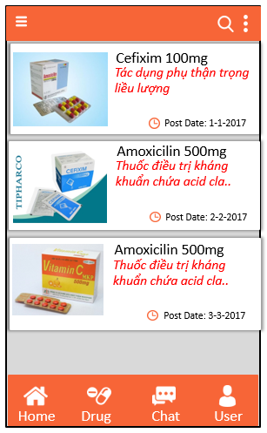

*Image1: Home*

### Functional Requirements

|  |  |  |  |
| --- | --- | --- | --- |
| **Item** | **Description** | **Action** | **Response** |
| **SDO Home Screen** | Home Screen has 4 buttons and 1 list view:   * Button “Home” * Button “Medicine” * Button “Chat” * Button Personal * List view   Screen has a Search Bar | N/A | N/A |
| **List view** | List view has 1 Image view and 2 text view and 1 image button: - Textview Title  - Text view Date | N/A | N/A |
| Show articles about drugs | N/A | N/A |
| When tap on a screen article will move you to the article page | Tap on the post | Move to post page |
| When swipe to the top of the page | Swipe on top | Reload the new data |
| When scroll down to the bottom of the listview | Swipe on bottom | Show 10 more old posts |
| **Button “Home”** | Use to switch to the home page | Tap on the button | After tapped the home button will automatically switch to the home page displayed the list of posts |
| **Button “Medicine”** | Use to switch to medicine page | Tap on the button | After tapped the button will automatically switch to the home page displayed the list of drug |
| **Button “Personal”** | Use to switch to the personal account page | Tap on the button | After tapped the home button will automatically switch to the home page displayed the posts information of drug |
| **Button “Chat”** | Use to switch to chat page | Tap on the button | After tapped the chat button, the screen will switch to the chat page for the user to contact the seller |
| **Search Bar** | Use to search for articles | N/A | N/A |
| When Tap and Search will display the articles to search | Tap on the button | Get the list of articles to find |

## **Feature/Component #2: SDO Home Screen**

### User Interfaces

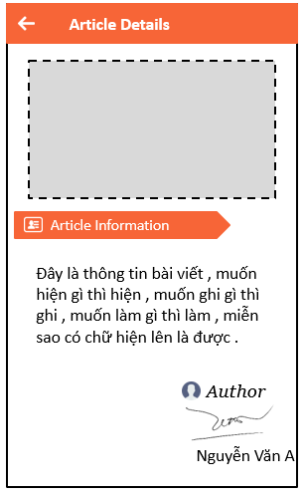

*Image2: Article details*

### Functional Requirements

|  |  |  |  |
| --- | --- | --- | --- |
| **Item** | **Description** | **Action** | **Response** |
| **Article Details Screen** | Article Details Screen has 1 ScrollView, 1 imageView , 1 button Back, 3 TextView | N/A | N/A |
| **ScrollView** | Use to pull up, pull down the article | Tap pull | Back up, move down |
| **Button Back** | Use to return to the home screen | Tap on the Button | Return to the home screen |
| **ImageView** | Display image of article | N/A | N/A |
| **Text view “Description”** | Display content of post | N/A | N/A |

## **Feature/Component #3: SDO Drugs List Screen**

### User Interfaces

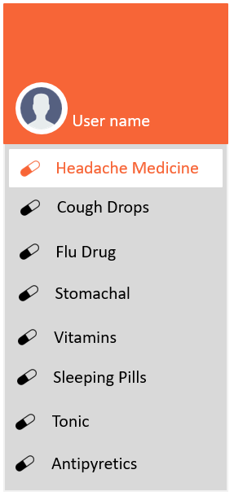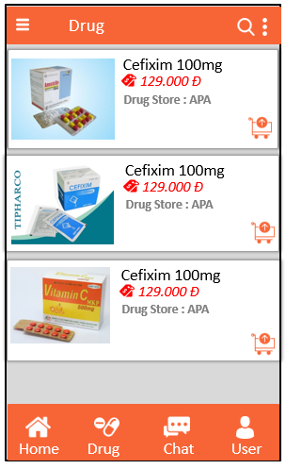

*Image3: Drug list*

### Functional Requirements

|  |  |  |  |
| --- | --- | --- | --- |
| **Item** | **Description** | **Action** | **Response** |
| SDO Drugs List | Drugs list has 1 list (1 Image view , 2 textview, 1 image button) view display:   * Image view * Textview “Title drug” * Textview “Cost” * Text view “Shop name” * Image button “Cart” * Spinner “Arrange” * List view “Menu”   Screen has a Search Bar | N/A | N/A |
| List view | Show articles about drugs | N/A | N/A |
| When tap on a screen article will move you to the drug details page | Tap on the post | Move to drug details page |
| When swipe to the top of the page | Swipe on top | Reload the new data |
| When scroll down to the bottom of the listview | Swipe on bottom | Show 10 more old posts |

|  |  |  |  |
| --- | --- | --- | --- |
| Image View | Display pictures of the drug | N/A | N/A |
| Text view title drug | Display name of drug | N/A | N/A |
| Textview cost | Display drug prices | N/A | N/A |
| Textview “Shop name” | Display name of drug store | N/A | N/A |
| **Search Bar** | Use to search for articles | N/A | N/A |
| When Tap and Search will display the articles to search | Tap on the button | Get the list of articles to find |
| List view “Menu” | Use list view to show the list of diseases that need medication | Swipe to left | Display the list of drugs needed for the disease |
| Filter medicines to cure: cough, cold, headache | Tap on the post | After tapped on a topic the disease will display the drugs needed for that disease |
| Menu“Arrange” | Use the Menu to arrange the drugs | Tap on menu | After tap on the menu will arrange the drugs at the drug price from high to low |
| Use the menu to arrange the drugs | Tap on menu | After tap on the menu will arrange the drugs at the drug price from low to high |

### 

## **Feature/Component #4: SDO Drug Details Screen**

### User Interfaces

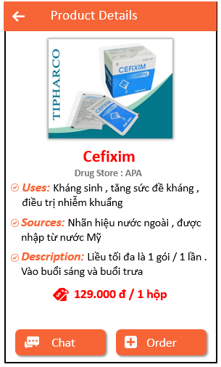

*Image4: Drug detail*

### Functional Requirements

|  |  |  |  |
| --- | --- | --- | --- |
| **Item** | **Description** | **Action** | **Response** |
| **SDO Drug Details Screen** | Drug details Screen has 1 list view(1 Image View and 9 textview,1 button )   * Textview title * Textview “Uses” * Textview “Sources” * Textview “Description” * Textview “Price” * Textview “Drug Store” * Button “Order” | N/A | N/A |
| **List view** | Contains data in the list view | N/A | N/A |
| **Image View** | Display pictures of the drug | N/A | N/A |
| **Button “Order”** | Use button to switch to the order page | Tap on the button | After tapped the button will switch to the shopping cart page allowing users to place orders online |
| Text view title | Display name of drug | N/A | N/A |
| Text view “Price” | Display drug prices | N/A | N/A |
| **Textview “Description ”** | Display how to use drugs, drug details | N/A | N/A |
| **Textview “Sources”** | Display the origin of the drug | N/A | N/A |
| **Textview “Uses”** | Display benefit of the drug | N/A | N/A |
| **Text view “Drug Store”** | Displays the name of the drug store | N/A | N/A |
| **Button “Chat”** | Use to switch to chat page | Tap on the button | After tapped the chat button, the screen will switch to the chat page for the user to contact the seller |

## 

## **Feature/Component #5: SDO Sign in, sign up Screen**

### User Interfaces

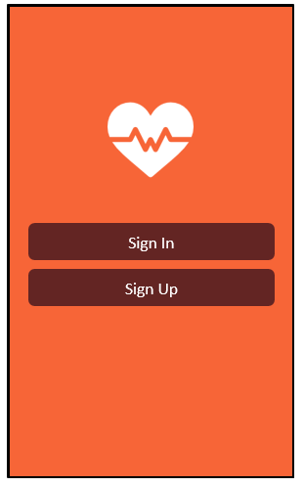

*Image5: Sign in, sign up*

### Functional Requirements

|  |  |  |  |
| --- | --- | --- | --- |
| **Item** | **Description** | **Action** | **Response** |
| Log in, log out Screen | Login, logout screen has 2 buttons:  - Button “Sign In”   * Button “Sign Up” | N/A | N/A |
| **Button “Sign In”** | Use to login | Tap on the  Button “Sign In” | Switch to login screen |
| **“Sign Up”** button | Use to register | Tap on the button “Sign Up” | Switch to register screen |

## **Feature/Component #6: SDO Login Screen**

### User Interfaces

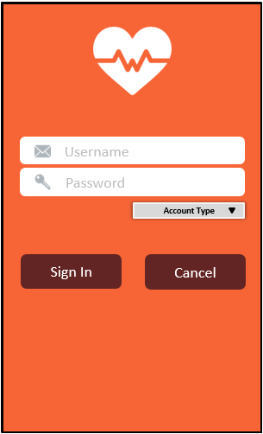

*Image6: Login*

### Functional Requirements

|  |  |  |  |
| --- | --- | --- | --- |
| **Item** | **Description** | **Action** | **Response** |
| **Login screen** | Login Screen has 2 textview, 2 edittext, 1 spinner, 3 button   * “Username” + edittext * “Password” + edittext * “Account Type” + Spinner * “Sign In” * “Exit” * “Sign Up” | N/A | N/A |
| **“Sign In”**  **button** | Use to login | Tap on the  Button “Sign In” | Display successful message |
| **“Cancel” button** | Use to cancel | Tap on the  button”Cancel” | Back to the User Interface screen |
| **“Username” textview + edittext** | Use to enter account | Tap on the edittext | Allow enter username |
| **“Password”textview+editext** | Use to enter the password | Tap on the edittext | Allow enter password |
| **“Account Type”textview+edittext** | Use to select the type of account login | Tap on the Spinner”Account Type” | Show 3 account types to choose from “user” + “shipper”+” seller” |

## **Feature/Component #7: SDO Registration Screen**

### User Interfaces

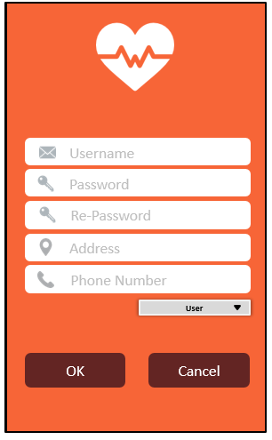

*Image7: Registration*

### Functional Requirements

|  |  |  |  |
| --- | --- | --- | --- |
| **Item** | **Description** | **Action** | **Response** |
| **Registration screen** | Registration screen has 10 textview, 9 edittext, 1 spinner, 2 button   * “Username” textvỉew + edittext * “Password” textview + edittext * “Re-Password” textview + edittext * “Phone Number” textview + edittext * “Address” textview + edittext * “CMND” textview +edittext * “Drug’s Store”textview – edittext * “Vehicle code” textview + edittext * “Carrier” textview + edittext * “Account Type” textview + edittext * “OK” button * “Cancel” button | N/A | N/A |
| “Username” textview + edittext | Use to enter account name | Tap on the  edittext | Allow enter account name |
| “Drug’s Store”textview+edittext | Use to enter the name of the Pharmacy | Tap on the  edittext | Allow enter the name of the pharmacy |
| “Vehicle code” | Use to enter code car | Tap on the  edittext | Allow enter code car |
| “CMND” textview +edittext | Use to enter the CMND | Tap on the  edittext | Allow enter the CMND |
| “Password”textview + edittext | Use to enter the password | Tap on the  edittext | Allow enter password |
| “Carriers”textview+edittext | Use to enter the carrier | Tap on the  edittext | Allow enter the carrier |
| “Re-Password” textview + edittext | Use to enter the password again | Tap on the edittext | Allow enter the password again |
| “Address” textview + edittext | Use to enter the address | Tap on the edittext. | Allow enter address |
| “Email”textview + edittext | Use to enter email | Tap on the edittext. | Allow enter the email |
| “Account Type” spinner | Use to select the type of account | Tap on the edittext. | Select account type |
| **“OK”** button | Use to register | Tap on the button | The display register success |
| **“Cancel” button** | Use to cancel | Tap on the  button | Back to the User Interface screen |

## **Feature/Component #8: SDO Account Management Screen**

### User Interfaces

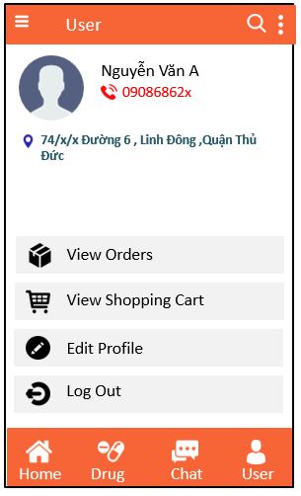

*Image8: Account Management Screen*

### Functional Requirements

|  |  |  |  |
| --- | --- | --- | --- |
| **Item** | **Description** | **Action** | **Response** |
| **SOD User Management Screen** | SOD User Management Screen has 5 buttons, 3 textview, 3 EditText and an Image View:   * “View Orders” button * “View Shopping Cart” button * “Edit Profile” button * Log Out button * Back button | Tap on the buttons | Each button will display a corresponding function screen |
| View Orders Button | Use to display a list of order view screen | Tap on button | A list of order view is showed |
| Back buttonAccount Image List | * Use to go back the previous screen | Tap on back button | A previous screen displayed after selected |
| An image view allow users to add photos | Tap on image list | A screen of library photo displayed |
| Fields EditText | Automatically displayed information account have been registered and can’t be able to edit | N/A | N/A |
| Edit Profile button | Use to edit account information in case of wrong account information | Tap on button | After Taped, all fields EditText can be editable |
| View Shopping Cart Button | Use to display a list of shopping cart screen | Tap on button | Screen of shopping cart displayed |
| **Button “Home”** | Use to switch to the home page | Tap on the button | After tapped the home button will automatically switch to the home page displayed the list of posts |
| **Button “Medicine”** | Use to switch to medicine page | Tap on the button | After tapped the button will automatically switch to the home page displayed the list of drug |
| **Button “Personal”** | Use to switch to the personal account page | Tap on the button | After tapped the home button will automatically switch to the home page displayed the posts information of drug |
| **Button “Chat”** | Use to switch to chat page | Tap on the button | After tapped the chat button, the screen will switch to the chat page for the user to contact the seller |
| **Button “ Log Out”** | Log out of the app | Tap button | After tap, Log out of the app |

## **Feature/Component #9: SDO View Orders Screen**

### User Interfaces

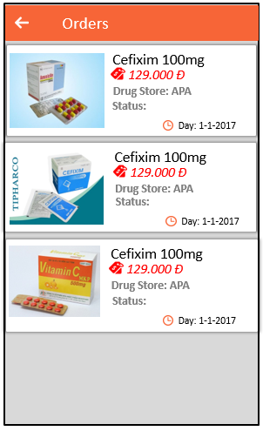

*Image9: View Orders Screen*

### Functional Requirements

|  |  |  |  |
| --- | --- | --- | --- |
| **Item** | **Description** | **Action** | **Response** |
| **SOD View Orders Screen** | SOD View Orders Screen has an Image View, a Back button and 5 TextView:   * Drug’s Name * Drug’s Store * Status * Price * Day * Back button | N/A | N/A |
|  | Screen displays a list of shopping cart | N/A | N/A |
| Image View | Use to display a list of image of drugs and can’t be able to edit | N/A | N/A |
| TextView | Use to display information of drugs that user have choosen  Can’t be able to edit | N/A | N/A |
| Back button | Use to go back the previous screen | Tap on button | Go back to the previous screen |

## **Feature/Component #10: SDO View Shopping Cart Screen**

### User Interfaces

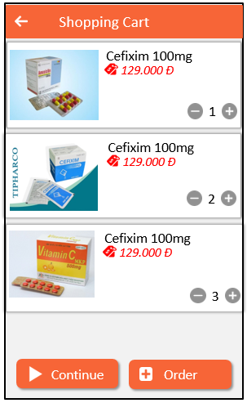

*Image10: Shopping Cart*

### Functional Requirements

|  |  |  |  |
| --- | --- | --- | --- |
| **Item** | **Description** | **Action** | **Response** |
| **SDO Shopping Cart Screen** | SDO View Shopping Cart Screen has an image view, an EditText, 3 buttons,1 customview and 2 TextViews:   * Continue Button * Order button * Total Number EditText * Customview increase,decrease * Back button | N/A | N/A |
|  | Screen displays a list of shopping cart view allow users to manipulate numbers of drugs and the Gia’s field will increase or decrease depend on the number of drug | Tap on – or + Buttons | The Price’s field increase or decrease depend on the number of drugs |
| Continue Button | Use to display a home screen after Taped | Tap on button | Home screen displayed after Taped |
| Back Button | Use to go back the previous screen | Tap on button | Previous screen displayed |
| Order Button | Payment Confirmation Screen displayed after Taped | Tap on button | Payment Confirmation Screen Displayed |
| Customview | “-” Use to decrease the number of drugs | Tap on button | After Taped, a number of drugs will be reduced to one |
| “+” Use to increase the number of drugs | Tap on the button | After Taped, a number of drugs will be increased to one |
| Price’s field | When user has Taped on – or + buttons | Tap on Proceed button | Pop up is showed |
| Total Number EditText | Allow user to input a number | Tap on EditText | User can input a number |

## **Feature/Component #10: SDO Payment Confirmation Screen**

### User Interfaces

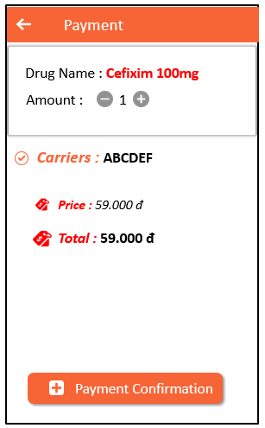

*Image10: Payment*

### Functional Requirements

|  |  |  |  |
| --- | --- | --- | --- |
| **Item** | **Description** | **Action** | **Response** |
| Payment confirmation screen | Payment confirmation screen has 1 listview, 5 textview,3 edittext, 1 button, 1 customview.   * Drug’s Name * Amount * Price * Total * Payment Confirmation button * Spinner * Customview increase, decrease | N/A | N/A |
| **“Drug’s Name”textview + edittext** | Use to enter the total amount | Tap on the edittext | Use to enter the total amount |
| Customview | “-“Use to decrease the number of | Tap on “-” | Use to increase the of number |
| “+”Use to increase the number of | Tap on “+” | Increase the number of |
| “Carriers” textview + edittext | Use to enter the tax money | Tap on the edittext | Enter the tax money |
| “Price” textview + edittext. | Use to import of medicines | Tap on the edittext | Enter the price of smoking. |
| “Total”textview + edittext | Use to enter the total amount | Tap on the edittext | Show the total amount |

## **Feature/Component #12: SDO Seller Management Screen**

### User Interfaces

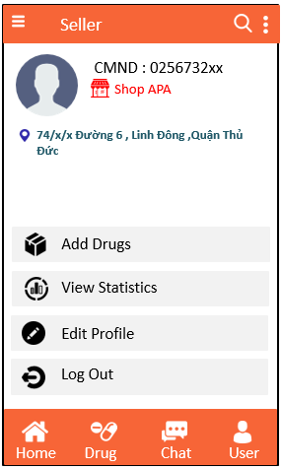

*Image12: Seller management*

### Functional Requirements

|  |  |  |  |
| --- | --- | --- | --- |
| **Item** | **Description** | **Action** | **Response** |
| **SDO seller management screen** | SDO seller management has 7 textview, 3 edittext,1 imageview:   * Add drugs * View Statistics * Log Out * Edit Profile * CMND * Drug’s Store * Address | N/A | N/A |
| **Add Drugs Button** | Use to display a Add Drugs Screen after Taped | Tap on the textview | Add Drugs Screen displayed |
| **3 edittexts CMND,Drug’sStore,Address** | Use to display information of seller | N/A | N/A |
| **Imageview** | Use to allow users to add photos by library photo | Tap on the image | Library photo displayed |
| **Button View Statistics** | Use to display View Statistics Screen | Tap on the textview | View Statistics Screen will be displayed. |
| **Button “Home”** | Use to switch to the home page | Tap on the button | After tapped the home button will automatically switch to the home page displayed the list of posts |
| **Button “Medicine”** | Use to switch to medicine page | Tap on the button | After tapped the button will automatically switch to the home page displayed the list of drug |
| **Button “Personal”** | Use to switch to the personal account page | Tap on the button | After tapped the home button will automatically switch to the home page displayed the posts information of drug |
| **Button “Chat”** | Use to switch to chat page | Tap on the button | After tapped the chat button, the screen will switch to the chat page for the user to contact the seller |
| **Button Edit Profile** | All fields EditText allow user to edit | Tap on TextView | After Tap ,all fields EditText can be able to edit |
| **Button “ Log out”** | Log out of the app | Tap button | After tap, Log out of the app |

### 

## **Feature/Component #13: SDO Entering Drugs Screen**

### User Interfaces

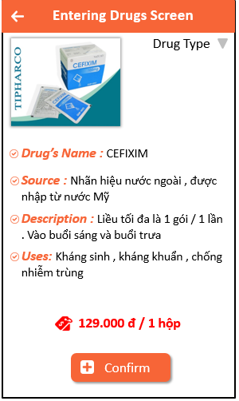

*Image13: Enter information drug*

### Functional Requirements

|  |  |  |  |
| --- | --- | --- | --- |
| **Item** | **Description** | **Action** | **Response** |
| SDO Entering Drugs Screen | SDO Entering Drugs Screen has 5 EditText, 5 TextView, 1 Button, An Image View,1 Spinner :   * Confirm button * Back button * Drug’s Name * Uses * Price * Sources * Description * Drug Type spinner | N/A | N/A |
| Back button | Use to go back the Seller Management Screen | Tap on button | Seller Management Screen will be displayed |
| Confirm Button | After Taped, a message “Save successfully or Save Failed” | Tap on the button | If save failed, the current screen is still be remain. If save successfully, then the Seller Management Screen will be displayed |
| Fields EditText | Use to allow users to input the information | Tap on the edittext | N/A |
| Image View | The library photo will be displayed to allow user to add photo | Tap on the image | After taped, Library Photo displayed |
| Spinner | Classification of imported drugs | Tap on the spinner | After taped, spinner drop down type of medicine. |

## **Feature/Component #14: SDO Sales Statistics Screen.**

### User Interfaces

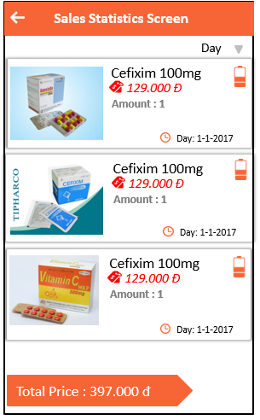

*Image14:* Sales Statistics

### Functional Requirements

|  |  |  |  |
| --- | --- | --- | --- |
| **Item** | **Description** | **Action** | **Response** |
| **SDO Sales Statistics Screen** | SDO Sales Statistics Screen has a button, a listview(1 Image View, 5 TextView, 1 Custom view), 2 TextView, 1 Spinner:   * Back Button * Arrange Spinner * ListView(name of medicine 1 Textview, amount 2 textview, day 2 textview and warehouse status customview ) * Total Price 2 TextView | N/A | N/A |
| **Back button** | Use to go back to the “Seller Management” Screen | Tap on button | Seller Management Screen will be displayed |
| Arrange Spinner | Use to arrange the listview by day, weeks, months | Tap on spinner | The listView displayed the type of arrange have been chosen |
| ListView | Use to displayed a list of drugs have been sold | N/A | N/A |
| Total Price TextView | Use to displayed the total of the price of all items | N/A | N/A |

## **Feature/Component #15: SDO Transport Company Screen**

### User Interfaces

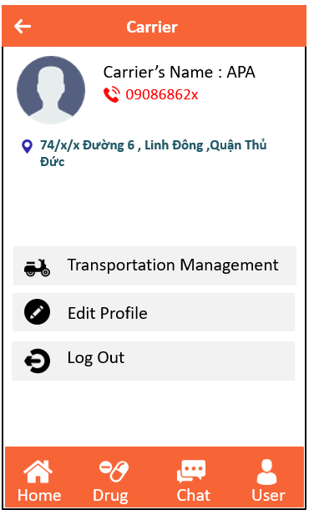

*Image15: Information company*

### Functional Requirements

|  |  |  |  |
| --- | --- | --- | --- |
| **Item** | **Description** | **Action** | **Response** |
| **Shipper information**  **screen** | Company Ship Information Screen has 3 textview and 3 edittext   * Carrier’s Name * Phone Number   # 3Button   * Edit Profile * Transportation Management * Log Out   # 1 imageview | N/A | N/A |
| **Button “Edit Profile”** | As the user Taps on the Button enables editing of the data and allows for altering the avatar | Tap on the button | Allows re-entering data in edittext and changes the avatar. |
| **Button “Transportation Management**  **”** | When the user Taps on the button, the program will switch to the " Transportation Management  " screen. | Tap on the Button | Switch to “Transportation Management  ” screen |
| **Button “ Log Out”** | Log out of the account and Use to switch to Log-in page | Tap on the button | After tap, Log out of the account, Use to switch to log-in page |
| **Button “Home”** | Use to switch to the home page | Tap on the button | After tapped the home button will automatically switch to the home page displayed the list of posts |
| **Button “Medicine”** | Use to switch to medicine page | Tap on the button | After tapped the button will automatically switch to the home page displayed the list of drug |
| **Button “Personal”** | Use to switch to the personal account page | Tap on the button | After tapped the home button will automatically switch to the home page displayed the posts information of drug |
| **Button “Chat”** | Use to switch to chat page | Tap on the button | After tapped the chat button, the screen will switch to the chat page for the user to contact the seller |
| **Textview** | Display the necessary content in the article | N/A | N/A |
| **ImageView** | Tap on imageview, the user can changes logo company | Tap on the imageview | Change avatar |

## **2.11 Feature/Component #16: SDO Transportation Management Screen**

### User Interfaces

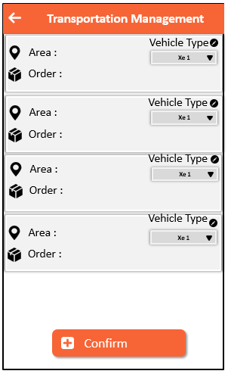

*Images 16: Manage shipping schdules*

### Functional Requirements

|  |  |  |  |
| --- | --- | --- | --- |
| **Item** | **Description** | **Action** | **Response** |
| **Manage shipping schedules**  **screen** | Manage shipping schedules Screen use listview to show the order, each listview contains two textview:  - Area  - Order  And 1 Spinner, 1 button Confirm | N/A | N/A |
| **”Vehicle Type”** | When the user tap on the spinner, show the vehicle list for the selected user | Tap on the spinner | Allow the user selects the shipper |
| **Button “Confirm”** | After selected the shipper, the user tap on the button to send the order to the shipper | Tap on the Button | Send orders to the selected shipper |

## **Feature/Component #17: SDO Shipper Screen**

### User Interfaces

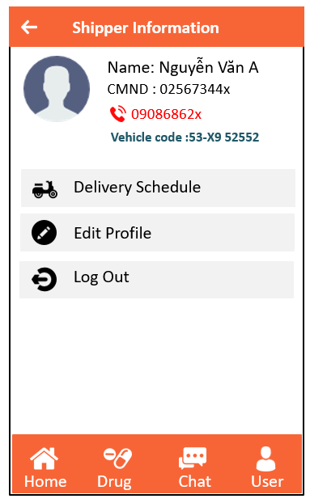

*Image17: Information shipper*

### Functional Requirements

|  |  |  |  |
| --- | --- | --- | --- |
| **Item** | **Description** | **Action** | **Response** |
| **Shipper information**  **screen** | Shipper Information Screen has 4 textview and 4 edittext:   * Name * Phone Number * CMND * Vehicle code * Edit Profile * Delivery Schedule * Log Out * ImageView | N/A | N/A |
| **Button “Edit Profile”** | As the user Taps on the Edittext line enables editing of the data and allows for altering the avatar | Tap on the button | Allows re-entering data in edittext and changes the avatar. |
| **Button “Delivery Schedule”** | When the user Taps on the button, the program will switch to the " Delivery Schedule" screen. | Tap on the Button | Switch to “Delivery Schedule” |
| **Button “Home”** | Use to switch to the home page | Tap on the button | After tapped the home button will automatically switch to the home page displayed the list of posts |
| **Button “Medicine”** | Use to switch to medicine page | Tap on the button | After tapped the button will automatically switch to the home page displayed the list of drug |
| **Button “Personal”** | Use to switch to the personal account page | Tap on the button | After tapped the home button will automatically switch to the home page displayed the posts information of drug |
| **Button “Chat”** | Use to switch to chat page | Tap on the button | After tapped the chat button, the screen will switch to the chat page for the user to contact the seller |
| **Button “ Log Out”** | Log out of the account and Use to switch to Log-in page | Tap on the button | After tap, Log out of the account, Use to switch to log-in page |

## **Feature/Component #18: SDO Delivery Schedules Screen**

### User Interfaces

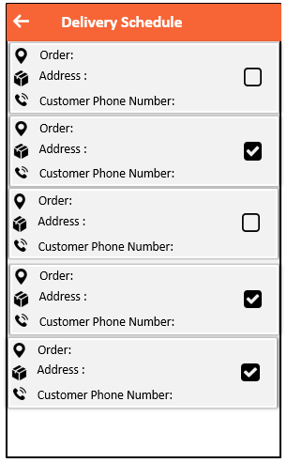

*Image18: Delivery Schedule Screen*

### Functional Requirements

|  |  |  |  |
| --- | --- | --- | --- |
| **Item** | **Description** | **Action** | **Response** |
| Delivery Schedule Screen | Delivery Schedule Screen has 1 button Back  The interface uses listview to display, A listview consists of 3 textviews and CheckBox   * Oder: * Customer Phone Number * Address | N/A | N/A |
| Button Back | Use to return to the “Shipper Information” screen | Tap on the Button | Return to the “Shipper Information” screen |
| CheckBox | When the shipper completes the delivery for the order, and then Taps on the checkbox, the ImagesView will appear. | Tap on the listview | List View will appear |

## **Feature/Component #19: SDO Chat Management Screen**

### User Interfaces

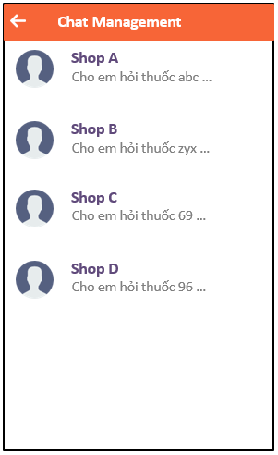

*Image19:* Chat Management Screen

### Functional Requirements

|  |  |  |  |
| --- | --- | --- | --- |
| **Item** | **Description** | **Action** | **Response** |
| **SRS Chat Management Screen** | Chat Management Screen has:- Back Button- Listview- Image Account- TextView | N/A | N/A |
| **Listview** | Use to contain a image account and User name | Tap on listview | Display the personal information of that person |
| **Back Button** | Use to go back previous screen | Tap on back arrow | Previous screen displayed |
| **Image Account** | Use to display Account image | N/A | N/A |
| **TextView** | Use to display user name and chatting content | N/A | N/A |

## **Feature/Component #20: SDO Screen Chat Screen**

### User Interfaces

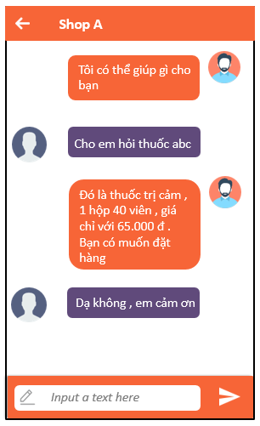

*Image20:* Screen Chat Content

### Functional Requirements

|  |  |  |  |
| --- | --- | --- | --- |
| **Item** | **Description** | **Action** | **Response** |
| **Screen Chat Content** | Screen Chat Content has:   * Back button * ListView * Chat EditText * Send Button * Account Image view * Chat Textview | N/A | N/A |
| Back button | Use to go back previous screen | Tap on button | Previous screen displayed |
| Image View | Use to display account image | N/A | N/A |
| Chat TextView | Use to display a text that user have inputed | N/A | N/A |
| Chat EditText | An edittext with a hint “Input a text here”, when users Tap on then hint will be disappeared and allow user to input a text | Tap on EditText | The hint will be disappeared and user can input text |
| Send button | Use to send the text that users have inputed to the Chat TextView above | Tap on button | Send the text to the Chat TextView above |
| ListView | Use to contain a image list and chat textview | N/A | N/A |

Database Design

A* - Added M – Modified D – Deleted

|  |  |  |  |  |
| --- | --- | --- | --- | --- |
| Effective  date | Changed item | A* M,D | Changed description | New version |
|  |  |  |  |  |
|  |  |  |  |  |
|  |  |  |  |  |
|  |  |  |  |  |
|  |  |  |  |  |
|  |  |  |  |  |
|  |  |  |  |  |
|  |  |  |  |  |
|  |  |  |  |  |
|  |  |  |  |  |
|  |  |  |  |  |
|  |  |  |  |  |
|  |  |  |  |  |
|  |  |  |  |  |
|  |  |  |  |  |
|  |  |  |  |  |
|  |  |  |  |  |
|  |  |  |  |  |
|  |  |  |  |  |

**Signature Pages**

**Originator :** Bùi Xuân Quang 20/03/2018

Leader

**Reviewers :** Bùi Xuân Quang 20/03/2018

Leader

**Approval :** Tiêu Kim Cương

Teacher

Table of Contents

**1.** **Introduction** 5

**1.1.** **Purpose** 5

**1.2.** **Definitions, Acronyms and Abbreviations** 5

**1.3.** **References** 5

**1.4.** **Overview** 5

**2.** **Database** 5

**2.1.** **User table** 5

**2.2.** **Seller table** 6

**2.3.** **Logistics table** 6

**2.4.** **Shipper table** 6

**2.5.** **Drug table** 7

**2.6.** **Warehouse table** 7

**2.7.** **Order table** 7

**2.8.** **Transport table** 8

**2.9.** **Delivery schedule** 8

**2.10.** **Firebase table** 8

1. **Introduction**
   1. **Purpose**
      * This profile will give the programmer and user the ability to see but the data used to create the application.
      * Inside the document will contain the database tables.
      * Reader of document: User, instructor.
   2. **Definitions, Acronyms and Abbreviations**

|  |  |  |
| --- | --- | --- |
| ***Abbreviations*** | ***Description*** | ***Comment*** |
| P/F key | Primary / Foreign key | Use to indicate that a field is a primary or foreign key in table |
|  |  |  |
|  |  |  |
|  |  |  |

* 1. **References**

|  |  |
| --- | --- |
| ***Document number*** | ***Tittle*** |
| UI design document |  |
| Software requirement specification |  |
|  |  |
|  |  |
|  |  |
|  |  |
|  |  |

* 1. **Overview**
* The document has a new table has a firebase table will compatible with many of the tables

1. **Database**
   1. **User table**

|  |  |  |  |  |  |  |  |  |  |
| --- | --- | --- | --- | --- | --- | --- | --- | --- | --- |
| ***No*** | ***Field Name*** | ***Type*** | ***Length*** | ***Size*** | ***Null*** | ***Unique*** | ***P/F key*** | ***Default*** | ***Descriptions*** |
| 01 | ID_User | Int | 4 |  |  | x | P |  | Code of id user, auto increment. |
| 02 | Username | Char | 40 |  |  | x |  |  | Code of username |
| 03 | Password | Text | 25 |  |  |  |  |  | Code of password |
| 04 | Name | Text | 255 |  |  |  |  |  | Code of name |
| 05 | Phone | Text | 20 |  |  |  |  |  | Code of phone |
| 06 | Address | Text | 255 |  |  |  |  |  | Code of address |

* 1. **Seller table**

|  |  |  |  |  |  |  |  |  |  |
| --- | --- | --- | --- | --- | --- | --- | --- | --- | --- |
| ***No*** | ***Field Name*** | ***Type*** | ***Length*** | ***Size*** | ***Null*** | ***Unique*** | ***P/F key*** | ***Default*** | ***Descriptions*** |
| 01 | ID_Seller | Int | 4 |  |  | x | P |  | Code of id seller , auto increment. |
| 02 | Username | Char | 40 |  |  | x |  |  | Code of username |
| 03 | Password | Text | 25 |  |  |  |  |  | Code of password |
| 04 | NameShop | Text | 255 |  |  |  |  |  | Code of nameshop |
| 05 | Phone | Text | 20 |  |  |  |  |  | Code of phone |
| 06 | Address | Text | 255 |  |  |  |  |  | Code of address |
| 07 | IdentifyCard | Text | 50 |  |  |  |  |  | Code of identifycard |

* 1. **Logistics table**

|  |  |  |  |  |  |  |  |  |  |
| --- | --- | --- | --- | --- | --- | --- | --- | --- | --- |
| ***No*** | ***Field Name*** | ***Type*** | ***Length*** | ***Size*** | ***Null*** | ***Unique*** | ***P/F key*** | ***Default*** | ***Descriptions*** |
| 01 | ID_Logistics | Int | 4 |  |  | x | P |  | Code of id logistics , auto increment. |
| 02 | Username | Char | 40 |  |  | x |  |  | Code of username |
| 03 | Password | Text | 25 |  |  |  |  |  | Code of password |
| 04 | NameLogistics | Text | 255 |  |  |  |  |  | Code of name logistic |
| 05 | Phone | Text | 20 |  |  | x |  |  | Code of phone |
| 06 | Address | Text | 255 |  |  | x |  |  | Code of address |
| 07 | Count number of vehicles | Text | 50 |  |  |  |  |  | Code of  count number vehicle |

* 1. **Shipper table**

|  |  |  |  |  |  |  |  |  |  |
| --- | --- | --- | --- | --- | --- | --- | --- | --- | --- |
| ***No*** | ***Field Name*** | ***Type*** | ***Length*** | ***Size*** | ***Null*** | ***Unique*** | ***P/F key*** | ***Default*** | ***Descriptions*** |
| 01 | ID | Int | 4 |  |  | x | P |  | Code of id shipper , auto increment. |
| 02 | Username | Char | 40 |  |  |  |  |  | Code of username |
| 03 | Password | Text | 25 |  |  |  |  |  | Code of password |
| 04 | NameShipper | Text | 255 |  |  |  |  |  | Code of name shipper |
| 05 | Phone | Text | 20 |  |  |  |  |  | Code of phone |
| 06 | Address | Text | 255 |  |  |  |  |  | Code of address |
| 07 | Vehicle number | Text | 50 |  |  |  |  |  | Code of vehicle number |

* 1. **Drug table**

|  |  |  |  |  |  |  |  |  |  |
| --- | --- | --- | --- | --- | --- | --- | --- | --- | --- |
| ***No*** | ***Field Name*** | ***Type*** | ***Length*** | ***Size*** | ***Null*** | ***Unique*** | ***P/F key*** | ***Default*** | ***Descriptions*** |
| 01 | ID_drug | Int | 4 |  |  | x | P |  | Code of id drug. |
| 02 | NameDrug | Text | 255 |  |  |  |  |  | Code of Drug name |
| 03 | UsesDrug | Text | 255 |  |  |  |  |  | Code of uses drug |
| 04 | Price | Text | 40 |  |  |  |  |  | Code of price |
| 05 | Amount | Number | 4 |  |  |  |  |  | Code of amount |
| 06 | Source | Text | 40 |  |  |  |  |  | Code of source |
| 07 | Describe | Text | 255 |  |  |  |  |  | Code of describe |

* 1. **Warehouse table**

|  |  |  |  |  |  |  |  |  |  |
| --- | --- | --- | --- | --- | --- | --- | --- | --- | --- |
| ***No*** | ***Field Name*** | ***Type*** | ***Length*** | ***Size*** | ***Null*** | ***Unique*** | ***P/F key*** | ***Default*** | ***Descriptions*** |
| 01 | ID_Warehouse | Int | 4 |  |  | x | P |  | Code of id warehouse, auto increment. |
| 02 | ID_drug | Int | 4 |  |  |  | F |  | Code of id drug |
| 03 | Drug name | Text | 255 |  |  |  |  |  | Code of drug name |
| 04 | Day | Date | 20 |  |  |  |  |  | Code of day |
| 05 | Total price | Text | 20 |  |  |  |  |  | Code of total price |

* 1. **Order table**

|  |  |  |  |  |  |  |  |  |  |
| --- | --- | --- | --- | --- | --- | --- | --- | --- | --- |
| ***No*** | ***Field Name*** | ***Type*** | ***Length*** | ***Size*** | ***Null*** | ***Unique*** | ***P/F key*** | ***Default*** | ***Descriptions*** |
| 01 | ID_order | Int | 4 |  |  |  | P |  | Code of id order |
| 02 | Drug name | Text | 255 |  |  |  |  |  | Code of drug name |
| 03 | Day | Date | 20 |  |  |  |  |  | Code of day |
| 04 | Status | Text | 50 |  |  | X |  |  | Code of status, auto |

* 1. **Transport table**

|  |  |  |  |  |  |  |  |  |  |
| --- | --- | --- | --- | --- | --- | --- | --- | --- | --- |
| ***No*** | ***Field Name*** | ***Type*** | ***Length*** | ***Size*** | ***Null*** | ***Unique*** | ***P/F key*** | ***Default*** | ***Descriptions*** |
| 01 | ID_logistics | Int | 4 |  |  |  | F |  | Code of id logistics |
| 02 | Area | Text | 255 |  |  |  |  |  | Code of address user |
| 03 | Drug name | Text | 255 |  |  |  |  |  | Code of drug name |
| 04 | Vehicle | Text | 20 |  |  |  |  |  | Code of vehicle number |
| 05 | ID_Order | Int | 4 |  |  |  | F |  | Code of id order |

* 1. **Delivery schedule**

|  |  |  |  |  |  |  |  |  |  |
| --- | --- | --- | --- | --- | --- | --- | --- | --- | --- |
| ***No*** | ***Field Name*** | ***Type*** | ***Length*** | ***Size*** | ***Null*** | ***Unique*** | ***P/F key*** | ***Default*** | ***Descriptions*** |
| 01 | ID_Order | Int | 4 |  |  |  | F |  | Code of id order |
| 02 | Address | Text | 255 |  |  | x |  |  | Code of address user |
| 03 | Phone | Text | 20 |  |  | x |  |  | Code of phone user |

* 1. **Firebase table**

|  |  |  |  |  |  |  |  |  |  |
| --- | --- | --- | --- | --- | --- | --- | --- | --- | --- |
| ***No*** | ***Field Name*** | ***Type*** | ***Length*** | ***Size*** | ***Null*** | ***Unique*** | ***P/F key*** | ***Default*** | ***Descriptions*** |
| 01 | ID_user | Int | 4 |  |  |  | F |  | Code of id user. |
| 02 | Username | Char | 40 |  |  | x |  |  | Code of username |
| 03 | Password | Text | 25 |  |  |  |  |  | Code of password |
| 04 | Name | Text | 255 |  |  |  |  |  | Code of name |
| 05 | Phone | Text | 20 |  |  | x |  |  | Code of phone |
| 06 | Address | Text | 255 |  |  | x |  |  | Code of address |
|  |  |  |  |  |  |  |  |  |  |
| 01 | ID_seller | Int | 4 |  |  |  | F |  | Code of id seller |
| 02 | Username | Char | 40 |  |  |  |  |  | Code of username |
| 03 | Password | Text | 25 |  |  |  |  |  | Code of password |
| 04 | Name | Text | 255 |  |  |  |  |  | Code of name |
| 05 | Phone | Text | 20 |  |  | x |  |  | Code of phone |
| 06 | Address | Text | 255 |  |  | x |  |  | Code of address |
|  |  |  |  |  |  |  |  |  |  |
| 01 | ID_shipper | Int | 4 |  |  |  | F |  | Code of id logistics |
| 02 | Username | Char | 40 |  |  |  |  |  | Code of username |
| 03 | Password | Text | 25 |  |  |  |  |  | Code of password |
| 04 | NameShipper | Text | 255 |  |  |  |  |  | Code of name shipper |
| 05 | Phone | Text | 20 |  |  | x |  |  | Code of phone |
| 06 | Address | Text | 255 |  |  | x |  |  | Code of address |
|  |  |  |  |  |  |  |  |  |  |
| 01 | ID_drug | Int | 4 |  |  |  | F |  | Code of id drug. |
| 02 | NameDrug | Text | 255 |  |  |  |  |  | Code of Drug name |
| 03 | UsesDrug | Text | 255 |  |  |  |  |  | Code of uses drug |
| 04 | Price | Text | 40 |  |  |  |  |  | Code of price |
| 05 | Amount | Number | 4 |  |  |  |  |  | Code of amount |
| 06 | Source | Text | 40 |  |  |  |  |  | Code of source |
| 07 | Describe | Text | 255 |  |  |  |  |  | Code of describe |
|  |  |  |  |  |  |  |  |  |  |
| 01 | ID_Warehouse | Int | 4 |  |  |  | F |  | Code of id warehouse, auto increment. |
| 02 | ID_drug | Int | 4 |  |  |  |  |  | Code of id drug |
| 03 | Drug name | Text | 255 |  |  |  |  |  | Code of drug name |
| 04 | Day | Date | 20 |  |  |  |  |  | Code of day |
| 05 | Total price | Text | 20 |  |  |  |  |  | Code of total price |
|  |  |  |  |  |  |  |  |  |  |
| 01 | ID_order | Int | 4 |  |  |  | F |  | Code of id order |
| 02 | Drug name | Text | 255 |  |  |  |  |  | Code of drug name |
| 03 | Day | Date | 20 |  |  |  |  |  | Code of day |
| 04 | Status | Text | 50 |  |  |  |  |  | Code of status, auto |
|  |  |  |  |  |  |  |  |  |  |
| 01 | ID_Order | Int | 4 |  |  |  | F |  | Code of id order |
| 02 | Address | Text | 255 |  |  | x |  |  | Code of address user |
| 03 | Phone | Text | 20 |  |  | x |  |  | Code of phone user |

Achitecture Design

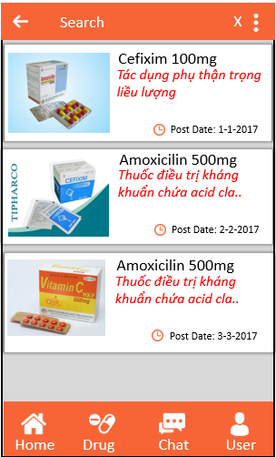



#MH3

#2

#MH4

#MH7

#MH5

#MH6

#MH9

#MH6

#MH1

#MH2

#MH3

Chưa có tài khoản

#1



#MH2



#MH7

#MH1

#MH9

Chưa có tài khoản

#MH8

Đăng kí thành công

#MH1

#MH11

#MH10

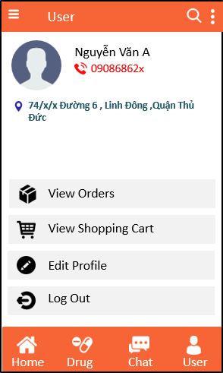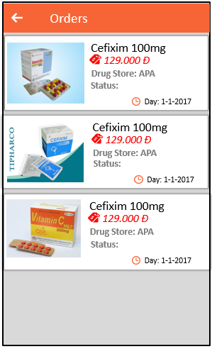

Loại user

#MH7

#MH1

#MH12

#MH3

#MH13

#MH2

Loại hãng vận chuyển

Loại seller

#MH17

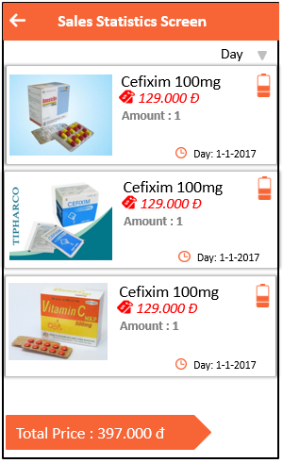

#MH15

#MH16

#MH3

#MH2

#MH14

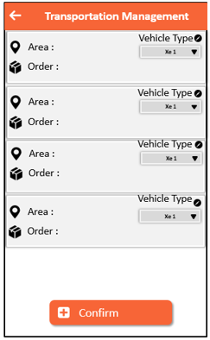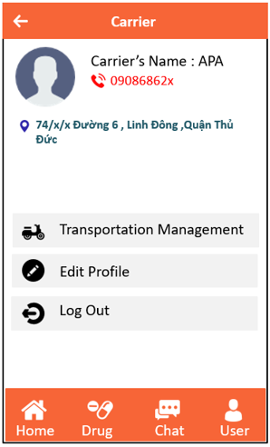

#MH19

#MH18

#MH3

#MH2

#MH17

#MH3

#MH2

#MH1

#MH3

#MH2

Loại ship

#MH20

|  |  |  |
| --- | --- | --- |
| Key | Name Screen | Description |
| #MH1 | Home | The screen starts is this screen, the screen contains a list of posts |
| #MH2 | Drug List | The screen contains a list of different drugs |
| #MH3 | Chat Management | The screen manages the chat list |
| #MH4 | Article Detail | The screen contains details of the article |
| #MH5 | Drug Detail | Show the information of drug |
| #MH6 | Chat Screen | Show the conversation chat directly to the seller |
| #MH7 | Shopping Cart | Contains drugs that have been added to the cart |
| #MH8 | Payment Confirmation | Confirmation will order the order from the cart |
| #MH9 | Login or Register | Can choose to sign in or sign up |
| #MH10 | Login | Sign in to your account |
| #MH11 | Register | Account registration |
| #MH12 | User Account | Details and management of the user account |
| #MH13 | View Order | View cart details |
| #MH14 | Seller Account | Details and management of the seller account |
| #MH15 | Entering Drugs | Input the information of the drug for sale |
| #MH16 | Sales Statistics | View inventory statistics |
| #MH17 | Carrier Account | Details and management of the carrier account |
| #MH18 | Transportation Management | management of transport vehicles |
| #MH19 | Shipper Account | Details and management of the shipper account |
| #MH20 | Delivery Schedules | Displays all transportation schedules of the vehicle |
| #1 | List of drug filters | Classify the drugs by topic |
| #2 | Sort list of articles | Sort articles by order by date |

UI Design

A* - Added M – Modified D - Deleted

**Signature Pages**

**Originator :** Đặng Văn Phú 19/03/2018

Member

**Reviewers :** Bùi Xuân Quang 19/03/2018

Leader

**Approval :** Tiêu Kim Cương

Teacher

Table of Contents

**1 INTRODUCTION** 5

**1.1** **Purpose** 5

**1.2** **Definitions, Acronyms and Abbreviations** 5

**1.3** **References** 5

**2** **SCREEN** 6

**2.1** **Home Screen** 7

**2.2** **Drug List Screen** 8

**2.3** **Chat management Screen** 10

**2.4** **Article Detail Screen** 11

**2.5** **Drug Detail Screen** 12

**2.6** **Chat Screen** 13

**2.7** **Shopping Cart Screen** 15

**2.8** **Payment Confirmation Screen** 16

**2.9** **Login or Register Screen** 18

**2.10** **Login Screen** 19

**2.11** **Register** 20

**2.12** **Account Management (User) Screen** 22

**2.13** **View Order Screen** 23

**2.14** **Account Management Screen** 24

**2.15** **Entering Drugs Screen** 25

**2.16** **Sales Statistics Screen** 27

**2.17** **Account Management Screen (Carrier)** 29

**2.18** **Transportation Management Screen** 30

**2.19** **Account Management Screen (Shipper)** 32

**2.20** **Delivery Schedules Screen** 33

# **1 INTRODUCTION**

Detail Design Document (DDD) allow users to see the screen interface in the application, detail documents related to each screen.

* 1. **Purpose**

Detail Design Document including:

* Displays the screens that are in the application : 20 screens.
* Documentation will provide a screen interface for each screen in the application
* Reader of document : user, instructor.
  1. **Definitions, Acronyms and Abbreviations**

|  |  |  |
| --- | --- | --- |
| Abbreviations | Description | Comment |
| SDO | Sell Drug Online |  |
| DDD | Detail Document Design |  |
| S1,S2,…. | Screen 1, Screen 2,… |  |
|  |  |  |
|  |  |  |
|  |  |  |

* 1. **References**

|  |  |
| --- | --- |
| Document Number | Title |
|  |  |
|  |  |
|  |  |
|  |  |
|  |  |
|  |  |
|  |  |

1. **SCREEN**

|  |  |  |
| --- | --- | --- |
| **No** | **Screen Name** | **Description** |
| 1 | Home | The screen starts is this screen, the screen contains a list of posts |
| 2 | Drug List | The screen contains a list of different drugs |
| 3 | Chat Management | The screen manages the chat list |
| 4 | Article Detail | The screen contains details of the article |
| 5 | Drug Detail | Show the information of drug |
| 6 | Chat Screen | Show the conversation chat directly to the seller |
| 7 | Shopping Cart | Contains drugs that have been added to the cart |
| 8 | Payment Confirmation | Confirmation will order the order from the cart |
| 9 | Login or Register | Can choose to sign in or sign up |
| 10 | Login | Sign in to your account |
| 11 | Register | Account registration |
| 12 | User Account | Details and management of the user account |
| 13 | View Order | View cart details |
| 14 | Seller Account | Details and management of the seller account |
| 15 | Entering Drugs | Input the information of the drug for sale |
| 16 | Sales Statistics | View inventory statistics |
| 17 | Carrier Account | Details and management of the carrier account |
| 18 | Transportation Management | management of transport vehicles |
| 19 | Shipper Account | Details and management of the shipper account |
| 20 | Delivery Schedules | Displays all transportation schedules of the vehicle |

* 1. **Home Screen**



S1: Home Screen

|  |  |  |  |  |  |
| --- | --- | --- | --- | --- | --- |
| No | Component Name | Required | Format | Reference | Note |
| 1 | Background |  | Color: #F76537 |  |  |
| 2 | Button Default : Home, Drug, Chat, User |  | Color: #FFFFFF  Button image  Size : 32x32 |  | Default button, located at the bottom of the screen |
| 3 | Text view “title” |  | Text color :#000000  Font : Arial  Text size : 13sp |  |  |
| 4 | Text view “Description” |  | Text color: #FF2424  Font : Arial  Text size : 13sp  Text style : Italic |  |  |
| 5 | Text view “post date” |  | Text color: #000000  Font : Arial  Text size : 12sp |  |  |
| 6 | Button “Search” |  | Button image |  | Position : located on the right of the action bar |
| 7 | Image View |  | Gravity : left  Size : 400 x 400 |  |  |
| 8 | Drawer |  | Color: #000000 | Filter data by topic | Position: located on the left of the action bar |
| 9 | Option Menu |  | Color: #000000 | Sort the list | Position : located on the right of the action bar ,next to button Search |

* 1. **Drug List Screen**



S2: Drug list

|  |  |  |  |  |  |
| --- | --- | --- | --- | --- | --- |
| No | Component Name | Required | Format | Reference | Note |
| 1 | Background action bar, background linear layout |  | Color: #F76537 |  |  |
| 2 | Button Default : Home, Drug, Chat, User |  | Color: #FFFFFF  Button image  Size : 32x32 |  | Default button, located at the bottom of the screen |
| 3 | Text view “title” |  | Text color :#000000  Font : Arial  Text size : 13sp |  |  |
| 4 | Text view “Cost” |  | Text color: #FF2424  Font : Arial  Text size : 13sp  Text style : Italic |  | Add icon in front of text view |
| 5 | Text view “Shop name” |  | Text color: #7D7D7D  Font : Arial  Text size : 12sp |  |  |
| 6 | Button “Search” |  | Button image |  | Position : located on the right of the action bar |
| 7 | Image View |  | Gravity : left  Size : 400 x 400 |  |  |
| 8 | Button “Cart” |  | Gravity :  the bottom right of the listview item  Button image | Save the product user want to buy in the cart |  |
| 9 | Drawer |  | Color: #000000 | Filter data by topic | Position: located on the left of the action bar |
| 10 | Option Menu |  | Color: #000000 | Sort the list | Position : located on the right of the action bar ,next to button Search |

* 1. **Chat management Screen**



S3: Chat Management

|  |  |  |  |  |  |
| --- | --- | --- | --- | --- | --- |
| No | Component Name | Required | Format | Reference | Note |
| 1 | Background action bar |  | Color: #F76537 |  |  |
| 2 | Text view “Shop name” |  | Text color: #76648D  Font : Arial  Text size : 13sp  Text style : Italic |  |  |
| 3 | Text view “Content” |  | Text color: #7D7D7D  Font : Arial  Text size : 12sp |  |  |
| 4 | Image View |  | Gravity : left  Size : 400 x 400 |  |  |
| 5 | Button “back” |  | Color: #000000 | Return to previous screen | Position : located on the left of the action bar |

* 1. **Article Detail Screen**



S4 : Article Detail

|  |  |  |  |  |  |
| --- | --- | --- | --- | --- | --- |
| No | Component Name | Required | Format | Reference | Note |
| 1 | Background action bar |  | Color: #F76537 |  |  |
| 2 | Text view “title content” |  | Text color: #FFFFFF  Background color : #F76537  Font : Arial  Text size : 13sp |  | Add icon in front of text view |
| 3 | Text view “Content” |  | Text color: #000000  Font : Arial  Text size : 13sp |  |  |
| 4 | Image View |  | Gravity : center  Size : 480 x 600 |  |  |
| 5 | Button “back” |  | Color: #000000 | Return to previous screen | Position : located on the left of the action bar |
| 6 | Text view “Author” |  | Text color: #000000  Font : Arial  Text size : 13sp |  |  |

* 1. **Drug Detail Screen**



S5: Drug detail

|  |  |  |  |  |  |
| --- | --- | --- | --- | --- | --- |
| No | Component Name | Required | Format | Reference | Note |
| 1 | Background action bar |  | Color: #F76537 |  |  |
| 2 | Text view default  : uses, sources, desciption |  | Text color: #F76537  Font : Arial  Text size : 13sp |  | Add icon in front of text view |
| 3 | Text view “content” |  | Text color: #000000  Font : Arial  Text size : 13sp | Get data from firebase |  |
| 4 | Image View |  | Gravity : center  Size : 480 x 600 |  |  |
| 5 | Button “back” |  | Color: #000000 | Return to previous screen | Position : located on the left of the action bar |
| 6 | Text view “Tiltle of drug” |  | Text color: #76648D  Font : Arial  Text size : 13sp  Text style : Bold  Gravity : Center |  |  |
| 7 | Text view “Shop name” |  | Text color: #7D7D7D  Font : Arial  Text size : 12sp |  |  |
| 8 | Button “Chat “ |  | Text color: #FFFFFF  Background color : #F76537  Font : Arial  Text size : 13sp | Go to the chat screen | Add icon in front of text |
| 9 | Button “Order“ |  | Text color: #FFFFFF  Background color : #F76537  Font : Arial  Text size : 13sp | Go to the shopping cart screen | Add icon in front of text |
| 10 | Text view “Cost” |  | Text color: #FF2424  Font : Arial  Text size : 13sp  Text style : Bold |  | Add icon in front of text view |

* 1. **Chat Screen**



S6 : Chat Screen

|  |  |  |  |  |  |
| --- | --- | --- | --- | --- | --- |
| No | Component Name | Required | Format | Reference | Note |
| 1 | Background action bar |  | Color: #F76537 |  |  |
| 2 | Text view “content chat of user” |  | Text color: #FFFFFF  Background color :# 604A7B  Font : Arial  Text size : 13sp |  |  |
| 3 | Text view “content chat of seller” |  | Text color: #FFFFFF  Background color :#F76537  Font : Arial  Text size : 13sp |  |  |
| 4 | Image View of user |  | Gravity : left  Size : 300 x300 |  |  |
| 5 | Image View of seller |  | Gravity : right  Size : 300 x300 |  |  |
| 6 | Button “back” |  | Color: #000000 | Return to previous screen | Position : located on the left of the action bar |
| 7 | Edit text “input” |  | Text color: #000000  Background color :#F76537  Hint: “Input text here”  Font : Arial  Text size : 13sp |  | Add icon in front of text view |
| 8 | Button “send” |  | Image button  Color: #FFFFFF | Send chat data |  |

* 1. **Shopping Cart Screen**



S7 : Shopping Cart

|  |  |  |  |  |  |
| --- | --- | --- | --- | --- | --- |
| No | Component Name | Required | Format | Reference | Note |
| 1 | Background action bar |  | Color: #F76537 |  |  |
| 2 | Text view “tilte of drug” |  | Text color: #000000  Font : Arial  Text size : 13sp |  |  |
| 3 | Text view “Cost” |  | Text color: #FF2424  Font : Arial  Text size : 13sp  Text style : Italic |  | Add icon in front of text view |
| 4 | Image View |  | Gravity : left  Size : 300 x300 |  |  |
| 5 | Custom view “-” |  | Background color : #D9D9D9  Text color : #FFFFFF |  |  |
| 6 | Custom view “+” |  | Background color : #D9D9D9  Text color : #FFFFFF |  |  |
| 7 | Edit text |  | Text color: #000000  Font : Arial  Text size : 13sp |  |  |
| 8 | Button “back” |  | Color: #000000 | Return to previous screen | Position : located on the left of the action bar |
| 9 | Button “Continue “ |  | Text color: #FFFFFF  Background color : #F76537  Font : Arial  Text size : 13sp | Go to the shopping cart screen | Add icon in front of text |
| 10 | Button “Order“ |  | Text color: #FFFFFF  Background color : #F76537  Font : Arial  Text size : 13sp | Go to the payment confirmation screen | Add icon in front of text |

* 1. **Payment Confirmation Screen**



S8 : Payment Confirmation

|  |  |  |  |  |  |
| --- | --- | --- | --- | --- | --- |
| No | Component Name | Required | Format | Reference | Note |
| 1 | Background action bar |  | Color: #F76537 |  |  |
| 2 | Text view “tilte of drug” |  | Text color: #FF2424  Font : Arial  Text size : 13sp |  |  |
| 3 | Text view default : Drug name, amount |  | Text color: #000000  Font : Arial  Text size : 13sp |  |  |
| 4 | Text view default : Price, total |  | Text color: #FF2424  Font : Arial  Text size : 13sp |  | Add icon in front of text |
| 5 | Custom view “-” |  | Background color : #D9D9D9  Text color : #FFFFFF |  |  |
| 6 | Custom view “+” |  | Background color : #D9D9D9  Text color : #FFFFFF |  |  |
| 7 | Edit text |  | Text color: #000000  Font : Arial  Text size : 13sp |  |  |
| 8 | Button “Payment Confirmation“ |  | Text color: #FFFFFF  Background color : #F76537  Font : Arial  Text size : 13sp | Go to the shopping cart screen | Add icon in front of text |

* 1. **Login or Register Screen**



S9 : Login or Register

|  |  |  |  |  |  |
| --- | --- | --- | --- | --- | --- |
| No | Component Name | Required | Format | Reference | Note |
| 1 | Background |  | Color: #F76537 |  |  |
| 2 | Button Sign in |  | Text color: #FFFFFF  Background color: #632523  Font : Arial  Text size : 13sp  Layout gravity : Center |  |  |
| 3 | Button Sign Up |  | Text color: #FFFFFF  Background color: #632523  Font : Arial  Text size : 13sp  Layout gravity : Center |  |  |
| 4 | Logo |  | Color : #FFFFFF  Gravity : Center  Image view |  |  |

* 1. **Login Screen**



S10 : Login

|  |  |  |  |  |  |
| --- | --- | --- | --- | --- | --- |
| No | Component Name | Required | Format | Reference | Note |
| 1 | Background |  | Color: #F76537 |  |  |
| 2 | Edit Text “Username” |  | Background color: #EEEEEE  Text color: #D4D4D4 |  |  |
| 3 | Edit Text “Password” |  | Background color: #EEEEEE  Text color: #D4D4D4 |  |  |
| 4 | Spinner “Account Type” |  | Background color: #D9D9D9  Text color: #000000  Font: Arial  Size: 10sp |  |  |
| 5 | Sign In button |  | Background color: #632523  Text color: #EEEEEE  Font : Arial  Text size : 13sp  Text style : Italic |  |  |
| 6 | Cancel button |  | Background color: #632523  Text color: #EEEEEE  Font : Arial  Text size : 13sp  Text style : Italic |  |  |

* 1. **Register**



S11 : Register

|  |  |  |  |  |  |
| --- | --- | --- | --- | --- | --- |
| No | Component Name | Required | Format | Reference | Note |
| 1 | Background |  | Color: #F76537 |  |  |
| 2 | Edit Text “Username” |  | Background color: #EEEEEE  Text color: #D4D4D4 |  |  |
| 3 | Edit Text “Password” |  | Background color: #EEEEEE  Text color: #D4D4D4 |  |  |
| 4 | Spinner “Account Type” |  | Background color: #D9D9D9  Text color: #000000  Font: Arial  Size: 10sp |  |  |
| 5 | OK button |  | Background color: #632523  Text color: #EEEEEE  Font : Arial  Text size : 13sp  Text style : Italic |  |  |
| 6 | Cancel button |  | Background color: #632523  Text color: #EEEEEE  Font : Arial  Text size : 13sp  Text style : Italic |  |  |
| 7 | Edit Text “Re-Password” |  | Background color: #EEEEEE  Text color: #D4D4D4 |  |  |
| 8 | Edit Text “Address” |  | Background color: #EEEEEE  Text color: #D4D4D4 |  |  |
| 9 | Edit Text “Phone Number” |  | Background color: #EEEEEE  Text color: #D4D4D4 |  |  |

* 1. **Account Management (User) Screen**

S12 : Account managment

|  |  |  |  |  |  |
| --- | --- | --- | --- | --- | --- |
| No | Component Name | Required | Format | Reference | Note |
| 1 | Background |  | Color: #F76537 |  |  |
| 2 | Text view “Title” |  | Text color :#000000  Font : Arial  Text size : 13sp |  |  |
| 3 | Text view “ Name” |  | Text color: #000000  Font : Arial  Text size : 13sp  Text style : Italic |  |  |
| 4 | Text view “Phone Number” |  | Text color: #FF0000  Font : Arial  Text size : 12sp |  |  |
| 5 | Text View “Adress” |  | Text color: #2E6271  Font: Arial  Text size: 12sp |  |  |
| 6 | Image View “Add Photo” |  | Size: 64x64 |  |  |
| 7 | Button |  | Color: #FFFFFF  Button image  Size : 32x32 |  | Default button, located at the bottom of the screen |
| 8 | View Orders button |  | Text color: #000000  Font: Arial  Text size: 12sp  Image View |  |  |
| 9 | View Shopping Cart button |  | Text color: #000000  Font: Arial  Text size: 12sp  Image View |  |  |
| 10 | Log Out |  | Text color: #000000  Font: Arial  Text size: 12sp  Image View |  |  |
| 11 | Edit Profile |  | Text color: #000000  Font: Arial  Text size: 12sp  Image View |  |  |

* 1. **View Order Screen**



S13 : View Order

|  |  |  |  |  |  |
| --- | --- | --- | --- | --- | --- |
| No | Component Name | Required | Format | Reference | Note |
| 1 | Background |  | Color: #F76537 |  |  |
| 2 | Back Button |  | Color: #EEEEEE  Button image  Size : 32x32 |  | Position: located on the left on the action bar |
| 3 | Text view “Title” |  | Text color :#000000  Font : Arial  Text size : 13sp |  |  |
| 4 | Text view “Prices” |  | Text color: #FF0000  Font : Arial  Text size : 13sp  Text style : Italic |  |  |
| 5 | Text view “post date” |  | Text color: #000000  Font : Arial  Text size : 12sp |  |  |
| 6 | Text View “Drug’s Store” |  | Text color: #666666  Font: Arial  Text size: 12sp |  | Position : located on the right of the action bar |
| 7 | Text View “Status” |  | Text color: #666666  Font: Arial  Text size: 12sp |  |  |
| 8 | Text View “Drug’s Name” |  | Text color: #000000  Font: Arial  Text size: 12sp |  | Position: located on the bottom of the end of screen |
| 9 | Image View Drugs |  | Size: 128x128 |  |  |

* 1. **Account Management Screen**



S14 : Seller Account

|  |  |  |  |  |  |
| --- | --- | --- | --- | --- | --- |
| No | Component Name | Required | Format | Reference | Note |
| 1 | Background |  | Color: #F76537 |  |  |
| 2 | Text view “Title” |  | Text color :#000000  Font : Arial  Text size : 13sp |  |  |
| 3 | Text view “ CMND” |  | Text color: #000000  Font : Arial  Text size : 13sp  Text style : Italic |  |  |
| 4 | Text view “Shop’s Name” |  | Text color: #FF0000  Font : Arial  Text size : 12sp |  |  |
| 5 | Text View “Adress” |  | Text color: #2E6271  Font: Arial  Text size: 12sp |  |  |
| 6 | Image View “Add Photo” |  | Size: 64x64 |  |  |
| 7 | Button |  | Color: #FFFFFF  Button image  Size : 32x32 |  | Default button, located at the bottom of the screen |
| 8 | Add Drugs button |  | Text color: #000000  Font: Arial  Text size: 12sp  Image View |  |  |
| 9 | View Statistics button |  | Text color: #000000  Font: Arial  Text size: 12sp  Image View |  |  |
| 10 | Log Out |  | Text color: #000000  Font: Arial  Text size: 12sp  Image View |  |  |
| 11 | Edit Profile |  | Text color: #000000  Font: Arial  Text size: 12sp  Image View |  |  |

* 1. **Entering Drugs Screen**



S15 : Entering Drug

|  |  |  |  |  |  |
| --- | --- | --- | --- | --- | --- |
| No | Component Name | Required | Format | Reference | Note |
| 1 | Background |  | Color: #F76537 |  |  |
| 2 | Back Button |  | Color: #EEEEEE  Button image  Size : 32x32 |  | Position: located on the left on the action bar |
| 3 | Text view “Title” |  | Text color :#000000  Font : Arial  Text size : 13sp |  |  |
| 4 | Text view “Drug’s Name” |  | Text color: # F76537  Font : Arial  Text size : 13sp  Text style : Italic  Image View |  |  |
| 5 | Text view “Uses” |  | Text color: # F76537  Font : Arial  Text size : 13sp  Text style : Italic  Image View |  |  |
| 6 | Text view “Description” |  | Text color: # F76537  Font : Arial  Text size : 13sp  Text style : Italic  Image View |  |  |
| 7 | Text view “Sources” |  | Text color: # F76537  Font : Arial  Text size : 13sp  Text style : Italic  Image View |  |  |
| 8 | Text View “Price” |  | Text color: #FF0000  Font: Arial  Size: 13sp  Image View |  |  |
| 9 | Confirm button |  | Background color: #F76537  Text color: #EEEEEE  Size: 13sp  Image view  Font : Arial |  |  |
| 10 | Spinner Arrange Drug Type |  | Text color: #000000  Font: Arial  Size: 13sp |  |  |
| 11 | Image View Drug |  | Size 128x128 |  |  |

* 1. **Sales Statistics Screen**



S16 : Sales Statistics

|  |  |  |  |  |  |
| --- | --- | --- | --- | --- | --- |
| No | Component Name | Required | Format | Reference | Note |
| 1 | Background |  | Color: #F76537 |  |  |
| 2 | Back Button |  | Color: #EEEEEE  Button image  Size : 32x32 |  | Position: located on the left on the action bar |
| 3 | Text view “Title” |  | Text color :#000000  Font : Arial  Text size : 13sp |  |  |
| 4 | Text view “Prices” |  | Text color: #FF0000  Font : Arial  Text size : 13sp  Text style : Italic |  |  |
| 5 | Text view “post date” |  | Text color: #000000  Font : Arial  Text size : 12sp |  |  |
| 6 | Text View “Drug’s Name” |  | Text color: #000000  Font: Arial  Text size: 12sp |  | Position : located on the right of the action bar |
| 7 | Text View “Amount” |  | Text color: #666666  Font: Arial  Text size: 12sp |  |  |
| 8 | Text View “Total Price” |  | Text color: #EEEEEE  Background color: #F76537  Font: Arial  Text size: 12sp |  | Position: located on the bottom of the end of screen |
| 9 | Spinner arrange |  | Text color: #000000  Font: Arial  Text size: 12sp |  | Position: located on the right and below of the Title Screen |
| 10 | Image View Drugs |  | Size: 128x128 |  |  |

* 1. **Account Management Screen (Carrier)**



S17 : Carrier Account

|  |  |  |  |  |  |
| --- | --- | --- | --- | --- | --- |
| No | Component Name | Required | Format | Reference | Note |
| 1 | Background |  | Color: #F76537 |  |  |
| 2 | Back Button |  | Color: #EEEEEE  Button image  Size : 32x32 |  | Position: located on the left on the action bar |
| 3 | Text view “Title” |  | Text color :#000000  Font : Arial  Text size : 13sp |  |  |
| 4 | Text view “Carrier’s Name” |  | Text color: #000000  Font : Arial  Text size : 13sp  Text style : Italic |  |  |
| 5 | Text view “Phone Number” |  | Text color: #FF0000  Font : Arial  Text size : 12sp |  |  |
| 6 | Text View “Address” |  | Text color: #2E6271  Font: Arial  Text size: 12sp |  |  |
| 7 | Image View “Add Photo” |  | Size: 64x64 |  |  |
| 8 | Button |  | Color: #FFFFFF  Button image  Size : 32x32 |  | Default button, located at the bottom of the screen |
| 9 | Transportation Management button |  | Text color: #000000  Font: Arial  Text size: 12sp  Image View |  |  |
| 10 | Log Out |  | Text color: #000000  Font: Arial  Text size: 12sp  Image View |  |  |
| 11 | Edit Profile |  | Text color: #000000  Font: Arial  Text size: 12sp  Image View |  |  |

* 1. **Transportation Management Screen**



S18 : Transportation Management

|  |  |  |  |  |  |
| --- | --- | --- | --- | --- | --- |
| No | Component Name | Required | Format | Reference | Note |
| 1 | Background |  | Color: #F76537 |  |  |
| 2 | Back Button |  | Color: #EEEEEE  Button image  Size : 32x32 |  | Position: located on the left on the action bar |
| 3 | Text view “Area” |  | Text color :#000000  Font : Arial  Text size : 13sp  Image View |  |  |
| 4 | Text view “Order” |  | Text color: #000000  Font : Arial  Text size : 13sp  Text style : Italic  Image View |  |  |
| 5 | Text view “Vehicle Type” |  | Text color: #000000  Font : Arial  Text size : 12sp  Image View |  |  |
| 6 | Confirm button |  | Background color: #F76537  Text color: #EEEEEE  Image View |  |  |
| 7 | Spinner Type of Vehicle |  | Background color: #D9D9D9  Text color: #000000  Font: Arial  Size: 10sp |  |  |

* 1. **Account Management Screen (Shipper)**



S19 : Shipper Account

|  |  |  |  |  |  |
| --- | --- | --- | --- | --- | --- |
| No | Component Name | Required | Format | Reference | Note |
| 1 | Background |  | Color: #F76537 |  |  |
| 2 | Back Button |  | Color: #EEEEEE  Button image  Size : 32x32 |  | Position: located on the left on the action bar |
| 3 | Text view “Title” |  | Text color :#000000  Font : Arial  Text size : 13sp |  |  |
| 4 | Text view “CMND” |  | Text color :#000000  Font : Arial  Text size : 13sp |  |  |
| 5 | Text view “ Name” |  | Text color: #000000  Font : Arial  Text size : 13sp  Text style : Italic |  |  |
| 6 | Text view “Phone Number” |  | Text color: #FF0000  Font : Arial  Text size : 12sp |  |  |
| 7 | Text View “Vehicle code” |  | Text color: #2E6271  Font: Arial  Text size: 12sp |  |  |
| 8 | Image View “Add Photo” |  | Size: 64x64 |  |  |
| 9 | Button |  | Color: #FFFFFF  Button image  Size : 32x32 |  | Default button, located at the bottom of the screen |
| 10 | Delivery Schedule button |  | Text color: #000000  Font: Arial  Text size: 12sp  Image View |  |  |
| 11 | Log Out |  | Text color: #000000  Font: Arial  Text size: 12sp  Image View |  |  |
| 12 | Edit Profile |  | Text color: #000000  Font: Arial  Text size: 12sp  Image View |  |  |

* 1. **Delivery Schedules Screen**



S20 : Delivery Schedule

|  |  |  |  |  |  |
| --- | --- | --- | --- | --- | --- |
| No | Component Name | Required | Format | Reference | Note |
| 1 | Background |  | Color: #F76537 |  |  |
| 2 | Back Button |  | Color: #EEEEEE  Button image  Size : 32x32 |  | Position: located on the left |
| 3 | Text view “Address” |  | Text color :#000000  Font : Arial  Text size : 13sp  Image View |  |  |
| 4 | Text view “Order” |  | Text color: #000000  Font : Arial  Text size : 13sp  Text style : Italic  Image View |  |  |
| 5 | Text view “Customer Phone Number” |  | Text color: #000000  Font : Arial  Text size : 13sp  Text style : Italic  Image View |  |  |
| 6 | Checkbox selected |  | background color: #000000 | Check box is selected |  |

***---------- End of Document ----------***