

**Sell Drug Online**

**Detail Design Document**

**Screen Design**

Project code : SDO

Document code : SDO-DD-v1.0

**THU DUC COLLEGE OF TECHNOLOGY**

**Issue date of document : 20/3/2018**

|  |  |  |  |  |
| --- | --- | --- | --- | --- |
| Effective  date | Changed item | A* M,D | Changed description | New version |
|  |  |  |  |  |
|  |  |  |  |  |
|  |  |  |  |  |
|  |  |  |  |  |
|  |  |  |  |  |
|  |  |  |  |  |
|  |  |  |  |  |
|  |  |  |  |  |
|  |  |  |  |  |
|  |  |  |  |  |
|  |  |  |  |  |
|  |  |  |  |  |
|  |  |  |  |  |
|  |  |  |  |  |
|  |  |  |  |  |
|  |  |  |  |  |
|  |  |  |  |  |
|  |  |  |  |  |
|  |  |  |  |  |

A* - Added M – Modified D - Deleted

**Signature Pages**

**Originator :** Đặng Văn Phú 19/03/2018

Member

**Reviewers :** Bùi Xuân Quang 19/03/2018

Leader

**Approval :** Tiêu Kim Cương

Teacher

Table of Contents

**1 INTRODUCTION** 5

**1.1** **Purpose** 5

**1.2** **Definitions, Acronyms and Abbreviations** 5

**1.3** **References** 5

**2** **SCREEN** 6

**2.1** **Home Screen** 7

**2.2** **Drug List Screen** 8

**2.3** **Chat management Screen** 10

**2.4** **Article Detail Screen** 11

**2.5** **Drug Detail Screen** 12

**2.6** **Chat Screen** 13

**2.7** **Shopping Cart Screen** 15

**2.8** **Payment Confirmation Screen** 16

**2.9** **Login or Register Screen** 18

**2.10** **Login Screen** 19

**2.11** **Register** 20

**2.12** **Account Management (User) Screen** 22

**2.13** **View Order Screen** 23

**2.14** **Account Management Screen** 24

**2.15** **Entering Drugs Screen** 25

**2.16** **Sales Statistics Screen** 27

**2.17** **Account Management Screen (Carrier)** 29

**2.18** **Transportation Management Screen** 30

**2.19** **Account Management Screen (Shipper)** 32

**2.20** **Delivery Schedules Screen** 33

# **1 INTRODUCTION**

Detail Design Document (DDD) allow users to see the screen interface in the application, detail documents related to each screen.

* 1. **Purpose**

Detail Design Document including:

* Displays the screens that are in the application : 20 screens.
* Documentation will provide a screen interface for each screen in the application
* Reader of document : user, instructor.
  1. **Definitions, Acronyms and Abbreviations**

|  |  |  |
| --- | --- | --- |
| Abbreviations | Description | Comment |
| SDO | Sell Drug Online |  |
| DDD | Detail Document Design |  |
| S1,S2,…. | Screen 1, Screen 2,… |  |
|  |  |  |
|  |  |  |
|  |  |  |

* 1. **References**

|  |  |
| --- | --- |
| Document Number | Title |
|  |  |
|  |  |
|  |  |
|  |  |
|  |  |
|  |  |
|  |  |

1. **SCREEN**

|  |  |  |
| --- | --- | --- |
| **No** | **Screen Name** | **Description** |
| 1 | Home | The screen starts is this screen, the screen contains a list of posts |
| 2 | Drug List | The screen contains a list of different drugs |
| 3 | Chat Management | The screen manages the chat list |
| 4 | Article Detail | The screen contains details of the article |
| 5 | Drug Detail | Show the information of drug |
| 6 | Chat Screen | Show the conversation chat directly to the seller |
| 7 | Shopping Cart | Contains drugs that have been added to the cart |
| 8 | Payment Confirmation | Confirmation will order the order from the cart |
| 9 | Login or Register | Can choose to sign in or sign up |
| 10 | Login | Sign in to your account |
| 11 | Register | Account registration |
| 12 | User Account | Details and management of the user account |
| 13 | View Order | View cart details |
| 14 | Seller Account | Details and management of the seller account |
| 15 | Entering Drugs | Input the information of the drug for sale |
| 16 | Sales Statistics | View inventory statistics |
| 17 | Carrier Account | Details and management of the carrier account |
| 18 | Transportation Management | management of transport vehicles |
| 19 | Shipper Account | Details and management of the shipper account |
| 20 | Delivery Schedules | Displays all transportation schedules of the vehicle |

* 1. **Home Screen**

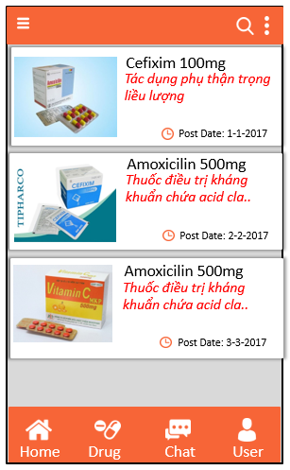

S1: Home Screen

|  |  |  |  |  |  |
| --- | --- | --- | --- | --- | --- |
| No | Component Name | Required | Format | Reference | Note |
| 1 | Background |  | Color: #F76537 |  |  |
| 2 | Button Default : Home, Drug, Chat, User |  | Color: #FFFFFF  Button image  Size : 32x32 |  | Default button, located at the bottom of the screen |
| 3 | Text view “title” |  | Text color :#000000  Font : Arial  Text size : 13sp |  |  |
| 4 | Text view “Description” |  | Text color: #FF2424  Font : Arial  Text size : 13sp  Text style : Italic |  |  |
| 5 | Text view “post date” |  | Text color: #000000  Font : Arial  Text size : 12sp |  |  |
| 6 | Button “Search” |  | Button image |  | Position : located on the right of the action bar |
| 7 | Image View |  | Gravity : left  Size : 400 x 400 |  |  |
| 8 | Drawer |  | Color: #000000 | Filter data by topic | Position: located on the left of the action bar |
| 9 | Option Menu |  | Color: #000000 | Sort the list | Position : located on the right of the action bar ,next to button Search |

* 1. **Drug List Screen**

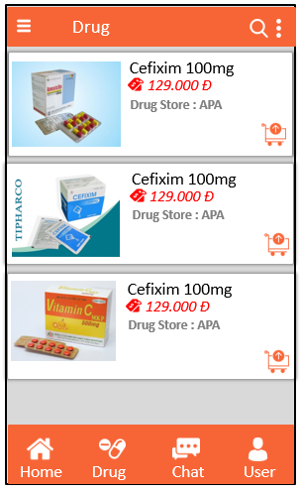

S2: Drug list

|  |  |  |  |  |  |
| --- | --- | --- | --- | --- | --- |
| No | Component Name | Required | Format | Reference | Note |
| 1 | Background action bar, background linear layout |  | Color: #F76537 |  |  |
| 2 | Button Default : Home, Drug, Chat, User |  | Color: #FFFFFF  Button image  Size : 32x32 |  | Default button, located at the bottom of the screen |
| 3 | Text view “title” |  | Text color :#000000  Font : Arial  Text size : 13sp |  |  |
| 4 | Text view “Cost” |  | Text color: #FF2424  Font : Arial  Text size : 13sp  Text style : Italic |  | Add icon in front of text view |
| 5 | Text view “Shop name” |  | Text color: #7D7D7D  Font : Arial  Text size : 12sp |  |  |
| 6 | Button “Search” |  | Button image |  | Position : located on the right of the action bar |
| 7 | Image View |  | Gravity : left  Size : 400 x 400 |  |  |
| 8 | Button “Cart” |  | Gravity :  the bottom right of the listview item  Button image | Save the product user want to buy in the cart |  |
| 9 | Drawer |  | Color: #000000 | Filter data by topic | Position: located on the left of the action bar |
| 10 | Option Menu |  | Color: #000000 | Sort the list | Position : located on the right of the action bar ,next to button Search |

* 1. **Chat management Screen**

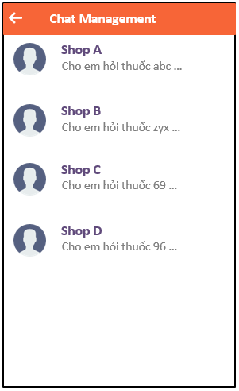

S3: Chat Management

|  |  |  |  |  |  |
| --- | --- | --- | --- | --- | --- |
| No | Component Name | Required | Format | Reference | Note |
| 1 | Background action bar |  | Color: #F76537 |  |  |
| 2 | Text view “Shop name” |  | Text color: #76648D  Font : Arial  Text size : 13sp  Text style : Italic |  |  |
| 3 | Text view “Content” |  | Text color: #7D7D7D  Font : Arial  Text size : 12sp |  |  |
| 4 | Image View |  | Gravity : left  Size : 400 x 400 |  |  |
| 5 | Button “back” |  | Color: #000000 | Return to previous screen | Position : located on the left of the action bar |

* 1. **Article Detail Screen**

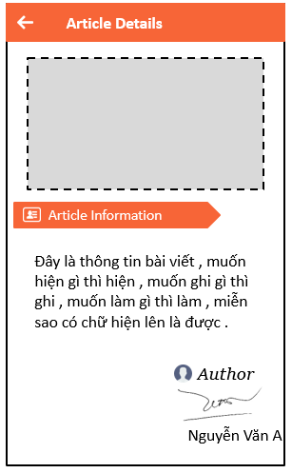

S4 : Article Detail

|  |  |  |  |  |  |
| --- | --- | --- | --- | --- | --- |
| No | Component Name | Required | Format | Reference | Note |
| 1 | Background action bar |  | Color: #F76537 |  |  |
| 2 | Text view “title content” |  | Text color: #FFFFFF  Background color : #F76537  Font : Arial  Text size : 13sp |  | Add icon in front of text view |
| 3 | Text view “Content” |  | Text color: #000000  Font : Arial  Text size : 13sp |  |  |
| 4 | Image View |  | Gravity : center  Size : 480 x 600 |  |  |
| 5 | Button “back” |  | Color: #000000 | Return to previous screen | Position : located on the left of the action bar |
| 6 | Text view “Author” |  | Text color: #000000  Font : Arial  Text size : 13sp |  |  |

* 1. **Drug Detail Screen**

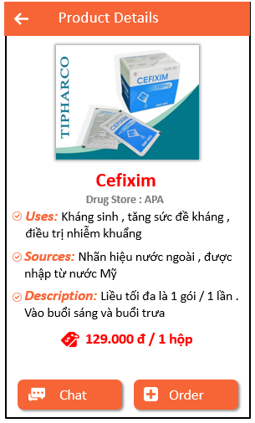

S5: Drug detail

|  |  |  |  |  |  |
| --- | --- | --- | --- | --- | --- |
| No | Component Name | Required | Format | Reference | Note |
| 1 | Background action bar |  | Color: #F76537 |  |  |
| 2 | Text view default  : uses, sources, desciption |  | Text color: #F76537  Font : Arial  Text size : 13sp |  | Add icon in front of text view |
| 3 | Text view “content” |  | Text color: #000000  Font : Arial  Text size : 13sp | Get data from firebase |  |
| 4 | Image View |  | Gravity : center  Size : 480 x 600 |  |  |
| 5 | Button “back” |  | Color: #000000 | Return to previous screen | Position : located on the left of the action bar |
| 6 | Text view “Tiltle of drug” |  | Text color: #76648D  Font : Arial  Text size : 13sp  Text style : Bold  Gravity : Center |  |  |
| 7 | Text view “Shop name” |  | Text color: #7D7D7D  Font : Arial  Text size : 12sp |  |  |
| 8 | Button “Chat “ |  | Text color: #FFFFFF  Background color : #F76537  Font : Arial  Text size : 13sp | Go to the chat screen | Add icon in front of text |
| 9 | Button “Order“ |  | Text color: #FFFFFF  Background color : #F76537  Font : Arial  Text size : 13sp | Go to the shopping cart screen | Add icon in front of text |
| 10 | Text view “Cost” |  | Text color: #FF2424  Font : Arial  Text size : 13sp  Text style : Bold |  | Add icon in front of text view |

* 1. **Chat Screen**

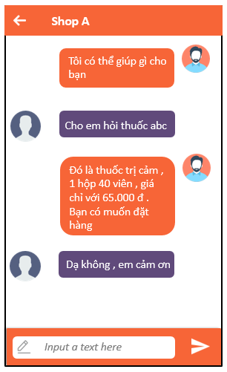

S6 : Chat Screen

|  |  |  |  |  |  |
| --- | --- | --- | --- | --- | --- |
| No | Component Name | Required | Format | Reference | Note |
| 1 | Background action bar |  | Color: #F76537 |  |  |
| 2 | Text view “content chat of user” |  | Text color: #FFFFFF  Background color :# 604A7B  Font : Arial  Text size : 13sp |  |  |
| 3 | Text view “content chat of seller” |  | Text color: #FFFFFF  Background color :#F76537  Font : Arial  Text size : 13sp |  |  |
| 4 | Image View of user |  | Gravity : left  Size : 300 x300 |  |  |
| 5 | Image View of seller |  | Gravity : right  Size : 300 x300 |  |  |
| 6 | Button “back” |  | Color: #000000 | Return to previous screen | Position : located on the left of the action bar |
| 7 | Edit text “input” |  | Text color: #000000  Background color :#F76537  Hint: “Input text here”  Font : Arial  Text size : 13sp |  | Add icon in front of text view |
| 8 | Button “send” |  | Image button  Color: #FFFFFF | Send chat data |  |

* 1. **Shopping Cart Screen**

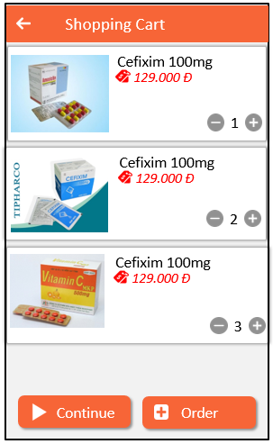

S7 : Shopping Cart

|  |  |  |  |  |  |
| --- | --- | --- | --- | --- | --- |
| No | Component Name | Required | Format | Reference | Note |
| 1 | Background action bar |  | Color: #F76537 |  |  |
| 2 | Text view “tilte of drug” |  | Text color: #000000  Font : Arial  Text size : 13sp |  |  |
| 3 | Text view “Cost” |  | Text color: #FF2424  Font : Arial  Text size : 13sp  Text style : Italic |  | Add icon in front of text view |
| 4 | Image View |  | Gravity : left  Size : 300 x300 |  |  |
| 5 | Custom view “-” |  | Background color : #D9D9D9  Text color : #FFFFFF |  |  |
| 6 | Custom view “+” |  | Background color : #D9D9D9  Text color : #FFFFFF |  |  |
| 7 | Edit text |  | Text color: #000000  Font : Arial  Text size : 13sp |  |  |
| 8 | Button “back” |  | Color: #000000 | Return to previous screen | Position : located on the left of the action bar |
| 9 | Button “Continue “ |  | Text color: #FFFFFF  Background color : #F76537  Font : Arial  Text size : 13sp | Go to the shopping cart screen | Add icon in front of text |
| 10 | Button “Order“ |  | Text color: #FFFFFF  Background color : #F76537  Font : Arial  Text size : 13sp | Go to the payment confirmation screen | Add icon in front of text |

* 1. **Payment Confirmation Screen**

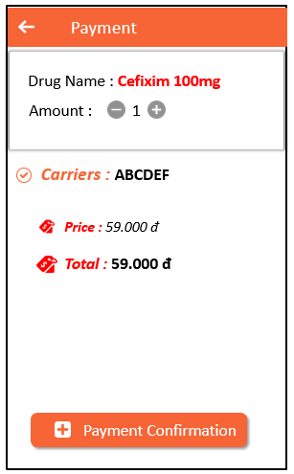

S8 : Payment Confirmation

|  |  |  |  |  |  |
| --- | --- | --- | --- | --- | --- |
| No | Component Name | Required | Format | Reference | Note |
| 1 | Background action bar |  | Color: #F76537 |  |  |
| 2 | Text view “tilte of drug” |  | Text color: #FF2424  Font : Arial  Text size : 13sp |  |  |
| 3 | Text view default : Drug name, amount |  | Text color: #000000  Font : Arial  Text size : 13sp |  |  |
| 4 | Text view default : Price, total |  | Text color: #FF2424  Font : Arial  Text size : 13sp |  | Add icon in front of text |
| 5 | Custom view “-” |  | Background color : #D9D9D9  Text color : #FFFFFF |  |  |
| 6 | Custom view “+” |  | Background color : #D9D9D9  Text color : #FFFFFF |  |  |
| 7 | Edit text |  | Text color: #000000  Font : Arial  Text size : 13sp |  |  |
| 8 | Button “Payment Confirmation“ |  | Text color: #FFFFFF  Background color : #F76537  Font : Arial  Text size : 13sp | Go to the shopping cart screen | Add icon in front of text |

* 1. **Login or Register Screen**

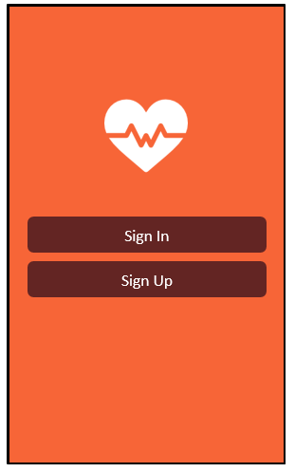

S9 : Login or Register

|  |  |  |  |  |  |
| --- | --- | --- | --- | --- | --- |
| No | Component Name | Required | Format | Reference | Note |
| 1 | Background |  | Color: #F76537 |  |  |
| 2 | Button Sign in |  | Text color: #FFFFFF  Background color: #632523  Font : Arial  Text size : 13sp  Layout gravity : Center |  |  |
| 3 | Button Sign Up |  | Text color: #FFFFFF  Background color: #632523  Font : Arial  Text size : 13sp  Layout gravity : Center |  |  |
| 4 | Logo |  | Color : #FFFFFF  Gravity : Center  Image view |  |  |

* 1. **Login Screen**

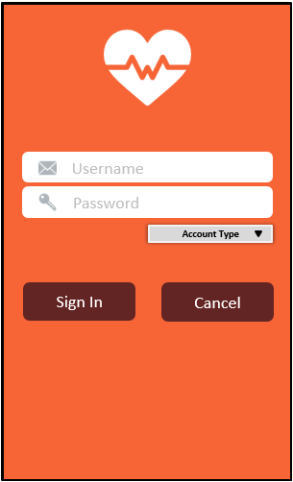

S10 : Login

|  |  |  |  |  |  |
| --- | --- | --- | --- | --- | --- |
| No | Component Name | Required | Format | Reference | Note |
| 1 | Background |  | Color: #F76537 |  |  |
| 2 | Edit Text “Username” |  | Background color: #EEEEEE  Text color: #D4D4D4 |  |  |
| 3 | Edit Text “Password” |  | Background color: #EEEEEE  Text color: #D4D4D4 |  |  |
| 4 | Spinner “Account Type” |  | Background color: #D9D9D9  Text color: #000000  Font: Arial  Size: 10sp |  |  |
| 5 | Sign In button |  | Background color: #632523  Text color: #EEEEEE  Font : Arial  Text size : 13sp  Text style : Italic |  |  |
| 6 | Cancel button |  | Background color: #632523  Text color: #EEEEEE  Font : Arial  Text size : 13sp  Text style : Italic |  |  |

* 1. **Register**

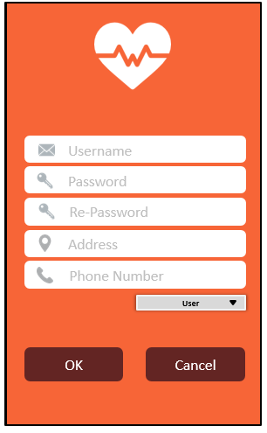

S11 : Register

|  |  |  |  |  |  |
| --- | --- | --- | --- | --- | --- |
| No | Component Name | Required | Format | Reference | Note |
| 1 | Background |  | Color: #F76537 |  |  |
| 2 | Edit Text “Username” |  | Background color: #EEEEEE  Text color: #D4D4D4 |  |  |
| 3 | Edit Text “Password” |  | Background color: #EEEEEE  Text color: #D4D4D4 |  |  |
| 4 | Spinner “Account Type” |  | Background color: #D9D9D9  Text color: #000000  Font: Arial  Size: 10sp |  |  |
| 5 | OK button |  | Background color: #632523  Text color: #EEEEEE  Font : Arial  Text size : 13sp  Text style : Italic |  |  |
| 6 | Cancel button |  | Background color: #632523  Text color: #EEEEEE  Font : Arial  Text size : 13sp  Text style : Italic |  |  |
| 7 | Edit Text “Re-Password” |  | Background color: #EEEEEE  Text color: #D4D4D4 |  |  |
| 8 | Edit Text “Address” |  | Background color: #EEEEEE  Text color: #D4D4D4 |  |  |
| 9 | Edit Text “Phone Number” |  | Background color: #EEEEEE  Text color: #D4D4D4 |  |  |

* 1. **Account Management (User) Screen**

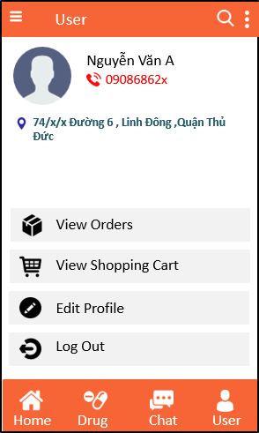

\

S12 : Account managment

|  |  |  |  |  |  |
| --- | --- | --- | --- | --- | --- |
| No | Component Name | Required | Format | Reference | Note |
| 1 | Background |  | Color: #F76537 |  |  |
| 2 | Text view “Title” |  | Text color :#000000  Font : Arial  Text size : 13sp |  |  |
| 3 | Text view “ Name” |  | Text color: #000000  Font : Arial  Text size : 13sp  Text style : Italic |  |  |
| 4 | Text view “Phone Number” |  | Text color: #FF0000  Font : Arial  Text size : 12sp |  |  |
| 5 | Text View “Adress” |  | Text color: #2E6271  Font: Arial  Text size: 12sp |  |  |
| 6 | Image View “Add Photo” |  | Size: 64x64 |  |  |
| 7 | Button |  | Color: #FFFFFF  Button image  Size : 32x32 |  | Default button, located at the bottom of the screen |
| 8 | View Orders button |  | Text color: #000000  Font: Arial  Text size: 12sp  Image View |  |  |
| 9 | View Shopping Cart button |  | Text color: #000000  Font: Arial  Text size: 12sp  Image View |  |  |
| 10 | Log Out |  | Text color: #000000  Font: Arial  Text size: 12sp  Image View |  |  |
| 11 | Edit Profile |  | Text color: #000000  Font: Arial  Text size: 12sp  Image View |  |  |

* 1. **View Order Screen**

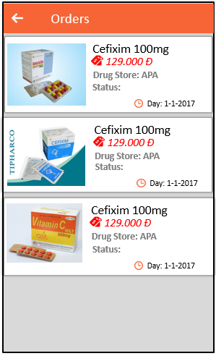

S13 : View Order

|  |  |  |  |  |  |
| --- | --- | --- | --- | --- | --- |
| No | Component Name | Required | Format | Reference | Note |
| 1 | Background |  | Color: #F76537 |  |  |
| 2 | Back Button |  | Color: #EEEEEE  Button image  Size : 32x32 |  | Position: located on the left on the action bar |
| 3 | Text view “Title” |  | Text color :#000000  Font : Arial  Text size : 13sp |  |  |
| 4 | Text view “Prices” |  | Text color: #FF0000  Font : Arial  Text size : 13sp  Text style : Italic |  |  |
| 5 | Text view “post date” |  | Text color: #000000  Font : Arial  Text size : 12sp |  |  |
| 6 | Text View “Drug’s Store” |  | Text color: #666666  Font: Arial  Text size: 12sp |  | Position : located on the right of the action bar |
| 7 | Text View “Status” |  | Text color: #666666  Font: Arial  Text size: 12sp |  |  |
| 8 | Text View “Drug’s Name” |  | Text color: #000000  Font: Arial  Text size: 12sp |  | Position: located on the bottom of the end of screen |
| 9 | Image View Drugs |  | Size: 128x128 |  |  |

* 1. **Account Management Screen**

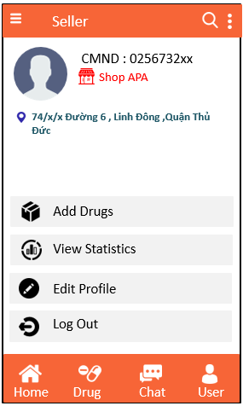

S14 : Seller Account

|  |  |  |  |  |  |
| --- | --- | --- | --- | --- | --- |
| No | Component Name | Required | Format | Reference | Note |
| 1 | Background |  | Color: #F76537 |  |  |
| 2 | Text view “Title” |  | Text color :#000000  Font : Arial  Text size : 13sp |  |  |
| 3 | Text view “ CMND” |  | Text color: #000000  Font : Arial  Text size : 13sp  Text style : Italic |  |  |
| 4 | Text view “Shop’s Name” |  | Text color: #FF0000  Font : Arial  Text size : 12sp |  |  |
| 5 | Text View “Adress” |  | Text color: #2E6271  Font: Arial  Text size: 12sp |  |  |
| 6 | Image View “Add Photo” |  | Size: 64x64 |  |  |
| 7 | Button |  | Color: #FFFFFF  Button image  Size : 32x32 |  | Default button, located at the bottom of the screen |
| 8 | Add Drugs button |  | Text color: #000000  Font: Arial  Text size: 12sp  Image View |  |  |
| 9 | View Statistics button |  | Text color: #000000  Font: Arial  Text size: 12sp  Image View |  |  |
| 10 | Log Out |  | Text color: #000000  Font: Arial  Text size: 12sp  Image View |  |  |
| 11 | Edit Profile |  | Text color: #000000  Font: Arial  Text size: 12sp  Image View |  |  |

* 1. **Entering Drugs Screen**

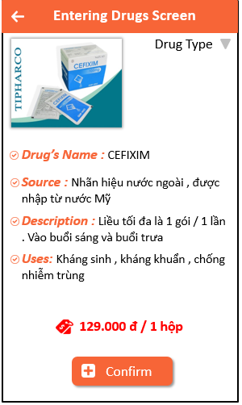

S15 : Entering Drug

|  |  |  |  |  |  |
| --- | --- | --- | --- | --- | --- |
| No | Component Name | Required | Format | Reference | Note |
| 1 | Background |  | Color: #F76537 |  |  |
| 2 | Back Button |  | Color: #EEEEEE  Button image  Size : 32x32 |  | Position: located on the left on the action bar |
| 3 | Text view “Title” |  | Text color :#000000  Font : Arial  Text size : 13sp |  |  |
| 4 | Text view “Drug’s Name” |  | Text color: # F76537  Font : Arial  Text size : 13sp  Text style : Italic  Image View |  |  |
| 5 | Text view “Uses” |  | Text color: # F76537  Font : Arial  Text size : 13sp  Text style : Italic  Image View |  |  |
| 6 | Text view “Description” |  | Text color: # F76537  Font : Arial  Text size : 13sp  Text style : Italic  Image View |  |  |
| 7 | Text view “Sources” |  | Text color: # F76537  Font : Arial  Text size : 13sp  Text style : Italic  Image View |  |  |
| 8 | Text View “Price” |  | Text color: #FF0000  Font: Arial  Size: 13sp  Image View |  |  |
| 9 | Confirm button |  | Background color: #F76537  Text color: #EEEEEE  Size: 13sp  Image view  Font : Arial |  |  |
| 10 | Spinner Arrange Drug Type |  | Text color: #000000  Font: Arial  Size: 13sp |  |  |
| 11 | Image View Drug |  | Size 128x128 |  |  |

* 1. **Sales Statistics Screen**

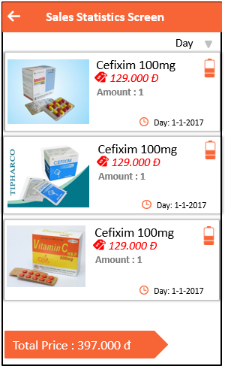

S16 : Sales Statistics

|  |  |  |  |  |  |
| --- | --- | --- | --- | --- | --- |
| No | Component Name | Required | Format | Reference | Note |
| 1 | Background |  | Color: #F76537 |  |  |
| 2 | Back Button |  | Color: #EEEEEE  Button image  Size : 32x32 |  | Position: located on the left on the action bar |
| 3 | Text view “Title” |  | Text color :#000000  Font : Arial  Text size : 13sp |  |  |
| 4 | Text view “Prices” |  | Text color: #FF0000  Font : Arial  Text size : 13sp  Text style : Italic |  |  |
| 5 | Text view “post date” |  | Text color: #000000  Font : Arial  Text size : 12sp |  |  |
| 6 | Text View “Drug’s Name” |  | Text color: #000000  Font: Arial  Text size: 12sp |  | Position : located on the right of the action bar |
| 7 | Text View “Amount” |  | Text color: #666666  Font: Arial  Text size: 12sp |  |  |
| 8 | Text View “Total Price” |  | Text color: #EEEEEE  Background color: #F76537  Font: Arial  Text size: 12sp |  | Position: located on the bottom of the end of screen |
| 9 | Spinner arrange |  | Text color: #000000  Font: Arial  Text size: 12sp |  | Position: located on the right and below of the Title Screen |
| 10 | Image View Drugs |  | Size: 128x128 |  |  |

* 1. **Account Management Screen (Carrier)**

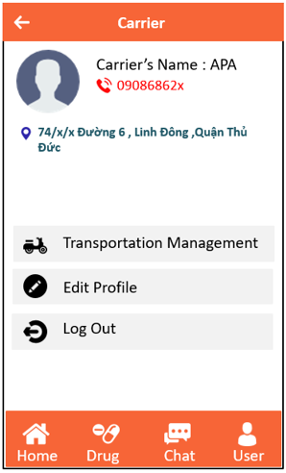

S17 : Carrier Account

|  |  |  |  |  |  |
| --- | --- | --- | --- | --- | --- |
| No | Component Name | Required | Format | Reference | Note |
| 1 | Background |  | Color: #F76537 |  |  |
| 2 | Back Button |  | Color: #EEEEEE  Button image  Size : 32x32 |  | Position: located on the left on the action bar |
| 3 | Text view “Title” |  | Text color :#000000  Font : Arial  Text size : 13sp |  |  |
| 4 | Text view “Carrier’s Name” |  | Text color: #000000  Font : Arial  Text size : 13sp  Text style : Italic |  |  |
| 5 | Text view “Phone Number” |  | Text color: #FF0000  Font : Arial  Text size : 12sp |  |  |
| 6 | Text View “Address” |  | Text color: #2E6271  Font: Arial  Text size: 12sp |  |  |
| 7 | Image View “Add Photo” |  | Size: 64x64 |  |  |
| 8 | Button |  | Color: #FFFFFF  Button image  Size : 32x32 |  | Default button, located at the bottom of the screen |
| 9 | Transportation Management button |  | Text color: #000000  Font: Arial  Text size: 12sp  Image View |  |  |
| 10 | Log Out |  | Text color: #000000  Font: Arial  Text size: 12sp  Image View |  |  |
| 11 | Edit Profile |  | Text color: #000000  Font: Arial  Text size: 12sp  Image View |  |  |

* 1. **Transportation Management Screen**

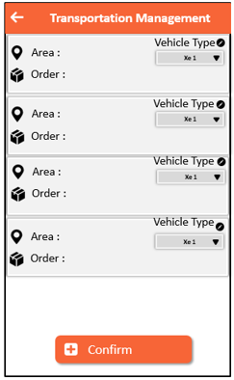

S18 : Transportation Management

|  |  |  |  |  |  |
| --- | --- | --- | --- | --- | --- |
| No | Component Name | Required | Format | Reference | Note |
| 1 | Background |  | Color: #F76537 |  |  |
| 2 | Back Button |  | Color: #EEEEEE  Button image  Size : 32x32 |  | Position: located on the left on the action bar |
| 3 | Text view “Area” |  | Text color :#000000  Font : Arial  Text size : 13sp  Image View |  |  |
| 4 | Text view “Order” |  | Text color: #000000  Font : Arial  Text size : 13sp  Text style : Italic  Image View |  |  |
| 5 | Text view “Vehicle Type” |  | Text color: #000000  Font : Arial  Text size : 12sp  Image View |  |  |
| 6 | Confirm button |  | Background color: #F76537  Text color: #EEEEEE  Image View |  |  |
| 7 | Spinner Type of Vehicle |  | Background color: #D9D9D9  Text color: #000000  Font: Arial  Size: 10sp |  |  |

* 1. **Account Management Screen (Shipper)**

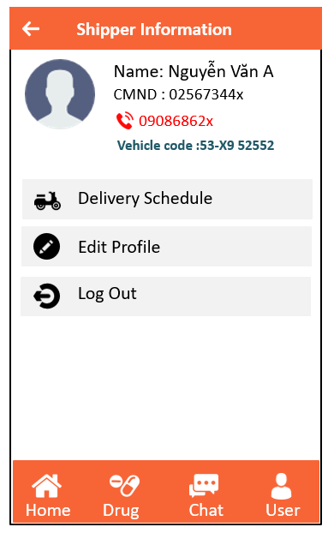

S19 : Shipper Account

|  |  |  |  |  |  |
| --- | --- | --- | --- | --- | --- |
| No | Component Name | Required | Format | Reference | Note |
| 1 | Background |  | Color: #F76537 |  |  |
| 2 | Back Button |  | Color: #EEEEEE  Button image  Size : 32x32 |  | Position: located on the left on the action bar |
| 3 | Text view “Title” |  | Text color :#000000  Font : Arial  Text size : 13sp |  |  |
| 4 | Text view “CMND” |  | Text color :#000000  Font : Arial  Text size : 13sp |  |  |
| 5 | Text view “ Name” |  | Text color: #000000  Font : Arial  Text size : 13sp  Text style : Italic |  |  |
| 6 | Text view “Phone Number” |  | Text color: #FF0000  Font : Arial  Text size : 12sp |  |  |
| 7 | Text View “Vehicle code” |  | Text color: #2E6271  Font: Arial  Text size: 12sp |  |  |
| 8 | Image View “Add Photo” |  | Size: 64x64 |  |  |
| 9 | Button |  | Color: #FFFFFF  Button image  Size : 32x32 |  | Default button, located at the bottom of the screen |
| 10 | Delivery Schedule button |  | Text color: #000000  Font: Arial  Text size: 12sp  Image View |  |  |
| 11 | Log Out |  | Text color: #000000  Font: Arial  Text size: 12sp  Image View |  |  |
| 12 | Edit Profile |  | Text color: #000000  Font: Arial  Text size: 12sp  Image View |  |  |

* 1. **Delivery Schedules Screen**

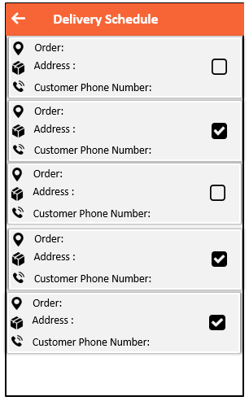

S20 : Delivery Schedule

|  |  |  |  |  |  |
| --- | --- | --- | --- | --- | --- |
| No | Component Name | Required | Format | Reference | Note |
| 1 | Background |  | Color: #F76537 |  |  |
| 2 | Back Button |  | Color: #EEEEEE  Button image  Size : 32x32 |  | Position: located on the left |
| 3 | Text view “Address” |  | Text color :#000000  Font : Arial  Text size : 13sp  Image View |  |  |
| 4 | Text view “Order” |  | Text color: #000000  Font : Arial  Text size : 13sp  Text style : Italic  Image View |  |  |
| 5 | Text view “Customer Phone Number” |  | Text color: #000000  Font : Arial  Text size : 13sp  Text style : Italic  Image View |  |  |
| 6 | Checkbox selected |  | background color: #000000 | Check box is selected |  |