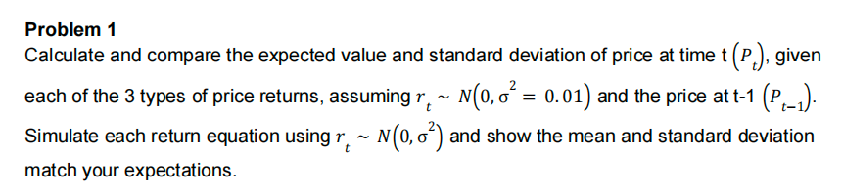

For simplicity, I use first 5 days of SPY price and simulate their next days price, the mean and std meet my expectation overall. Classic price’s std is small because it’s formula is count as drift term directly as price difference, and the rt simulation is small so its std is small. By looking at actual price, it’s actual price is more fluctuated than simulation, if we want to simulate the Pt, we should increase variance of simulation.

Output of code:

for day1 SPY price, expected price is (443.04376997495604, 443.39794583318314, 445.6724504270646), std is (0.10126840145807187, 44.866253222550824, 45.09769910775857)

for day2 SPY price, expected price is (440.0629573968157, 439.33924014928994, 441.589979762478), std is (0.10112891442988567, 44.50325585476032, 44.71544832475863)

for day3 SPY price, expected price is (438.7153777436695, 439.5368640445973, 441.76630831244216), std is (0.10069446085640182, 44.17601945125952, 44.439911670363685)

for day4 SPY price, expected price is (439.37407227080183, 439.28845456604506, 441.6246082024265), std is (0.10312420604802766, 45.31012250192765, 45.49365152488549)

for day5 SPY price, expected price is (442.26440143994415, 442.4920679662477, 444.6592738501966), std is (0.09859262943665519, 43.60395937612404, 44.288698178415075)

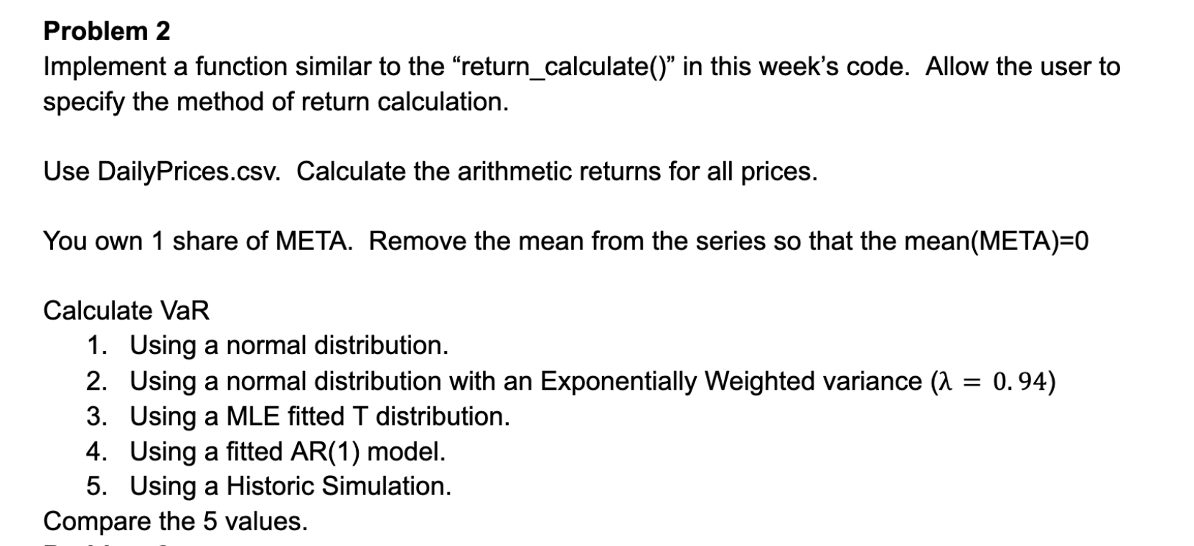

Here the value of investment is last day price of Meta in ‘DailyPrice’,around 521$

for historic simulation, I didn’t use remove mean list because it will lose meaning. VaR of those five method overall meet my expectation.

Output of code:

Delta-Normal VaR: $19.94

EWMA VaR: $15.46

MLE t-distribution VaR: $16.42

AR(1) VaR: $19.83

Historic Simulation VaR: $13.74

