BumbleBee - GOLD CABIN Lab

Scenario
CompliantSecure Company has fallen victim to a significant security breach initiated by a phishing email. An unsuspecting employee interacted with the malicious email, allowing the attacker to infiltrate the company's network. Leveraging this initial access, the attacker escalated privileges, gaining control over critical systems, including the Domain Controller.
This breach has resulted in substantial operational disruption, raising concerns about potential exposure or compromise of sensitive data. Your team has been assigned the critical task of investigating the incident to unravel the attack’s progression and assess the full scope of the compromise.
I. Initial Access
1. The Mail Server logs indicate a connection was made to a suspicious domain known for malicious email activities. What was the IP address of the domain involved in this connection?
- Start your investigation at the mail server. What external IPs were it communicating with?
- Use Kibana to query mail logs for SMTP activities on MAIL01. Watch for IP addresses related to known phishing domains.
- A malicious IP address connected to the mail server to submit an email, check the logs for suspicious IP addresses.

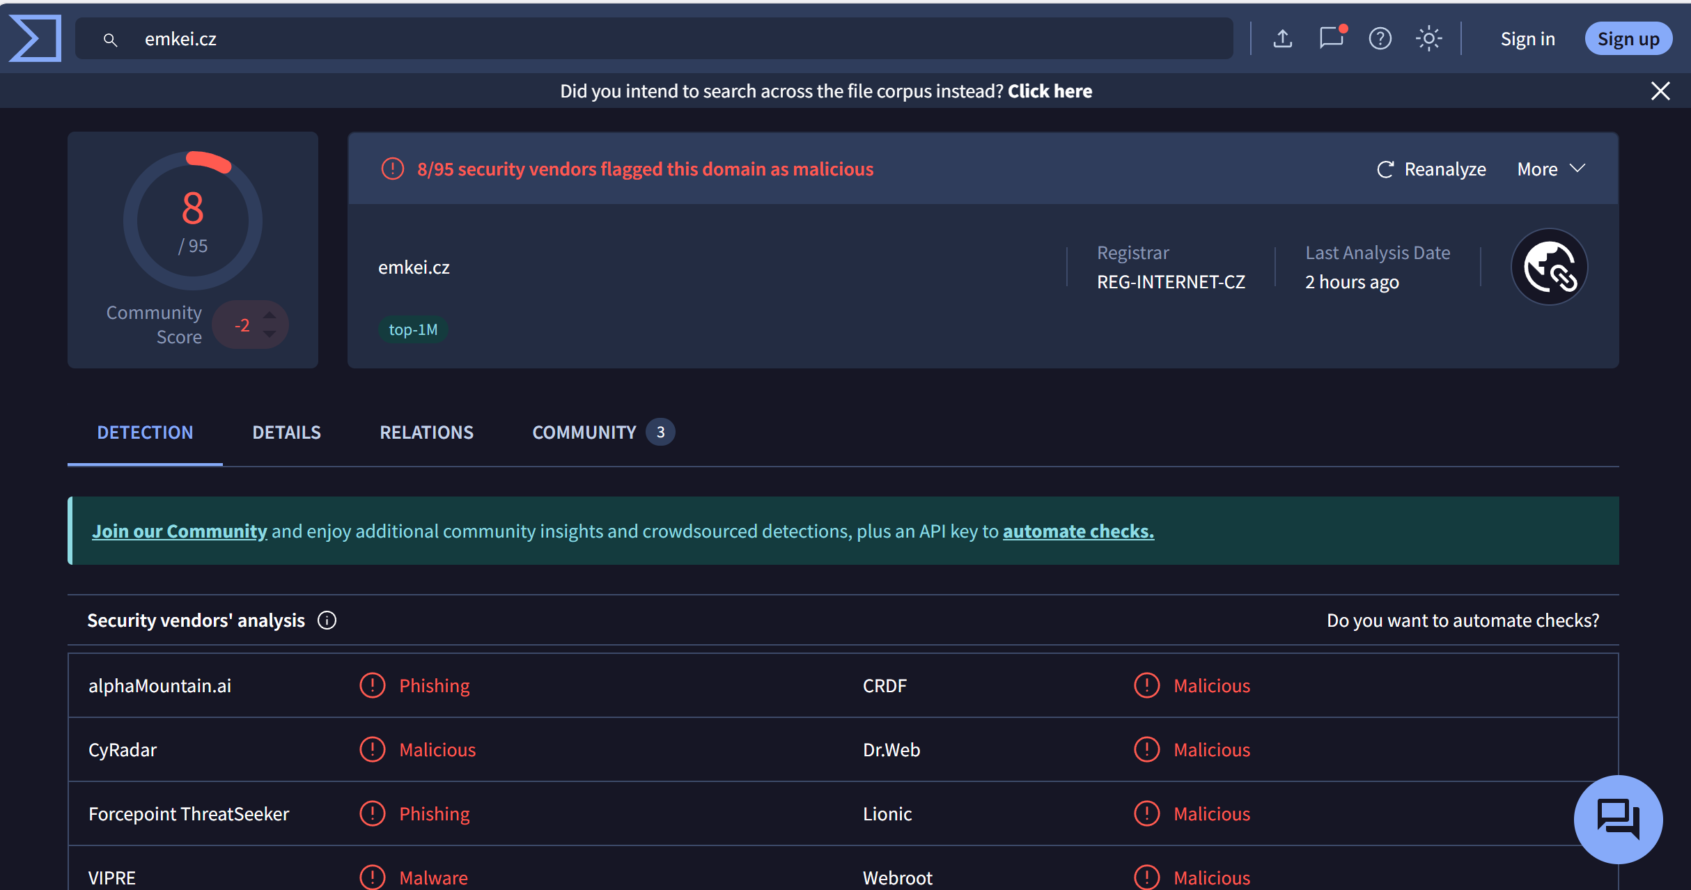
domain : emkei.cz
Answer: 114.29.236.247

Q2: During the initial phase of the attack, a suspicious file was downloaded via a webmail client. The file's hash can help confirm its identity and origin. Identify the SHA256 hash of the downloaded file and provide it.
- Examine file creation logs around the time the phishing email was interacted with.
- Focus on Sysmon Event IDs 11 and 15 related to file creation. Look in the Downloads folder for files with indicators like iso files.

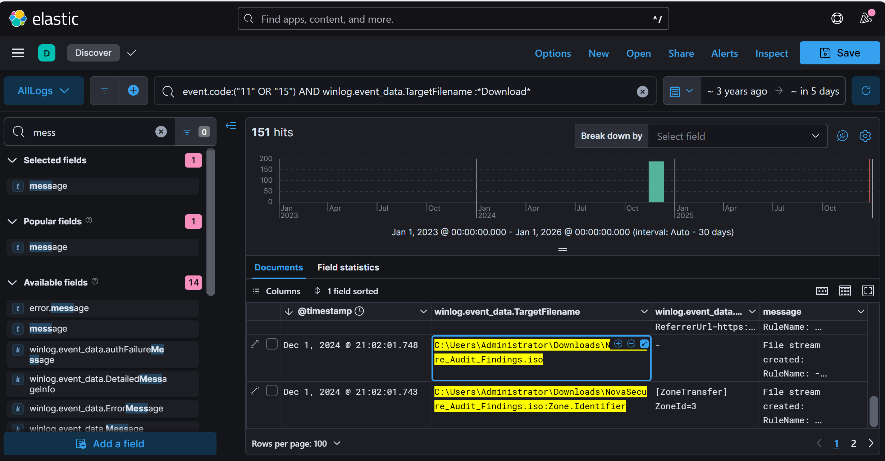
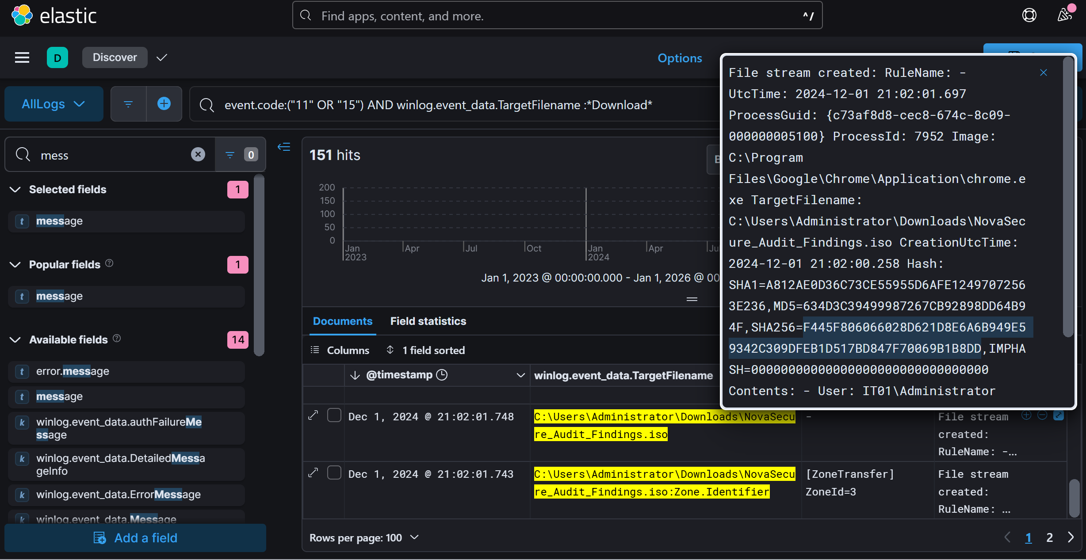

Answer: SHA256=F445F806066028D621D8E6A6B949E59342C309DFEB1D517BD847F70069B1B8DD
II. Execution
Q3: During the investigation, it was identified that a file executed by the user initiated a series of events that led to the execution of malicious code. What is the name of the file executed by the user?
- Consider what file might be executed immediately after opening a phishing-delivered ISO.
- Trace Sysmon Event ID 1 for process creation from explorer.exe. Look for suspicious shortcut files.
- Locate an LNK file inside the ISO. This .lnk file executed rundll32.exe with a DLL payload—evidence it was the trigger.

