Kerberoasted Lab Official Walkthrough

Scenario
As a diligent cyber threat hunter, your investigation begins with a hypothesis: 'Recent trends suggest an upsurge in Kerberoasting attacks within the industry. Could your organization be a potential target for this attack technique?' This hypothesis lays the foundation for your comprehensive investigation, starting with an in-depth analysis of the domain controller logs to detect and mitigate any potential threats to the security landscape.
Note: Your Domain Controller is configured to audit Kerberos Service Ticket Operations, which is necessary to investigate kerberoasting attacks. Additionally, Sysmon is installed for enhanced monitoring.
Q1: To mitigate Kerberoasting attacks effectively, we need to strengthen the encryption Kerberos protocol uses. What encryption type is currently in use within the network?
- Review logs for service ticket requests, focusing on entries mentioning encryption types. Have you checked any event IDs that could help detect a Kerberoasting attack?
- Event ID 4769 logs information about Kerberos Service Ticket Requests, including the encryption type used. This event is important to analyze the strength of encryption used in Kerberos tickets.
- In your query, filter Event ID 4769 and examine the TicketEncryptionType field to identify any weak encryption types.
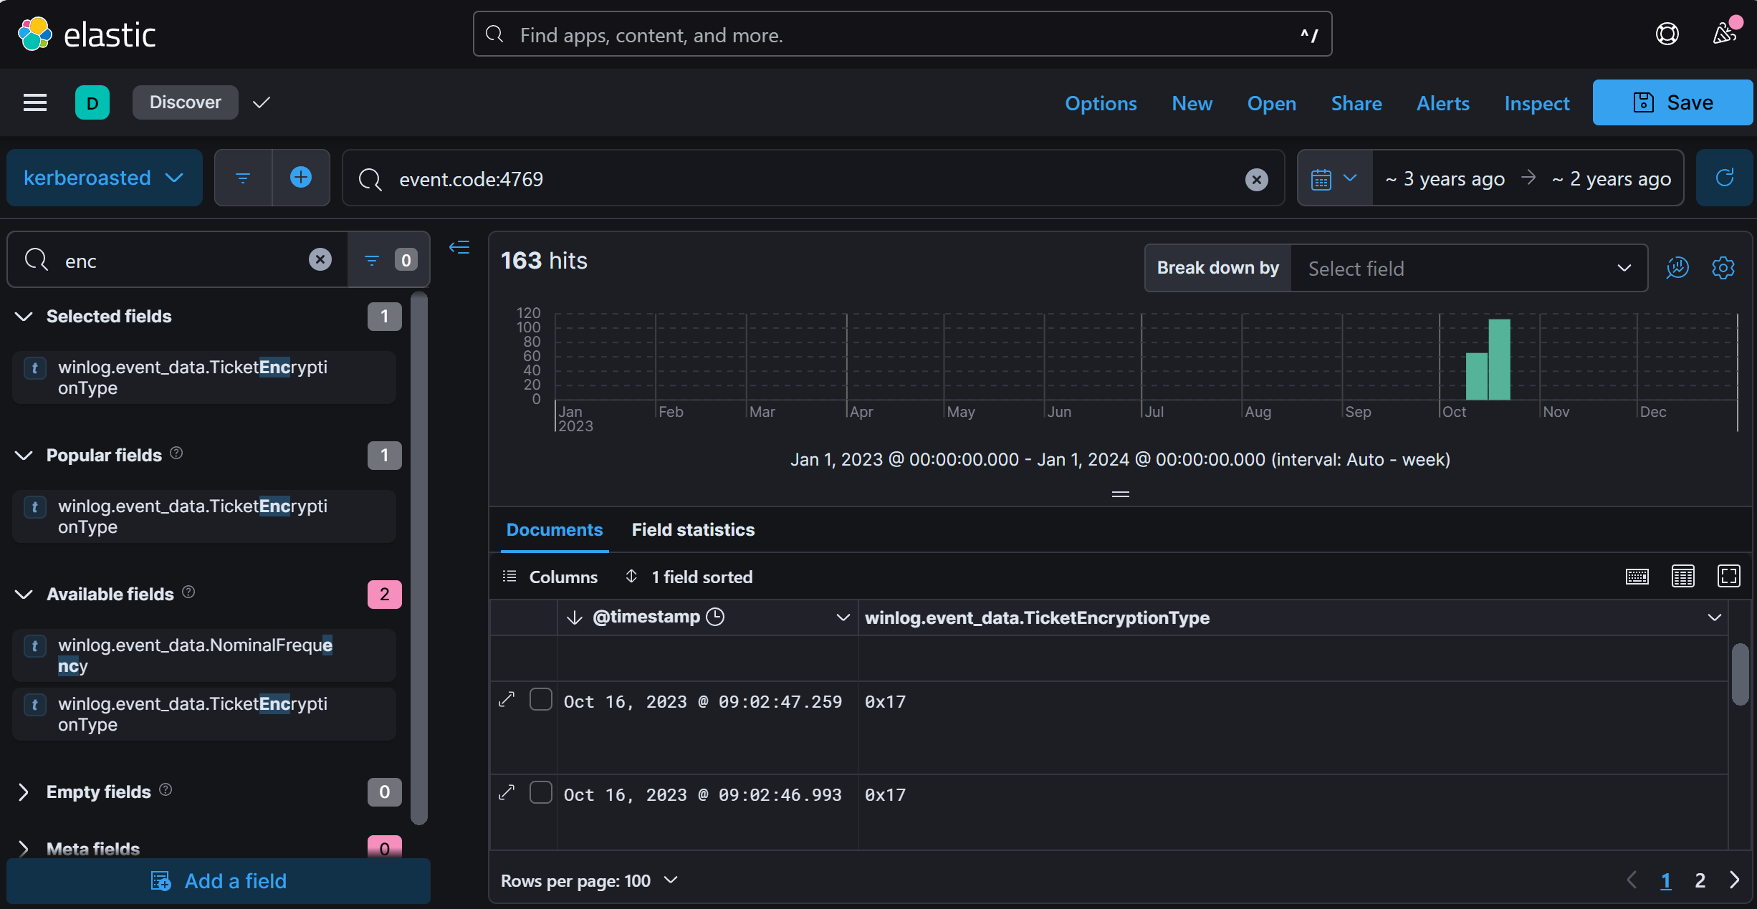

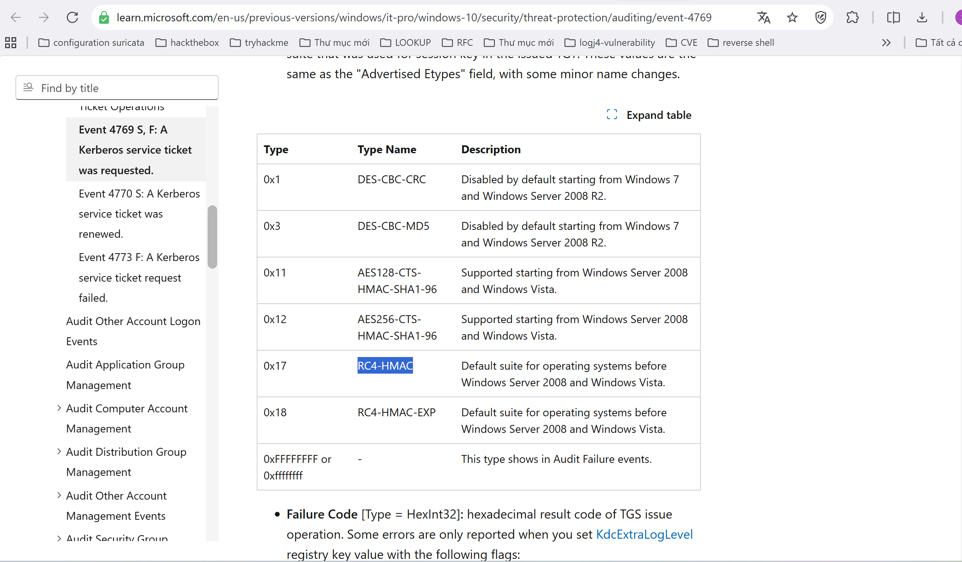
Answer: RC4-HMAC (0x17)
Q2: What is the username of the account that sequentially requested Ticket Granting Service (TGS) for two distinct application services within a short timeframe?
- Look for repeated Ticket Granting Service (TGS) requests from a single user over a brief period. Focus on Event ID 4769.
- Within your query, examine Event ID 4769 for repeated TGS requests, paying attention to TargetUserName and ServiceName to detect patterns of sequential service access.
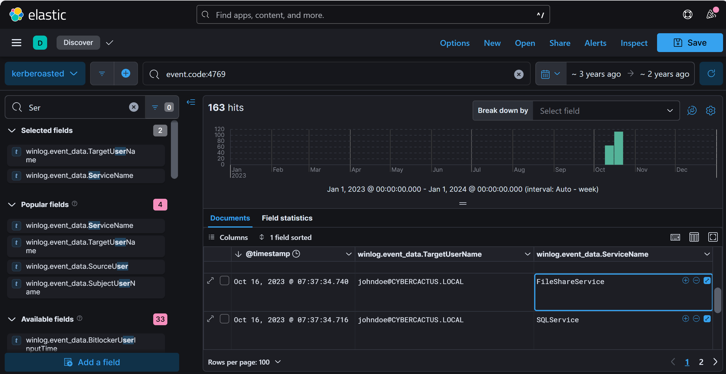
Answer: johndoe
Q3: We must delve deeper into the logs to pinpoint any compromised service accounts for a comprehensive investigation into potential successful kerberoasting attack attempts. Can you provide the account name of the compromised service account?
- Look for TGS requests to service accounts by examining Event ID 4769 in your query. Service accounts associated with administrative privileges or high-value services are typically high-risk.
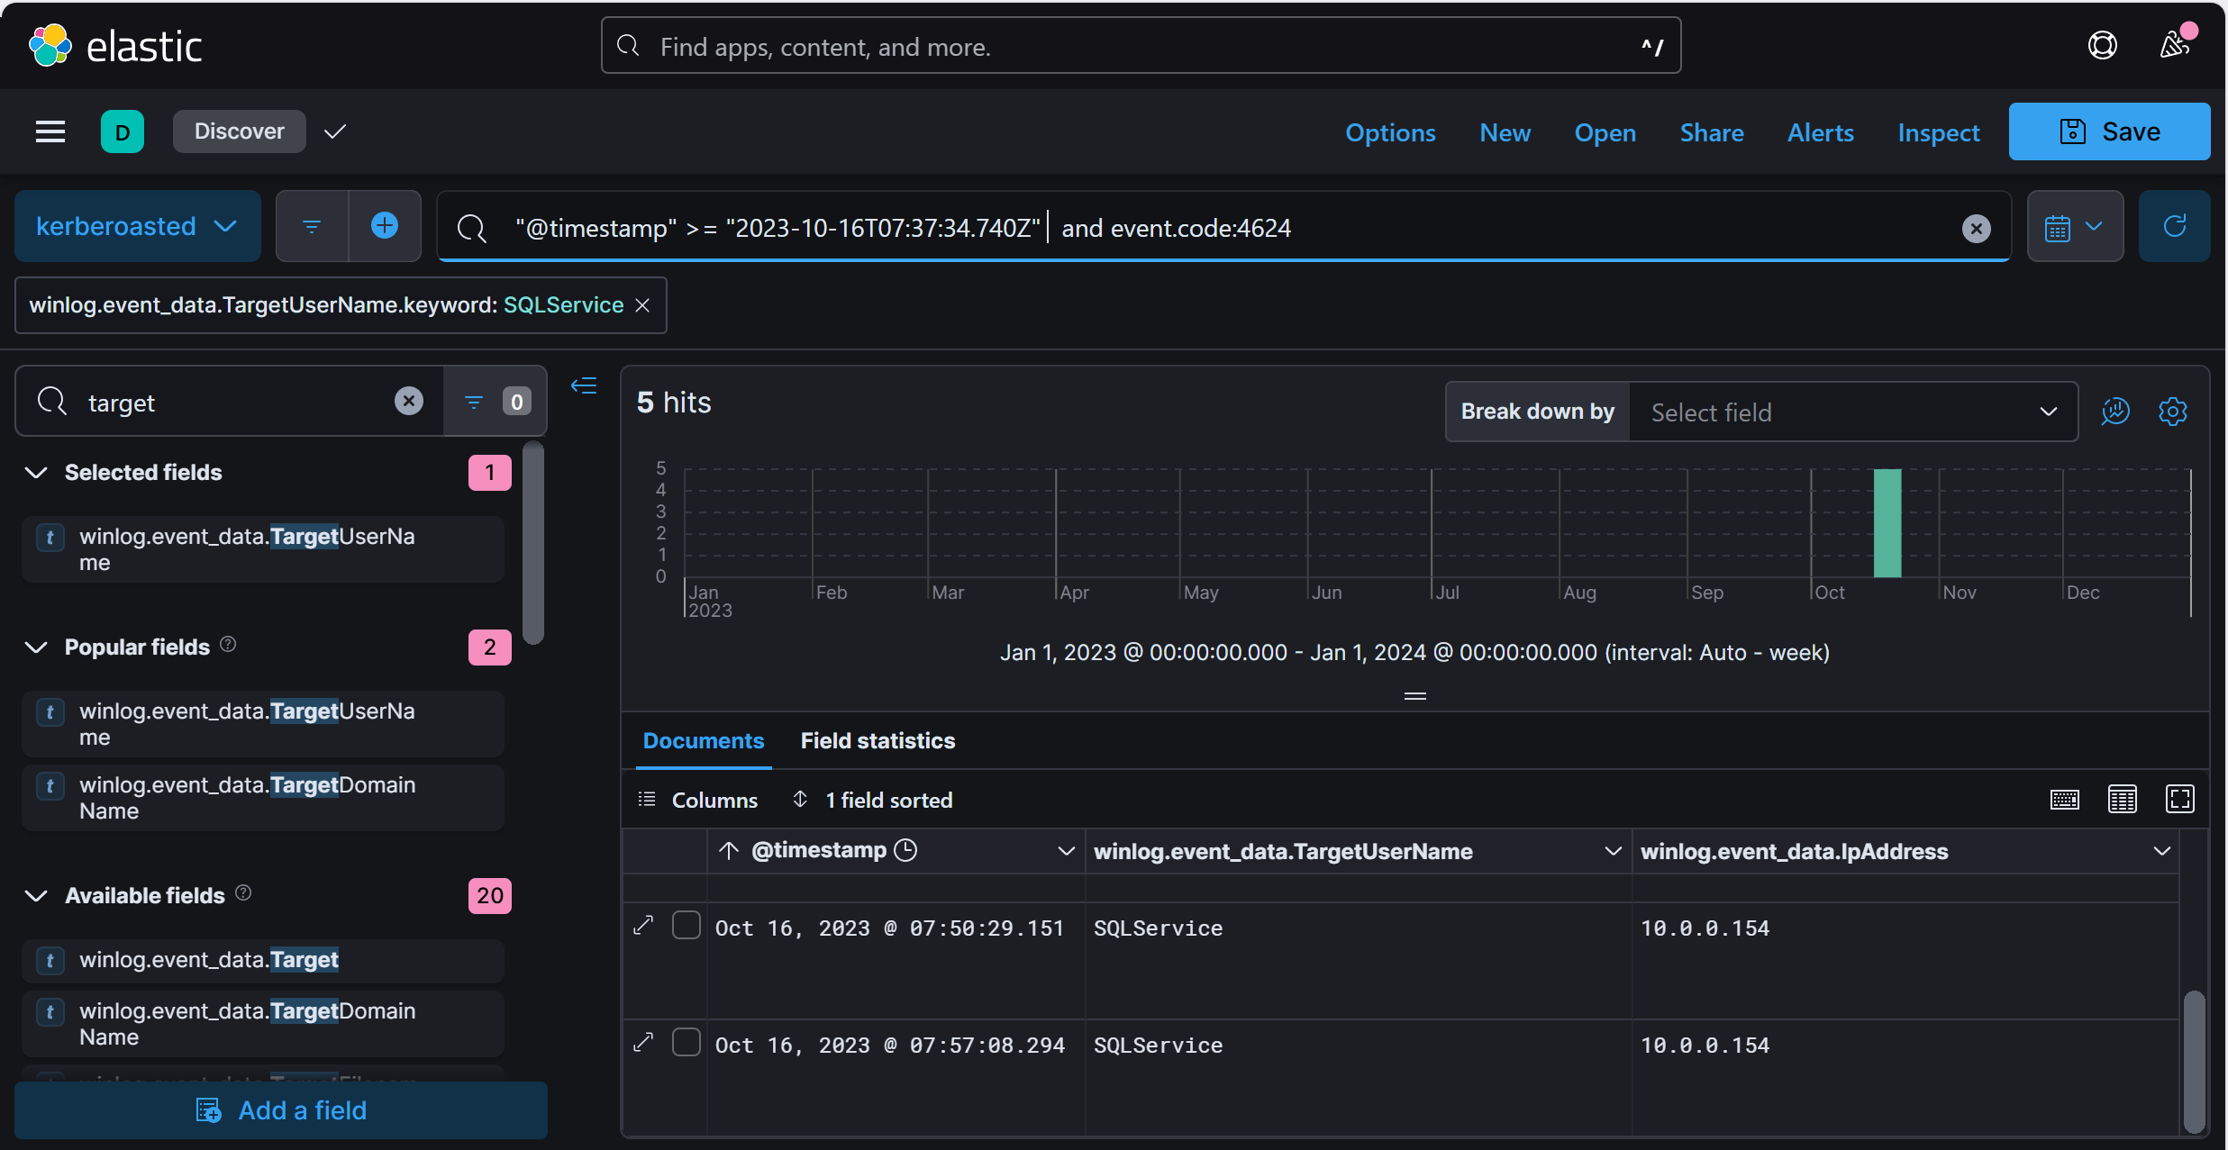

Query: SQLService

Q4: To track the attacker's entry point, we need to identify the machine initially compromised by the attacker. What is the machine's IP address?
- Look for successful logons associated with the user suspected of Kerberoasting activity from your previous analysis.
- Event ID 4624 logs successful logons and includes the SourceIPAddress, which can help identify the originating IP.
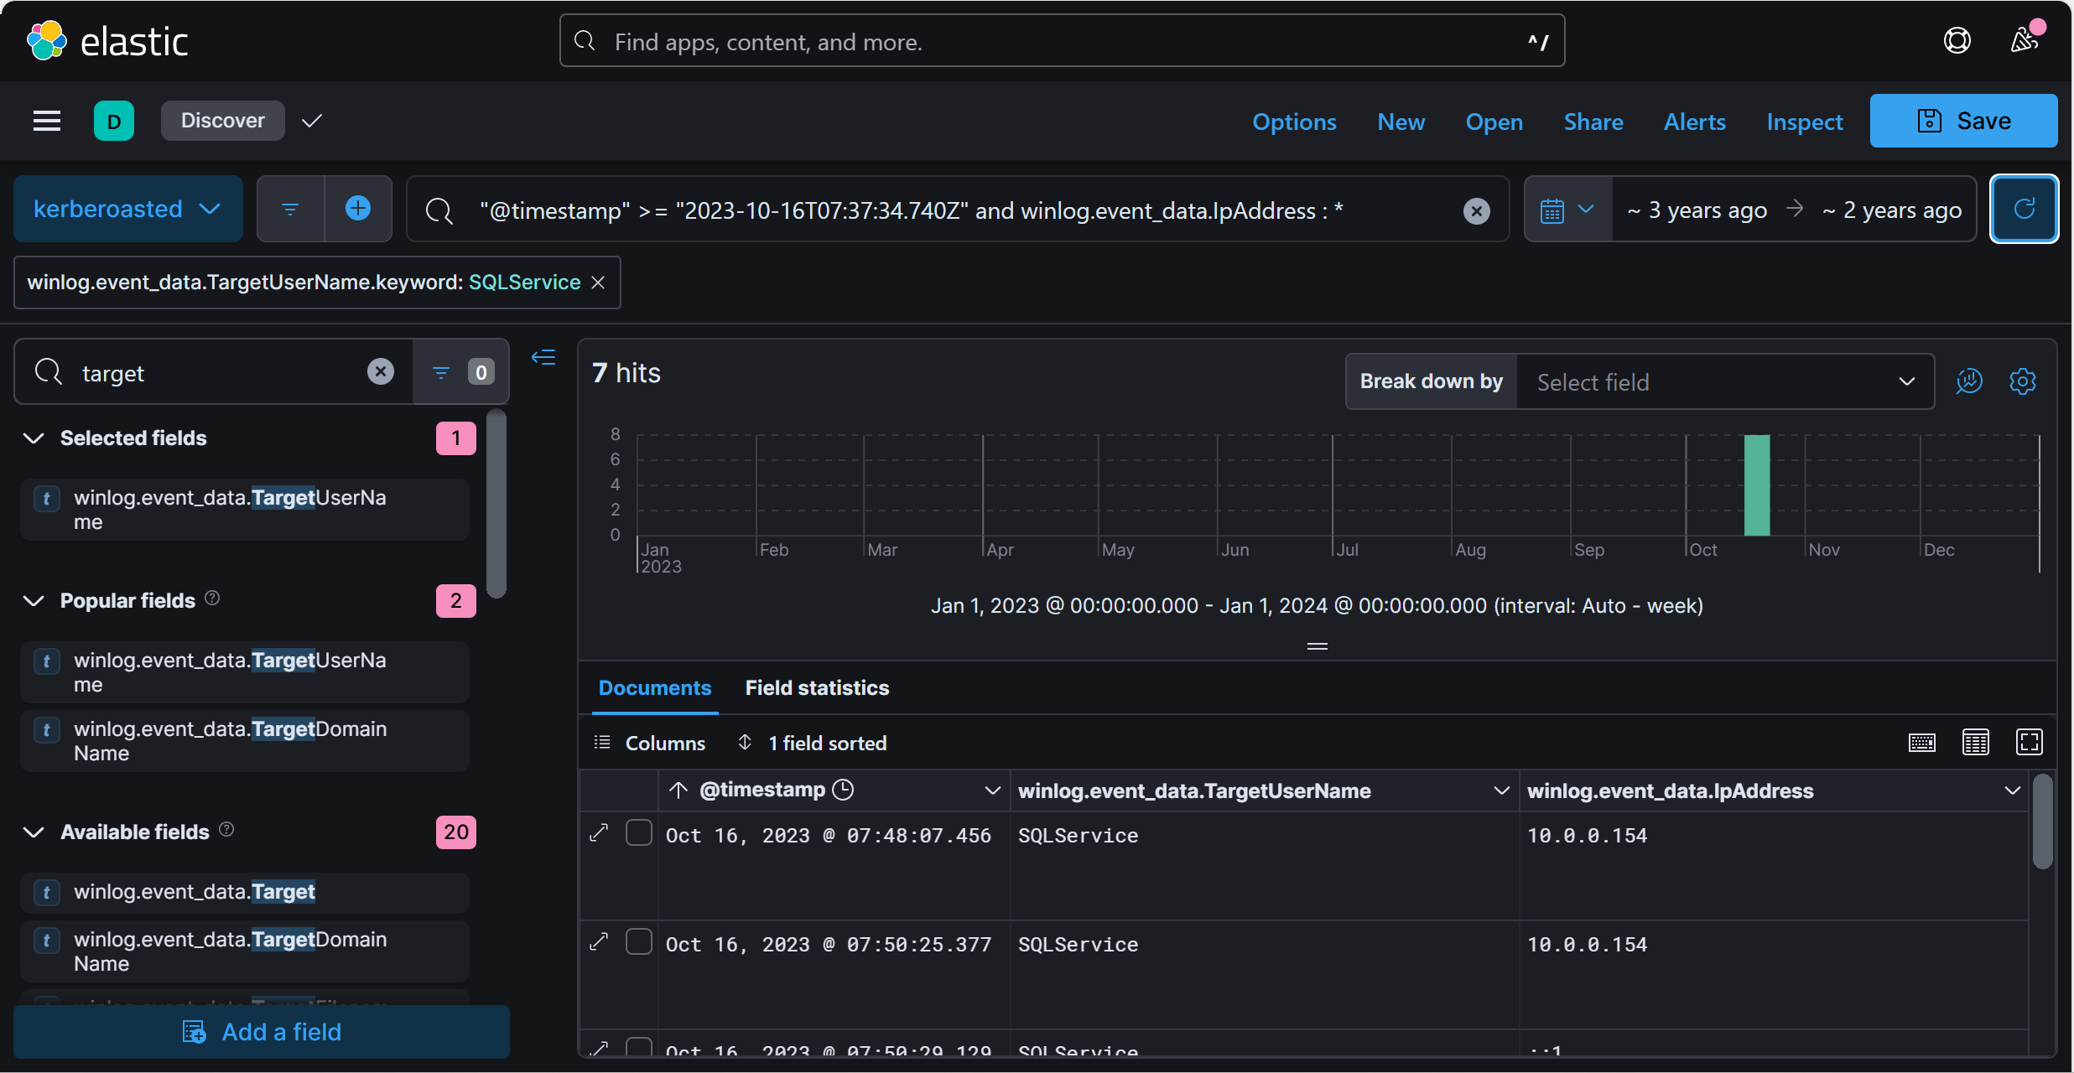

Answer: 10.0.0.154

Q5: To understand the attacker's actions following the login with the compromised service account, can you specify the service name installed on the Domain Controller (DC)?
- Service installations are logged and can reveal post-compromise activities on the DC. Have you reviewed the corresponding event ID?
- Event ID 7045 provides details about the service name, installation path, and the account responsible for the installation.
Query: "@timestamp" >= "2023-10-16T07:37:34.740Z" and event.code:7045
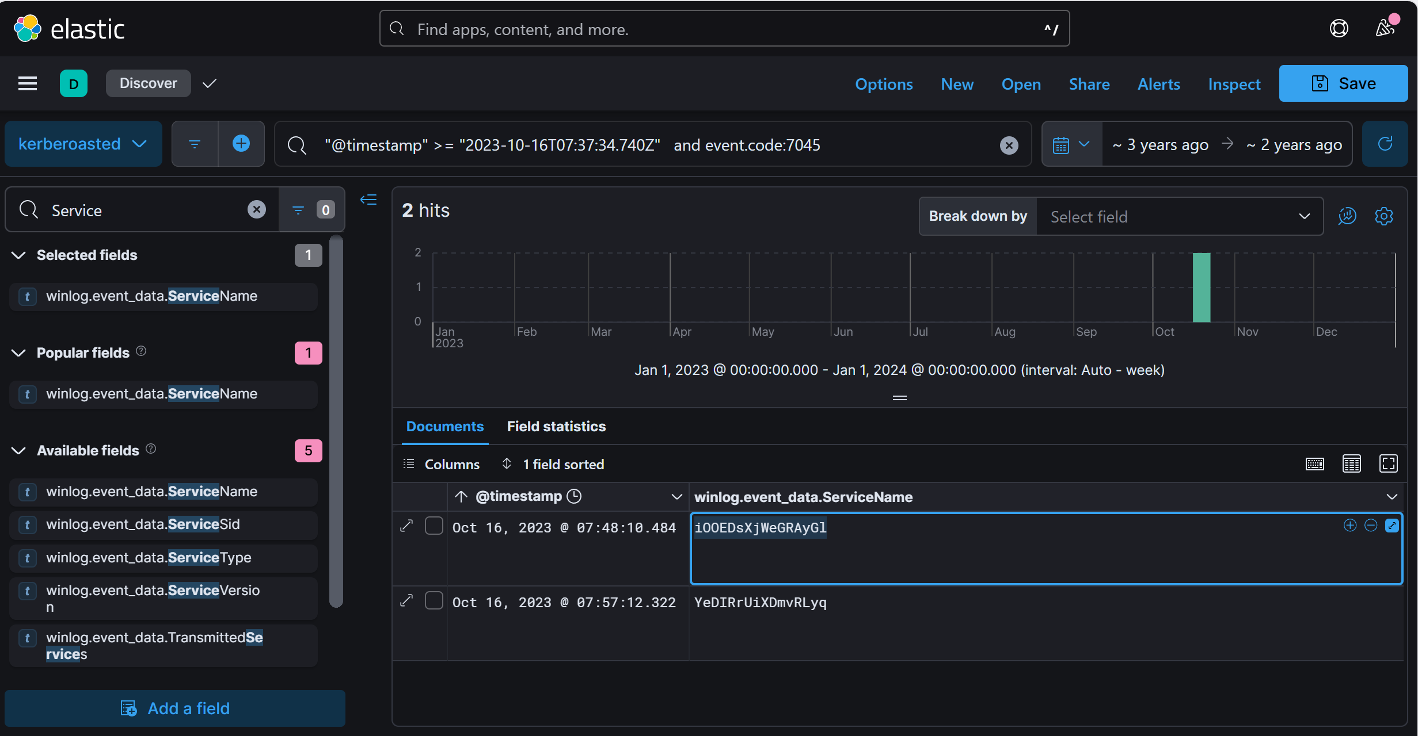
Answer: iOOEDsXjWeGRAyGl
Q6: To grasp the extent of the attacker's intentions, What's the complete registry key path where the attacker modified the value to enable Remote Desktop Protocol (RDP)?
- Enabling RDP typically modifies registry keys. Have you checked the event ID associated with registry key changes?
- Look for entries with Event ID 13, focusing on registry changes linked to RDP configurations.
- Event ID 13 in Windows logs provides details on modified registry paths. Focus on registry keys associated with Remote Desktop Protocol (RDP) settings, especially within the HKLM\SYSTEM\CurrentControlSet\Control\Terminal Server path.

- Query : "@timestamp" >= "2023-10-16T07:37:34.740Z" and event.code: "13"
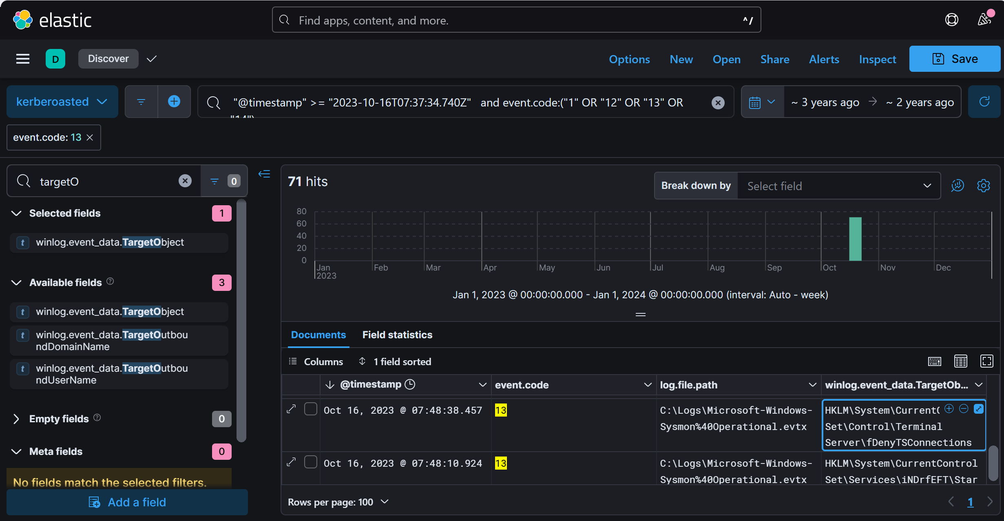
Answer: HKLM\System\CurrentControlSet\Control\Terminal Server\fDenyTSConnections

Q7: To create a comprehensive timeline of the attack, what is the UTC timestamp of the first recorded Remote Desktop Protocol (RDP) login event?
- Remote Desktop Protocol (RDP) logins utilize a specific logon type, which is recorded under a particular event ID. Have you reviewed these logs?
- Use Event ID 4624 with Logon Type 10 in your query to pinpoint the initial RDP login. Focus on the time and TargetUserName for a complete view.
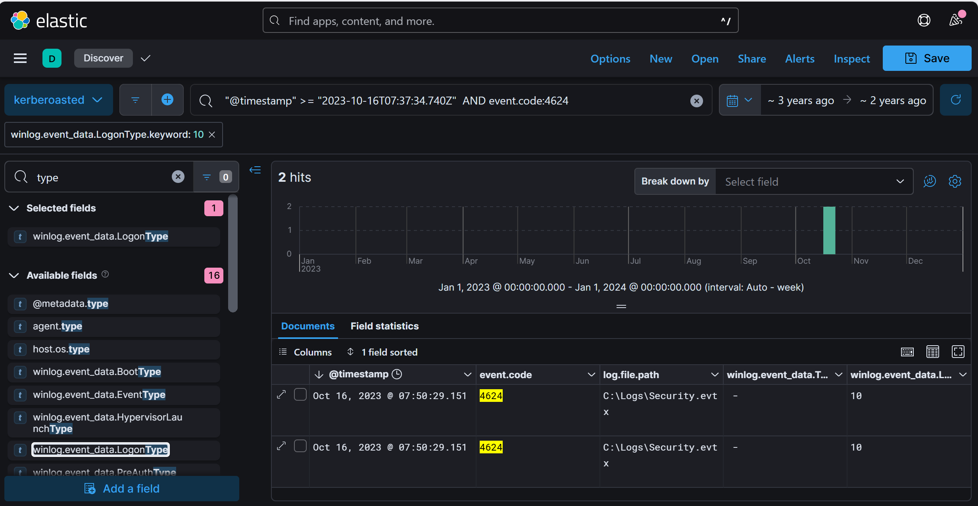

Answer: 2023-10-16 07:50

Q8: To unravel the persistence mechanism employed by the attacker, what is the name of the WMI event consumer responsible for maintaining persistence?
- Windows Management Instrumentation (WMI) event consumers are often leveraged by attackers for persistence. Have you reviewed the event ID associated with WMI activity?
- Sysmon Event ID 20 logs the creation of WMI event consumers, a common persistence tactic. Include this in your query, as WMI consumers may trigger actions or scripts that help malware or applications maintain a foothold on the system.
Query : "@timestamp" >= "2023-10-16T07:37:34.740Z" AND event.code:20

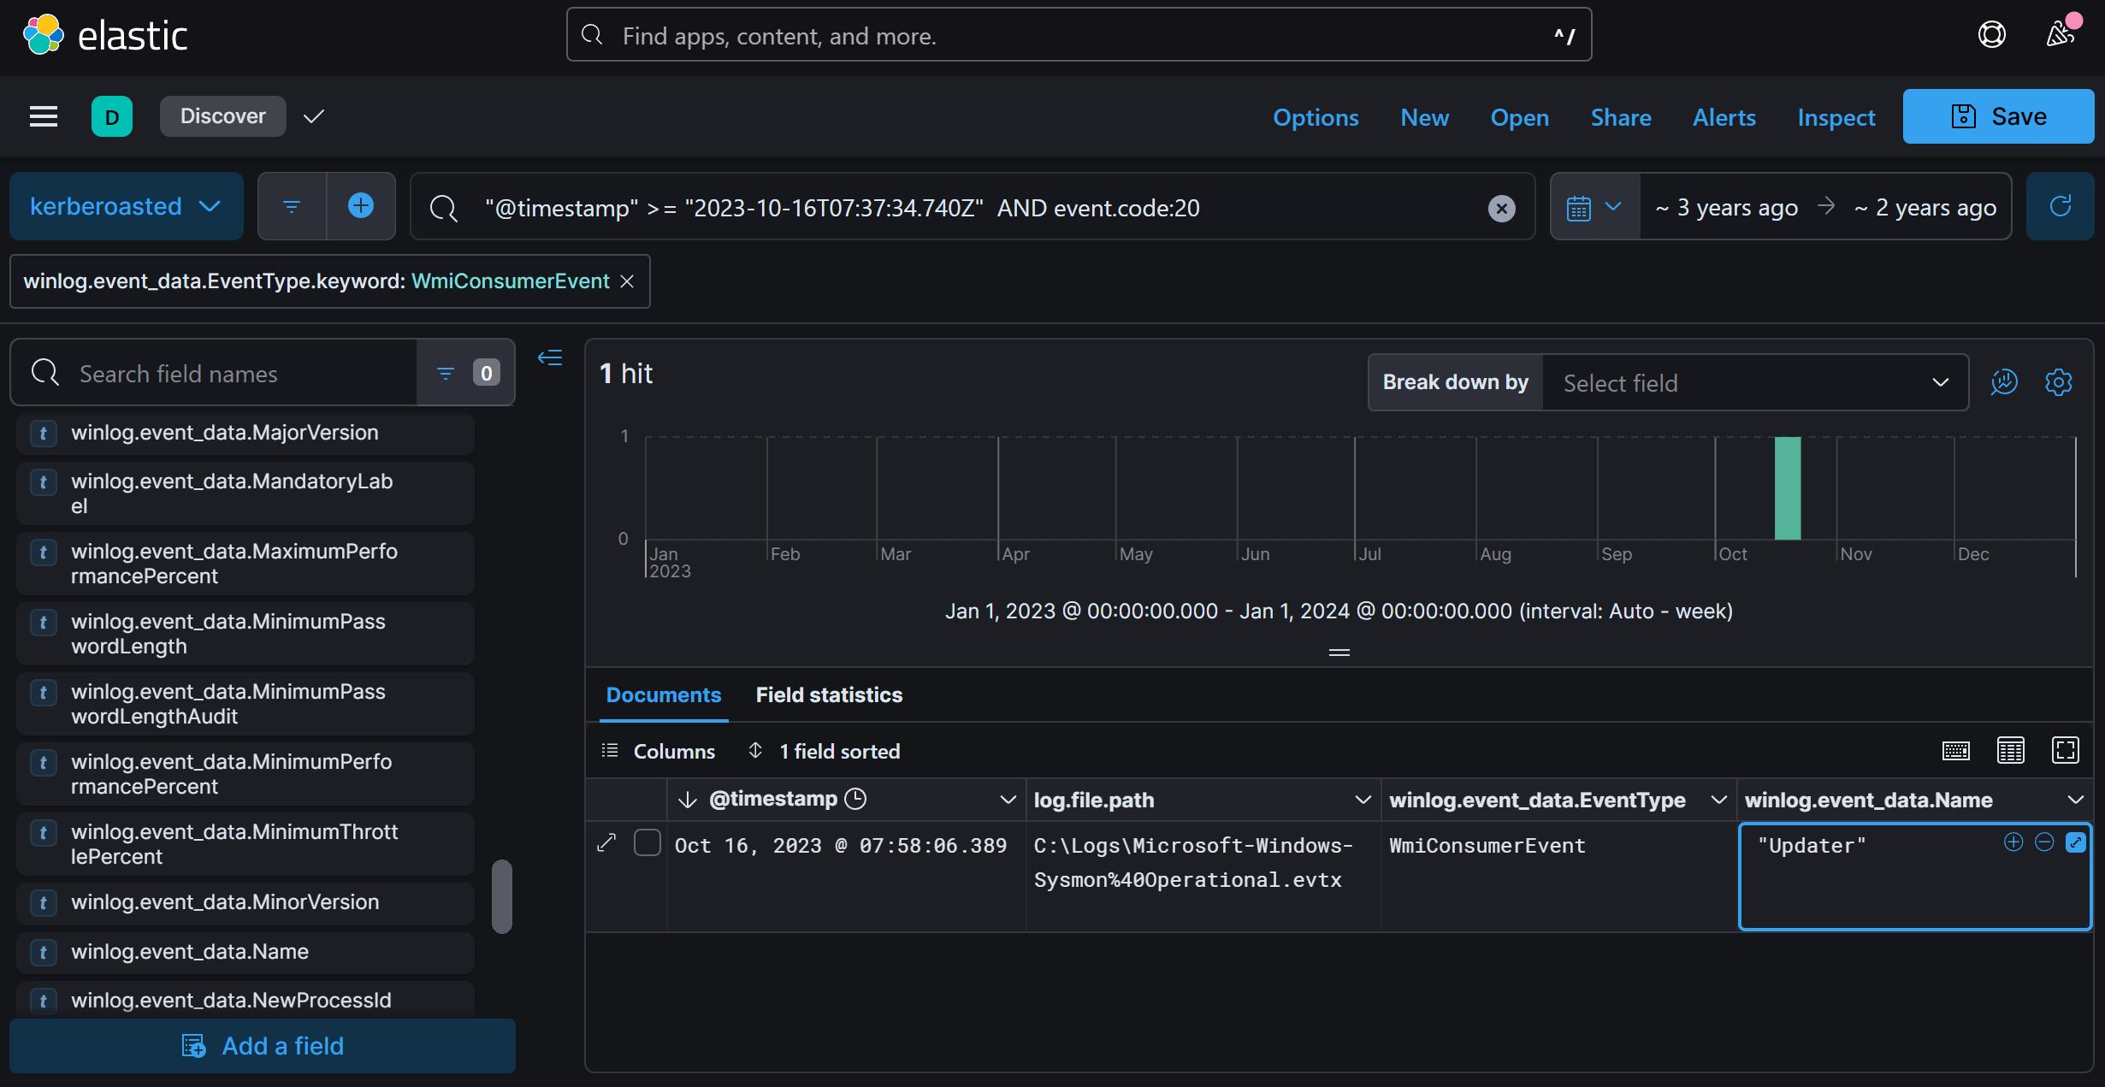

Answer: Updater
Q9: Which class does the WMI event subscription filter target in the WMI Event Subscription you've identified?
- WMI event filters target specific classes and activate actions when certain conditions are met. Have you reviewed the relevant event ID for this?
- Sysmon Event ID 19 records details on WMI filters, including potentially targeted WMI classes. Consider using this in your query for more insights.

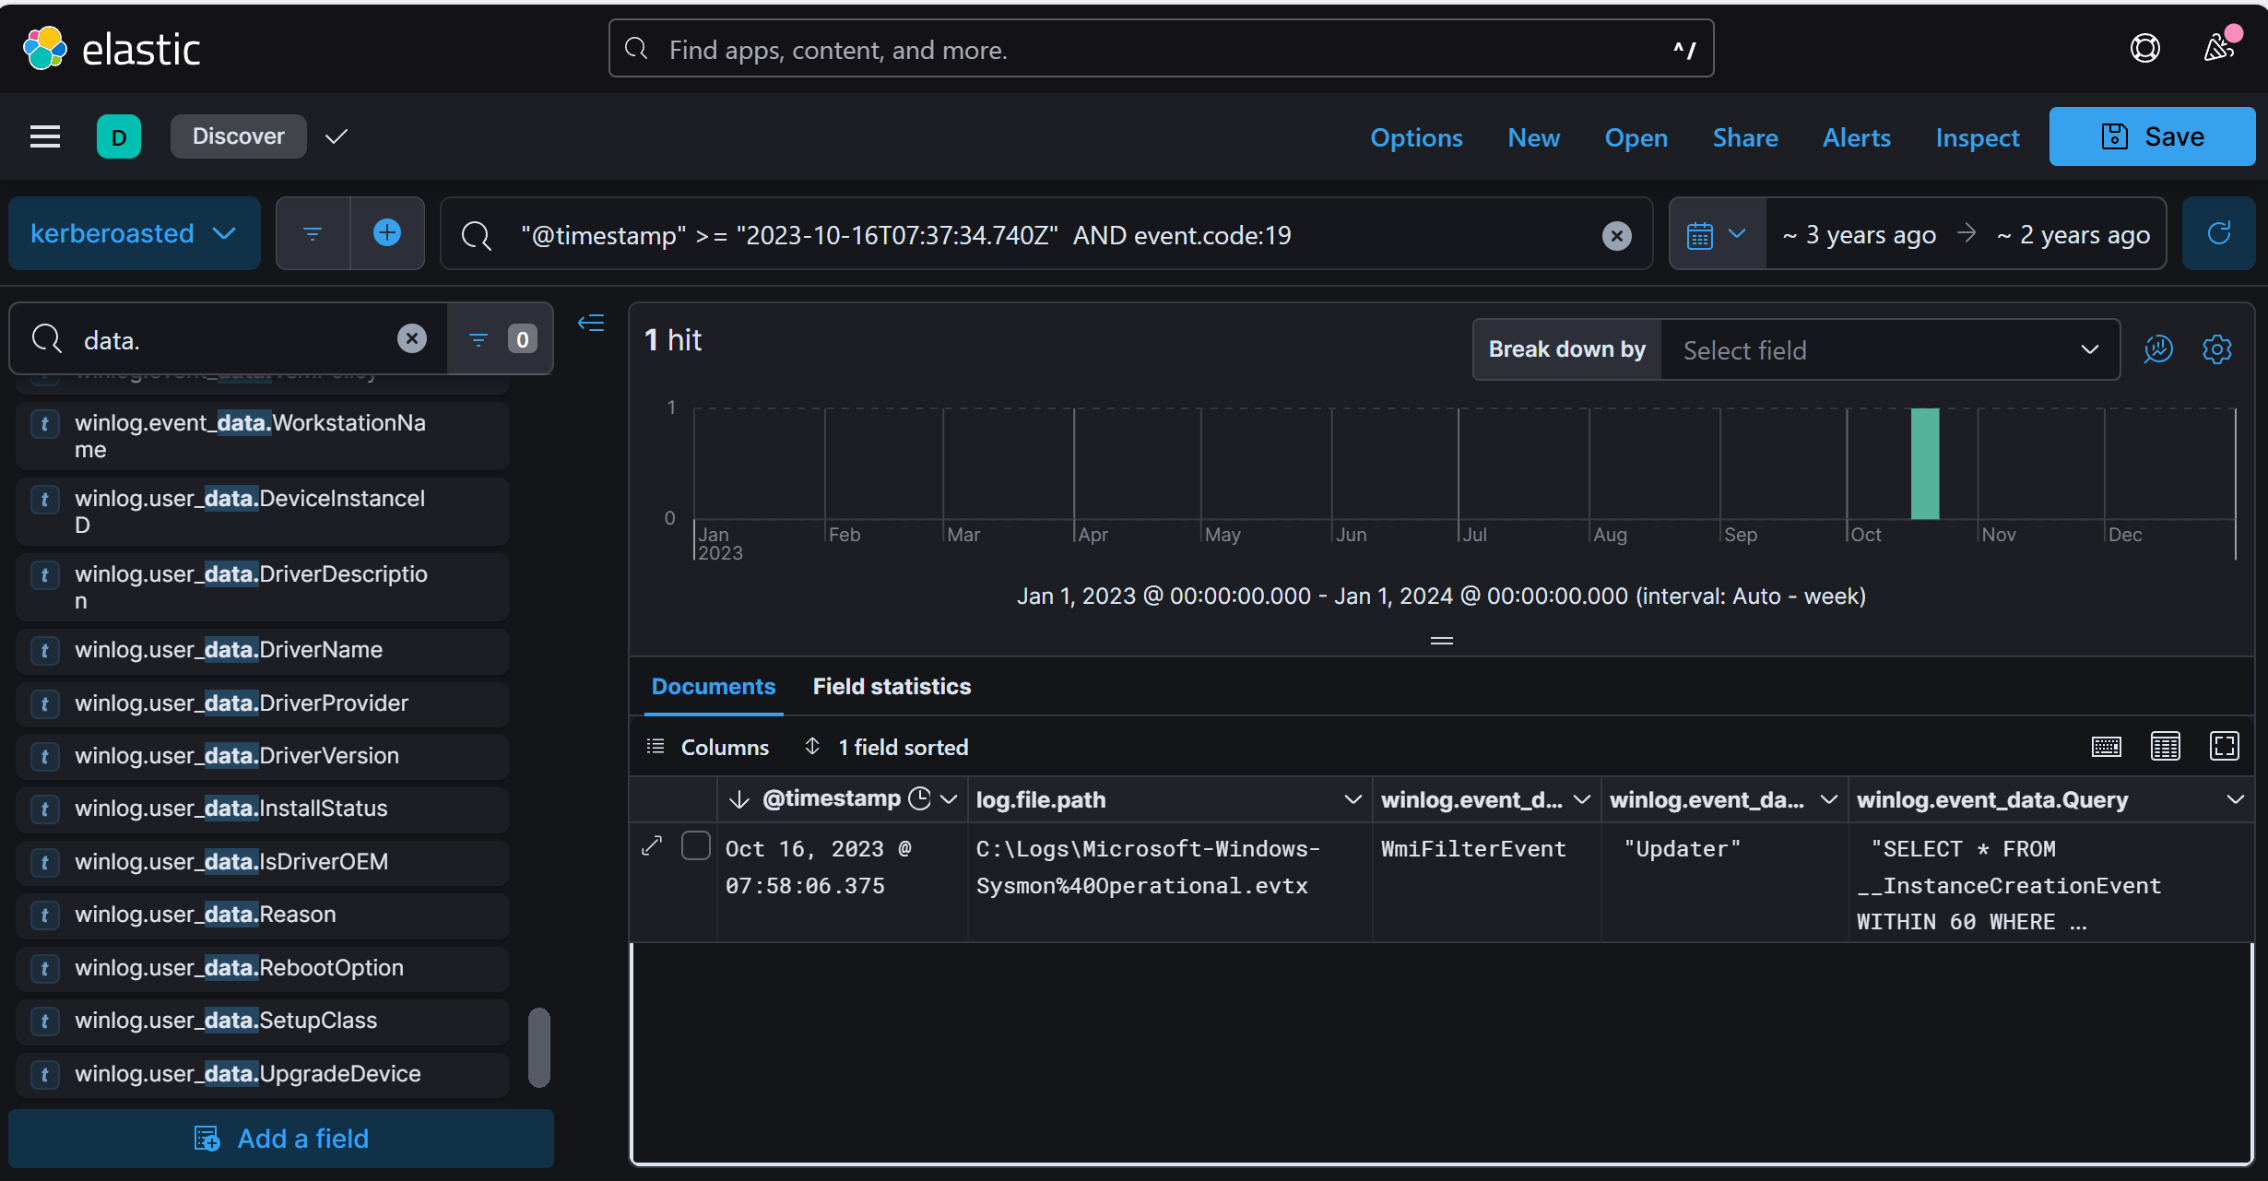
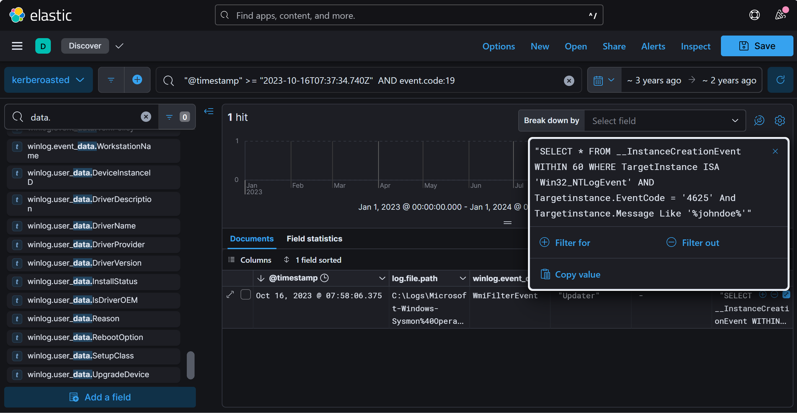

Answer: Win32_NTLogEvent

