**INDIVIDUAL EXERCISE 3**

**Student’s Name: Tran Thi Xuan Xuan**

**Student’s ID: 20IT027**

Let’s design the set of TCs for the problem (see the attached file) by using the "Basic-Path Coverage"!

*Note: The steps are follows:

1. Determine the nodes and construct a control flow graph.

2. Compute Cyclomatic Complexity of the control flow graph.

3. Determine all paths.

4. Identify and eliminate unreasonable paths.

5. Determine basis paths.

6. Design test scenarios to go through these basis paths

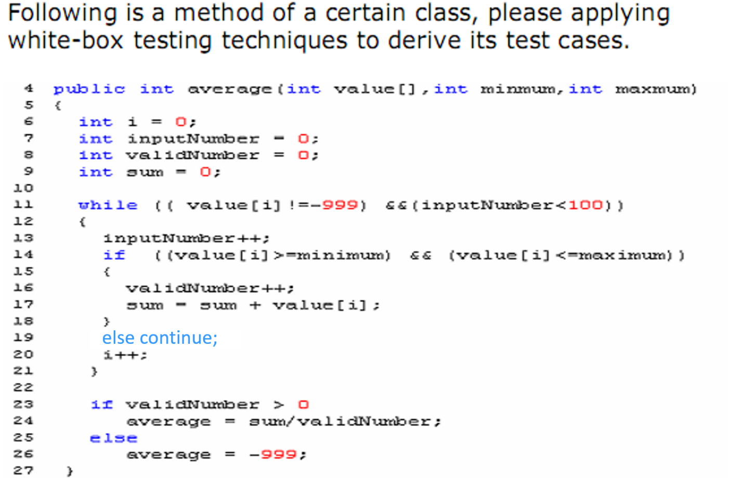

**YOUR SOLUTION**

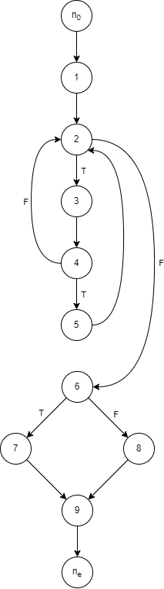• ***Cyclomatic Complexity:*** CC = edges – nodes + 2p

= 13 – 11 + 2 * 2 = 6

• ***All Paths:***

* Path 1: n0 - 1 - 2 - 3 - 4 - 2 - 6 - 7 - 9 - ne
* Path 2: n0 - 1 - 2 - 3 - 4 - 2 - 6 - 8 - 9 - ne
* Path 3: n0 - 1 - 2 - 3 - 4 - 5 - 2 - 6 - 7 - 9 - ne
* Path 4: n0 - 1 - 2 - 3 - 4 - 5 - 2 - 6 - 8 - 9 - ne
* Path 5: n0 - 1 - 2 - 6 - 7 - 9 - ne
* Path 6: n0 - 1 - 2 - 6 - 8 - 9 - ne

• ***Basic Paths:***

* Path 1: n0 - 1 - 2 - 3 - 4 - 2 - 6 - 7 - 9 - ne
* Path 2: n0 - 1 - 2 - 3 - 4 - 2 - 6 - 8 - 9 - ne
* Path 3: n0 - 1 - 2 - 3 - 4 - 5 - 2 - 6 - 7 - 9 - ne
* Path 4: n0 - 1 - 2 - 3 - 4 - 5 - 2 - 6 - 8 - 9 - ne

Path 5 and 6 are unreasonable, because inputNumber is less than 100 and value[i] doesn’t equal -999 in the beginning.

• ***Test scenarios:***

|  |  |  |  |  |  |
| --- | --- | --- | --- | --- | --- |
| **TC** | **Path** | **value** | **minimum** | **maximum** | **Result** |
| 1 | P1 | [0, 1, 2] | 0 | 1 | average = |
| 2 | P1 | [0, 1, 2] | 3 | 4 | average = |
| 3 | P2 |  |  |  | average = |
| 4 | P2 |  |  |  | average = |