Phần 1 Một số lệnh Docker Compose cơ bản + Phần 2 Docker Compose file
docker compose version
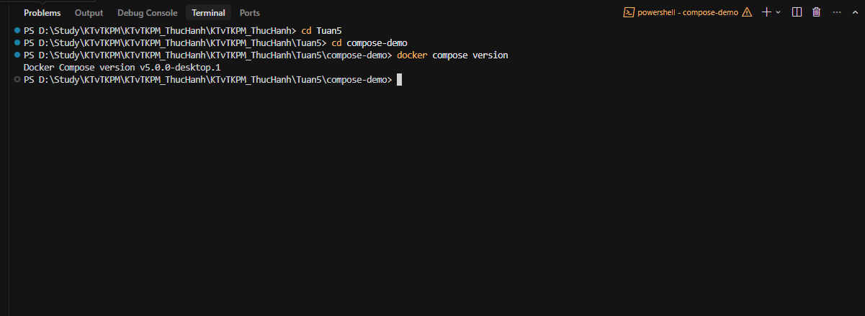
docker compose up
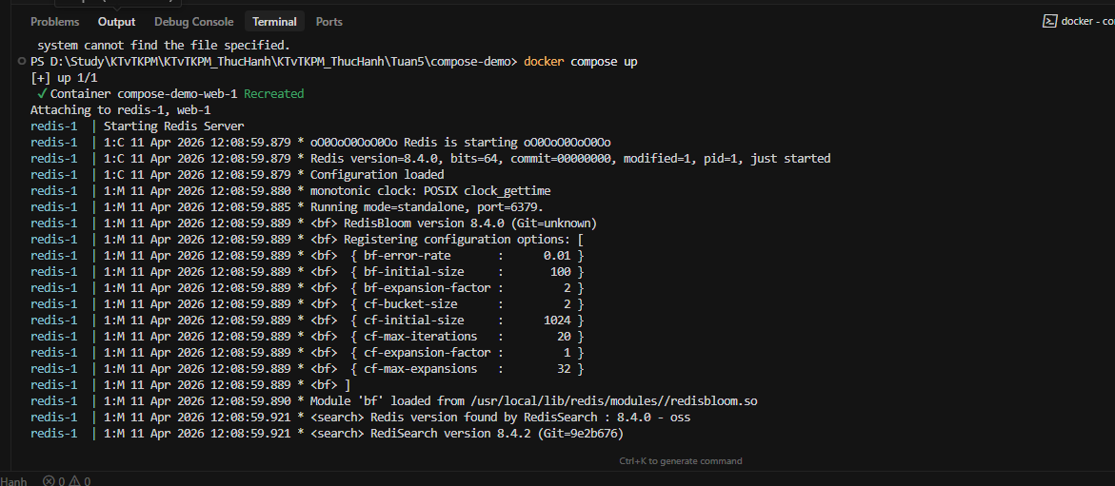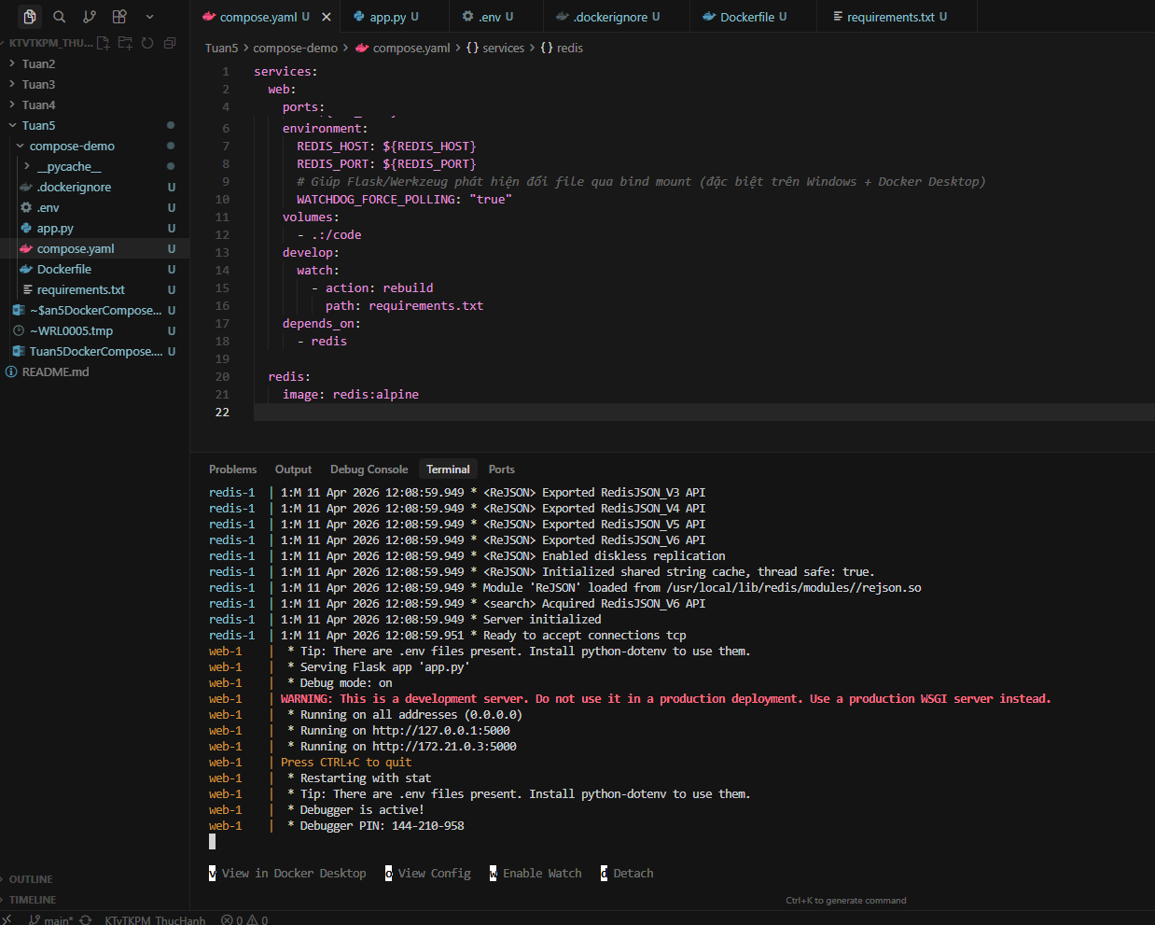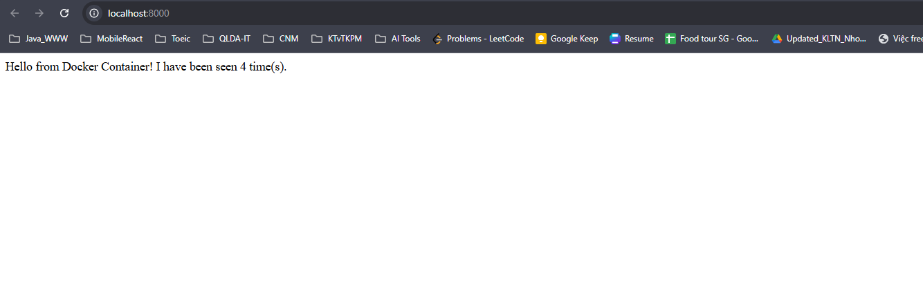
docker compose up -d
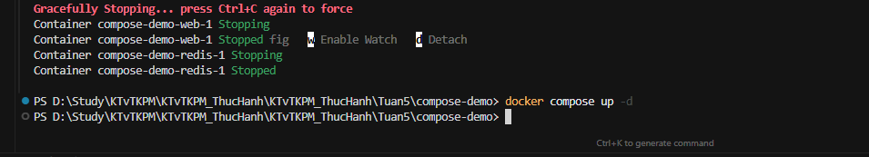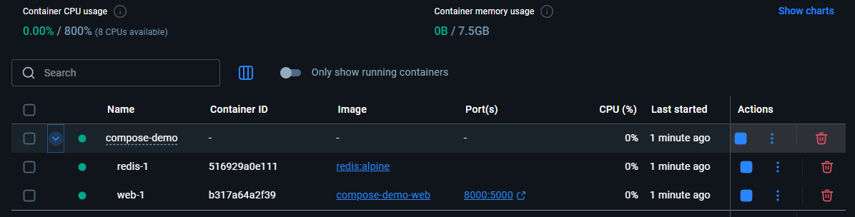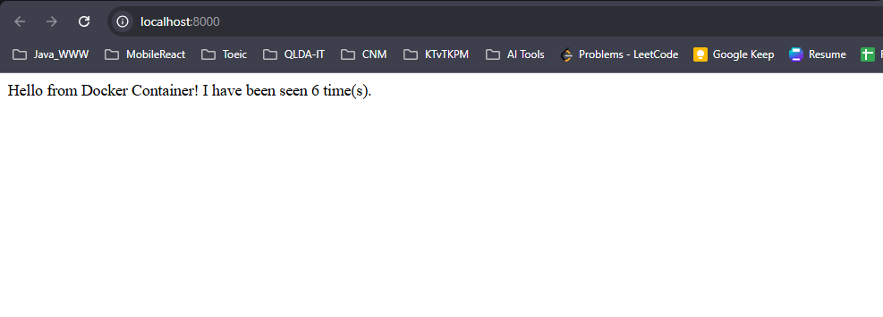docker compose ps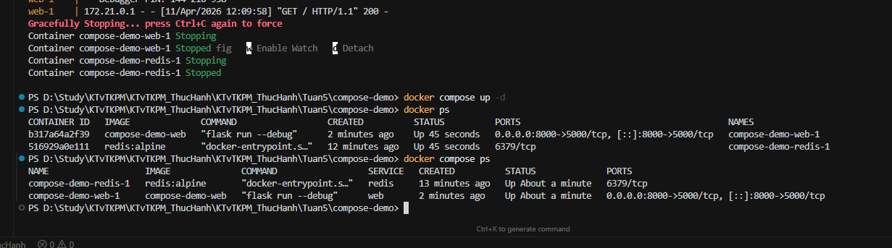docker compose down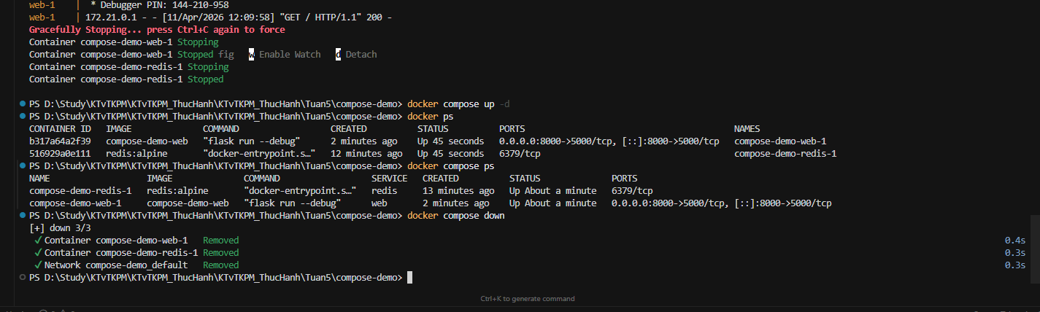docker compose restart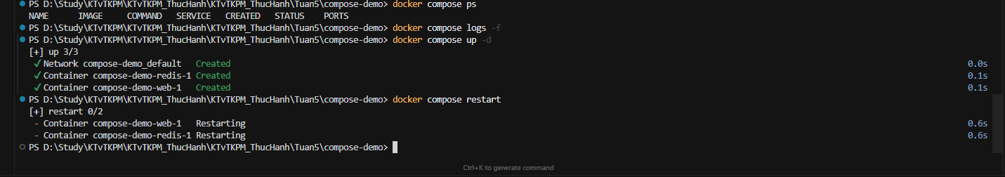docker compose logs -f 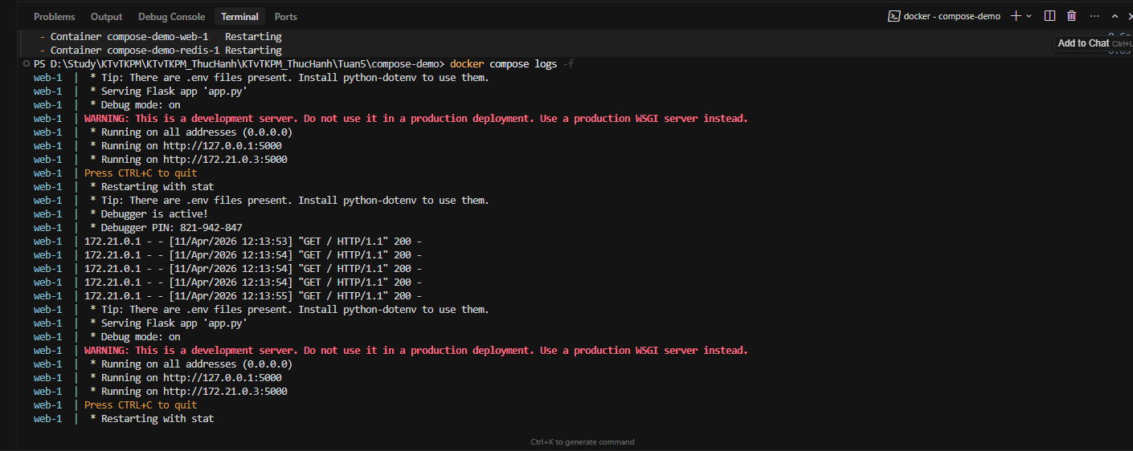 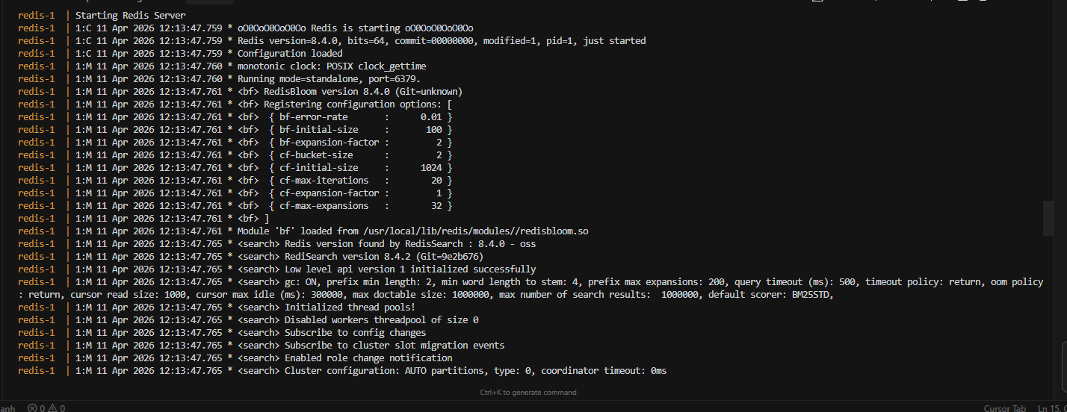 docker compose build 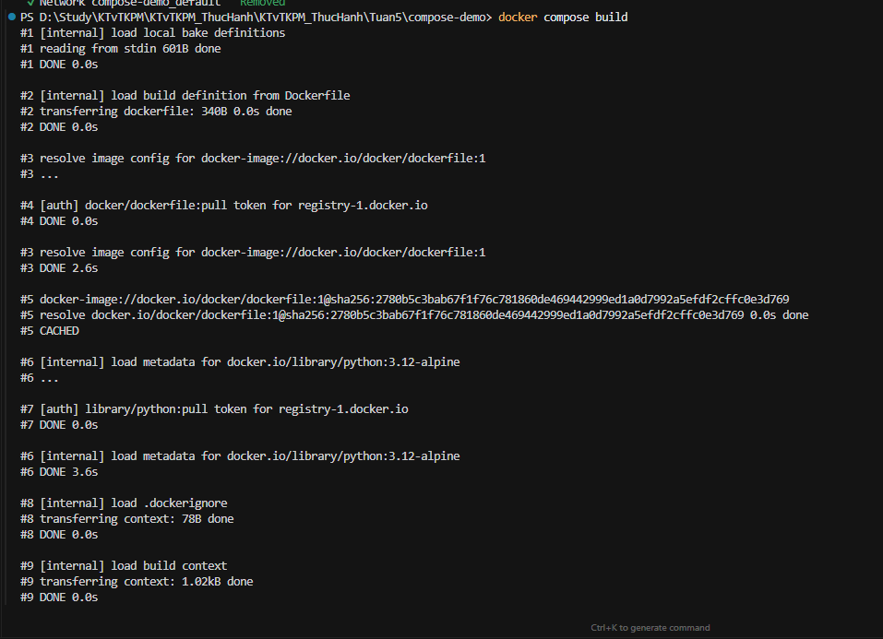 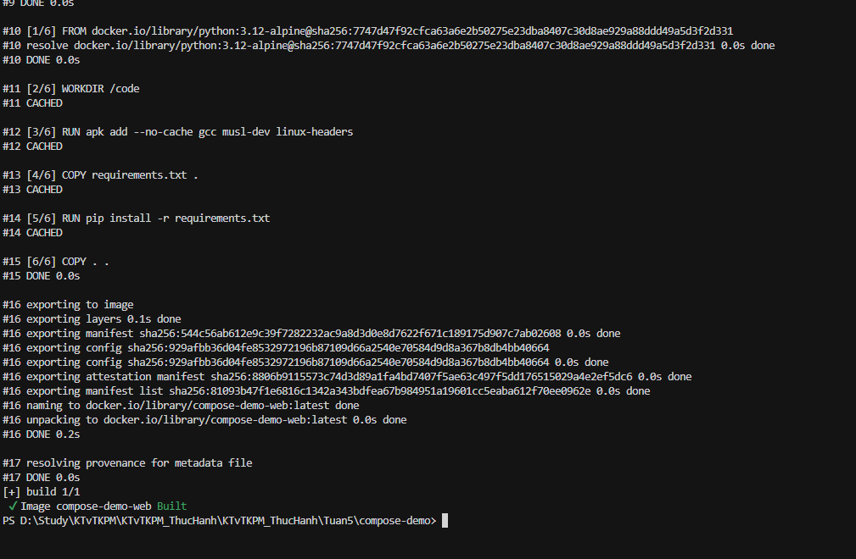 docker compose exec <service_name> <command>
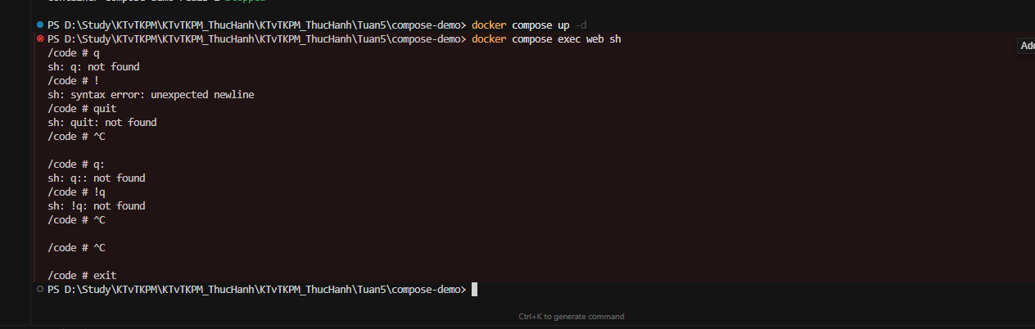 docker compose down -v 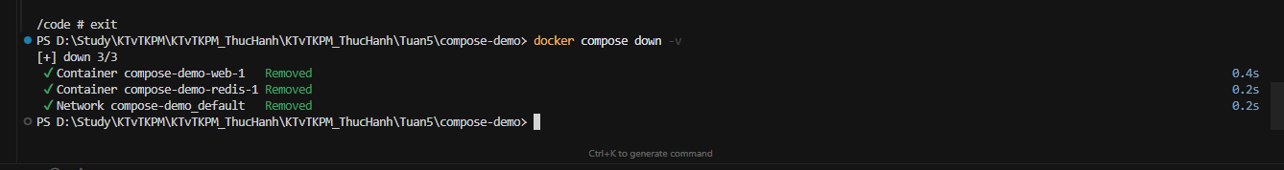 docker compose run <service_name> <command>
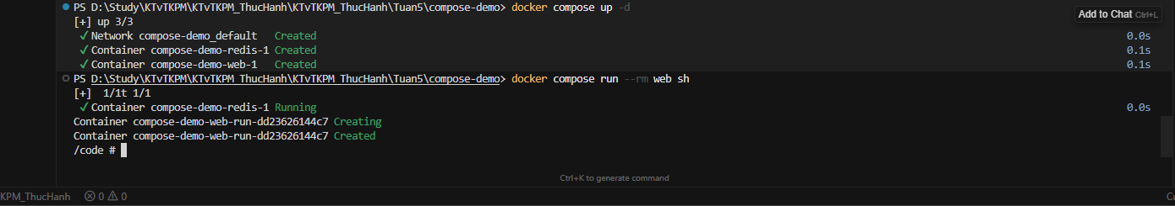 docker compose stop <service_name> docker compose rm <service_name>
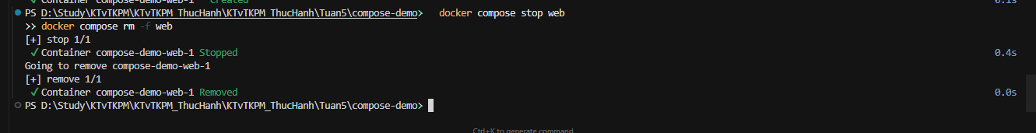
docker compose config
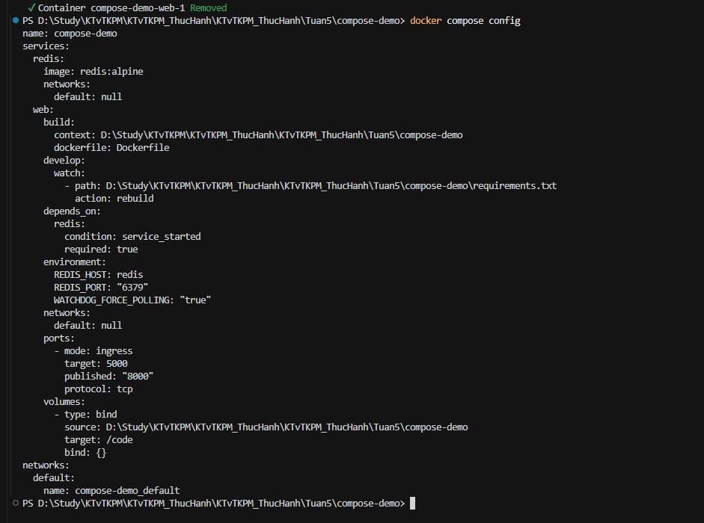
docker compose up -d –-build
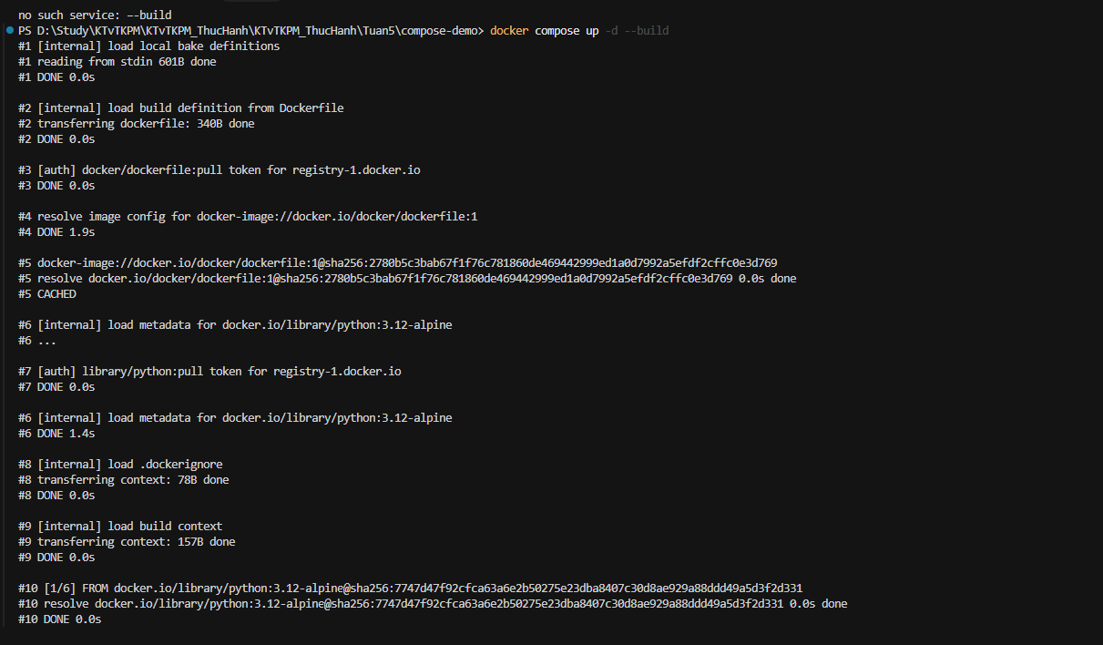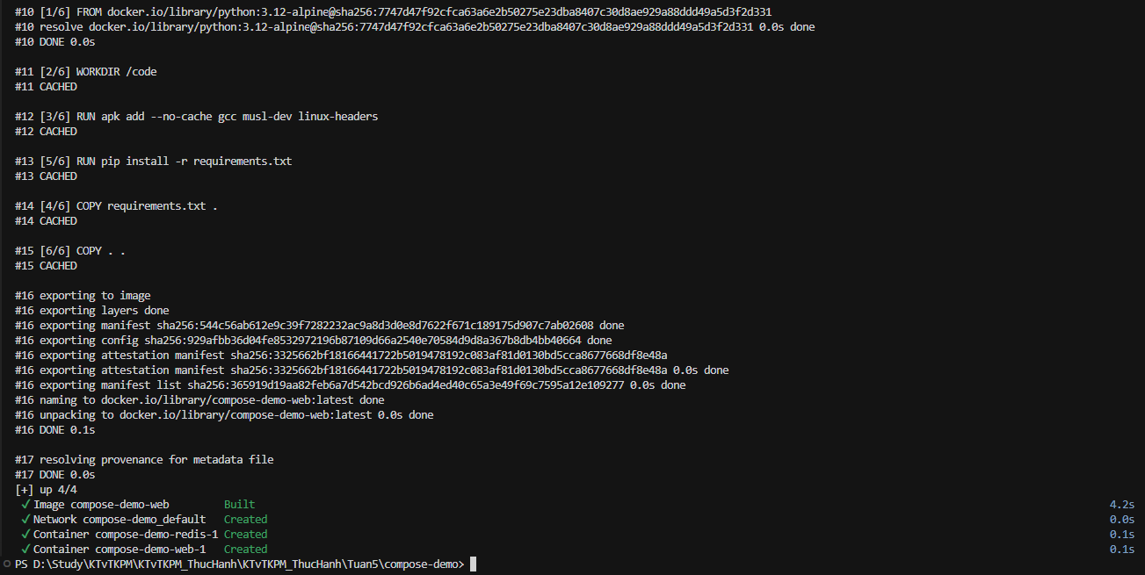
Bài 1:
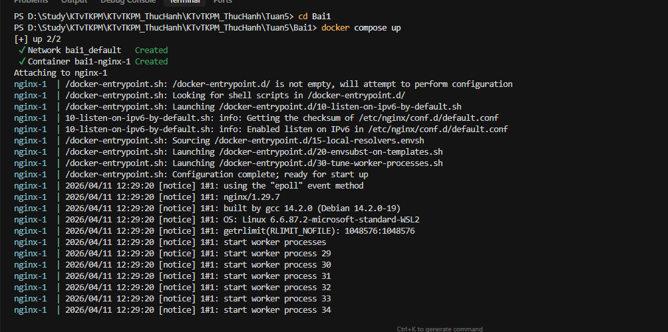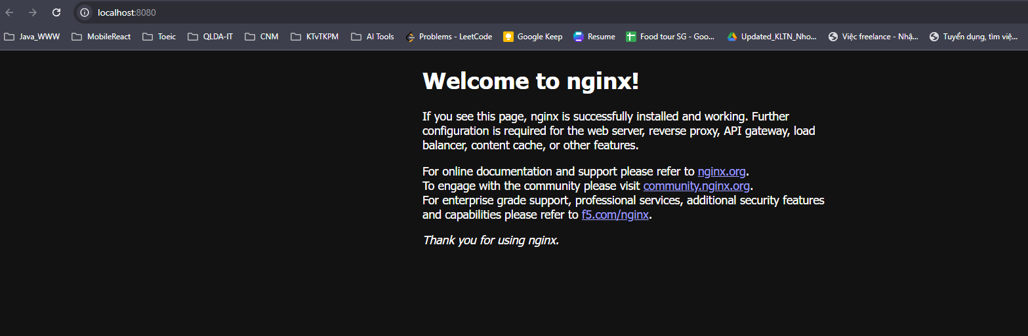
Bai 2

