Question 1
Higher frequencies correspond to:
- Larger wavelengths
- Larger wavelengths in air, but shorter in liquids and gases
- Shorter wavelengths

Question 2
A periodic wave with wavelength λ = 40 m, has speed v = 80 m/s. What is the wave’s frequency?
- 320 Hz
- 0.5 Hz
- 2 Hz

Question 3
The frequency of a wave is 100 Hz. What is its period?
- 10 s
- 0.01 s
- 1 s

Question 4
Below is a representation of a sound wave travelling in a uniform medium at a particular instant. What do the A and B represent?
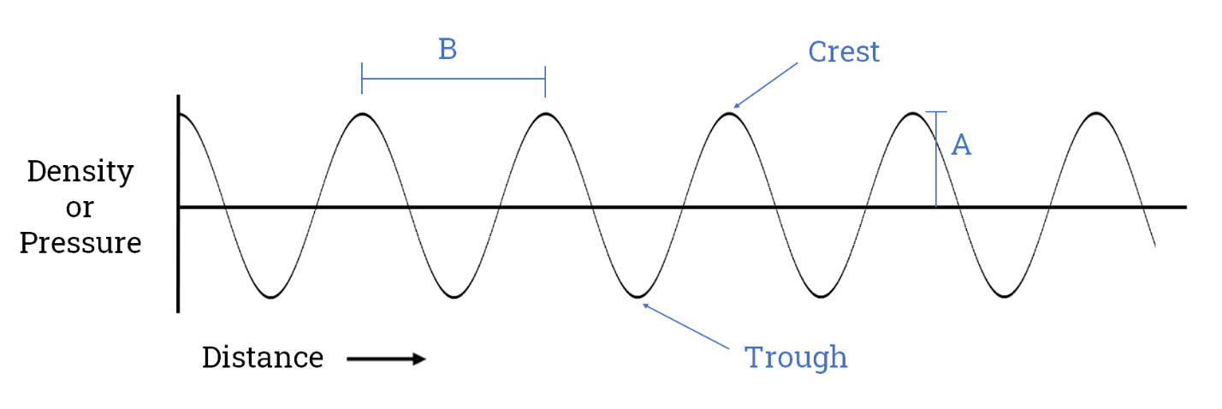
- A = Amplitude, B = Wavelength
- A = Wavelength, B = Period
- A = Amplitude, B = Period

Question 5
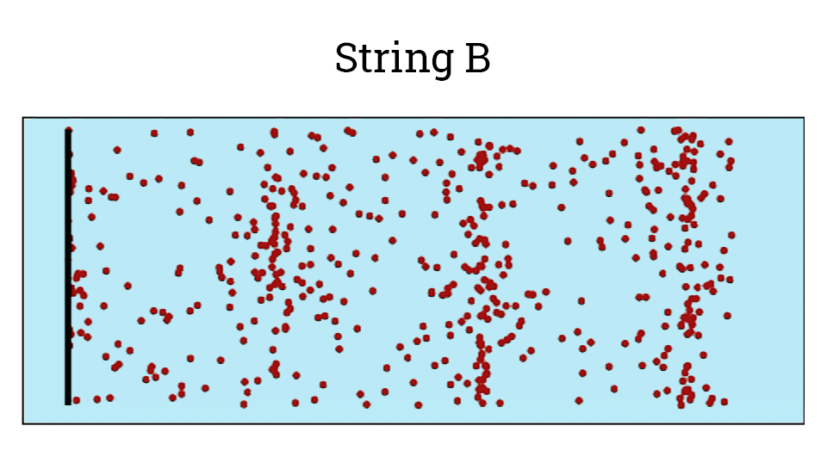
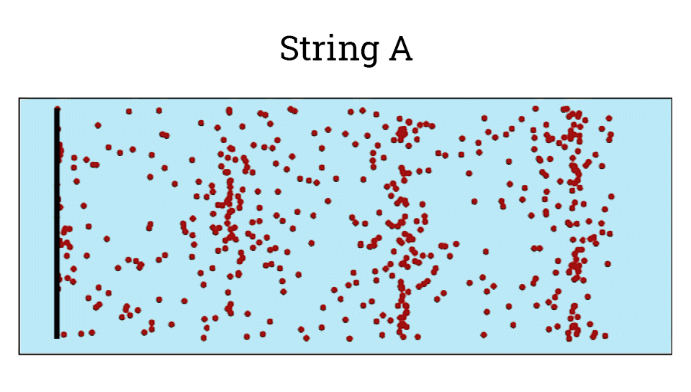
The following two animations represent how the strings A and B of a guitar displaces the air particles that surround them.

According to these animations, if A is the sound wave generated by the string A, and B the sound wave generated by the string B, which of the following statements is correct?
- The frequency of the sound wave B is higher than the one of wave A, and both waves have the same amplitude.
- The frequency and amplitude of the sound wave B is lower than the frequency and amplitude of the sound wave A.
- Both sound waves have the same frequency and amplitude.

Question 6
The following sound corresponds to a pure tone that changes one of its characteristics over time. Which characteristic is that?
Sound 1
- Amplitude
- Frequency
- Waveform
Question 7
The following two sounds correspond to pure tones at different frequencies. Which one do you think has the higher amplitude?
Sound 1
Sound 2
- The Sound 1
- The Sound 2
- Both sounds have the same amplitude

Question 8
What is a pure tone?
- A pure tone is a sound wave with frequency greater than 20 kHz.
- A pure tone is a sound with a sinusoidal waveform of any frequency, phase and amplitude. A pure tone is composed of a single frequency.
- A pure tone is a sound that contains every frequency within the range of human hearing in equal amounts.

Question 9
By what characteristic can you recognise the voice of your friends?
- Pitch
- Timbre
- Loudness

Question 10
What process could produce a harsh, distorted sound?
- Clipping.
- To record at high sample rates.
- To reduce the dynamic range of a sound.

Question 11
Let us suppose that the fastest our ADC (analogue to digital converter) can sample is 8,000 Hz. What is the highest frequency we can properly capture?
- 8,000 Hz
- 16,000 Hz
- 4,000 Hz

Question 12
A microphone converts sound pressure variations into:
- voltage variations
- digital samples
- digital measurements

Question 13
What does ADC mean?
- Amplitude domain converter
- Analog to digital converter
- Amplitude to digital converter

Question 14
What device is missing in the following image?
- A DAC
- An ADC
- A sound level meter

