Xuan Tung Luu - 30236798 - README

1. My SOF file is located at "xuan_tung_luu_30236798_Lab_1\rtl\Basic_Organ_Solution.sof"

2. Everything works I believe.

3. Please zoom in to see clearer.

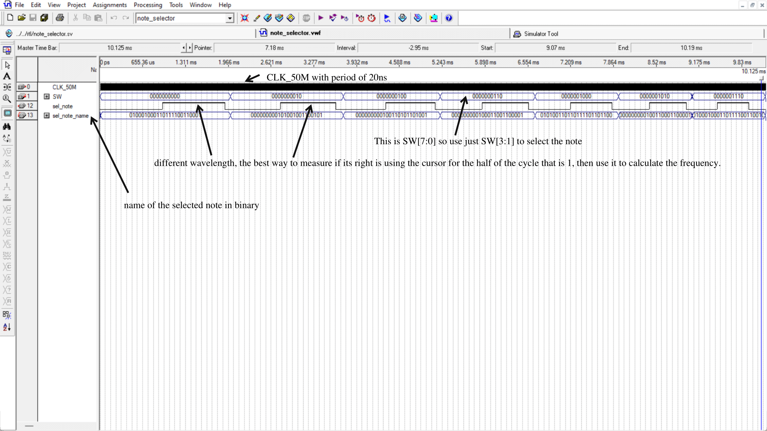

Simulation for tone organ

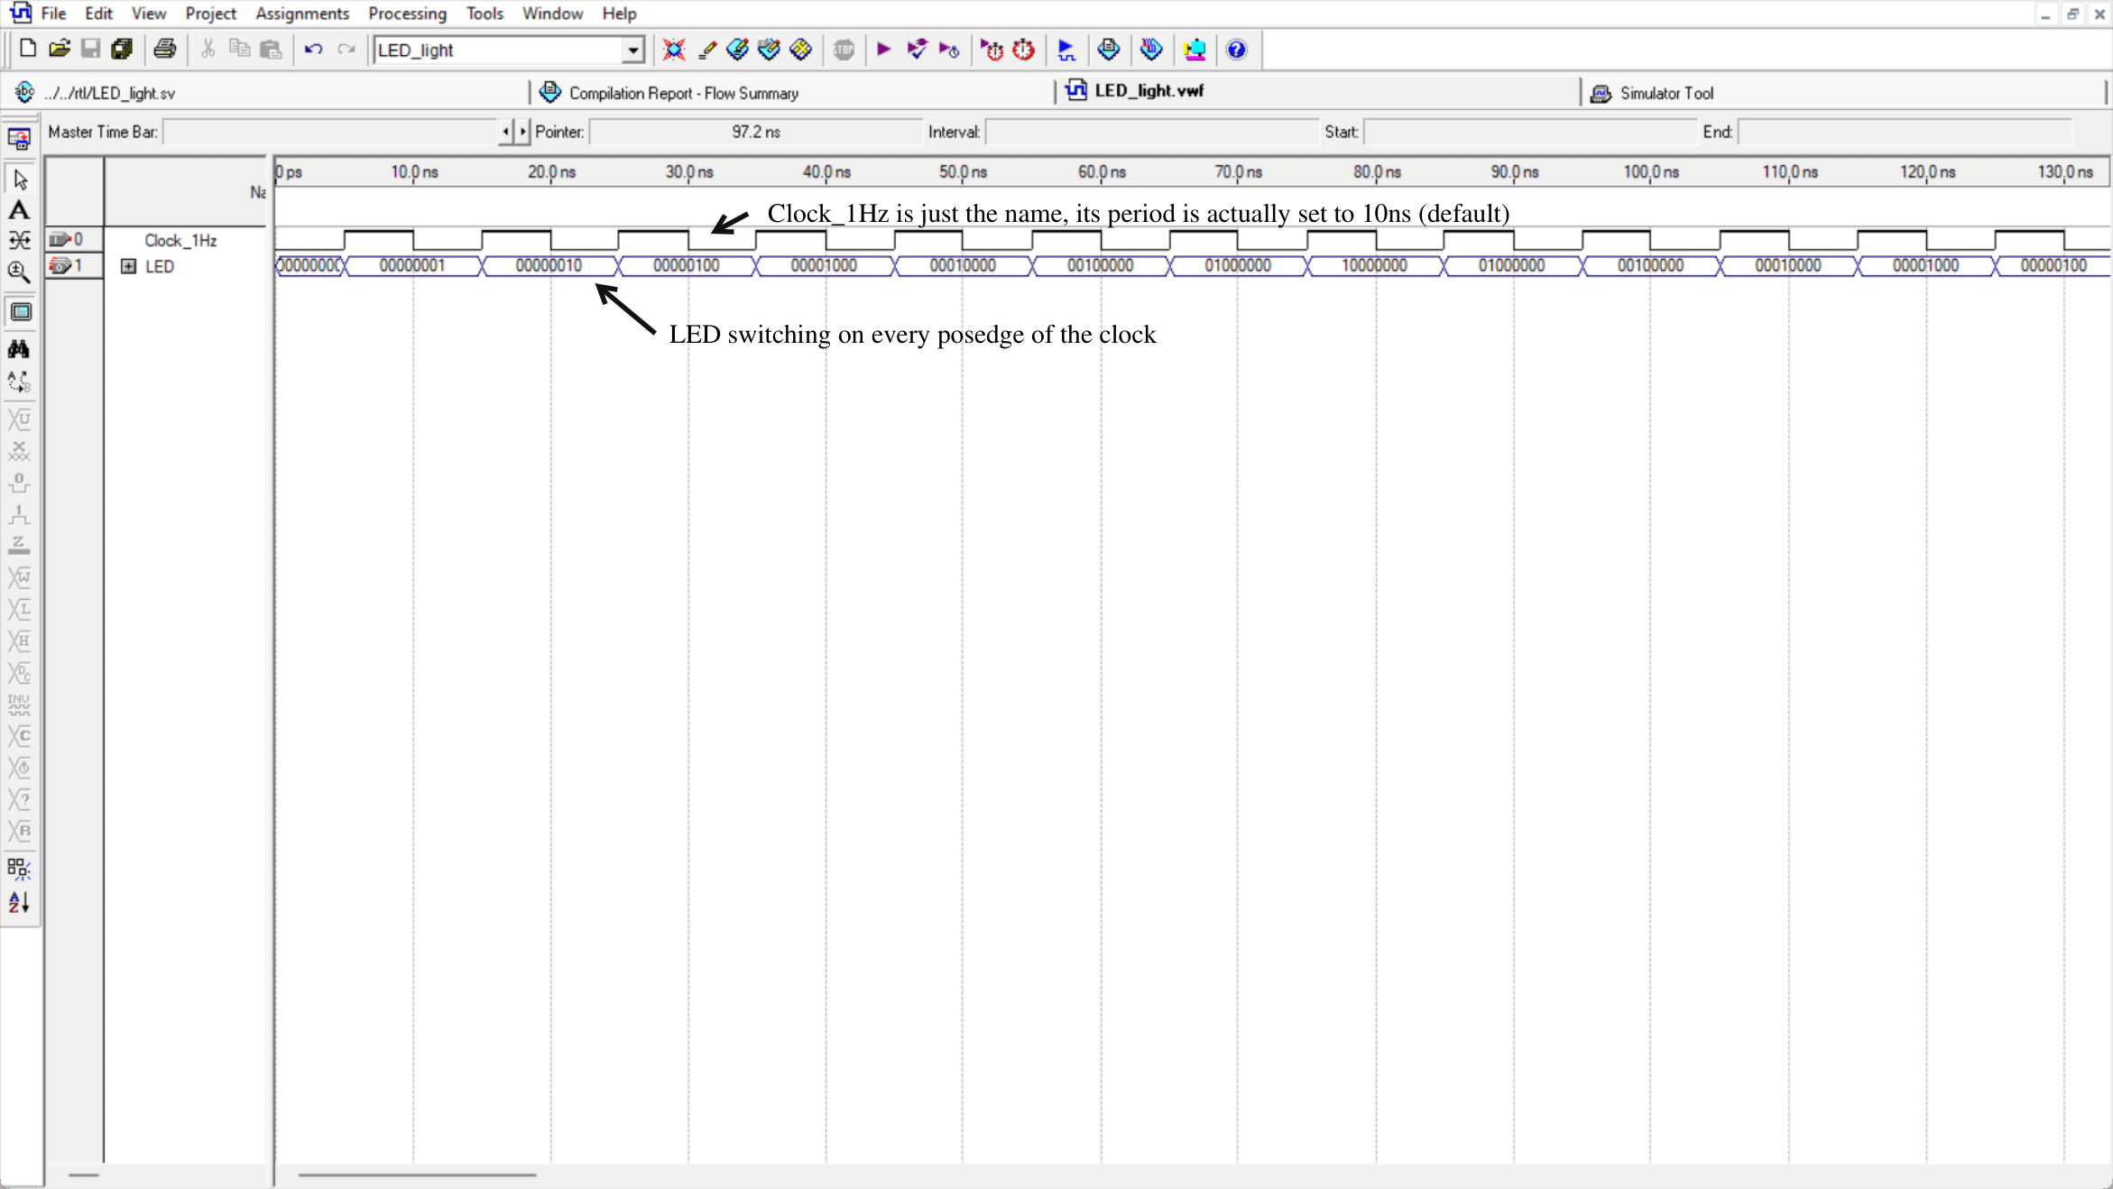Simulation for LED switching

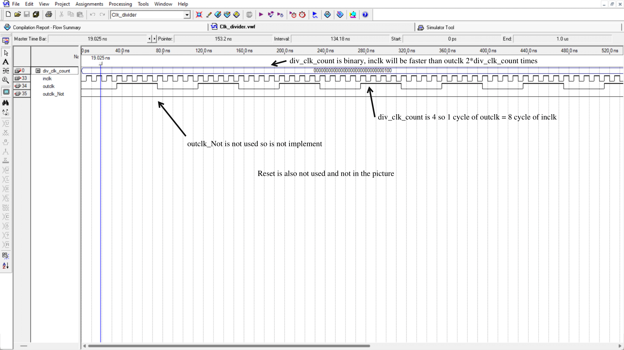

Simulation for clock divider

4. Please zoom in to see clearer

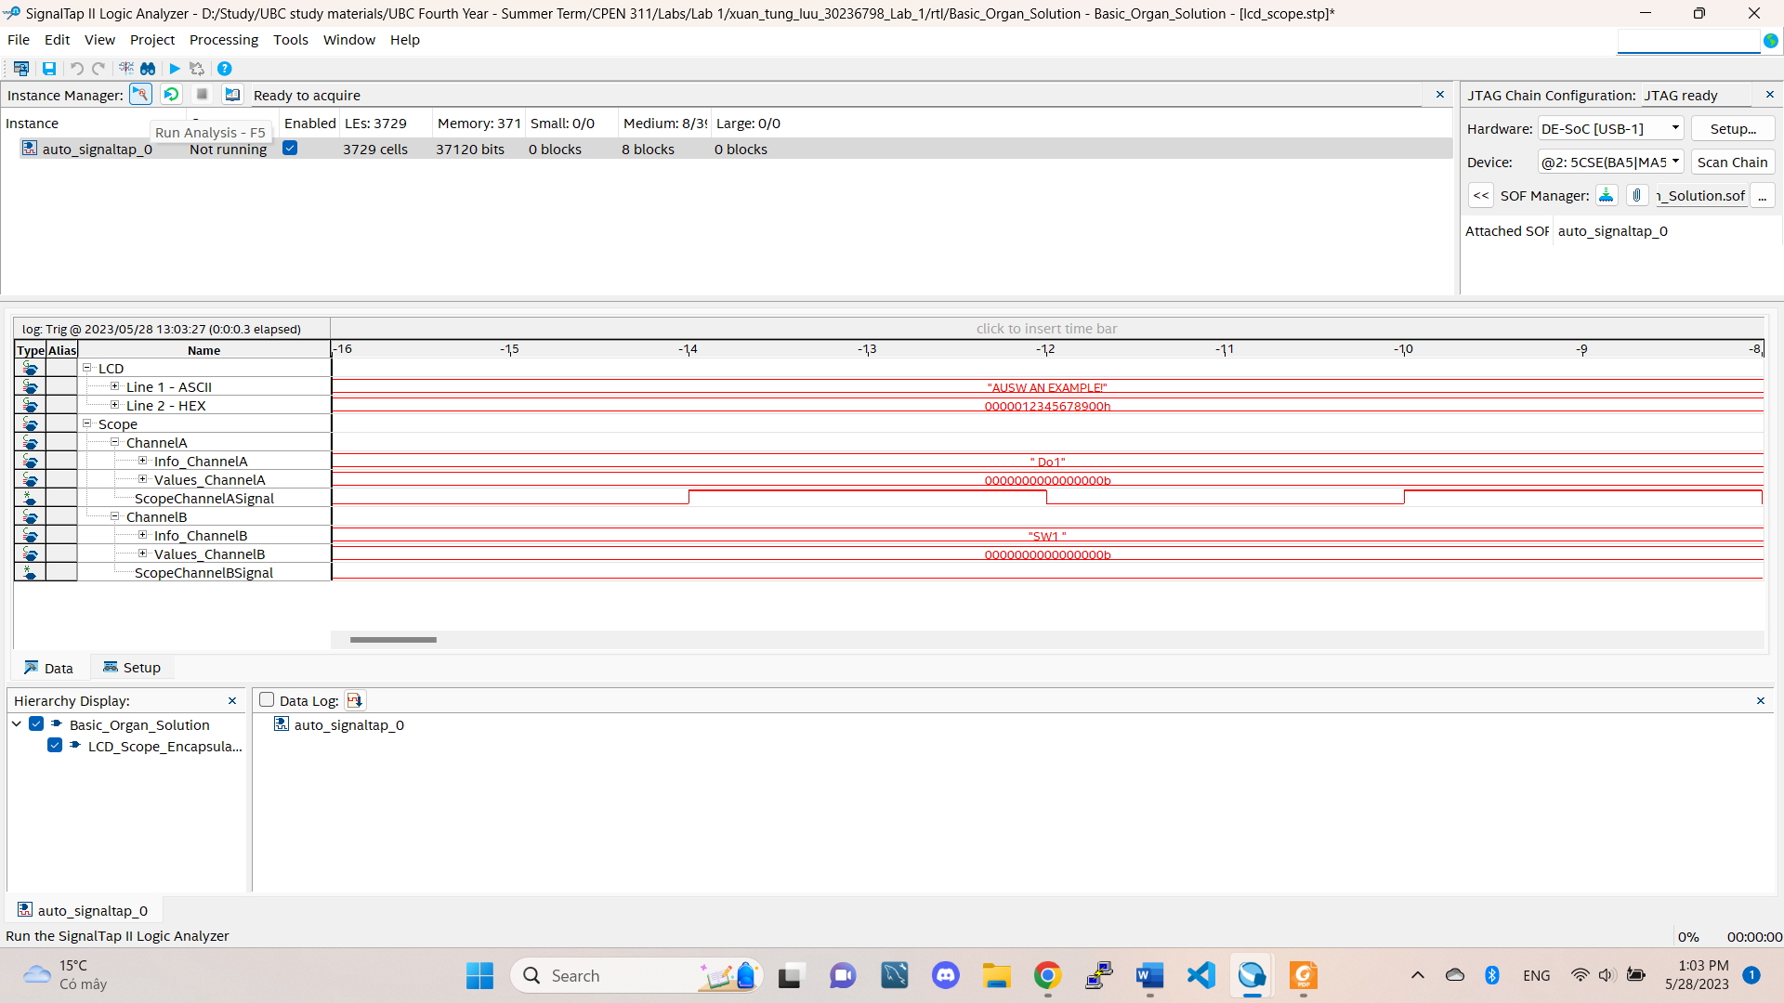

Do1 with SW0 off

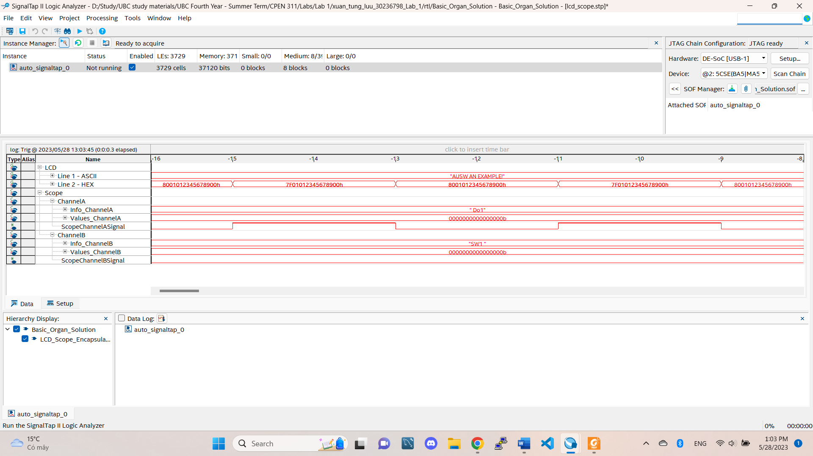Do1 with SW0 on

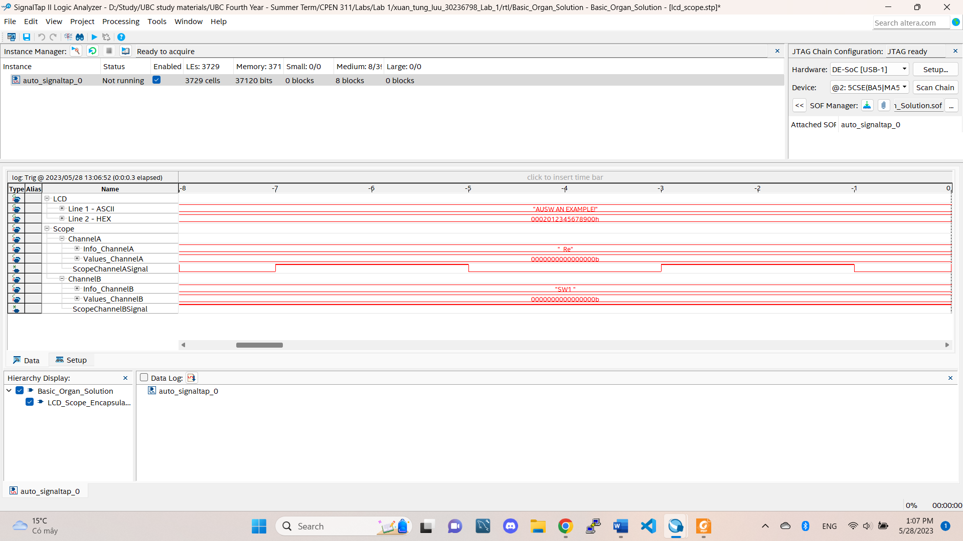

Re with SW0 off

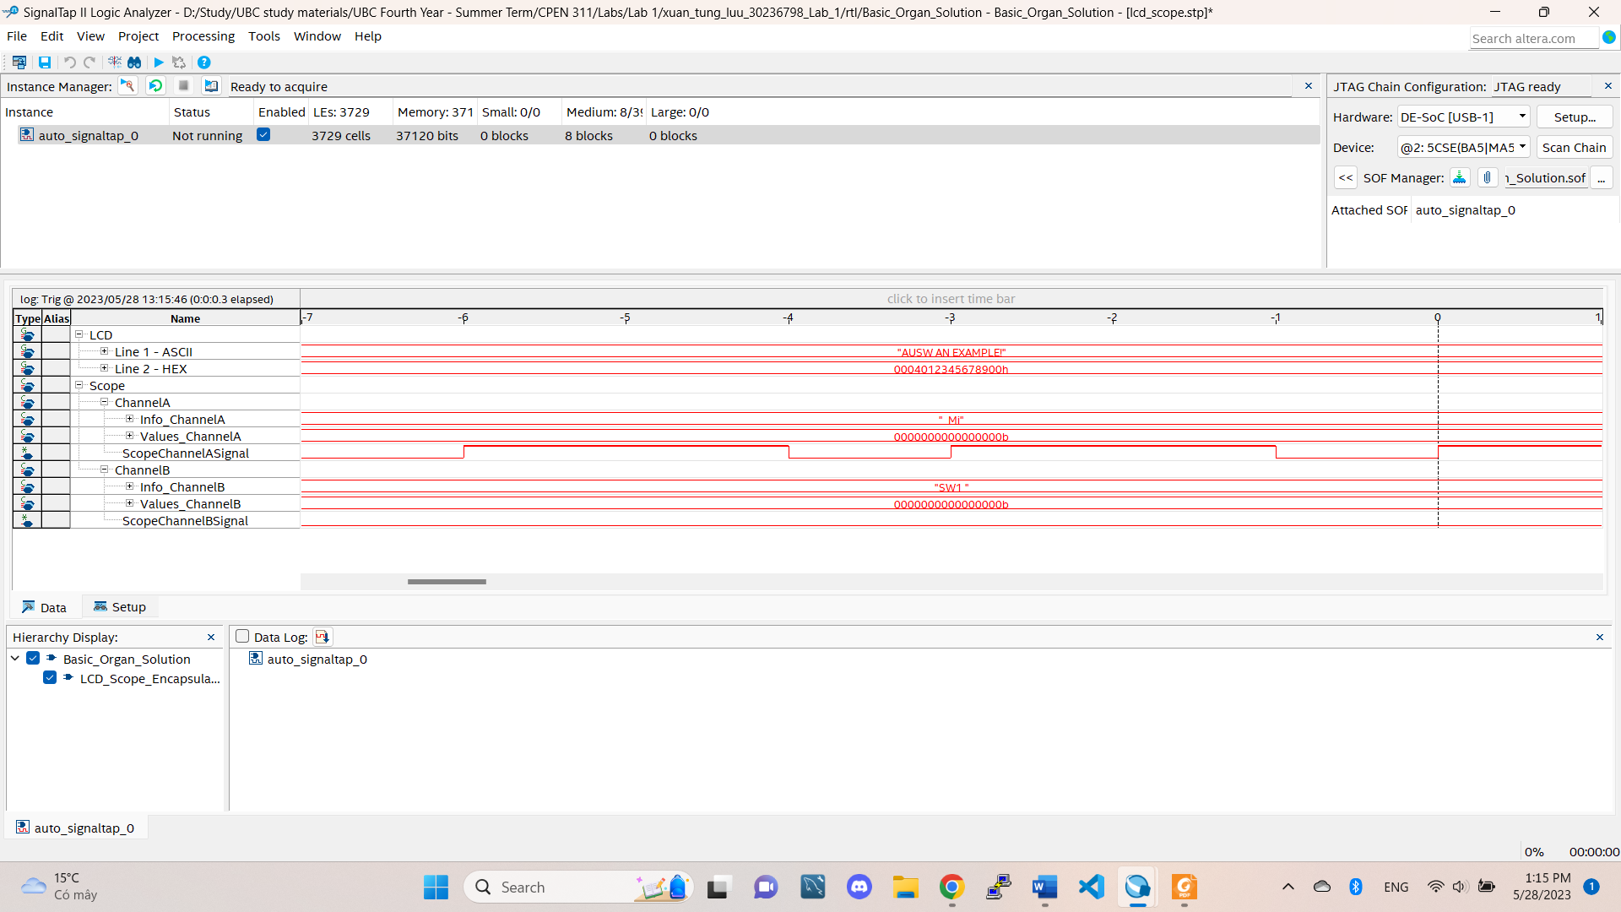

Mi with SW0 off

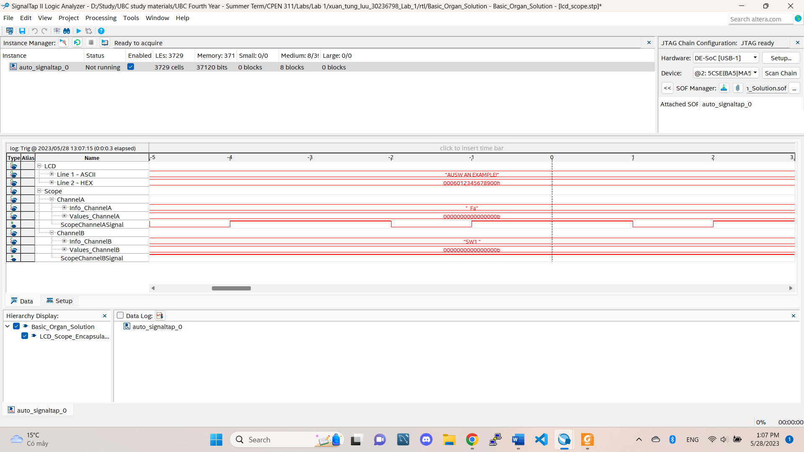

Fa with SW0 off

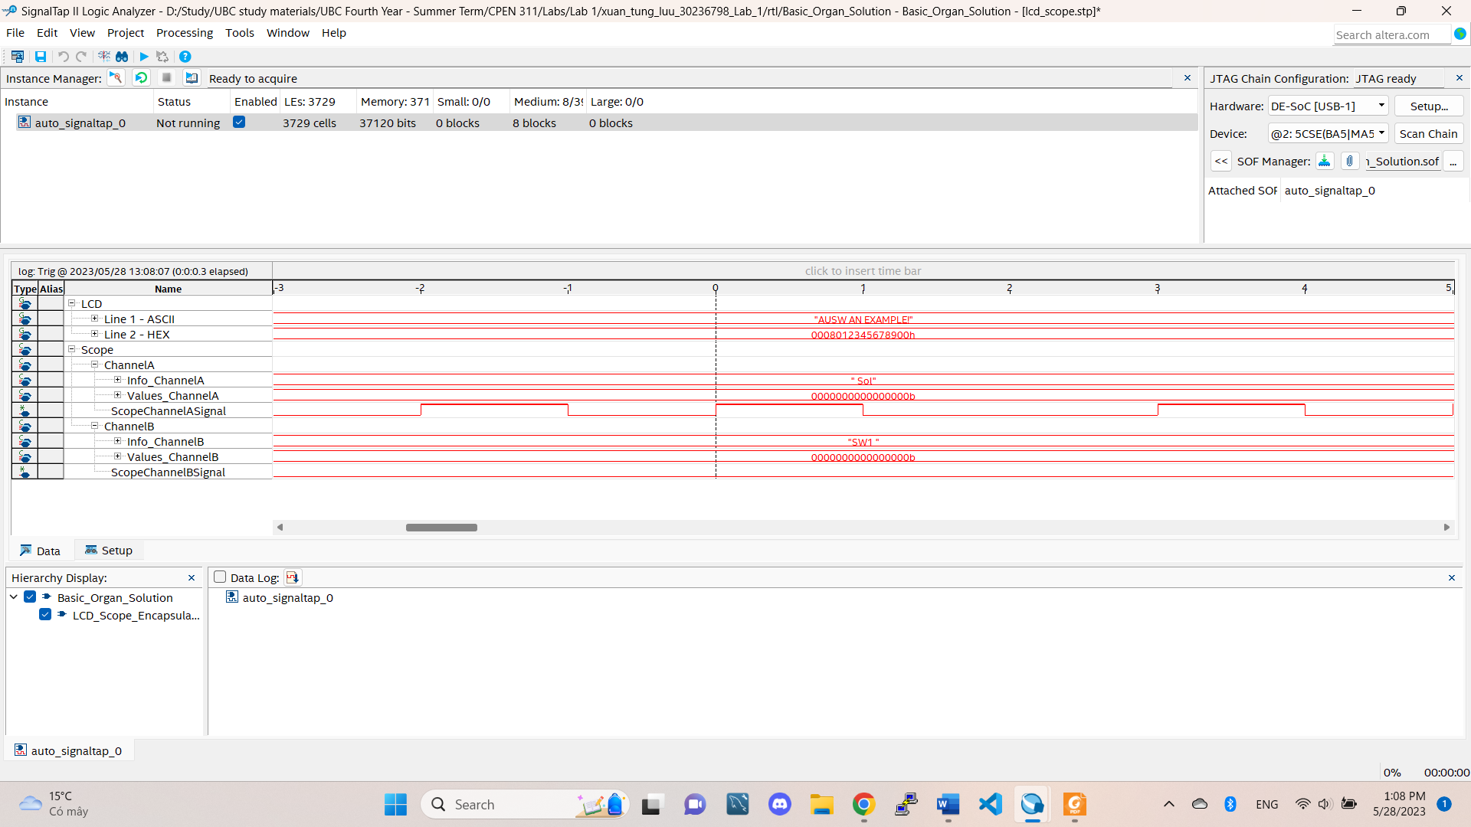

Sol with SW0 off

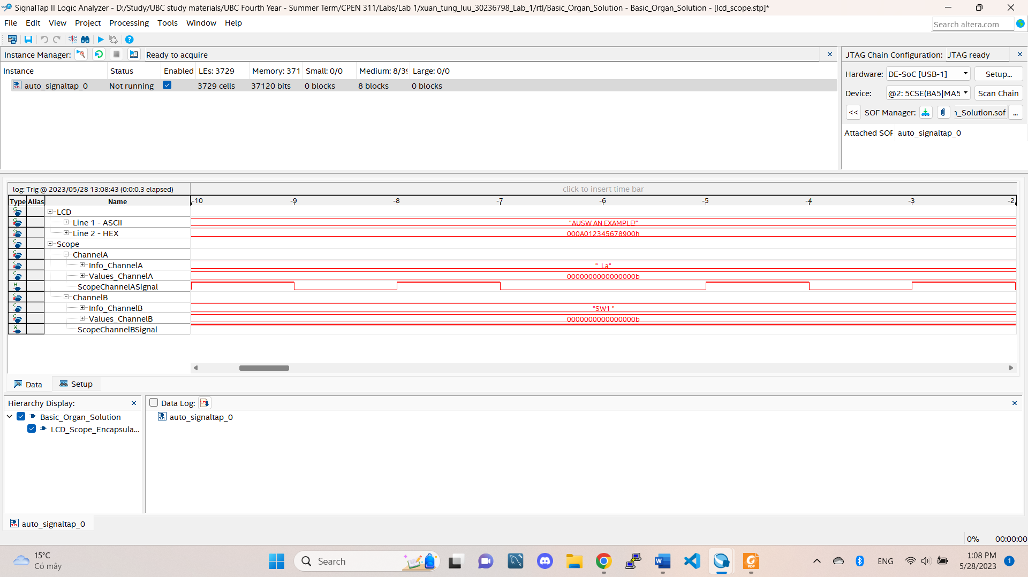

La with SW0 off

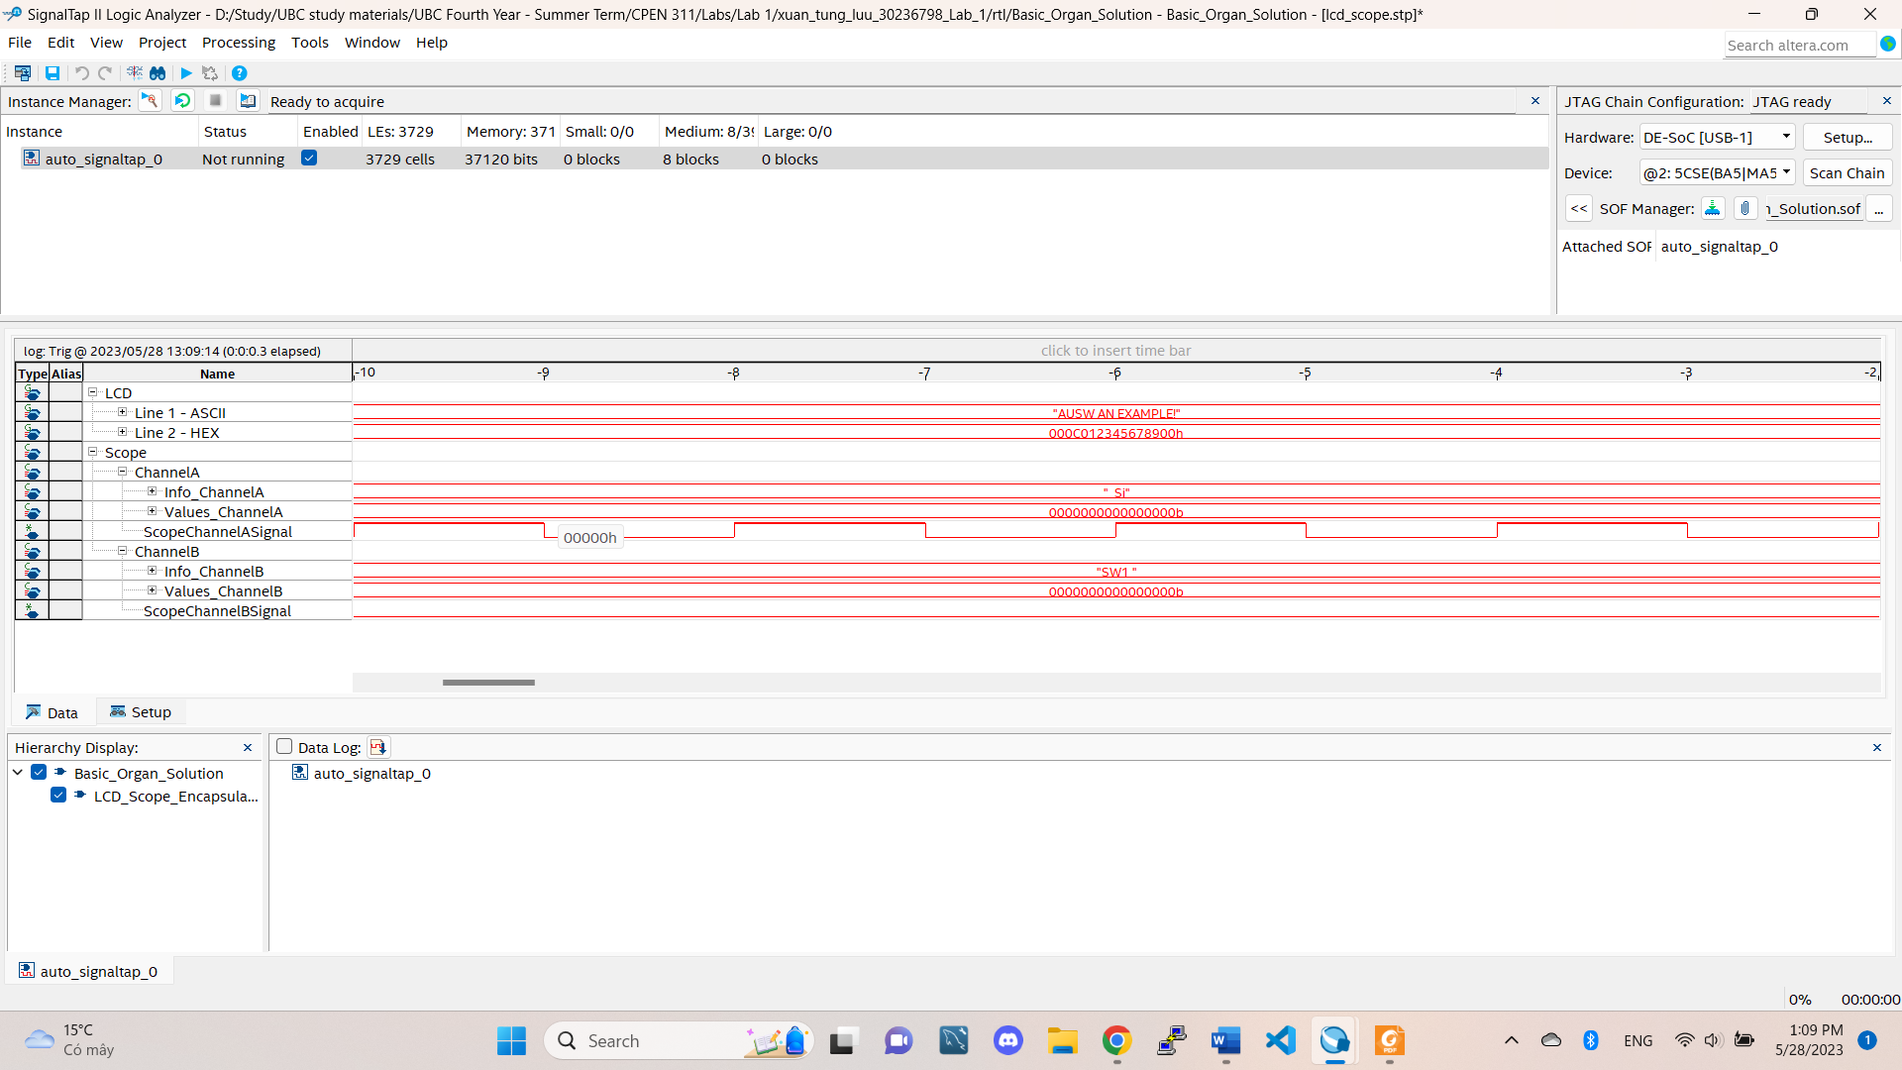

Si with SW0 off

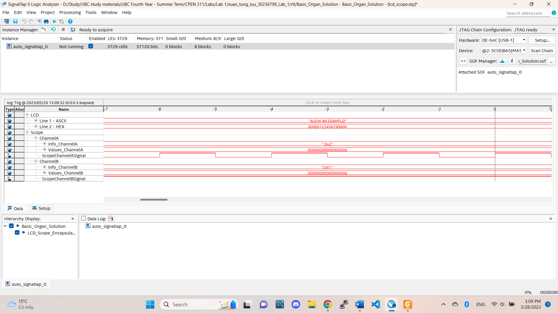

Do2 with SW0 off

5. I use Quartus 9.0sp2 to run the simulation.

- The simulation project for clock divider is located at "xuan_tung_luu_30236798_Lab_1\sim\frequency_divider\Clk_divider.qpf"

- The simulation project for LED switching is located at

"xuan_tung_luu_30236798_Lab_1\sim\LEDS\LED_light.qpf"

- The simulation project for tone organ is located at

"xuan_tung_luu_30236798_Lab_1\sim\tone_organ\note_selector.qpf"

Open the project using Quartus 9.0sp2 and inside the files of each project, there is a waveform file ready to be used. The waves on the waveform file are exactly the same as the pictures. If there are further simulation, just change the inputs in the waveform files.

6. The files I wrote for this lab is Clk_divider.sv, note_selector.sv and LED_light, I only instantiated a little bit in Basic_Organ_Solution.v. In the simulator tool of Quartus 9.0sp2, tick on the box to allow it overwrite the original input file so that the same file can show the simulation (it took me 15min to figure this out…).

The bonus question is in the doc/ folder.