Xuan Tung Luu - 30236798 - README

1. My SOF file is located at xuan_tung_luu_30236798_Lab_2/rtl/simple_ipod_solution.sof

2. Everything works.

3. I have 2 FSM. The first one is to control the signals such as flash_mem_waitrequest, flash_mem_readdatavalid, flash_mem_byteenable, flash_mem_read to interact with the flash. This first module is called fsm. The other FSM controls the address, also sending signal to the first one if the music needs to stop. This second module is called fsm_addr.

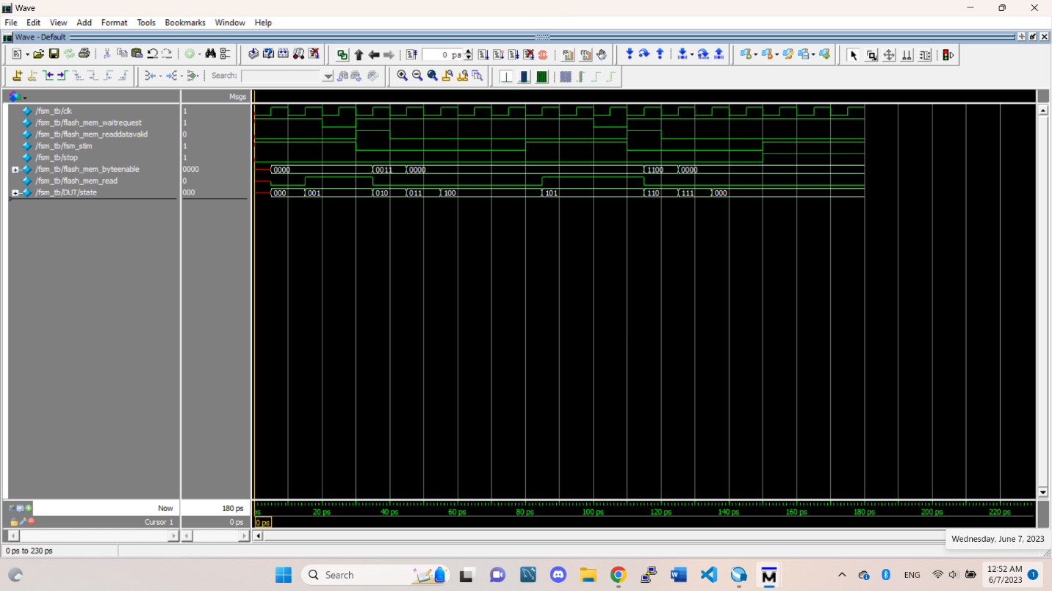

FSM for control signals with FLASH

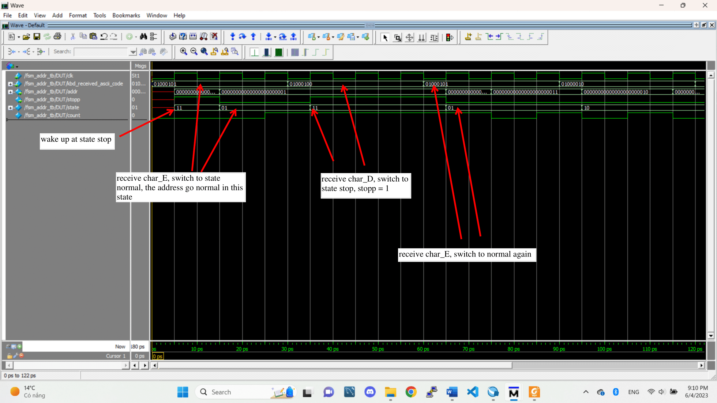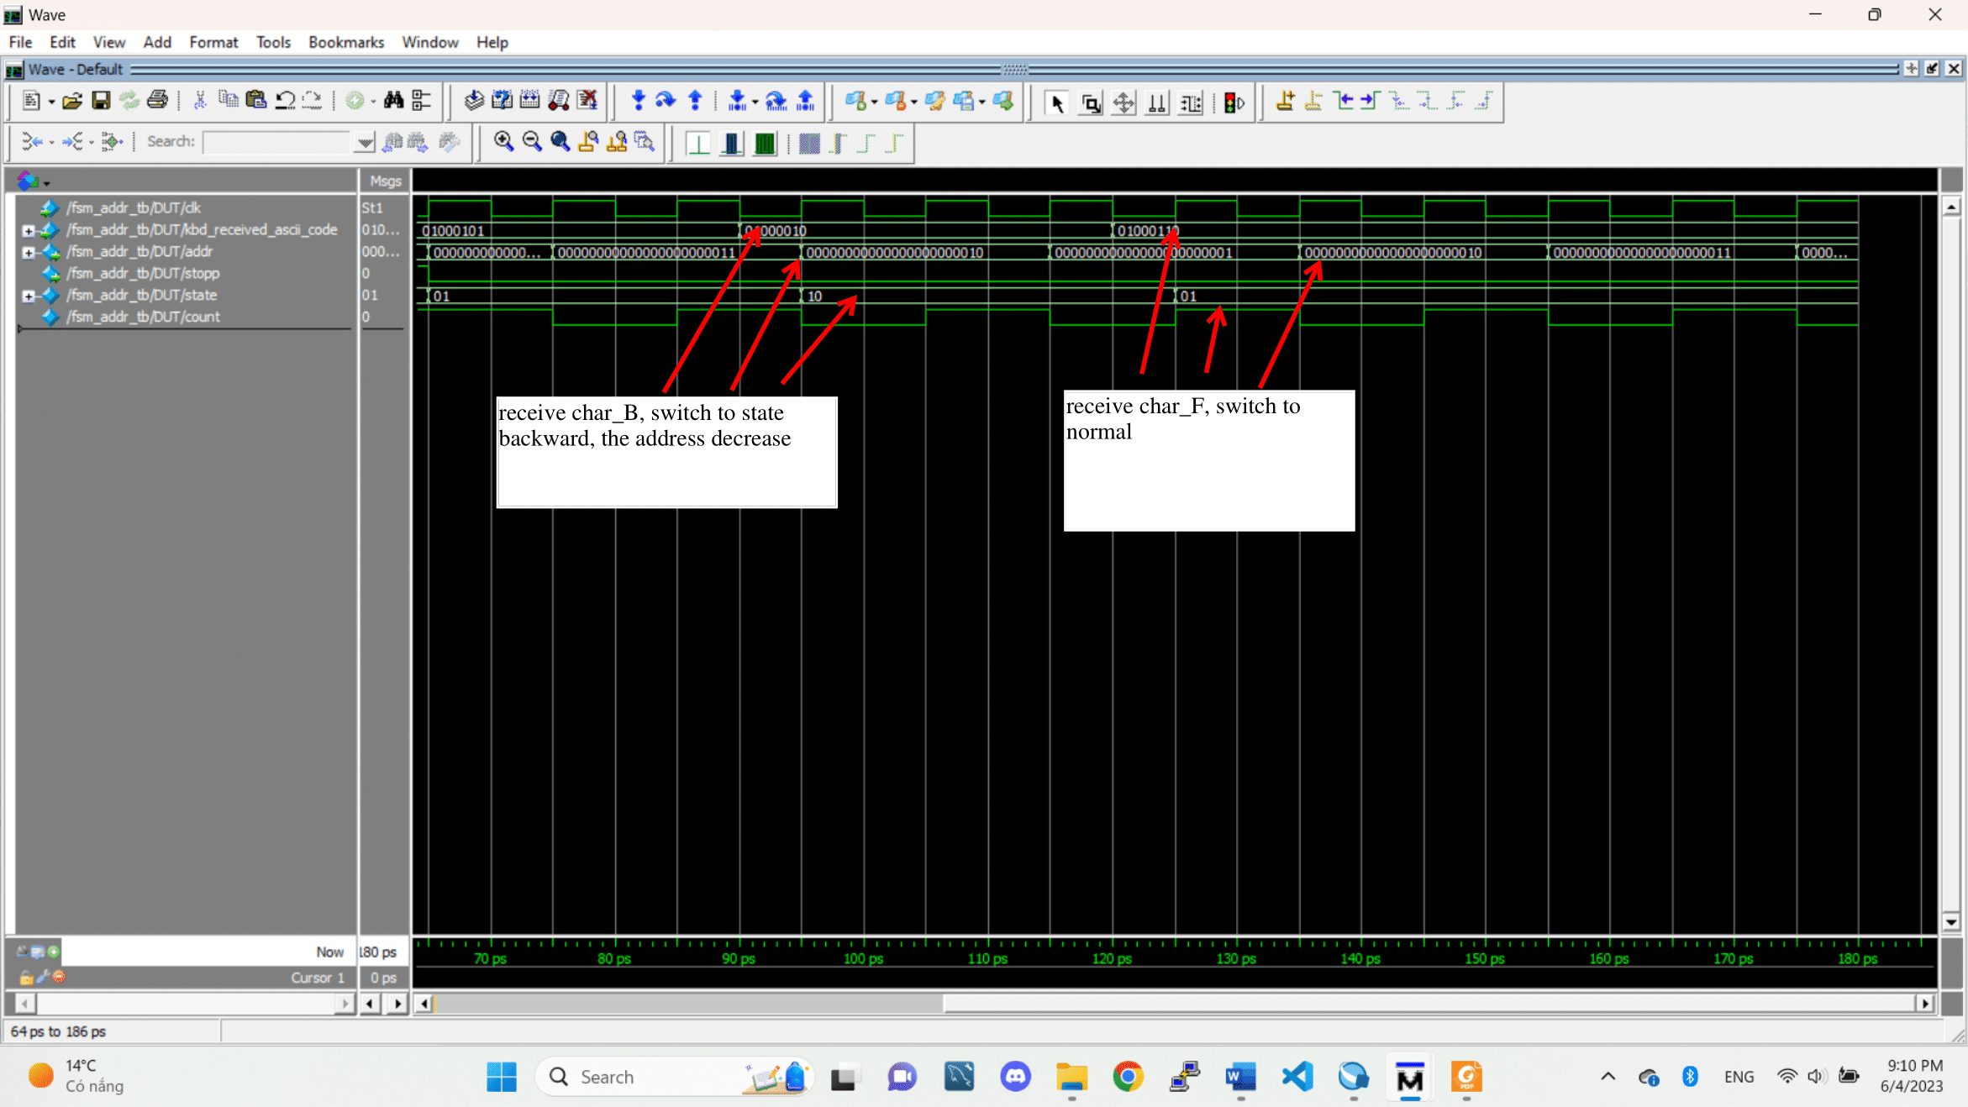

2 pictures of FSM controlling the address

4.Signal tap

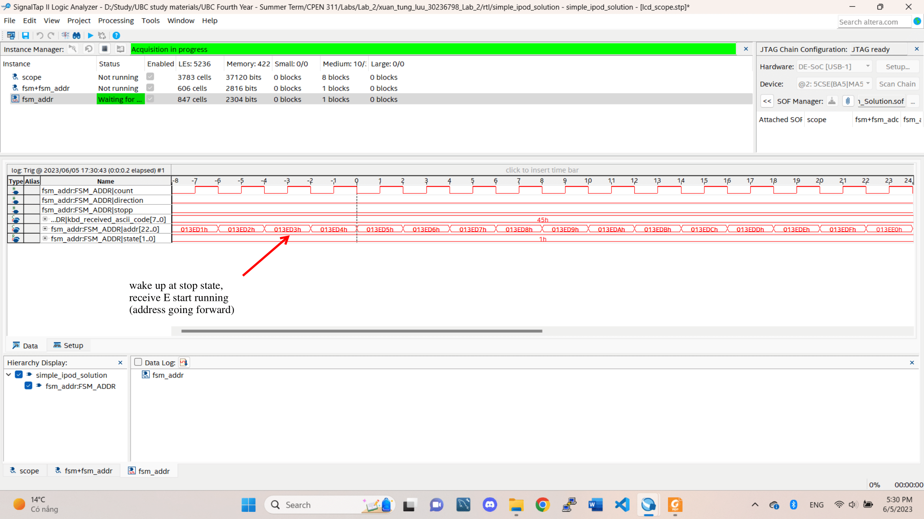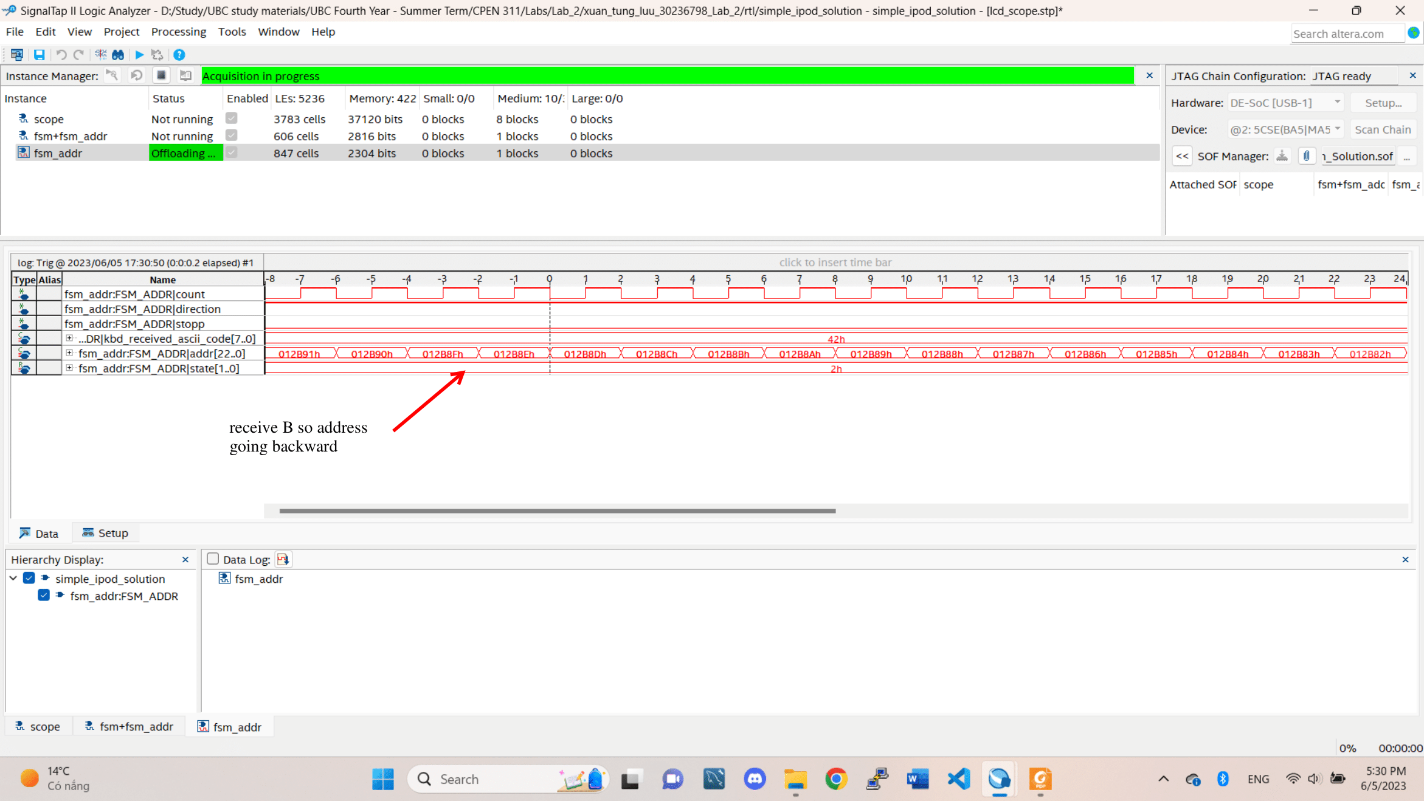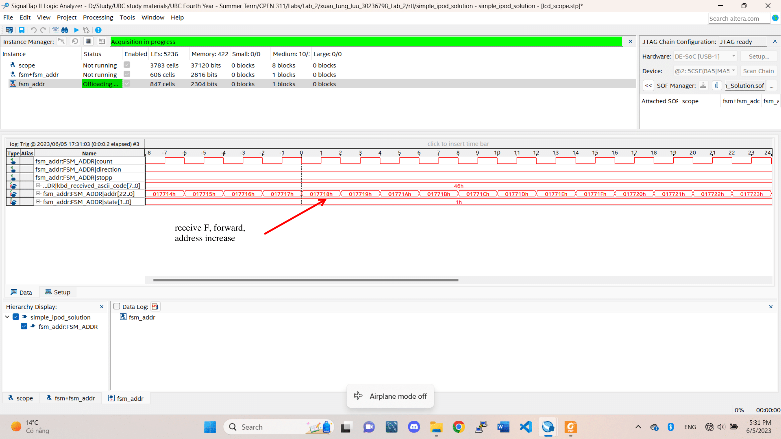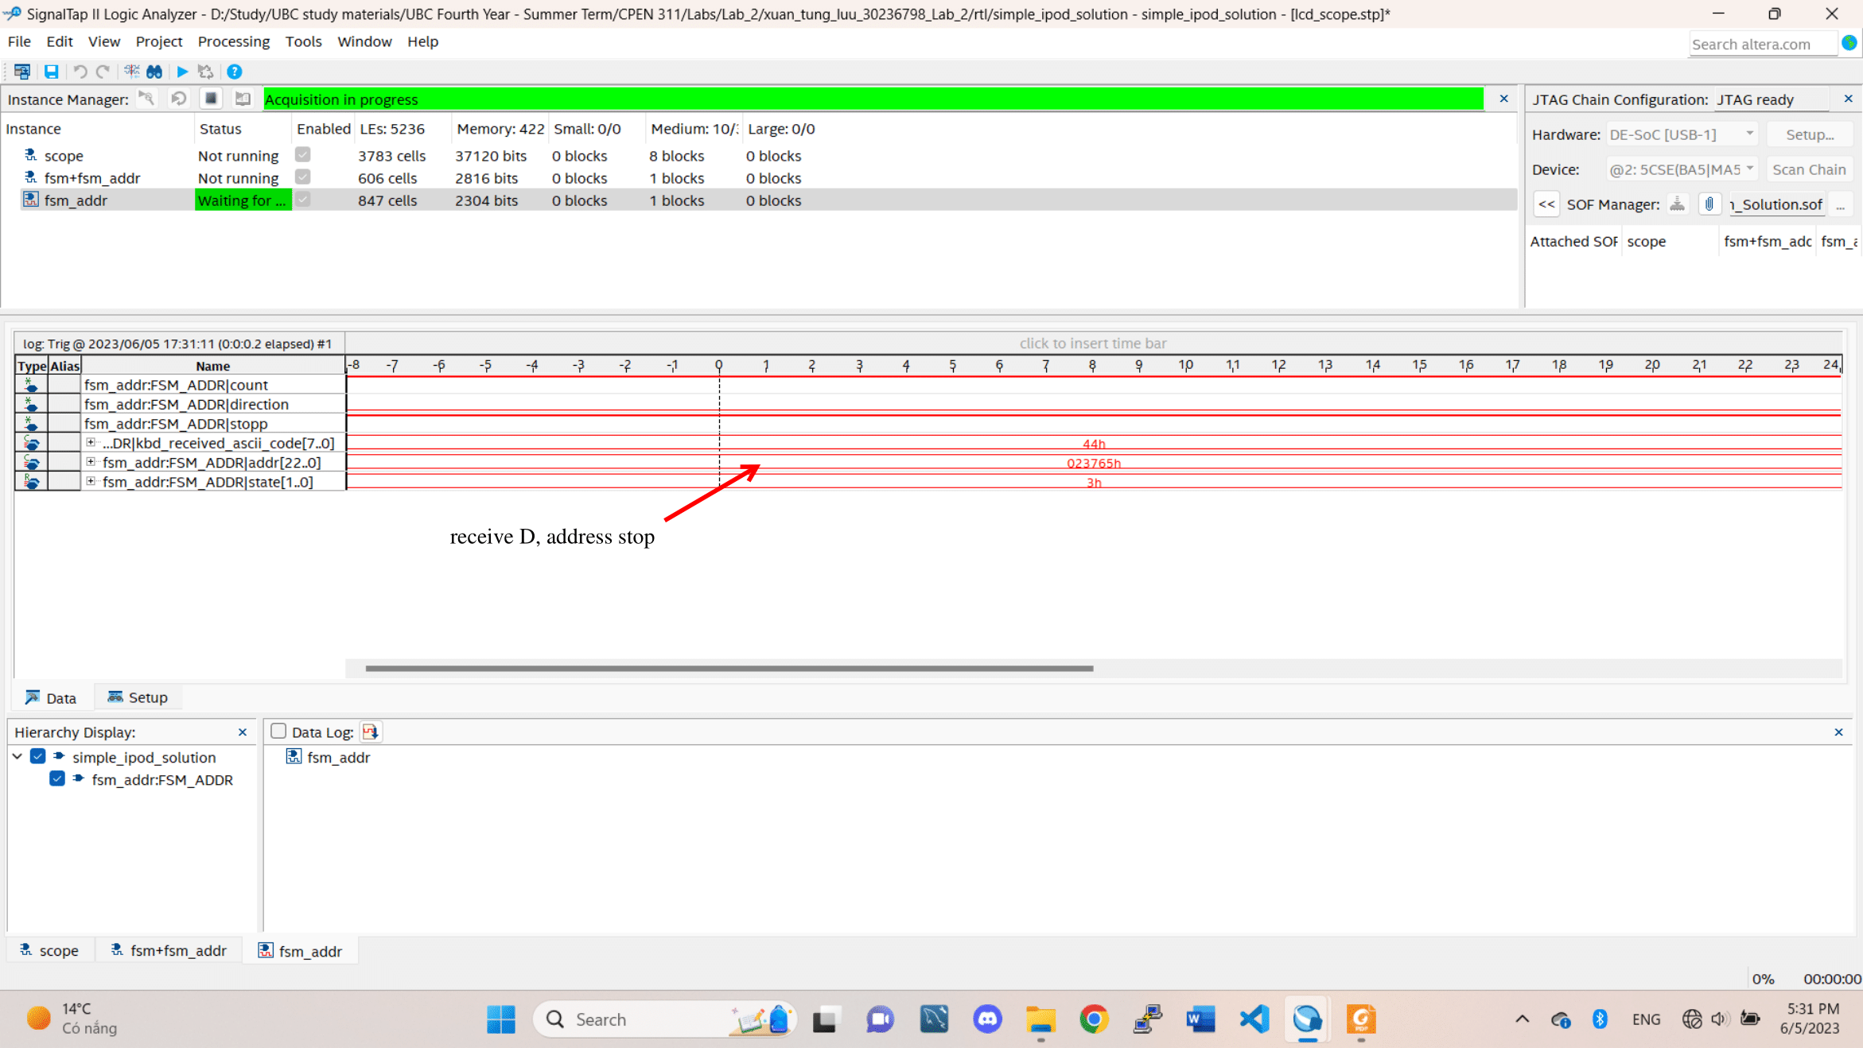

FSM for controlling address

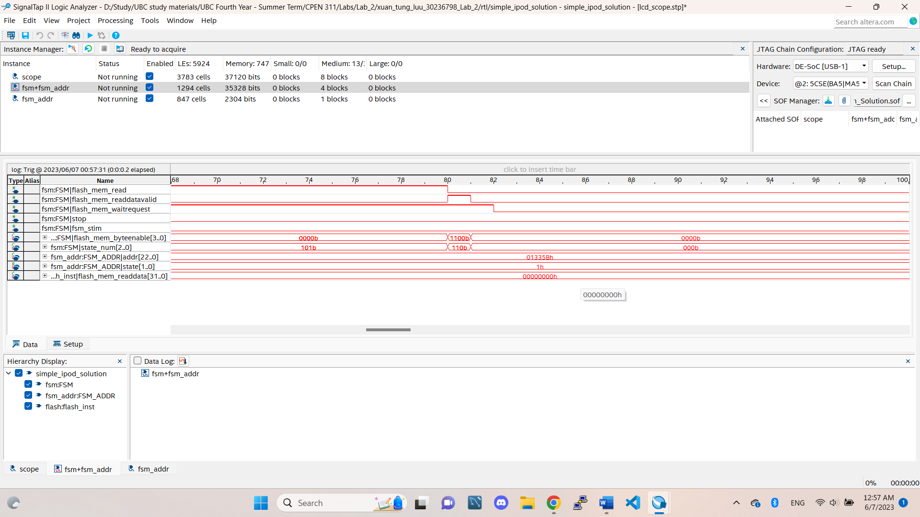

FSM for signals with FLASH

5. I use modelsim to run the simulation. There is a wave.do file in the same folder as the project.

The modelsim project for the first FSM (fsm) is located at: xuan_tung_luu_30236798_Lab_2/sim/fsm/fsm.mpf

The modelsim project for the second FSM (fsm_addr) is located at: xuan_tung_luu_30236798_Lab_2/sim/fsm_addr/fsm_addr.mpf

6. State diagram

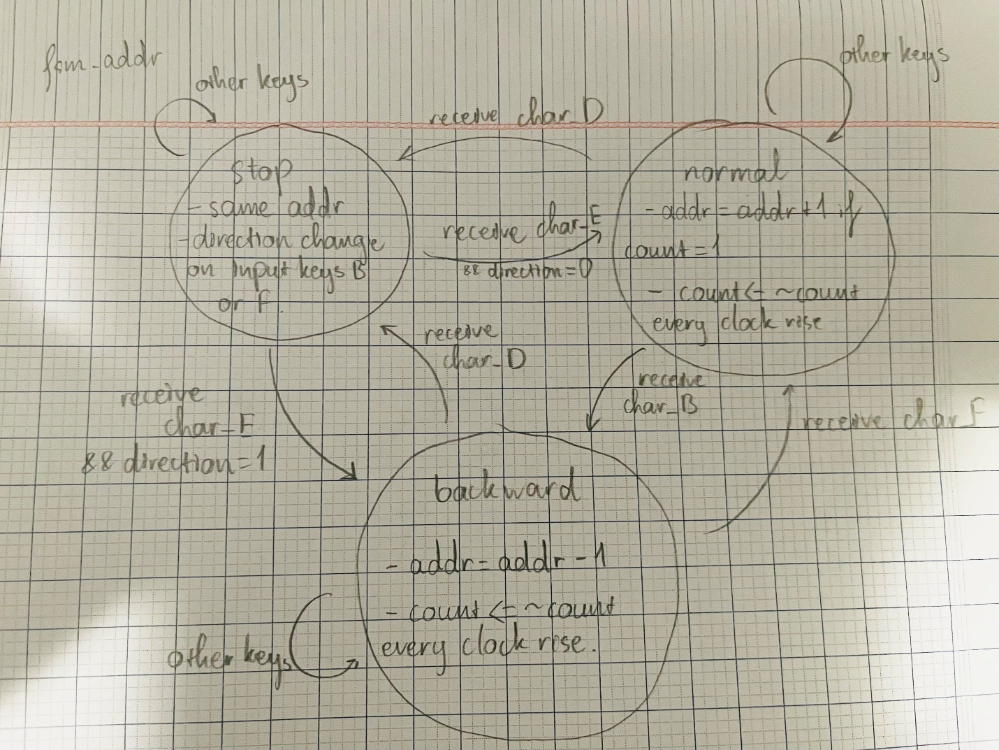

State diagram for fsm_addr (control address)

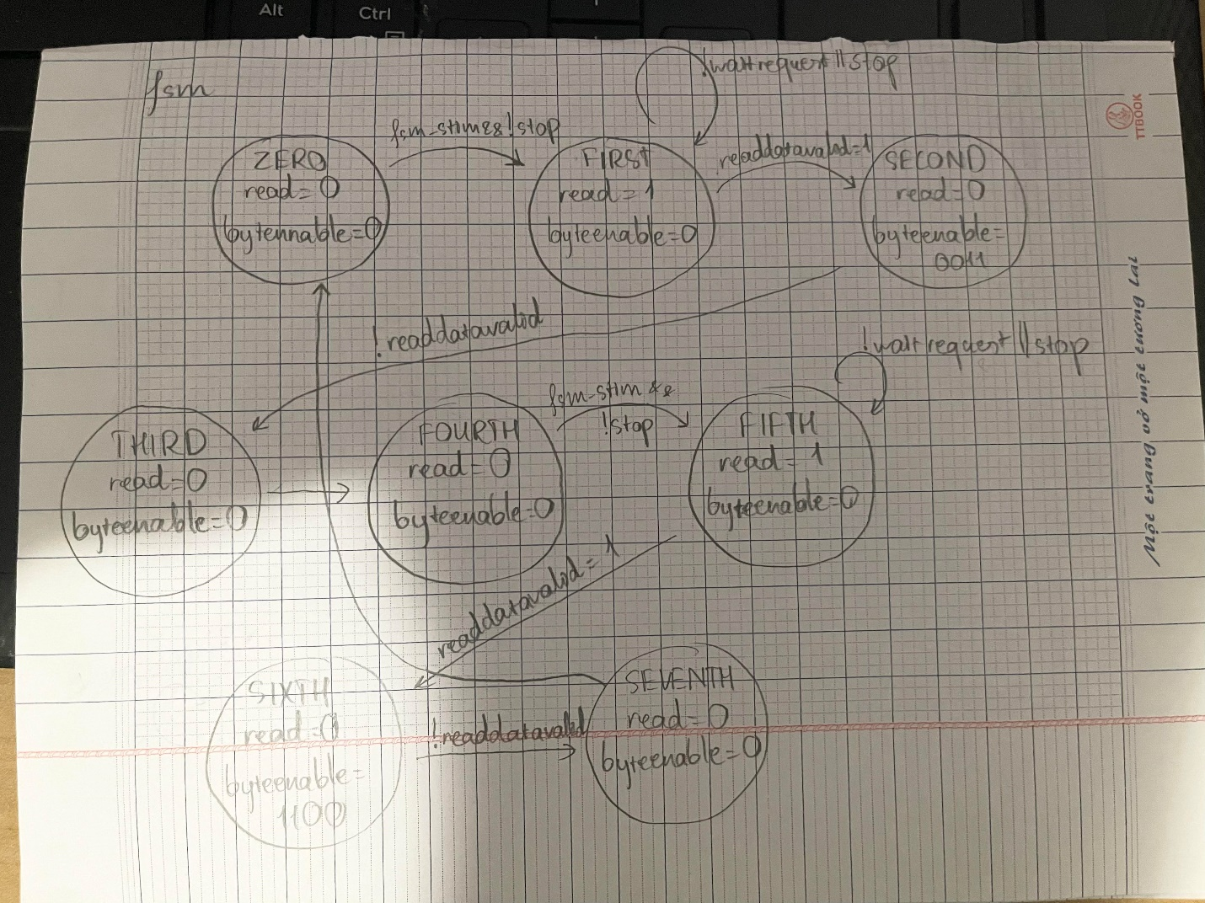

State diagram for fsm (for control signals to FLASH)