VIETNAM GENERAL CONFEDERATION OF LABOR

**TON DUC THANG UNIVERSITY FACULTY OF**

**INFORMATION TECHNOLOGY**



**INTRODUCTION TO ARTIFICIAL INTELLIGENCE**

**FINAL REPORT**

*Instructing Lecturer*: **Mr. DANG MINH THANG**

*Student’s name*: **LE NGOC XUAN TUYEN-517H0094**

**PHAM QUANG TRUONG-517H0091**

Class **: 17050211**

Course **: 21**

**THANH PHO HO CHI MINH, YEAR 2019.**

VIETNAM GENERAL CONFEDERATION OF LABOR

**TON DUC THANG UNIVERSITY FACULTY OF**

**INFORMATION TECHNOLOGY**



**INTRODUCTION TO ARTIFICIAL INTELLIGENCE**

**FINAL REPORT**

*Instructing Lecturer*: **Mr. DANG MINH THANG**

*Student’s name*: **LE NGOC XUAN TUYEN-517H0094**

**PHAM QUANG TRUONG-517H0091**

Class **: 17050211**

Course **: 21**

**THANH PHO HO CHI MINH, YEAR 2019.**

**ACKNOWLEDGEMENT**

In order to make this report complete and achieve good results, we have received the support and assistance of many teachers and classmates.

With deep affection, sincerity, we express deep gratitude to all individuals and agencies who have helped us in our study and research.

First of all, I would like to express a special appreciation to Ton Duc Thang University’s teachers for their conscientious guidance and advices throughout the last semester by gave me their modern outlook and meticulous supervision to carry out the job perfectly.

Especially we would like to send our sincere thanks to Ms. Nguyen Thi Hai Binh has paid attention, help, guide us to complete the report well over the past time.

We would like to express our sincere gratitude to the leadership of Ton Duc Thang University for supporting, helping and facilitating us to complete the report well during the study period.

With limited time and experience, this report can not avoid mistakes. We are looking forward to receiving advice and comments from teachers so that we can improve our awareness, better serve the practical work later.

We sincerely thank you!

**THE PROJECT WAS COMPLETED AT TON DUC THANG UNIVERSITY**

I pledge that this is a product of our own project and is under the guidance of Ms. Nguyen Thi Hai Binh. The content of research, results in this subject is honest and not published in any form before. The data in the tables used for the analysis, comment, and evaluation were collected by the authors themselves from various sources indicated in the reference section.

Besides, in my project, I also use many comments, evaluations as well as figures of other authors, organizations. Their documental sources are all quoted.

*Ho Chi Minh City, April 29th 2019*

*Authors*

*(Sign and write full name)*

*Le Ngoc Xuan Tuyen*

*Pham Quang Truong*

**EVALUATION AND INSTRUCTION LECTURER**

**Confirmation of the instructor**

Ho Chi Minh City, October 1st 2019

(Sign and write full name)

**The assessment of the teacher marked**

Ho Chi Minh City, October 1tst 2019

(Sign and write full name)

**TABLE OF CONTENTS**

ACKNOWLEDGEMENT i

THE PROJECT WAS COMPLETED AT TON DUC THANG UNIVERSITY ii

EVALUATION AND INSTRUCTION LECTURER iii

TABLE OF CONTENTS 1

CHAPTER 1 – REQUIMENTS ENGINEERING 2

CHAPTER 2 – USE CASE SPECIFICATION AND DIAGRAMS 3

2.1 Use scase specification 2

2.2 Diagrams. 1

3.2.1 Class Diagram 1

3.2.2 Activity Diagram 1

3.2.3 Sequence Diagram 1

3.2.4 Entity Relationship Diagram 1

3.2.5 Relationship And Data Model 1

CHAPTER 3 – APPLICATION 3

3.1 Log in 2

3.2 Sign in. 1

3.3 Cart. 1

3.3.1 Add items to cart 1

3.3.2 Delete item from cart 1

3.4 Manage. 1

3.2.3 Search items 1

3.2.4 Manage items ype 1

3.2.5 Manage items brand 1

3.2.5 Manage items 1

CHAPTER 4 – REFERENCES 3

**CHAPTER 1 – REQUIREMENTS ENGINEERING**

**1.1.** **Table of Requirements Engineering**

|  |  |  |  |  |  |  |  |
| --- | --- | --- | --- | --- | --- | --- | --- |
| **No.** | **Module/**  **Screen** | **Description** | **Creator** | **Create date** | **Answer** | **Answer date** | **Status** |
| **1** | Log in | When the customer enter wrong password or username. Then what should we do in this problem, we propose 2 ideas:   * First way, we will announce customer what they enter wrong and underline what they do wrong. * Second way, we only announce customer and customer must find the error. | Pham Quang Truong | 22/11/2019 |  |  | Open |
| **2** | Register | In case Register, customer must enter: Full Name, username, password, phone number, email, and accept the register’s condition. If customer enter identical username with other accounts, what will we do. We offer the idea: Announce the customer to fix. | Pham Quang Truong | 23/11/2019 |  |  | Open |
| **3** | Research Item | If customer research items which the shop doesn’t have or out of stock, what will we do. We will announce the customer and recommend the same items with same prices or same companies | Pham Quang Truong | 24/11/2019 |  |  | Open |
| **4** | Research Items | If customer don’t remember the name of flower or don’t want search base on the name. We suggest the idea: Website will show the category of computer’s attribute tag like: price, color, company, foreign or inland,… | Pham Quang Truong | 25/11/2019 |  |  | open |
| **5** | Add to Shopping Cart | .In case to Add to Shopping Cart function, when customers add the items in cart, if they turn off the website before purchase it, I understand this situation in 2 ways:   * If customer didn’t log in the account, system won’t save this cart. * If customer logged in account, the cart will save the item selected. | Pham Quang Truong | 24/11/2019 |  |  | open |
| **6** | Delete items in shopping cart | According to Delete Shopping Cart. If customer want to delete the items in shopping cart, they will select item and click “Delete” button. The announcement will display on the screen to ask customer really want to delete. Customer will click 1 of 2 idea, if customer click “Yes”, selected item will deleted and, if customer click “No”, the website will return back page.  Do I understand like that is correct? | Pham Quang Truong | 25/11/2019 |  |  | Open |
| **7** | Checkout | In case Checkout, if the order was confirmed, the customer want to cancel the order, what will they do, we offer the solution: They will contact with manager on the phone or email address before the items were delivered to this customer. | Pham Quang Truong | 27/11/2019 |  |  | Open |
| **8** | Make Purchase | According to the Make Purchase function, if the customer turn off the website while make purchase, what will we do, we propose the 2 ideas:   * If customer still log in account, the process will be continued. * If customer without login, the process will be restarted and don’t remember information which customer filled. | Pham Quang Truong | 28/11/2019 |  |  | Open |
| **9** | Add to shopping cart | In case Add to shopping cart. If 2 customers add the same items in the same time while the shop only have 1 item to sell. The system will choose the customer faster than other to add shopping cart. | Pham Quang Truong | 29/11/2019 |  |  | Open |

**1.2. Functional and Non-functional Requirements:**

**Functional Requirements:**

* External Interface – Bright Colors, good looking and medium font not too small, need to highlight important information like Prices of items, Information of item,..
* Reporting Requirement – Need a place to get contact information and suggestion.
* Historical Data – Need show the order’s history and the order’s status.
* Transaction corrections, adjustments and cancellations.
* Administrative functions.

**Non-functional Requirements:**

Response time – Response time must shortest, maximum 2 – 3 seconds.

Capacity - up to 1,000 people accessing at the same time.

Reliability - Product information and product prices must be exactly the same as those on the web.

Security – Automatically encrypt password and user’s information.

Environmental – Can run on many environments: web, mobile,….

**CHAPTER 2 – USE CASE SPECIFICATION AND DIAGRAMS**

**2.1.** **Use case diagram:**

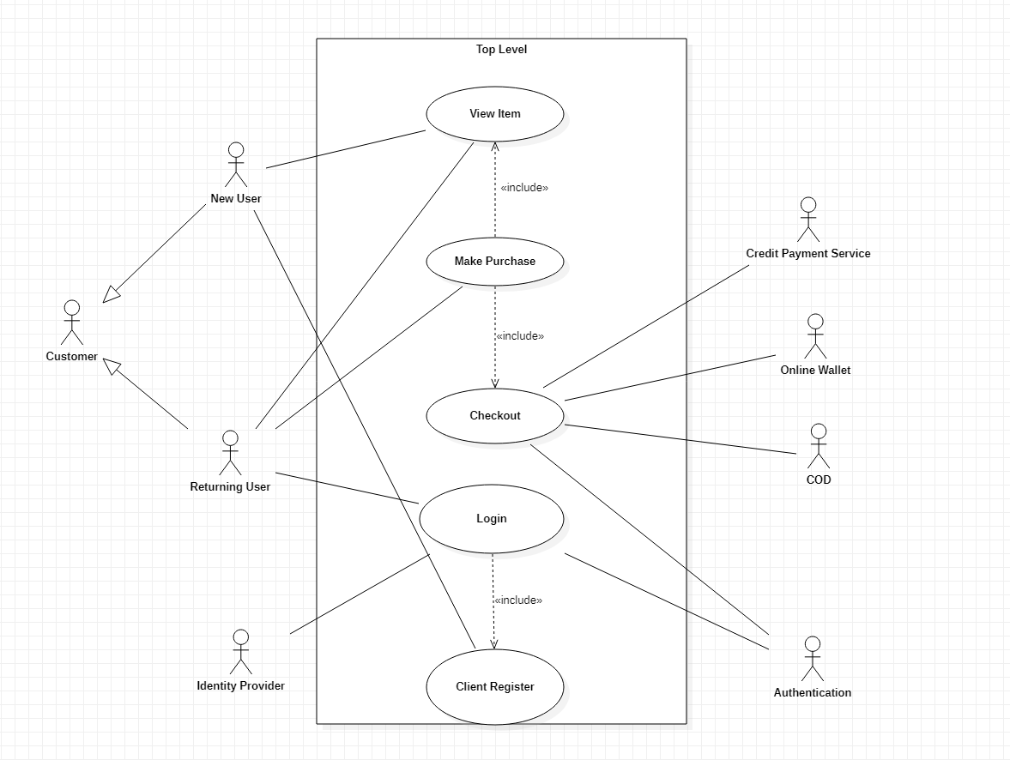

*Figure 1: Top Level Use Case*

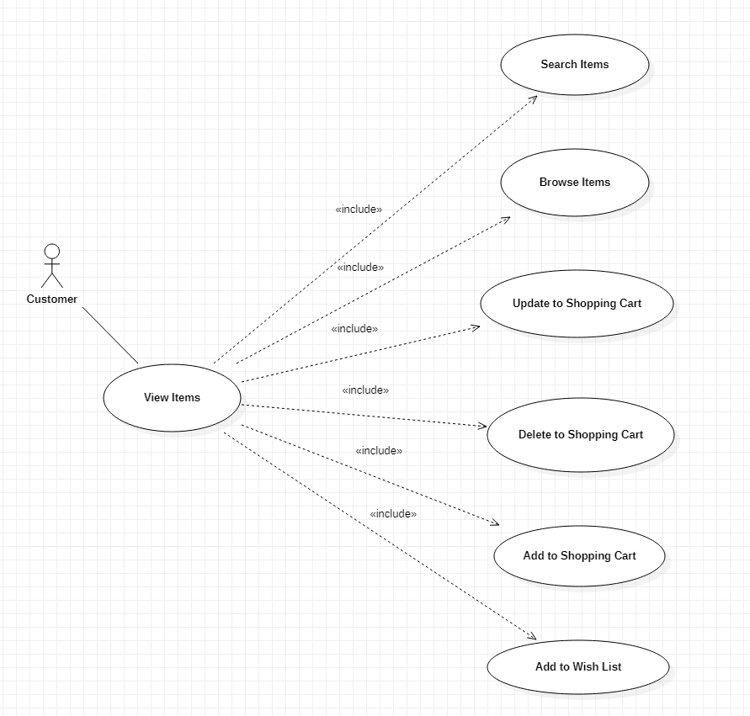

*Figure 2: View Items Use Case*

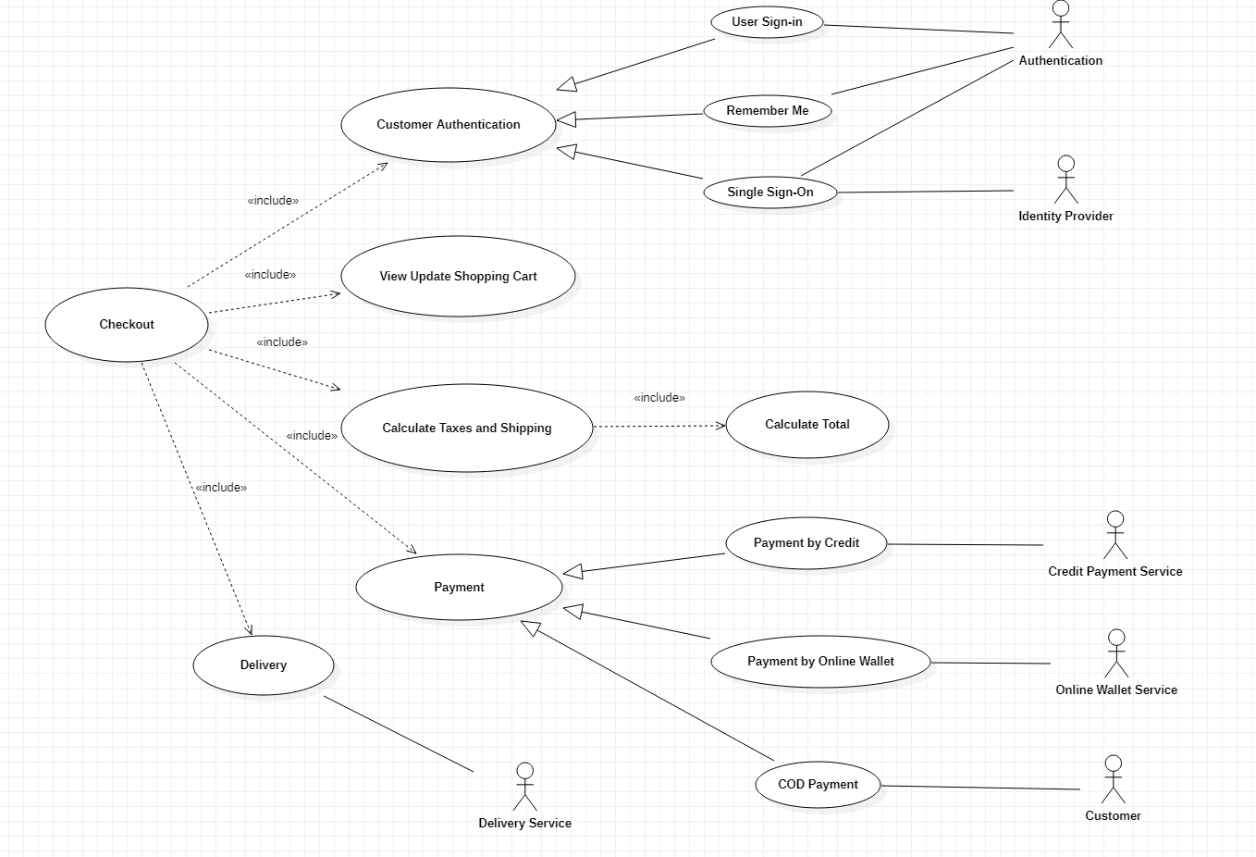

*Figure 3: Checkout Use Case*

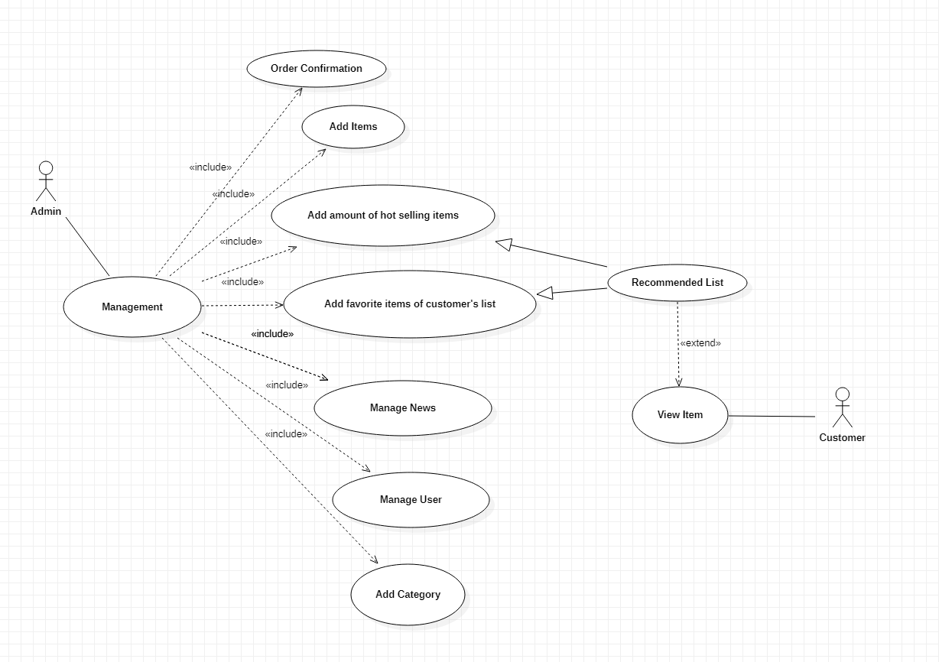

*Figure 4: Management Use Case*

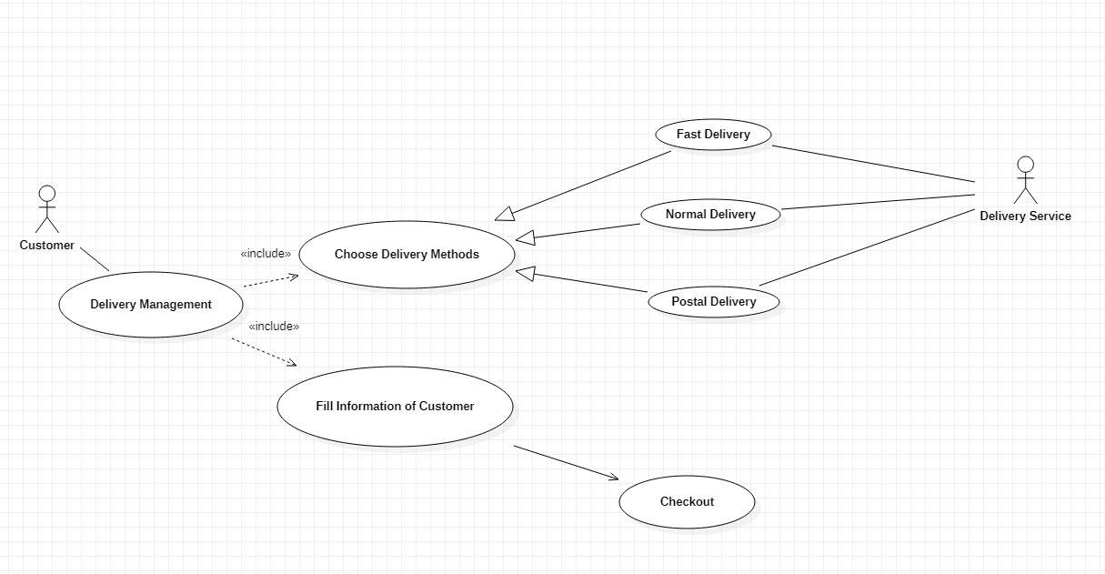

*Figure 5: Delivery Use Case*

**2.2 Use case specification:**

*Top Level Use Case:*

|  |  |
| --- | --- |
| **Use case name** | **Top Level** |
| **Scenario** | The system to use onlinie shopping |
| **Triggering Event** | When the customer join to web online shopping |
| **Breif Description** | When customer join to the web online shopping, returning user can view item, client register, make purchases, check out and new user can view item, client register. In here, customer can contact with objects like : Authentication, Indentity Provider, Credit Payment Service, Online Wallet, COD. |
| **Actors** | Customer, Authentication, Identity Provider, Credit Payment Service, Online Wallet Service, COD. |
| **Related use case** | Include: View Item, Checkout |
| **Stake holder** | * Customer can register account and make purchase and confirm information. * Authentication/ Identity Provider manage customer’s information and authentic customer. * Credit Payment Service, Online Wallet, COD is payment methods in checkout. |
| **Precondition** | * Customer want buy item must have account. * Identity Provider, Credit Payment Service, Online Wallet, COD must connect with Web Online. |
| **Post Condition** | * Customer buy items successful and display the information for customer |

**Flow Event**:

|  |  |
| --- | --- |
| **Actor** | **System** |
| 1. If customer is new customer, customer must register account. 2. Customer can View Item, Make Purchase and Check Out. | * 1. Authentication Information of customer.   2.1 Manage Make Purchase and Checkout authentication and link stakes holders. |
| **Exception**: If customer don’t have account, system must give a notice asking for an account registration. | |

*View Items Use Case:*

|  |  |
| --- | --- |
| **Use case name** | **View Item** |
| **Scenario** | The system to make purchase |
| **Triggering Event** | When the customer log in account and authentic successful |
| **Breif Description** | View Items use case is extended by several optional use cases - customer may search for items, browse catalog, view items recommended for him/her, add items to shopping cart or wish list. All these use cases are extending use cases because they provide some optional functions allowing customer to find item. |
| **Actors** | Customer, |
| **Related use case** | Include: Authentication |
| **Stake holder** | * Customer log in and confirm authentication and can search, browse, view recommended items, add items to shopping cart or wish list. |
| **Precondition** | Customer must go in website, log in and select items. |
| **Post Condition** | Selected Items and take it in shopping cart. |

**Flow Event:**

|  |  |
| --- | --- |
| **Actor** | **System** |
| 1. Customer log in account. 2. Customer can search items. 3. Customer can browse items. 4. Customer can view recommended items. 5. Customer can add, delete, update items to shopping cart. 6. Customer can add items to wish list | * 1. Authentic customer’s information.   2.1 Search items in menu according to the requirement. ( name of items, cost, type of item,…)  3.1 Check items and confirm.  4.1 Give the recommended items list.  5.1 Authentic and save items in shopping cart.  6.1 Authentic and save items in wish lish. |
| **Exception**: If customer search items and the system not found the items, the system will display the announcement about result.  If customer don’t select items and add in shopping cart, customer can’t purchase. | |

Checkout Use Case:

|  |  |
| --- | --- |
| **Use case name** | **Checkout** |
| **Scenario** | The system to use make purchase, payment and receive items |
| **Triggering Event** | When customer want to pay and receive items. |
| **Breif Description** | * Checkout use case includes several required uses cases. Web customer should be authenticated. It could be done through user login page, user authentication cookie ("Remember me") or Single Sign-On (SSO). Web site authentication service is used in all these use cases, while SSO also requires participation of external identity provider. * Checkout use case also includes Payment use case which could be done either by using credit card and external credit payment service or Online Wallet, COD,… * Checkout use case includes Delivery use case to customer choose the delivery methods. |
| **Actors** | Customer, Authentication, Identity Provider, Credit Payment Service, Online Wallet Service, COD. |
| **Related use case** | Include: Customer Authentication, Payment, Delivery |
| **Stake holder** | * Customer must authentic by 3 method: user login page, user authentication cookie, SSO. * Payment provide payment methods like: Credit card, Online Wallet, COD. |
| **Precondition** | Customer must have account and have items in cart shopping. |
| **Post Condition** | Purchase successful and confirmed order. |
|  |  |

**Flow Event:**

|  |  |
| --- | --- |
| **Actor** | **System** |
| 1. Customer choose checkout 2. Customer confirm information 3. Customer choose payment methods and delivery. | 1.1 Authentic customer’s information and display cart shopping of customer.  2.1 Save items and calculate total.  3.1 Save data and calculate cost and give the receipt |
| **Exception:** If customer want to cancel the order, customer can click on history of order and click cancel ( before order would be confirmed). | |

Manage Use Case:

|  |  |
| --- | --- |
| **Use case name** | **Management** |
| **Scenario** | Manage Order and Items and Users |
| **Triggering Event** | When manager log in. |
| **Breif Description** | After customer checkout successful, admin/manager confirm order, print a receipt.  Manager can statistic hot selling items by day/week/month and favorite items to create the recommended items list.  Manager can check items in inventory and check sales of month.  Customer can view recommended items list.  Manager can active/unactive user and update, add, delete items. |
| **Actors** | Admin/Manager, Customer, Identity Provider |
| **Related use case** | Include: Checkout, View Items |
| **Stake holder** | Customer checkout successful.  Manager confirm and check items, sales. |
| **Precondition** | Manager must have account and check the order |
| **Post Condition** | Confirm the order successfully and the website is always update |

**Flow Event:**

|  |  |
| --- | --- |
| **Actor** | **System** |
| 1. Manager log in and choose a order. 2. Manager confirm a order. 3. Manager can statistic hot selling items by day/week/month and favorite items to create the recommended items list. 4. Manager can summary monthly sales | * 1. Authentic manager’s information.   2.1 Confirm a order, print a receipt.  3.1 Statistic items have most purchase during day/week/month and favorite items, create recommended items list.  3.2 Display recommended items list for customer.  4. Summary sales all days of month |
| **Exception:**If system have error, system will close the website and change to maintenance status. | |

Delivery Use Case:

|  |  |
| --- | --- |
| **Use case name** | **Delivery** |
| **Scenario** | Manage Delivery |
| **Triggering Event** | After Customer choose the payment method. |
| **Breif Description** | After customer choose the payment method, customer will choose the delivery method and fill information to ship items. |
| **Actors** | Customer, Delivery Service |
| **Related use case** | Delivery Method, Checkout |
| **Stake holder** | Customer choose the delivery method and fill information.  Delivery Service will ship items and fee the cost in order |
| **Precondition** | Customer must make purchase and have items in shopping cart |
| **Post Condition** | Order will send to Admin to confirm. |

**Flow Event:**

|  |  |
| --- | --- |
| **Actor** | **System** |
| 1. Customer choose the delivery method. 2. Fill information to ship | 1. Confirm and fee the cost 2. Add the cost in order 3. Save and send information for Delivery Service |
| **Exception:**If customer fill wrong information and want to fix after confirm, customer need contact with Delivery Service or Admin. | |

**2.3. Diagrams:**

**2.2.1. Class Diagram:**

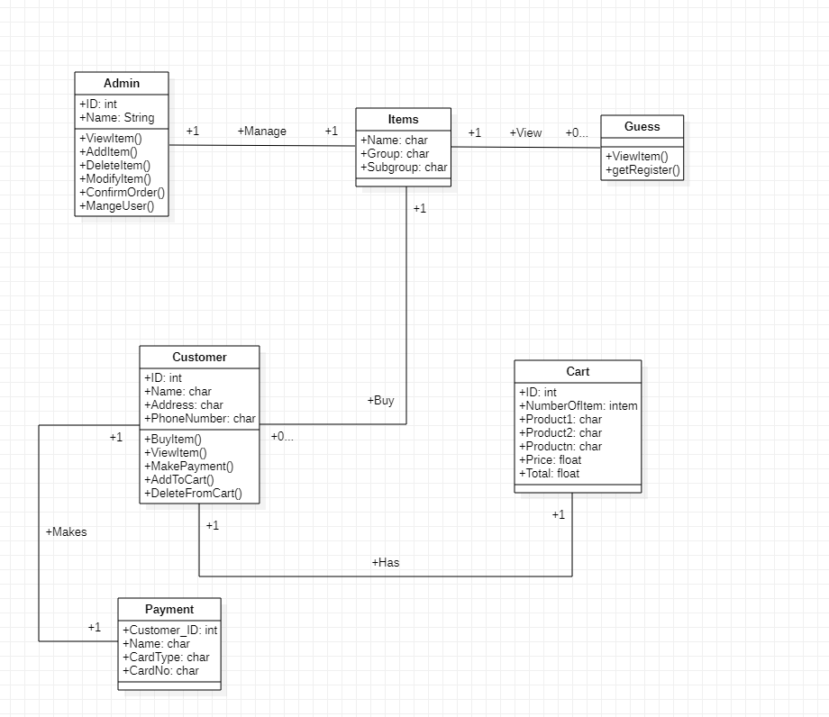

*Figure 7: Class Diagram*

**2.2.2. Activity Diagram:**

**Activity Diagram for Customer:**

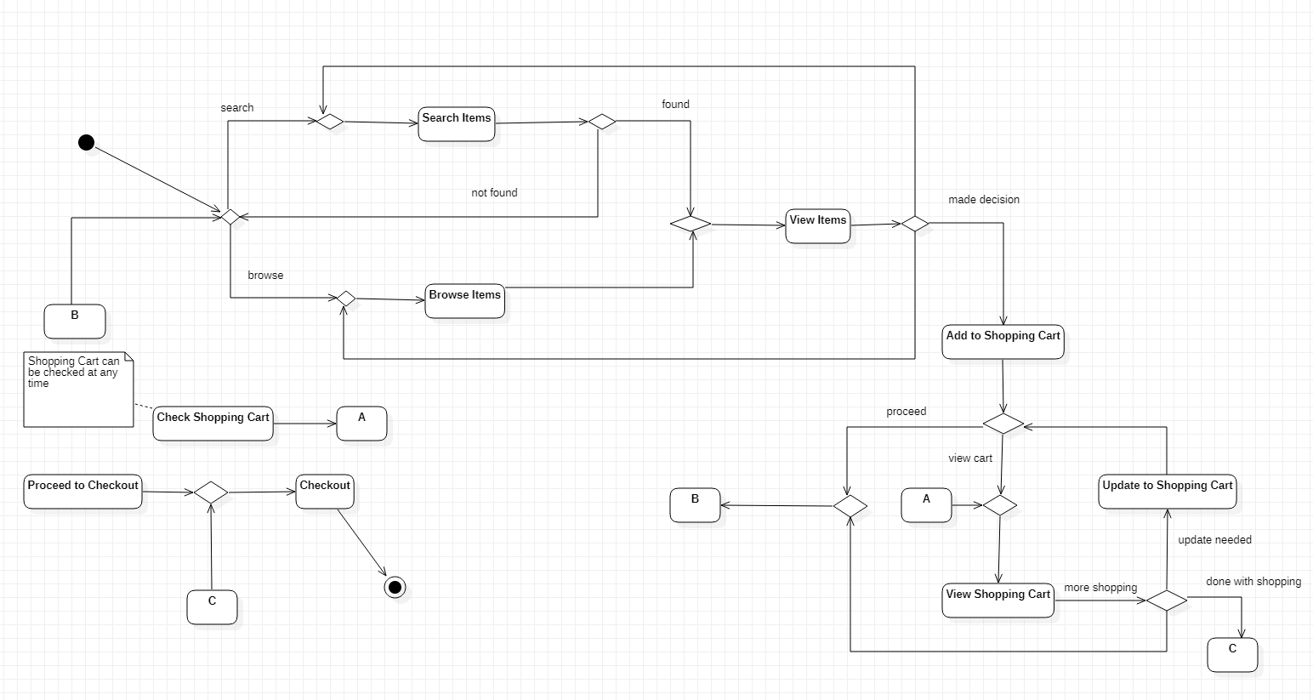

*Figure 8: Activity Diagram for Customer*

**Activity Diagram for Admin:**

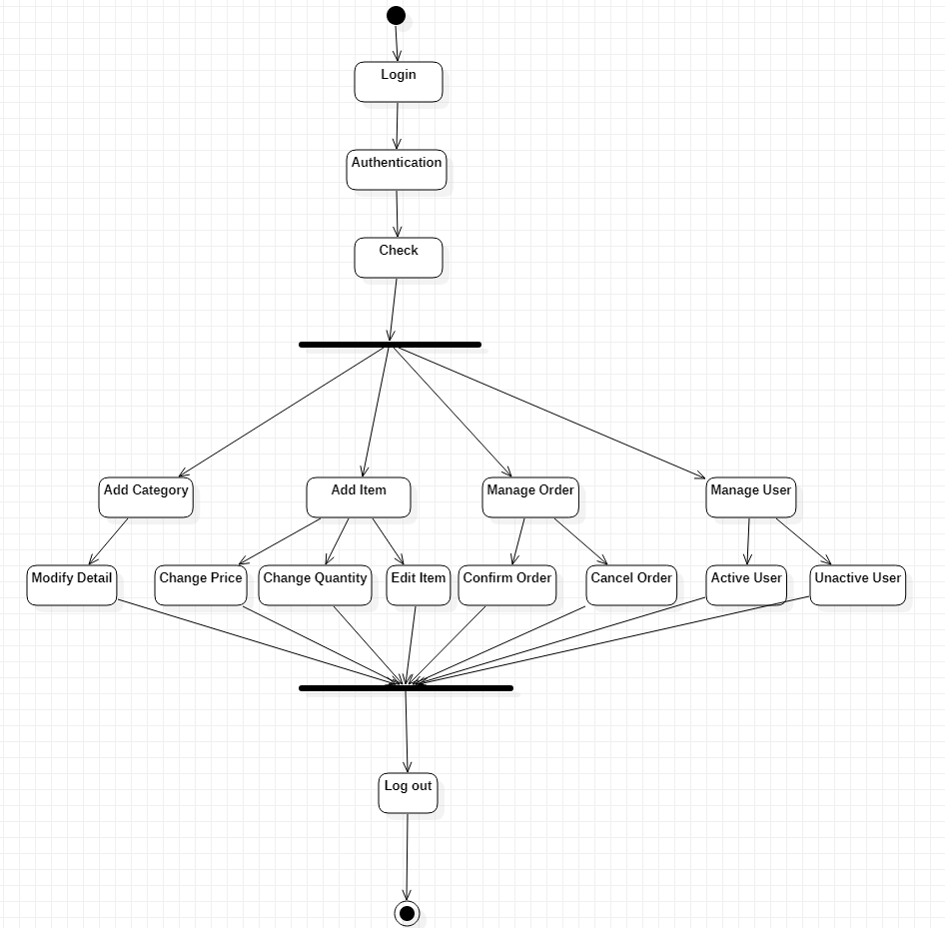

*Figure 9: Activity Diagram for Admin*

**2.2.3. Sequence Diagram:**

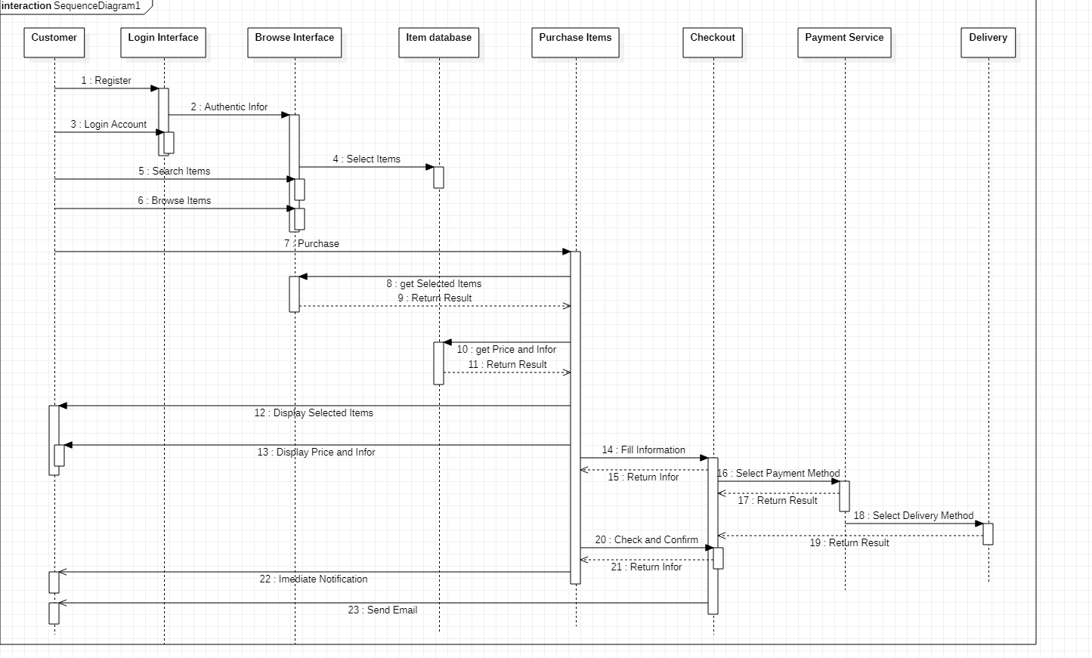

*Figure 10: Sequence Diagram*

**2.2.4. Entity Relationship Diagram:**

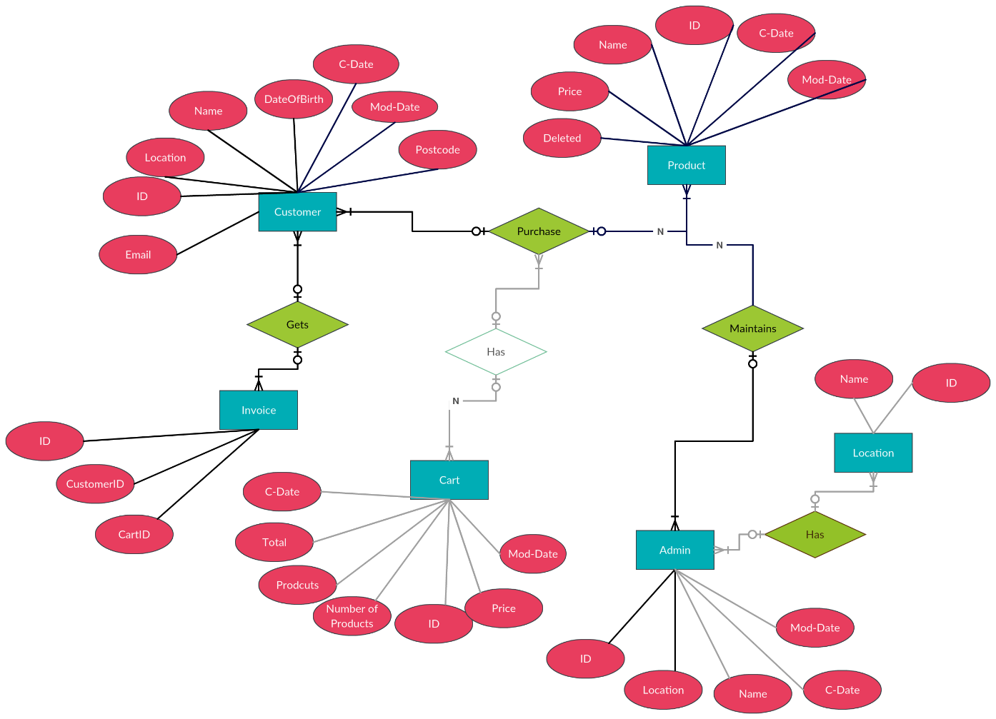

*Figure 11: Entity Relationship Diagram*

**2.2.5. Relational Data Model**

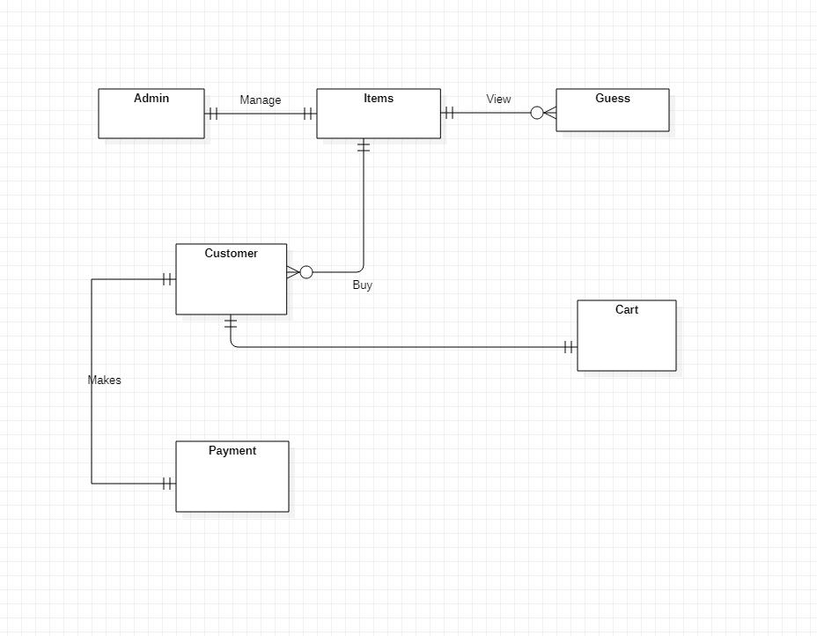

*Figure 12: Relational Data Model*

**CHAPTER 3 – APPLICATION**

Application to Web with Funtions

* 1. **Log in:**

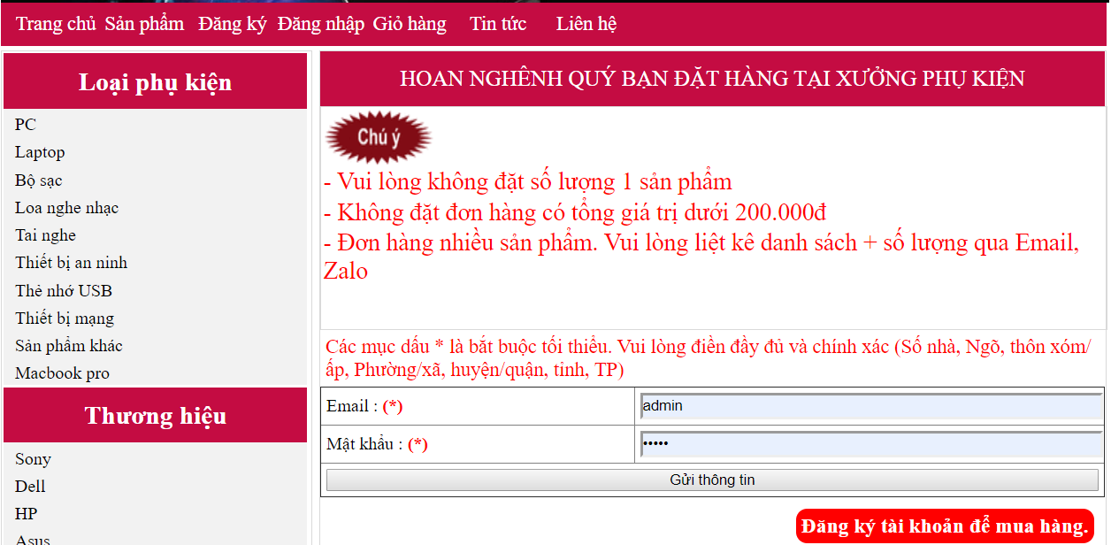

*Figure 13: Login funtion*

* 1. **Sign in:**

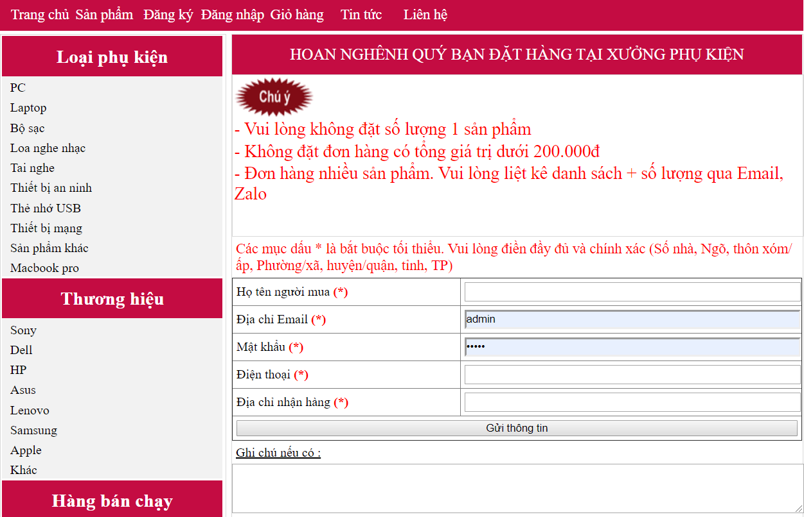

*Figure 14: Sign in function*

* 1. **Cart:**
     1. **Add item to cart:**

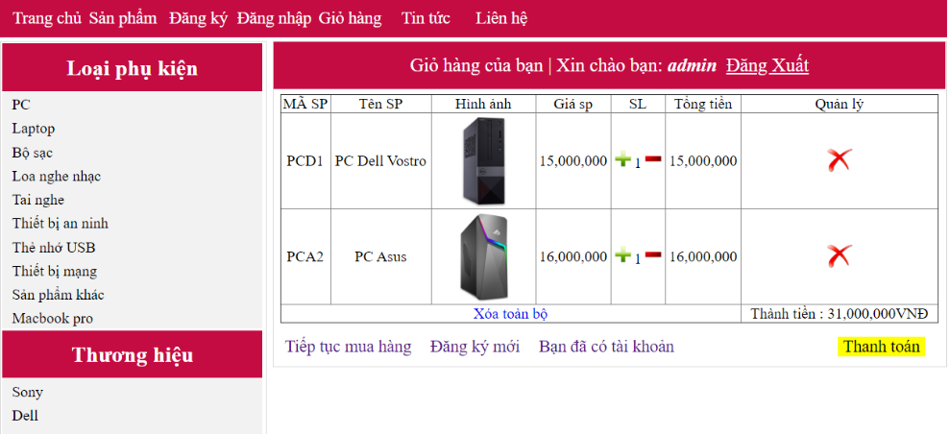

*Figure 15: Add items to cart funtion*

* + 1. **Delete item from cart:**

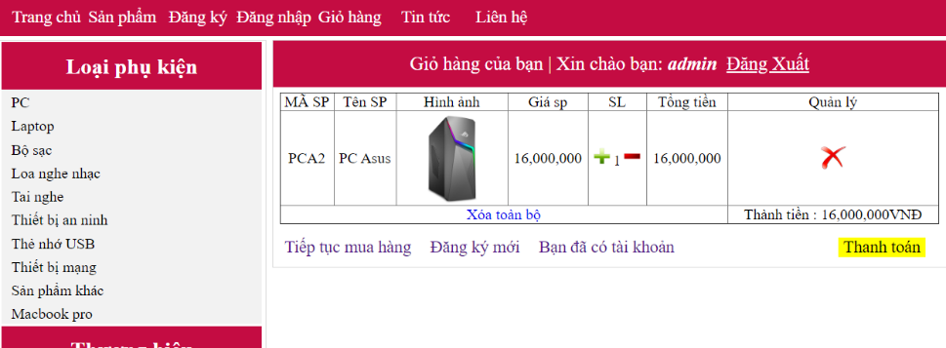

*Figure 16: Delete item from cart funtion*

* 1. **Manage:**

**3.4.1. Search item:**

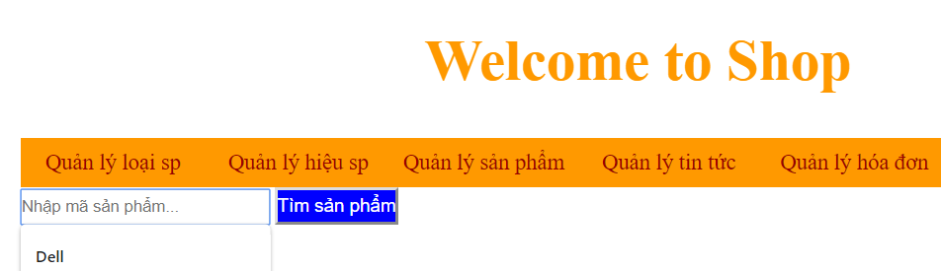

*Figure 17: Search items funtion*

* + 1. **Manage items type:**

**Include: Add/Delete/Setup Items type**

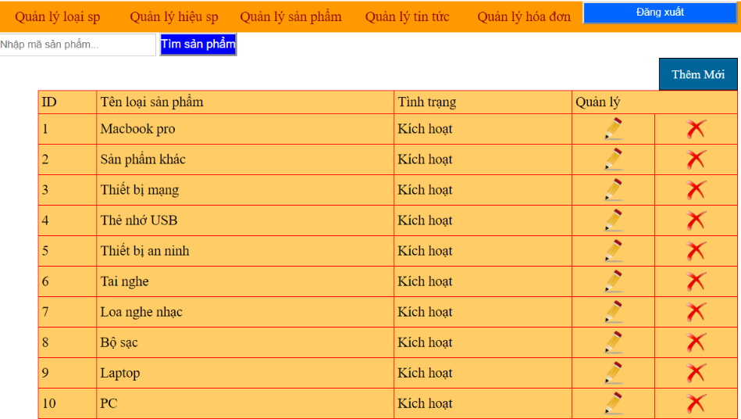

*Figure 18: Manage item type funtion*

* + 1. **Manage items brand:**

**Include Add/Delete/Set up Items brand**

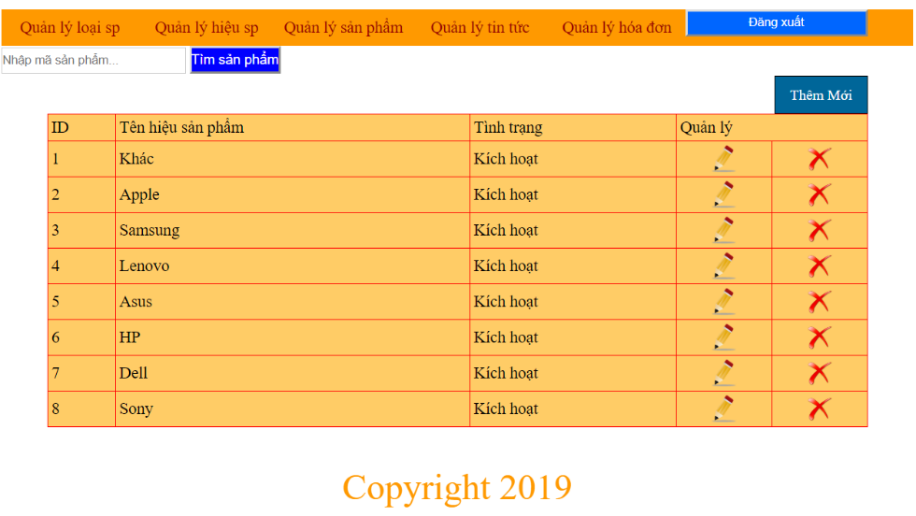

*Figure 19: Manage item brand funtion*

* + 1. **Manage Items:**

**Include Add/Delete/Set up Items**

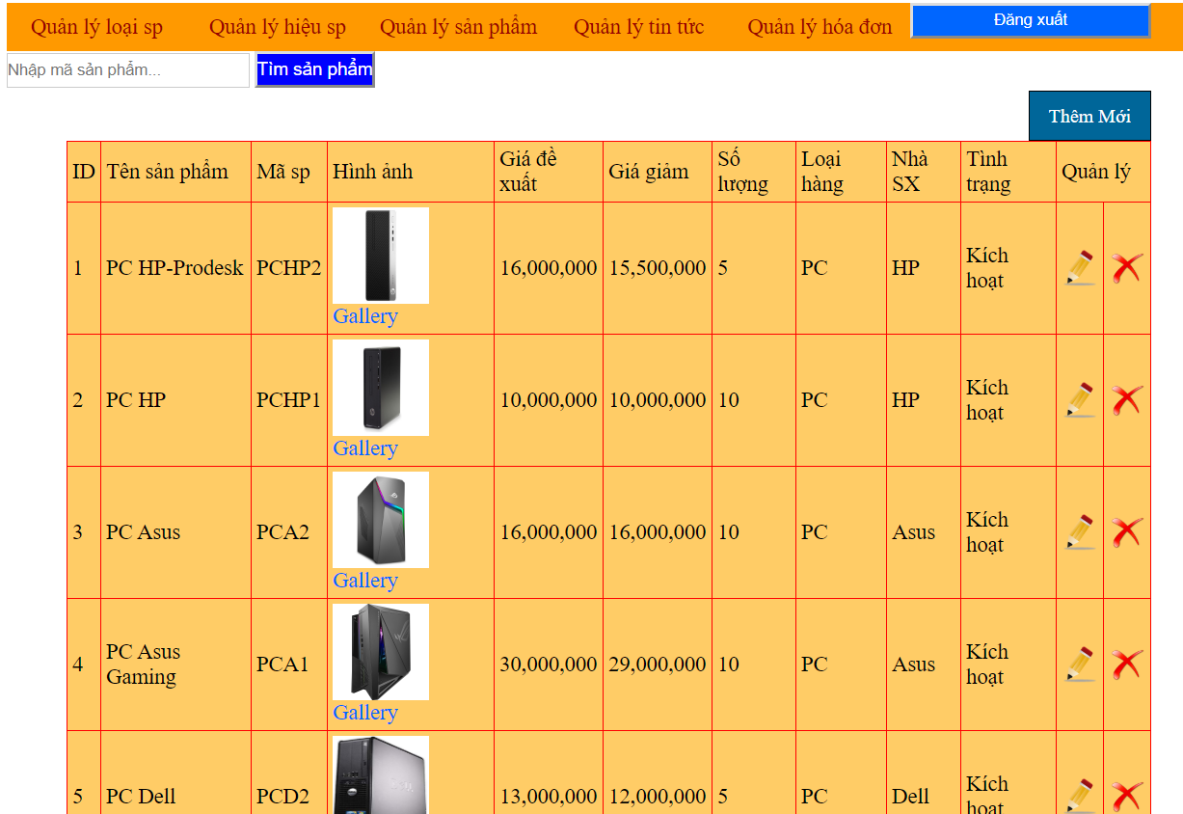

*Figure 20: Manage items funtion*

**CHAPTER 4 – REFERENCES**

1. <https://www.kaggle.com/c/landmark-recognition-challenge/overview/description>

2. <https://ai.googleblog.com/2019/05/announcing-google-landmarks-v2-improved.html>

3.<https://towardsdatascience.com/google-landmark-recognition-using-transfer-learning-dde35cc760e1>