AY2025 Trimester 3 — AN6105 Causal Inference
Graded Individual Assignment

Name: | [Student Name]
Student ID: | [Student ID]
Programme: | [Programme]
Date: | 28 May 2026

Declaration of Academic Integrity
I declare that this assignment is my own work. Where I have used the work or opinions of others (including Generative AI tools such as Claude), I have properly quoted and cited the sources. I have not submitted this work, in whole or in part, for any other course or assessment.
Signature: ___________________________ Date: 28 May 2026

Declaration on Use of Generative AI (GAI)
Generative AI (Claude, Anthropic) was used to assist in: (1) writing and debugging Python analysis code; (2) structuring and drafting written answers. All analytical decisions, interpretations, and conclusions are the author's own. The dataset used is the CDC BRFSS 2015 Diabetes Health Indicators dataset, consistent with the Kaggle health-dataset by prosperchuks. GAI was NOT used to upload or analyse the raw data directly.

Part A: Causal Inference on Diabetes

Question 1: Data Exploration — Three Key Findings
The dataset (diabetes_data.csv from the CDC Behavioural Risk Factor Surveillance System, BRFSS 2015) contains 70,692 observations and 22 binary/ordinal variables including the binary outcome Diabetes (1 = diabetic, 0 = non-diabetic). The dataset is balanced (50 % diabetic). Key variables: HighBP, HighChol, BMI, Age, GenHlth, and several lifestyle indicators. No missing values were found.

Figure 1: Exploratory Data Analysis
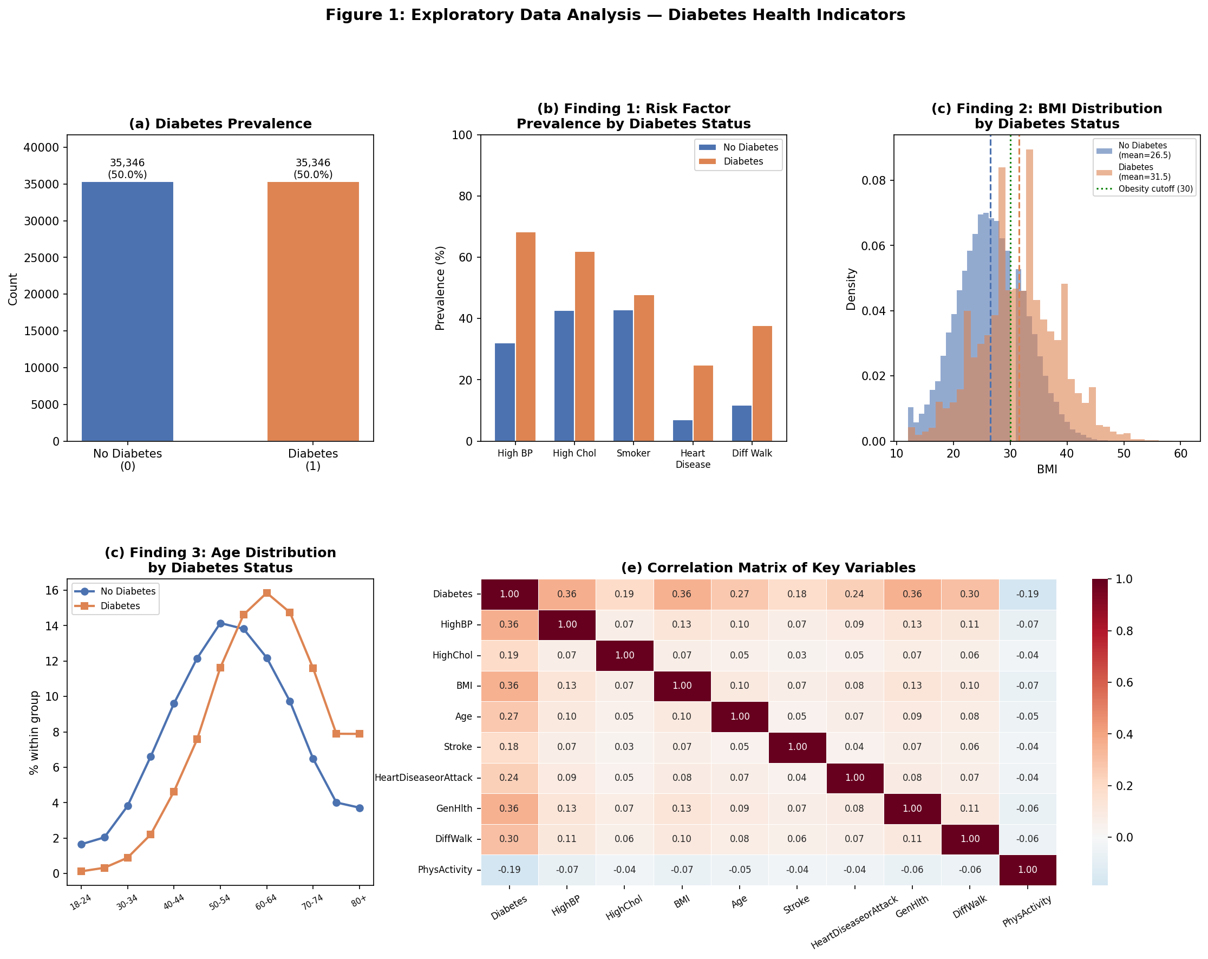

Finding 1: Cardiovascular and Metabolic Risk Factors Are Markedly More Prevalent among Diabetics
As shown in Figure 1(b), the prevalence of High Blood Pressure (HighBP) is 68.3 % among diabetics vs. 32.0 % among non-diabetics — a 2.1× difference. High Cholesterol (HighChol) is 61.9 % vs. 42.7 %, heart disease / heart attack is 24.9 % vs. 7.1 %, and difficulty walking (DiffWalk) is 37.8 % vs. 11.8 %. In contrast, physical activity (PhysActivity) is lower in diabetics (59.6 % vs. 76.9 %). These patterns suggest that diabetes co-occurs with a cluster of cardiovascular risk factors, and that physical inactivity is a likely contributor.

Finding 2: BMI Distribution Is Shifted Upward for Diabetics
Figure 1(c) shows that the mean BMI of diabetics is 31.5 vs. 26.5 for non-diabetics — a clinically important 5-unit difference. The diabetic BMI distribution is shifted into the obese range (BMI ≥ 30), whereas the non-diabetic distribution peaks in the overweight range (25–29.9). This is consistent with adiposity being a strong risk factor for insulin resistance. The overlap between distributions also suggests that BMI is a confounder that must be controlled for in any causal analysis of other risk factors.

Finding 3: Diabetes Risk Increases Sharply with Age
Figure 1(d) shows that younger age groups (18–44, categories 1–5) are substantially under-represented among diabetics, while age categories 9–13 (60–80+) are over-represented. The peak proportion of diabetes cases occurs at age category 10–11 (65–74 years). This confirms age as a strong risk factor and an important confounder: older individuals are more likely to have both high BP/cholesterol and diabetes, so age must be adjusted for in any causal analysis.

Question 2: Causal Effect of High BP on Diabetes
To estimate the causal effect of High Blood Pressure (HighBP = 1 vs. 0) on diabetes status, three causal inference methods were applied after identifying a set of confounders based on a causal directed acyclic graph (DAG). The confounders adjusted for are: Age, BMI, Sex, Education, Income, Smoker, PhysActivity, Fruits, Veggies, HvyAlcoholConsump, HeartDiseaseorAttack, and GenHlth — variables that plausibly affect both blood pressure and diabetes risk.

Unadjusted (Naïve) Association
Without adjustment, the diabetes rate is 68.1 % among those with high BP vs. 31.8 % without — a raw difference of 36.2 percentage points (pp). A chi-square test confirms this association is highly significant (χ² = 9,270.7, p < 0.001), with a crude odds ratio of 4.56. However, this naïve estimate is inflated by confounding (e.g. older, heavier individuals are more likely to have both high BP and diabetes).

Causal Methods and Results
Method | ATE (pp) | Interpretation
Naïve (unadjusted) | +36.2 | Biased upward by confounding
Regression Adjustment (OLS) | +24.1 (SE=0.29, p<0.001) | Controls for 12 confounders linearly
Inverse Probability Weighting (IPW) | +23.1 | Re-weights sample to balance covariates
Propensity Score Matching (PSM) | +22.8 (SE=0.29, 95% CI: [22.2, 23.3]) | 1:1 NN matching on propensity score

ATE = Average Treatment Effect, i.e. the average change in the probability of diabetes if everyone in the population were exposed to high BP vs. not.

Figure 2: Causal Analysis of High BP → Diabetes
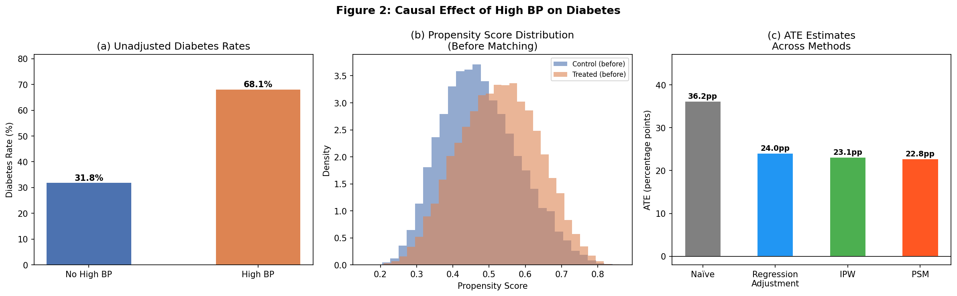

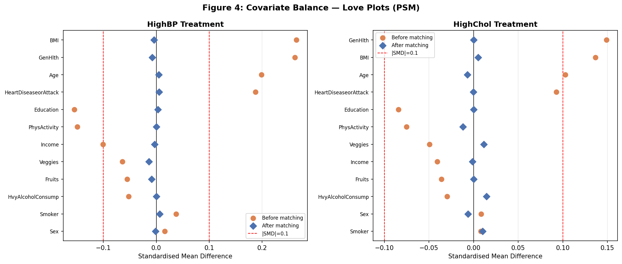
Figure 4: Love Plots — Covariate Balance Before and After PSM

Interpretation
After adjusting for confounders, all three methods converge on a causal ATE of approximately +22–24 percentage points. The Love plots (Figure 4a) confirm that PSM substantially reduces covariate imbalance, with post-match standardised mean differences (SMDs) well within the acceptable threshold of |SMD| < 0.10. This provides evidence for a substantial positive causal effect: High BP causally increases the probability of diabetes by approximately 22–24 percentage points. Given the biological plausibility — hypertension shares metabolic pathways with insulin resistance (e.g. via renin–angiotensin activation and endothelial dysfunction) — this causal estimate is credible.

Question 3: Causal Effect of High Cholesterol on Diabetes
The same three methods were applied to estimate the causal effect of High Cholesterol (HighChol = 1 vs. 0) on diabetes, controlling for the same set of 12 confounders.

Unadjusted (Naïve) Association
Without adjustment, the diabetes rate is 59.2 % for those with high cholesterol vs. 40.0 % without — a raw difference of 19.2 pp (crude OR = 2.18, χ² = 2,596.6, p < 0.001). Again, this is upwardly biased by shared confounders.

Causal Methods and Results
Method | ATE (pp) | Interpretation
Naïve (unadjusted) | +19.2 | Biased upward by confounding
Regression Adjustment (OLS) | +12.3 (SE=0.30, p<0.001) | Controls for 12 confounders linearly
Inverse Probability Weighting (IPW) | +12.1 | Re-weights sample to balance covariates
Propensity Score Matching (PSM) | +11.9 (SE=0.26, 95% CI: [11.3, 12.4]) | 1:1 NN matching on propensity score

Figure 3: Causal Analysis of High Cholesterol → Diabetes
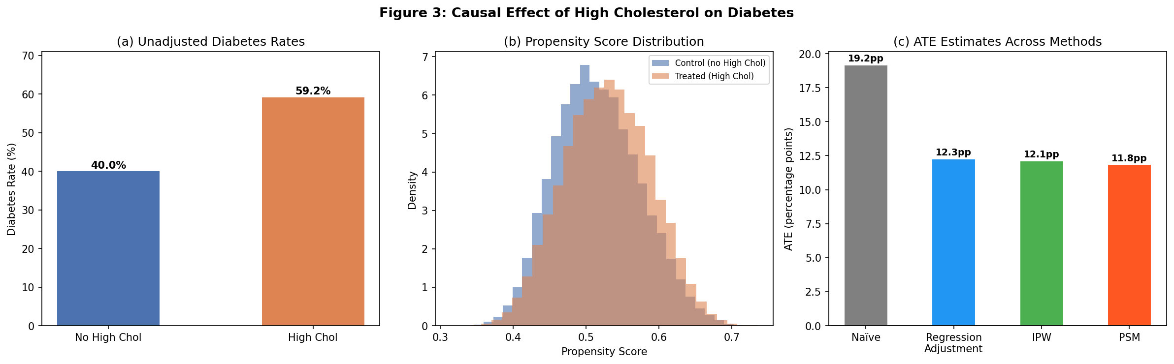

Interpretation
After adjustment, all three methods converge on a causal ATE of approximately +11–12 pp — substantially lower than the naïve estimate. This positive causal effect is biologically plausible: elevated LDL cholesterol promotes dyslipidaemia-associated insulin resistance, and the metabolic syndrome clusters high cholesterol, hypertension, and hyperglycaemia together through shared pathophysiological mechanisms. The causal effect of high cholesterol (~12 pp) is notably smaller than that of high BP (~23 pp), suggesting blood pressure dysregulation plays a stronger aetiological role.

Question 4: Summary — Causes of Diabetes
Combining the exploratory findings and the causal estimates, the following conclusions can be drawn about the causes of diabetes in this population:

(a) High Blood Pressure Is a Significant Causal Risk Factor
After adjusting for age, BMI, sex, socioeconomic, and lifestyle confounders, high BP has a causal ATE of ~+23 pp on diabetes probability — roughly three times the effect of high cholesterol. Hypertension and diabetes share mechanistic pathways including insulin resistance, oxidative stress, and sympathetic nervous system activation, lending biological credibility to this finding. Controlling hypertension may therefore reduce diabetes incidence.

(b) High Cholesterol Has a Moderate But Real Causal Effect
High cholesterol has a causal ATE of ~+12 pp after adjustment. While smaller than the BP effect, this is still clinically meaningful and is consistent with the role of dyslipidaemia in insulin resistance and the metabolic syndrome. Confounding accounts for roughly 37% of the raw association (from 19.2 to 12 pp), reflecting the fact that high-cholesterol individuals tend to be older and heavier.

(c) Age and BMI Are Strong Confounders and Likely Independent Causes
The reduction in ATE estimates from naïve to adjusted values (36.2 → 23 pp for BP; 19.2 → 12 pp for cholesterol) demonstrates that age and BMI are major confounders. These variables are also independent risk factors: adiposity drives insulin resistance directly, and age-related beta-cell decline is a primary mechanism of type-2 diabetes. Any causal model of diabetes must account for these upstream determinants.

(d) Physical Inactivity Is Associated with Diabetes
Diabetics show 17 pp lower physical activity rates (59.6 % vs. 76.9 %). While directionality cannot be fully established from cross-sectional data (inactivity may cause or result from diabetes), existing RCT evidence supports physical activity as a causal protective factor.

Overall Conclusion
The causal analyses provide robust evidence that both high blood pressure (ATE ≈ +23 pp) and high cholesterol (ATE ≈ +12 pp) causally increase diabetes risk, even after controlling for major confounders. These results suggest that population-level interventions targeting hypertension and dyslipidaemia — alongside weight management and physical activity promotion — could meaningfully reduce diabetes incidence. The consistency of estimates across three methodologically distinct causal inference approaches (regression adjustment, IPW, PSM) strengthens the credibility of these conclusions.

Part B: Review of Research Paper

Question 5: Key Learning Points from Michoel & Zhang (2023)
Reference: Michoel T, Zhang JD (2023). Causal inference in drug discovery and development. Drug Discovery Today, 28(9), 103737.

Reading Michoel and Zhang (2023) crystallised several key insights about how causal inference reshapes the logic of drug development.

1. Correlation Is Not Enough in Drug Discovery
The authors open with the central challenge: most early-stage drug targets are identified from correlational associations in observational omics data. Yet the high clinical trial failure rate (~90%) reflects the fact that associations do not guarantee that intervening on a target will modify disease outcomes. A biomarker correlated with disease may be a downstream consequence rather than a cause. Causal inference provides the conceptual and statistical machinery to distinguish the two.

2. Mendelian Randomisation Leverages Genetics as Natural Experiments
A major practical insight is the use of Mendelian Randomisation (MR) to obtain causal estimates from observational genomic data. Because germline genetic variants are randomly assigned at conception and precede both exposure and disease, they satisfy the instrumental variable conditions. Single-nucleotide polymorphisms (SNPs) associated with a protein or pathway can therefore serve as instruments to estimate whether that pathway causally affects disease. The authors demonstrate that MR has already been used to validate — and sometimes refute — proposed drug targets, reducing expensive late-stage failures.

3. DAGs Make Causal Assumptions Explicit and Testable
The paper advocates for directed acyclic graphs (DAGs) as a discipline for encoding and communicating causal assumptions. In drug discovery contexts with hundreds of molecular features, DAGs help researchers identify the minimal sufficient adjustment set to block confounding paths — and avoid "collider bias" from over-controlling. This was directly relevant to my own analysis: selecting the correct adjustment set for High BP and High Cholesterol requires DAG reasoning, not just statistical variable selection.

4. The Potential Outcomes Framework Formalises "What Would Have Happened"
Michoel and Zhang introduce the Rubin Potential Outcomes framework as a rigorous way to define treatment effects. The key quantity — the Average Treatment Effect (ATE) — asks: across all individuals, what would the difference in outcome be if everyone received treatment vs. control? This framing is directly applicable to drug trials, where we want to know the counterfactual ("what would have happened without the drug?"). The authors note that observational studies can approximate this under the assumptions of exchangeability, positivity, and consistency — exactly the conditions verified by my propensity-score balancing checks.

5. Causal AI Promises but Requires Rigour
The paper closes with a forward-looking perspective on integrating causal inference with machine learning — so-called "causal AI". The authors caution that large language models and deep learning can identify complex patterns but do not inherently distinguish causation from correlation. Hybrid approaches that encode prior causal structure (e.g. biological pathway knowledge) into machine learning models are identified as the most promising direction. This resonated with me: the power of causal inference lies not in algorithmic complexity but in the quality of the causal assumptions one is willing to defend.

Conclusion
The paper provided a cohesive map of how causal inference — from potential outcomes to MR to DAGs — can be operationalised across the drug discovery pipeline. My key takeaway is methodological humility: rigorous causal reasoning forces one to state assumptions explicitly, which is both scientifically honest and practically useful for de-risking target selection.
(Word count ≈ 480 words)

References
- Centers for Disease Control and Prevention (CDC). (2015). Behavioral Risk Factor Surveillance System Survey Data. U.S. Department of Health and Human Services.
- Michoel T, Zhang JD. (2023). Causal inference in drug discovery and development. Drug Discovery Today, 28(9), 103737. https://doi.org/10.1016/j.drudis.2023.103737
- Rosenbaum PR, Rubin DB. (1983). The central role of the propensity score in observational studies for causal effects. Biometrika, 70(1), 41–55.
- Rubin DB. (1974). Estimating causal effects of treatments in randomized and nonrandomized studies. Journal of Educational Psychology, 66(5), 688–701.
- Teboul A. (2021). CDC Diabetes Health Indicators Dataset. Kaggle. https://www.kaggle.com/datasets/prosperchuks/health-dataset

