<Game> I LIKE THANKSGIVING TURKEY!!



Author: Xuanyu Dong

CSE321

University at Buffalo

[xuanyudo@buffalo.edu](mailto:xuanyudo@buffalo.edu)

**Executive** **Summary**:

This is an awesome third person game made with unity3d. This is just for fun purpose, at least it gave me a lot of fun. I come up with this idea from the thanksgiving night, I and my friends play a game call “dodge ball and eat turkey” which literally mean that dodge ball and you get turkey. Therefore, everyone can be the user of this game, it is fun.

**Project Objective**:

<I Like THANKSGIVING TURKEY>

Hardware required:

* An android phone with this game installed.

**Design Detail**:

Game Engine 🡪Unity3D

Blender: use for constructing the 3d model in game.

**Reference:**

Unity Library.

**Project Presentation Detail:**

Just Let TA play this Game.

**Project Approach:**

**Prepare for next Thanksgiving, play this Game next Thanksgiving to decide who can first choose which part to eat (ranking by higher score in the top)!!**

**User’s Manual**:

1. Click on start you can start game.



1. Chick on exit, there will pop up a sub menu for user to make sure their actions.

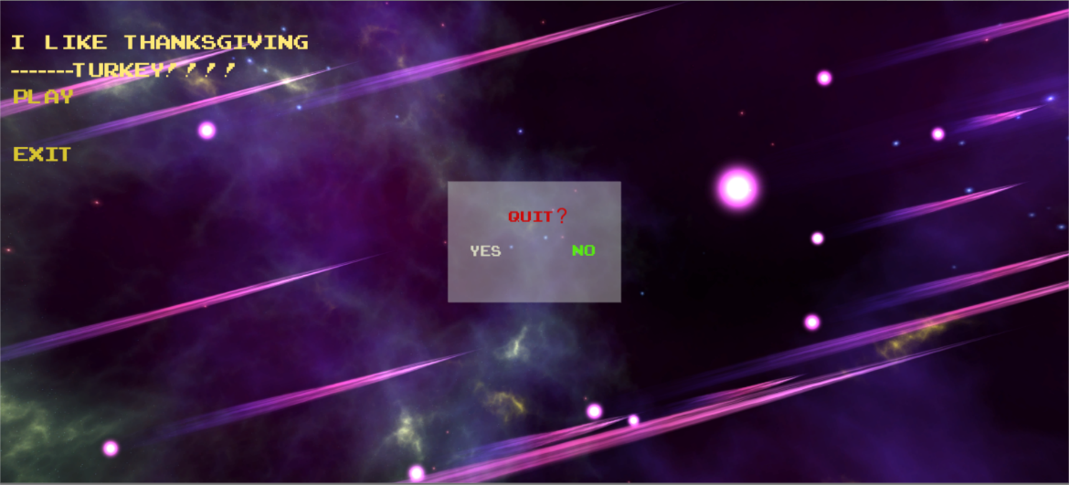

1. Press WSAD to control the character and Space for jump



Be careful the floor label in red. And eat as much turkey as possible.