Presentation
视听说教程 p. 106-107 Unit project:
A campaign against food waste on campus (参考Step 2,3,4小组成员分工完成调查紫金港校园食物浪费现象（拍照、采访浙大学生或食堂工作人员或麦斯威咖啡馆等）、分析原因、提出解决方案，在展示中每位同学负责讲解一部份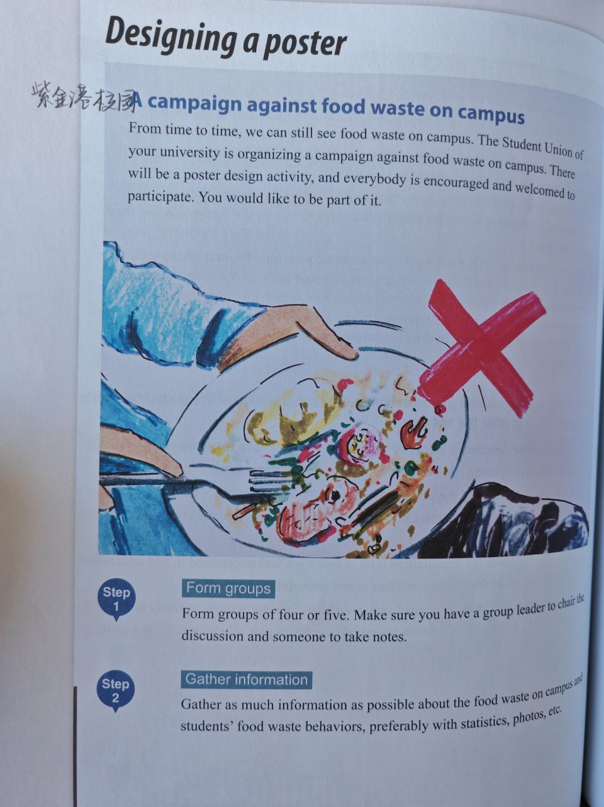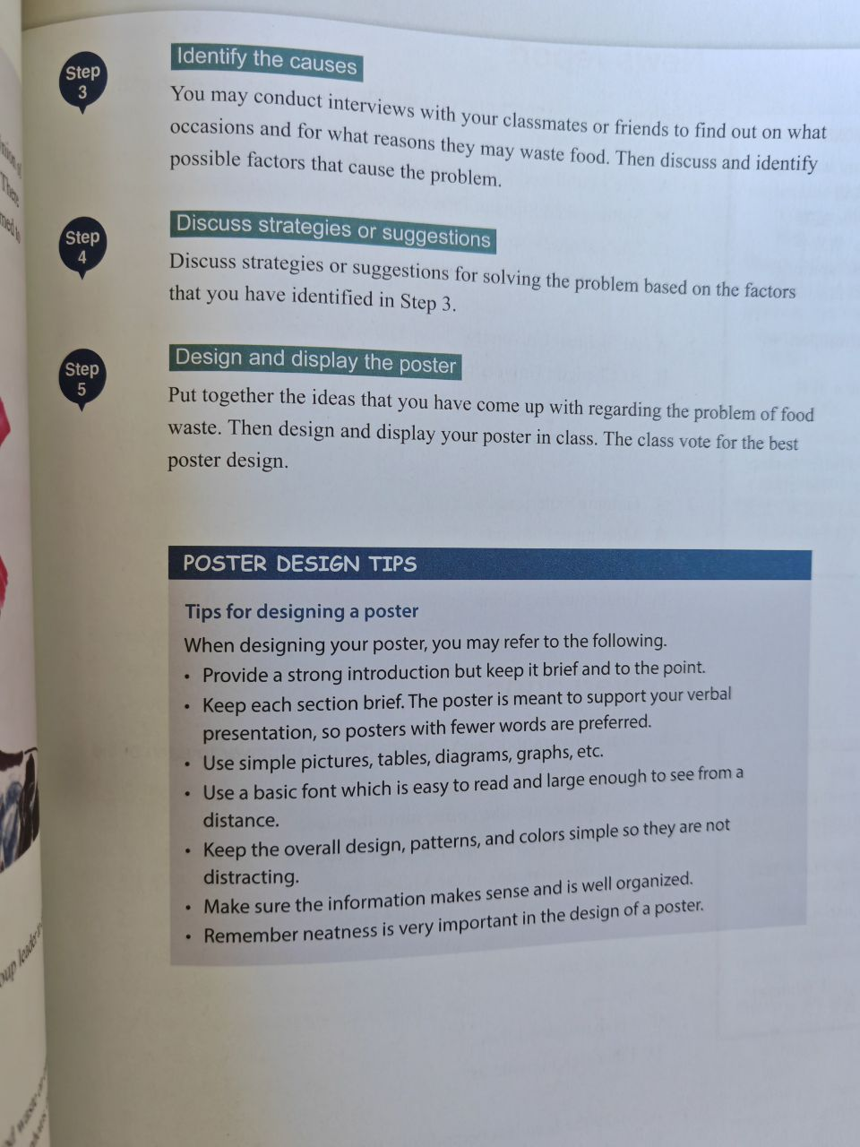
Phenomenon & Gathering information & Conclusion(1 person)
statistics,photos

Food waste on college campuses has become a prevalent issue, with significant implications for both the environment and the student community. The phenomenon of food waste in campus settings is characterized by the excessive disposal of edible food in dining halls contributing to an unsustainable and wasteful cycle.

By addressing the phenomenon, understanding the reasons, and implementing effective strategies, campuses can foster a sustainable food culture, encouraging students to adopt responsible habits,and contributing to a more environmentally conscious future.

Identify the causes:(2 person)
Cause 1 2(1 person);Cause 3 4(1 person)
couduct interviews
“occasions reasons”
Possible Reasons for Food Waste:

Over-purchasing: Consumers often buy more food than they can consume, leading to items spoiling before they are used.

Portion Sizes: Large portion sizes in restaurants can result in uneaten food.

Lack of Awareness: Some individuals may not be aware of the environmental and economic impacts of food waste.

Discuss strategies or suggestions (2 person)
Strategy 1 2(1 person),Strategy 3 4(1 person)

based on the factors above

Strategies to Reduce Food Waste:

Meal Planning: Plan meals in advance, create shopping lists, and only buy what you need to reduce over-purchasing.

Reducing Portion Sizes: Restaurants can offer smaller portion sizes or provide take-home containers to reduce food waste.

Awareness Campaigns: Launch public awareness campaigns about the environmental and social consequences of food waste.

