Detecting Plant Stress through Airborne Ultrasound

Abstract
Khait et al. recorded airborne ultrasound from stressed plants. Sound features distinguished species, treatments and two soil-moisture ranges, while counts changed during drying. These findings support non-contact assessment of plant condition.

1. Introduction
Zweifel and Zeugin (2008) recorded ultrasound from drought-stressed trees using sensors coupled to exposed xylem [1]. Whether stressed plants also emit detectable airborne sounds remained unresolved. Khait et al. (2023) investigated this question and what the sounds reveal about plant identity and condition, studying tomato and tobacco in an acoustic box, then tomato in a greenhouse [2].

2. Key Findings
To test stress effects, plants underwent water deprivation or stem cutting. Sounds were retained only when detected by two microphones, each 10 cm away. Controls included the same plants before treatment, untreated neighbors and soil-only pots. Drought-stressed tomato and tobacco averaged 35.4 and 11.0 sounds per hour, respectively, compared with fewer than one in plant controls. Cutting also increased emissions. Soil-only pots yielded no qualifying sounds in over 500 recording hours, supporting a plant source (original Figure 1A–B) [2].
The researchers examined information encoded in the sounds. Scattering-network features and support vector machines distinguished species or treatments in separate binary comparisons, with about 70% accuracy on sounds from held-out plants (original Figure 1F) [2]. Greenhouse trials tested classification amid noise. A convolutional neural network (CNN) separated tomato sounds from noise. Classifying plants emitting more than three sounds per hour as dry achieved 84% balanced accuracy for dry versus irrigated plants (original Figure 2D) [2].
Longer recordings examined changes during dehydration. Over nine days without watering, mean daily counts from 23 tomato plants rose and then fell; both well-watered and severely dehydrated plants could emit few sounds (original Figure 3A). Individual sounds also differed with soil moisture: a separate CNN distinguished sounds recorded at soil volumetric water content below 1% versus above 5%, with 81% balanced accuracy in leave-one-plant-out validation. Intermediate levels were excluded (original Figure 3D) [2].
To examine physiological associations, the authors monitored transpiration in seven tomato plants. Hourly sound counts correlated with transpiration rate. However, across the four consecutive days with the most sounds, selected separately for each plant, transpiration declined without a corresponding decrease in daily counts (original Figure 4). This association therefore depended on the timescale [2].
The authors considered cavitation as a possible physical source of some sounds. Across grapevine, tobacco and tomato, species with greater mean xylem vessel widths emitted lower-frequency sounds, providing indirect anatomical support for this hypothesis (original Figure S4) [2].

3. Conclusion
The study established non-contact detection of plant sounds carrying information about species and stress conditions. Greenhouse classification demonstrated feasibility amid noise. During dehydration, counts first rose and then fell, while individual sounds distinguished the tested moisture ranges. Interpreting a low count therefore requires knowledge of the dehydration stage [2].

4. Discussion and Limitations
Assessing drought progression requires testing acoustic indicators at intermediate moisture levels. Simultaneous acoustic and physiological measurements throughout drying could clarify how sounds reflect water status over hours and days.
Vessel width may influence sound frequency without identifying its cause. Simultaneous acoustic recording and embolism imaging could test whether clicks coincide with xylem embolism formation.
Other studies have further examined the potential of plant sounds for drought monitoring. Practical monitoring requires reliable detection of plant sounds. Bonisoli et al. recorded ultrasound outdoors under shelter but screened events manually; separate recordings documented substantial wind and rain noise [3]. Automated detection therefore needs testing across weather conditions to quantify missed events and false alarms. The early-warning value of plant sounds also depends on when acoustic changes appear. Dutta et al. observed acoustic, stem-diameter and stomatal changes about 24 h after irrigation stopped, although limited replication restricted comparisons [4]. Larger experiments measuring these indicators in the same plants could test whether acoustic changes consistently precede the other responses.

Original Figure 1. Experimental Design and Stress Classification
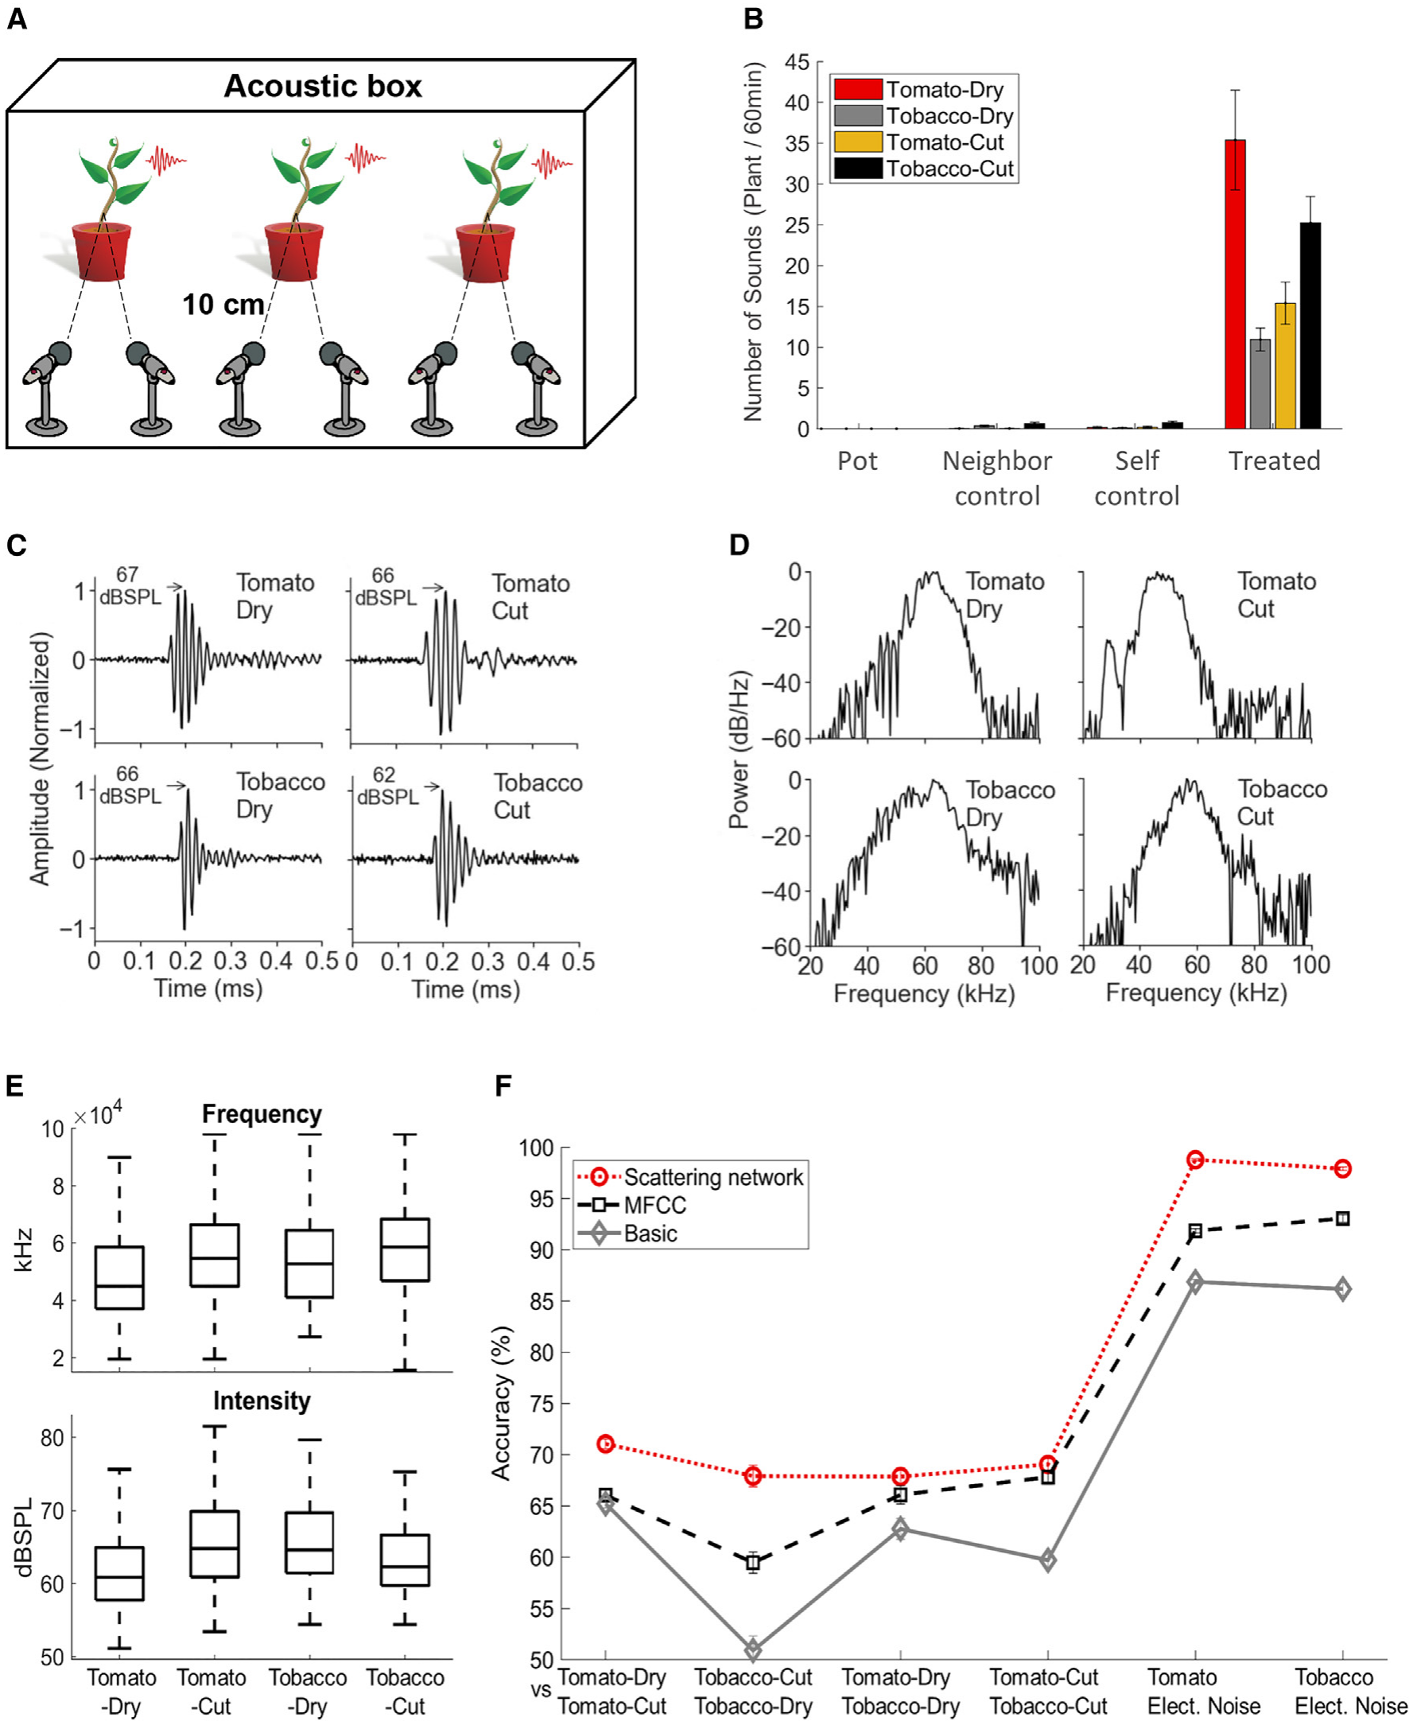
From Khait et al. [2]. (A) Paired microphones 10 cm from each plant. (B) Hourly sound counts (plant groups: n = 19–51; means ± SEM). (C–E) Waveforms, spectra and acoustic features. (F) Binary species or treatment classification (~70% accuracy); plant sounds and electrical noise were classified separately.

Original Figure 3. Acoustic Changes during Dehydration
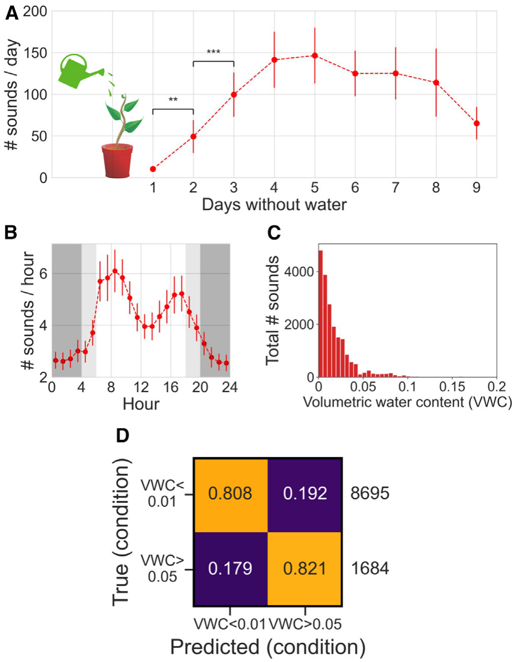
From Khait et al. [2]. Twenty-three tomato plants were monitored for nine days. (A) Daily sound counts during drying. (B) Hourly pattern of emissions. (C) Total sound counts by soil volumetric water content (VWC). (D) Individual-sound classification at VWC <1% versus >5%: 81% balanced accuracy. A–B show means ± SEM.

References
[1] Zweifel R, Zeugin F. Ultrasonic acoustic emissions in drought-stressed trees—more than signals from cavitation? New Phytol. 2008;179(4):1070-1079. doi: 10.1111/j.1469-8137.2008.02521.x.
[2] Khait I, Lewin-Epstein O, Sharon R, Saban K, Goldstein R, Anikster Y, et al. Sounds emitted by plants under stress are airborne and informative. Cell. 2023;186(7):1328-1336.e10. doi: 10.1016/j.cell.2023.03.009.
[3] Bonisoli L, Forti L, Arru L. Outdoor detection of plant ultrasonic emissions using a contactless microphone. Physiologia. 2025;5(1):9. doi: 10.3390/physiologia5010009.
[4] Dutta S, van den Berg T, Koning M, Bij de Vaate I, Bieling TJ, Kaiser E, et al. Comparison of multiple plant sensors aimed at early detection of drought stress in the greenhouse. Agric Water Manag. 2025;315:109535. doi: 10.1016/j.agwat.2025.109535.

