作业3

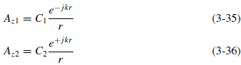

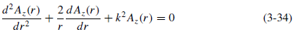

第三版第四章问题：4.1, 4.5 (only calculate (a)), 4.29，或第四版第四章问题：4.1, 4.5 (only calculate (a)), 4.31

HFSS Simulation
Frequency: 200MHz-400MHz

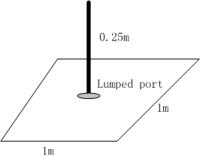

To find:
- Zin and VSWR (when this monopole is connected to a 50Ohm transmission line) for the whole frequency band
- Radiation Pattern @300MHz

