实验报告
姓名： 郑智瑄 专业： 电子科学与技术 学号： 3230103913
课程名称： 数字系统 任课老师： 李宇波
实验名称： lab4 实验日期： 2024/3/27
1 实验目的和要求
1.1 实验目的
学习如何使用FSM实现电子锁。
1.2 实验要求
用下面的功能图实现在课堂上学到的电子锁。
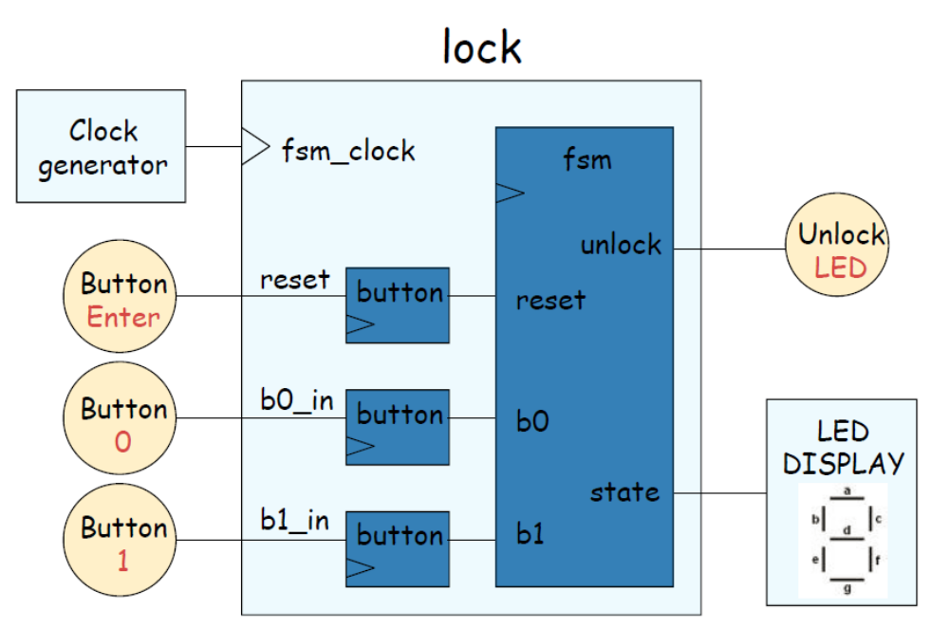
在实验报告中呈现以下结果：
1. prelab4文档要求中的测试结果
2.行为级代码、仿真以及板子上的结果
3.手写状态图，由状态转换表获得状态方程、驱动方程的过程，以及最后的状态机电路
4.根据手写的状态机电路写成的电路级代码

2 实验内容
- prelab4文档要求中的测试结果（prelab4附于文末）
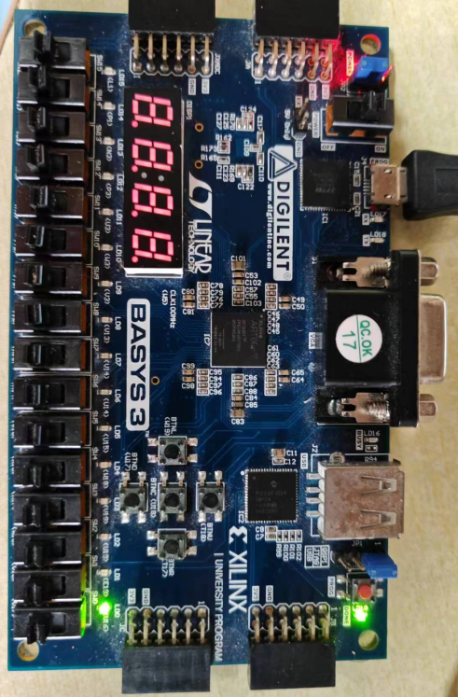
按下按钮W19，LED灯U16亮，再次按下按钮，LED熄灭
- 行为级代码、仿真以及板子上的结果（lab4 behavior level代码，ab4_tb代码附于文末）
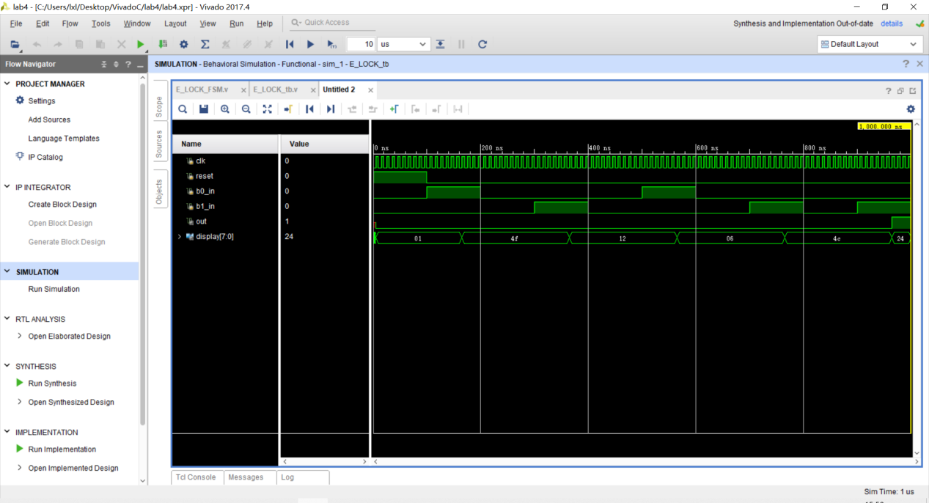
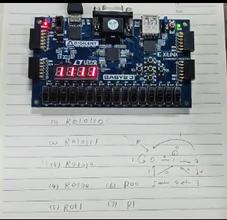
- 手写状态图，由状态转换表获得状态方程、驱动方程的过程，以及最后的状态机电路
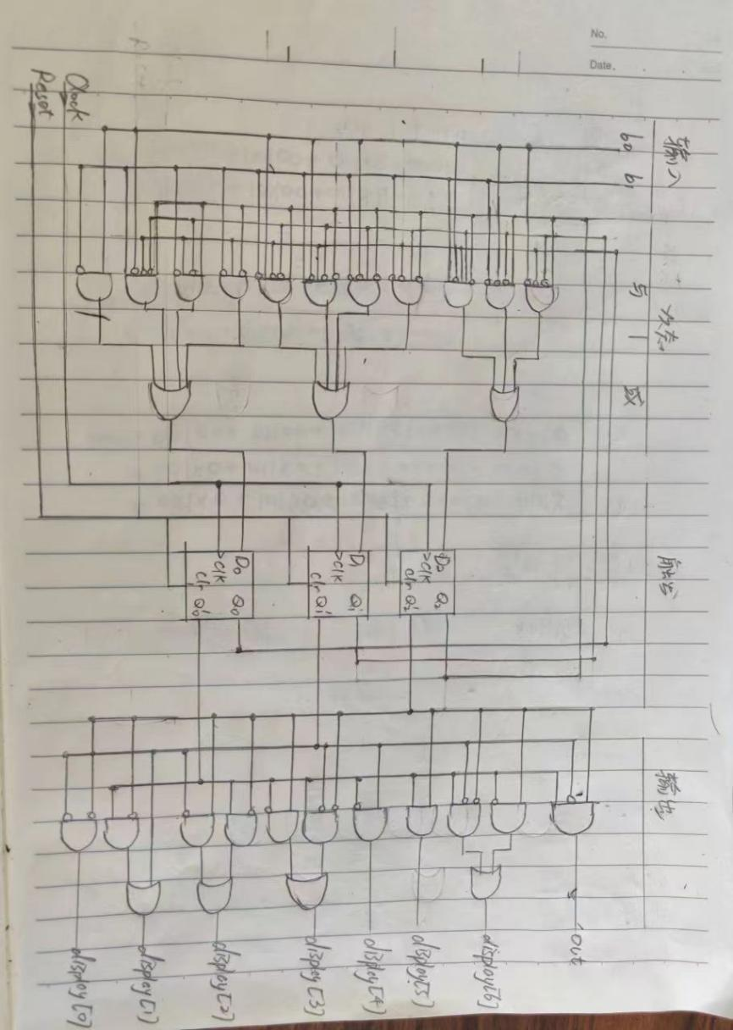
4.根据手写的状态机电路写成的电路级代码（lab4 assign_implementation附于文末）

3 实验总结
- 要持之以恒的学习，不畏难不惧难
- 要学会多问，多与老师交流
4 源代码
//prelab4
module onoff_sync
(input clk,reset, button_in,
output reg light);
// synchronizer
reg button,btemp;
always @(posedge clk)
{button,btemp} <={btemp,button_in};

// debounce push button
wire bpressed;
debounceIndex db1(.reset(reset),.clk(clk),.noisy(button),.clean(bpressed));

reg old_bpressed;//state last clk cycle
always @(posedge clk)
begin
if (reset)
begin light <=0;old_bpressed <=0; end
else if(old_bpressed==0 && bpressed==1)
// button changed from 0 to 1
light <= ~light;
old_bpressed <= bpressed;
end
endmodule
module debounceIndex (reset, clk, noisy, clean);
input reset, clk, noisy;
output clean;

parameter NDELAY = 65000;
parameter NBITS = 20;

reg [NBITS-1:0] count;
reg xnew, clean;

always @(posedge clk)
if (reset)
begin
xnew <= noisy;
clean <= noisy;
count <= 0 ;
end
else if (noisy!=xnew)
begin
xnew <= noisy;
count <= 0;
end
else if (count == NDELAY)
clean <= noisy;
else
count <= count+1;
endmodule

//lab4 behavior level
module E_LOCK_FSM(
input clk,reset,b0_in,b1_in,
output out,
output [7:0] display
);
//synchronizer
reg b0_sync,b0temp,b1_sync,b1temp;
always @(posedge clk)
{b0_sync,b0temp} <={b0temp,b0_in};
always @(posedge clk)
{b1_sync,b1temp} <={b1temp,b1_in};
//debounce
wire b0_de,b1_de;
debounceIndex de1(.reset(reset), .clk(clk), .noisy(b0_sync), .clean(b0_de));
debounceIndex de2(.reset(reset), .clk(clk), .noisy(b1_sync), .clean(b1_de));
//conversion
reg b0,b1;
reg Q0,Q1;
always @(posedge clk) begin
Q0 <= b0_de;
b0 <= ~Q0&b0_de;
end
always @(posedge clk) begin
Q1 <= b1_de;
b1 <= ~Q1&b1_de;
end

parameter S_RESET = 0; parameter S_0 = 1;
parameter S_01 = 2; parameter S_010 = 3;
parameter S_0101 = 4; parameter S_01011 = 5;

reg [2:0] state ,next_state;

always@(*) begin
if(reset) next_state = S_RESET;
else case (state)
S_RESET: next_state = b0 ? S_0 :b1 ? S_RESET:state;
S_0: next_state = b0 ? S_0 :b1 ? S_01 :state;
S_01: next_state = b0 ? S_010:b1 ? S_RESET:state;
S_010: next_state = b0 ? S_0 :b1 ? S_0101 :state;
S_0101: next_state = b0 ? S_010:b1 ? S_01011:state;
S_01011: next_state = b0 ? S_0 :b1 ? S_RESET:state;
default: next_state = S_RESET;
endcase
end

always@(posedge clk) state<= next_state;
// LED
wire [6:0]segs;
LED L1(.I(state),.Segs(segs));
assign out = (state == S_01011);
assign display = {1'b0,segs};

endmodule

module debounceIndex (reset, clk, noisy, clean);
input reset, clk, noisy;
output clean;

parameter NDELAY = 65000;
parameter NBITS = 20;

reg [NBITS-1:0] count;
reg xnew, clean;

always @(posedge clk)
if (reset)
begin
xnew <= noisy;
clean <= noisy;
count <= 0 ;
end
else if (noisy!=xnew)
begin
xnew <= noisy;
count <= 0;
end
else if (count == NDELAY)
clean <= noisy;
else
count <= count+1;
endmodule

module LED(
input [2:0]I,
output reg [6:0]Segs
);
always @(I)begin
case (I)
0:Segs= 7'b0000001;
1:Segs= 7'b1001111;
2:Segs= 7'b0010010;
3:Segs= 7'b0000110;
4:Segs= 7'b1001100;
5:Segs= 7'b0100100;
6:Segs= 7'b0100000;
7:Segs= 7'b0001111;
default:Segs= 7'b0000000;
endcase
end
endmodule

//lab4_tb
module E_LOCK_tb();

reg clk,reset,b0_in,b1_in;
wire out;
wire [7:0] display;

E_LOCK_FSM E1(.clk(clk),.reset(reset),.b0_in(b0_in),.b1_in(b1_in),.out(out),.display(display));
initial begin
clk=0;
reset=1;
b0_in=0;
b1_in=0;
#100
reset=0;
end
always begin
#5
clk=~clk;
end
always begin
#100 b0_in=1;
#100 b0_in=0;

#100 b1_in=1;
#100 b1_in=0;

#100 b0_in=1;
#100 b0_in=0;

#100 b1_in=1;
#100 b1_in=0;

#100 b1_in=1;
#100 b1_in=0;
end
endmodule

//lab4 assign_implementation
`timescale 1ns / 1ps
//////////////////////////////////////////////////////////////////////////////////
module E_LOCK_FSM(
input clk,reset,b0_in,b1_in,
output reg out,
output reg [7:0] display,
output reg [2:0] next_state,
output reg b0,b1
);
//synchronizer
reg b0_sync,b0temp,b1_sync,b1temp;
always @(posedge clk)
{b0_sync,b0temp} <={b0temp,b0_in};
always @(posedge clk)
{b1_sync,b1temp} <={b1temp,b1_in};
//debounce
wire b0_de,b1_de;
debounceIndex de1(.reset(reset), .clk(clk), .noisy(b0_sync), .clean(b0_de));
debounceIndex de2(.reset(reset), .clk(clk), .noisy(b1_sync), .clean(b1_de));
//conversion
// reg b0,b1;
reg Q0,Q1;
always @(posedge clk) begin
Q0 <= b0_de;
b0 <= ~Q0&b0_de;
end
always @(posedge clk) begin
Q1 <= b1_de;
b1 <= ~Q1&b1_de;
end

parameter S_RESET = 0; parameter S_0 = 1;
parameter S_01 = 2; parameter S_010 = 3;
parameter S_0101 = 4; parameter S_01011 = 5;

reg [2:0] state ;
//reg [2:0] next_state;
//Secondary logic circuit
always@(posedge clk) begin
if(reset) next_state =S_RESET;
else begin
//1000X+10X00+01101
next_state[2]= state[2]&~state[1]&~state[0]&~b0|
state[2]&~state[1] &~b0&~b1|
~state[2]& state[1]& state[0]&~b0& b1;
//010X0+01X00+00101+10010
next_state[1]=~state[2]& state[1]&~state[0]& ~b1|
~state[2]& state[1] &~b0&~b1|
~state[2]&~state[1]& state[0]&~b0& b1|
state[2]&~state[1]&~state[0]& b0&~b1;
//0X1X0+101X0+10001+XXX10
next_state[0]=~state[2]& state[0] &~b1|
state[2]&~state[1]& state[0] &~b1|
state[2]&~state[1]&~state[0]&~b0& b1|
b0&~b1;
end
end
always@(posedge clk) state<= next_state;
// LED
always @(*) begin
out=state[2]&~state[1]&state[0];
display[7]=0;
display[6]=state[2]&~state[0]|~state[2]&~state[1]&state[0];
display[5]=state[2]&state[0];
display[4]=state[1]&~state[0];
display[3]=~state[2]&~state[1]&state[0]|state[2]&~state[0];
display[2]=~state[2]&state[0]|state[2]&~state[1];
display[1]=state[1]|~state[2]&state[0];
display[0]=~state[2]&~state[1];
end

endmodule

module debounceIndex (reset, clk, noisy, clean);
input reset, clk, noisy;
output clean;

parameter NDELAY = 1;
parameter NBITS = 20;

reg [NBITS-1:0] count;
reg xnew, clean;

always @(posedge clk)
if (reset)
begin
xnew <= noisy;
clean <= noisy;
count <= 0 ;
end
else if (noisy!=xnew)
begin
xnew <= noisy;
count <= 0;
end
else if (count == NDELAY)
clean <= noisy;
else
count <= count+1;
endmodule

