实验报告
姓名： 郑智瑄 专业： 电子科学与技术 学号： 3230103913
课程名称： 数字系统 任课老师： 李宇波
实验名称： lab6 实验日期： 2024/4/14
1 实验目的和要求
1.1 实验目的
学习如何实现专用微处理器。
1.2 实验要求
1)热身:在Basys 3板中实现第6课中的IF-THEN-ELSE示例。将按钮和开关连接到模块的输入引脚，并将led连接到输出引脚。
2)在FPGA上手工设计并实现一个专用微处理器输入一个8位值，然后判断输入值是否有相等的0位和1位。如果输入值具有相同数量的0和1，则微处理器输出1;否则，它输出0。例如，数字10111011将产生0输出;然而，数字00110011将产生1输出。算法如下所示。绘制数据路径和相应的FSM状态图，FSM电路，列出控制字。
1 Count = 0 // for counting the number of 1 bits
2 INPUT N
3 WHILE (N ≠ 0){
4 IF (N(0) = 1) THEN // least significant bit of N
5 Count = Count + 1
6 END IF
7 N = N >> 1 // shift N right one bit
8 }
9 OUTPUT (Count = 4) // output 1 if the test (Count = 4) is true
3)在Verilog模块中分别实现数据路径电路和FSM电路，用顶部模块连接在一起，在你的Basys3板上实现。将板内开关连接到输入引脚，并将输出引脚连接到LED。
2 实验内容
- 画出datapath如图2-1
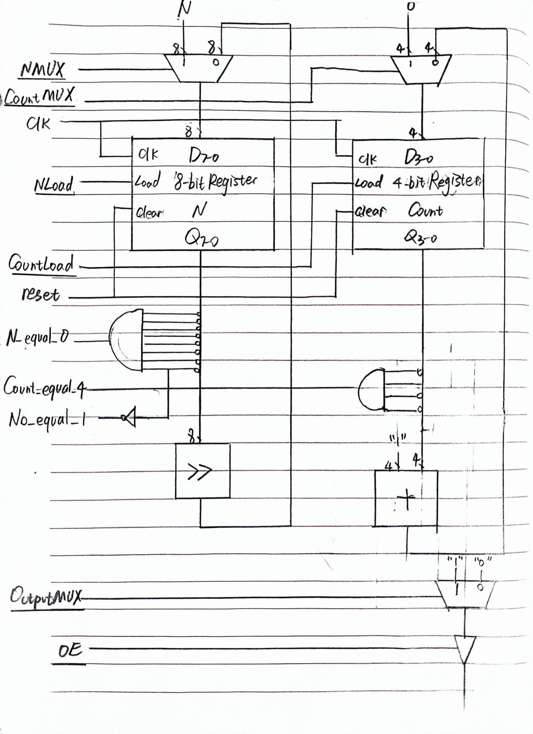
图2-1 datapath
- 画出状态图与控制字，如图2-2
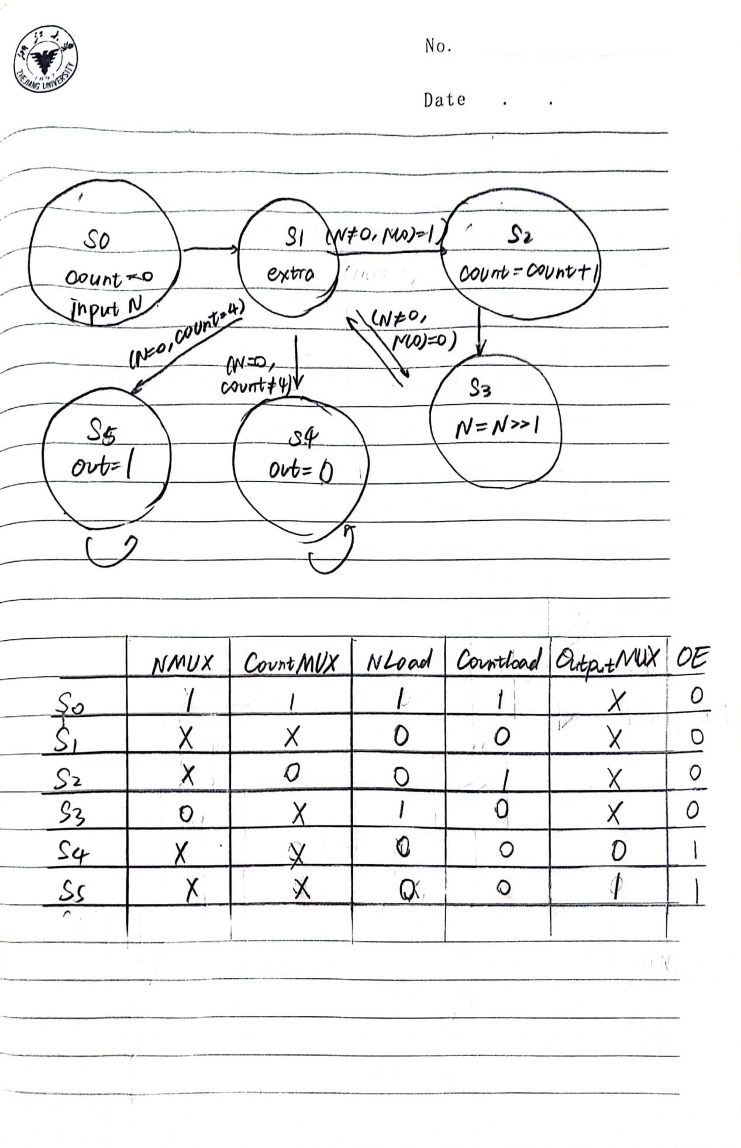
图2-2 状态图与控制字
- 根据所画内容分别写出Datapath与Control的代码
- 用顶层模块连接在一起
- 分别对Datapath与Control的代码进行仿真，如图2-3,2-4
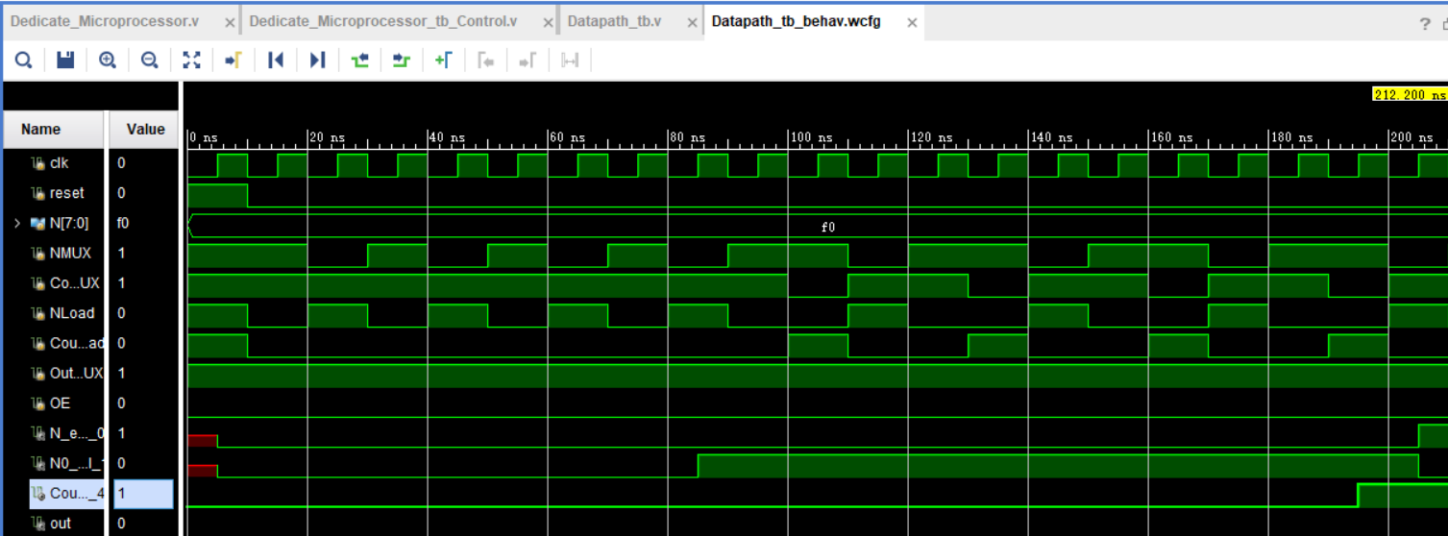
图2-3 Datapath代码仿真
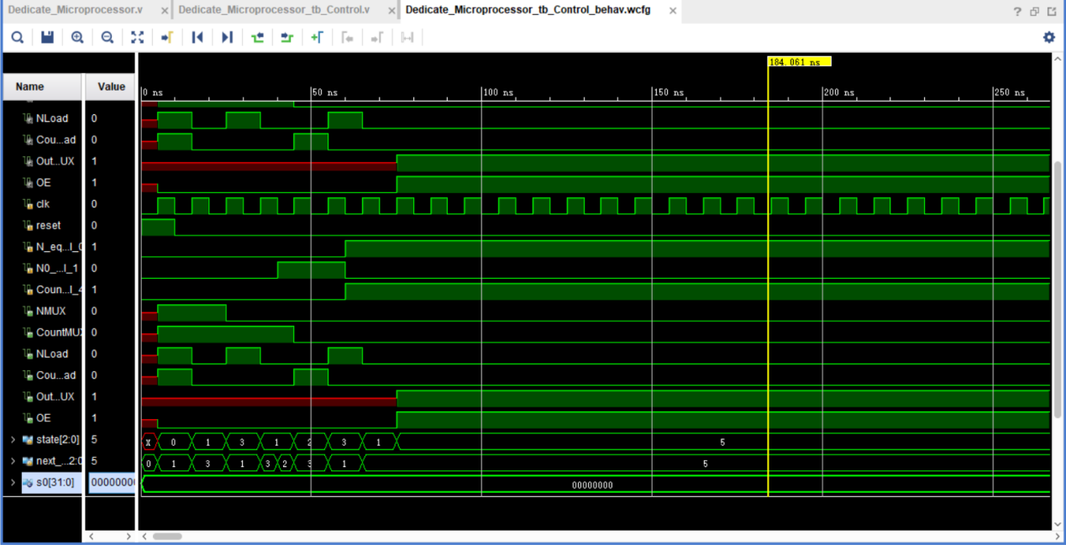
图2-4 Control代码仿真
- 对顶层模块进行仿真，如图2-5
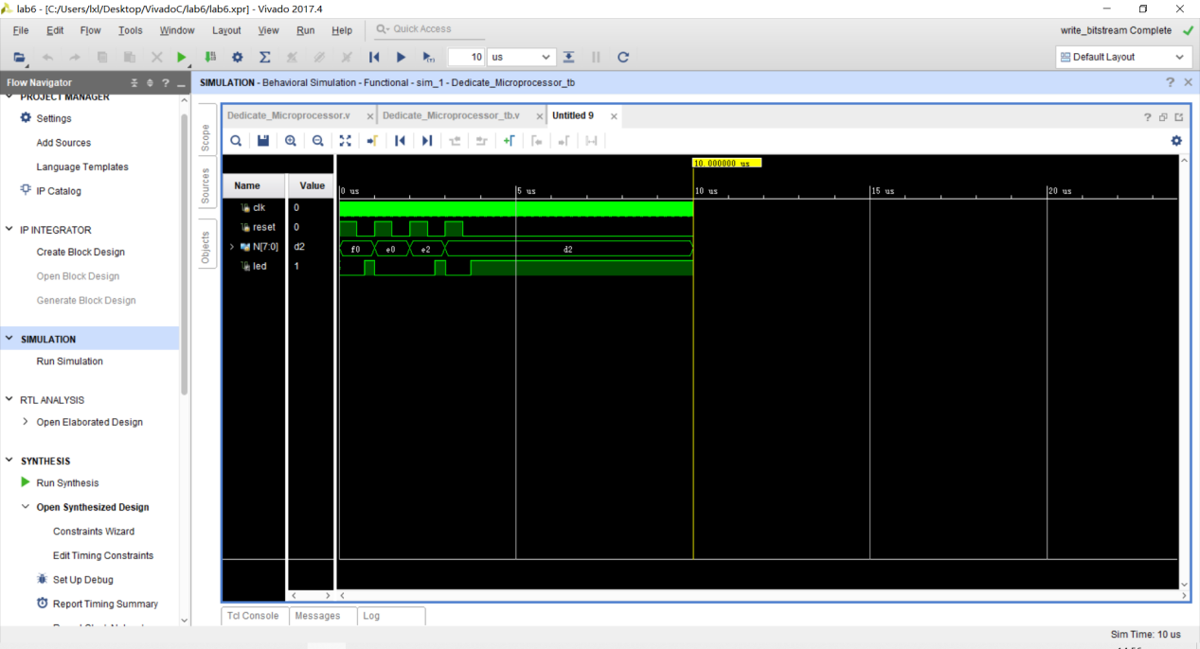
图2-5 顶层模块仿真
- 上板子验证
3 实验总结
- debug时间一定会远远大于写代码时间，可能产出不高，但是需细心
- 仔细思考reset的意义，在每个设计时考虑reset
4 源代码
以下分别附上Dedicate_Microprocessor，Dedicate_Microprocessor_tb，Datapath_tb，Control_tb的代码

module Control(clk,reset,N_equal_0,N0_equal_1,Count_equal_4,NMUX, CountMUX,NLoad,CountLoad,OutputMUX,OE);
//I/O port
input clk,reset,N_equal_0,N0_equal_1,Count_equal_4;
output reg NMUX,CountMUX,NLoad,CountLoad,OutputMUX,OE;
//state definition
parameter s0 = 0;
parameter s1 = 1;
parameter s2 = 2;
parameter s3 = 3;
parameter s4 = 4;
parameter s5 = 5;
reg [2:0] state,next_state;
//次态逻辑
always @(*)begin
case(state)
s0:next_state = s1;
s1:
case(N_equal_0)
1: case(Count_equal_4)
1:next_state = s5;
0:next_state = s4;
endcase
0: case(N0_equal_1)
1:next_state = s2;
0:next_state = s3;
endcase
endcase
s2:next_state = s3;
s3:next_state = s1;
s4:next_state = s4;
s5:next_state = s5;
default:next_state = s0;
endcase
end
//现态逻辑
always @(posedge clk)begin
if (reset) state=0;
else state = next_state;
end
//输出逻辑
always @(*)begin
case(state)
s0:begin //根据表格输出控制字,标记为X的不改变即可
NMUX = 1;
CountMUX = 1;
NLoad = 1;
CountLoad = 1;
OE = 0;
end
s1:begin
NLoad = 0;
CountLoad = 0;
OE = 0;
end
s2:begin
CountMUX = 0;
NLoad = 0;
CountLoad = 1;
OE = 0;
end
s3:begin
NMUX = 0;
NLoad = 1;
CountLoad = 0;
OE = 0;
end
s4:begin
NLoad = 0;
CountLoad = 0;
OutputMUX = 0;
OE = 1;
end
s5:begin
NLoad = 0;
CountLoad = 0;
OutputMUX = 1;
OE = 1;
end
default:begin
NMUX = 0;
CountMUX = 0;
NLoad = 0;
CountLoad = 0;
OutputMUX = 0;
OE = 0;
end
endcase
end
endmodule

module Dedicate_Microprocessor(
input clk,
input reset,
input [7:0]N,
//output [7:0] check,
output led
);
//C_O port D_I_port
wire NMUX,CountMUX,NLoad,CountLoad,OutputMUX,OE;
//C_I port D_O_port
wire N_equal_0,N0_equal_1,Count_equal_4;
//control
Control c1(.clk(clk),.reset(reset),
.N_equal_0(N_equal_0),.N0_equal_1(N0_equal_1),.Count_equal_4(Count_equal_4),
.NMUX(NMUX),.CountMUX(CountMUX),.NLoad(NLoad),.CountLoad(CountLoad),.OutputMUX(OutputMUX),.OE(OE));
//datapath
Datapath d1(.clk(clk),.N(N),.reset(reset),
.NMUX(NMUX),.CountMUX(CountMUX),.NLoad(NLoad),.CountLoad(CountLoad),.OutputMUX(OutputMUX),.OE(OE),
.N_equal_0(N_equal_0),.N0_equal_1(N0_equal_1),.Count_equal_4(Count_equal_4),.out(led));
//assign check =N;
endmodule

module Datapath(clk,reset,N,
NMUX,CountMUX,NLoad,CountLoad,OutputMUX,OE,
N_equal_0,N0_equal_1,Count_equal_4,out);
input clk,reset;
input [7:0] N;
input NMUX,CountMUX,NLoad,CountLoad,OutputMUX,OE;
output N_equal_0,N0_equal_1,Count_equal_4;
output reg out;
//N
reg [7:0] N_in,N_out;
always @(*) begin
case(NMUX)
1:N_in <= N;
0:N_in <= N_out >> 1;
endcase
end
always @(posedge clk)
begin
if(NLoad) N_out <= N_in;
end
assign N_equal_0=~N_out[7]&~N_out[6]&~N_out[5]&~N_out[4]&~N_out[3]&~N_out[2]&~N_out[1]&~N_out[0];
assign N0_equal_1=N_out[0];

//Count
reg [3:0]Count_in,Count_out;
always @(*) begin
case(CountMUX)
1:Count_in <= 0;
0:Count_in <= Count_out+1;
endcase
end
always @(posedge clk or posedge reset)
begin
if(reset) Count_out <= 0;
else if(CountLoad) Count_out <= Count_in;
end
assign Count_equal_4=~Count_out[3]&Count_out[2]&~Count_out[1]&~Count_out[0];

//output
reg out_in;
always @(*) begin
case (OutputMUX)
1: out_in <= 1;
0: out_in <= 0;
endcase
end
always @(*) begin
case (OE)
1:out <= out_in;
0:out <= 0;
endcase
end
endmodule

module Dedicate_Microprocessor_tb();
reg clk,reset;
reg [7:0] N;
wire led;
Dedicate_Microprocessor D1(.clk(clk),.reset(reset),.N(N),.led(led));
initial begin
clk=0;
N=8'b11110000;
reset=1;
#500
reset=0;
#500
N=8'b11100000;
reset=1;
#500
reset=0;
#500
N=8'b11100010;
reset=1;
#500
reset=0;
#500
N=8'b11010010;
reset=1;
#500
reset=0;
end
always begin
#5
clk=~clk;
end
endmodule

module Datapath_tb();
reg clk,reset;
reg [7:0]N;
reg NMUX,CountMUX,NLoad,CountLoad,OutputMUX,OE;
wire N_equal_0,N0_equal_1,Count_equal_4,out;
Datapath d1(.clk(clk),.N(N),.reset(reset),
.NMUX(NMUX),.CountMUX(CountMUX),.NLoad(NLoad),.CountLoad(CountLoad),.OutputMUX(OutputMUX),.OE(OE),
.N_equal_0(N_equal_0),.N0_equal_1(N0_equal_1),.Count_equal_4(Count_equal_4),.out(out));
initial begin
clk=0;
reset=1;
N=8'b11110000;
NMUX=1;CountMUX=1;NLoad=1;CountLoad=1;OutputMUX=1;OE=0;//s0

#10
reset=0;
NMUX=1;CountMUX=1;NLoad=0;CountLoad=0;OutputMUX=1;OE=0;//s1
#10
NMUX=0;CountMUX=1;NLoad=1;CountLoad=0;OutputMUX=1;OE=0;//s3
#10
NMUX=1;CountMUX=1;NLoad=0;CountLoad=0;OutputMUX=1;OE=0;//s1
#10
NMUX=0;CountMUX=1;NLoad=1;CountLoad=0;OutputMUX=1;OE=0;//s3
#10
NMUX=1;CountMUX=1;NLoad=0;CountLoad=0;OutputMUX=1;OE=0;//s1
#10
NMUX=0;CountMUX=1;NLoad=1;CountLoad=0;OutputMUX=1;OE=0;//s3
#10
NMUX=1;CountMUX=1;NLoad=0;CountLoad=0;OutputMUX=1;OE=0;//s1
#10
NMUX=0;CountMUX=1;NLoad=1;CountLoad=0;OutputMUX=1;OE=0;//s3

#10
NMUX=1;CountMUX=1;NLoad=0;CountLoad=0;OutputMUX=1;OE=0;//s1
#10
NMUX=1;CountMUX=0;NLoad=0;CountLoad=1;OutputMUX=1;OE=0;//s2
#10
NMUX=0;CountMUX=1;NLoad=1;CountLoad=0;OutputMUX=1;OE=0;//s3
#10
NMUX=1;CountMUX=1;NLoad=0;CountLoad=0;OutputMUX=1;OE=0;//s1
#10
NMUX=1;CountMUX=0;NLoad=0;CountLoad=1;OutputMUX=1;OE=0;//s2
#10
NMUX=0;CountMUX=1;NLoad=1;CountLoad=0;OutputMUX=1;OE=0;//s3
#10
NMUX=1;CountMUX=1;NLoad=0;CountLoad=0;OutputMUX=1;OE=0;//s1
#10
NMUX=1;CountMUX=0;NLoad=0;CountLoad=1;OutputMUX=1;OE=0;//s2
#10
NMUX=0;CountMUX=1;NLoad=1;CountLoad=0;OutputMUX=1;OE=0;//s3
#10
NMUX=1;CountMUX=1;NLoad=0;CountLoad=0;OutputMUX=1;OE=0;//s1
#10
NMUX=1;CountMUX=0;NLoad=0;CountLoad=1;OutputMUX=1;OE=0;//s2
#10
NMUX=0;CountMUX=1;NLoad=1;CountLoad=0;OutputMUX=1;OE=0;//s3

#10
NMUX=1;CountMUX=1;NLoad=0;CountLoad=0;OutputMUX=1;OE=0;//s1
#10
NMUX=1;CountMUX=1;NLoad=0;CountLoad=0;OutputMUX=1;OE=1;//s5

end
always begin
#5
clk=~clk;
end
endmodule

module Dedicate_Microprocessor_Control_tb();
reg clk,reset,N_equal_0,N0_equal_1,Count_equal_4;
wire NMUX,CountMUX,NLoad,CountLoad,OutputMUX,OE;
Control C1(.clk(clk),.reset(reset),
.N_equal_0(N_equal_0),.N0_equal_1(N0_equal_1),.Count_equal_4(Count_equal_4),
.NMUX(NMUX),. CountMUX(CountMUX),.NLoad(NLoad),.CountLoad(CountLoad),.OutputMUX(OutputMUX),.OE(OE));
initial begin
clk=0;
reset=1;
N_equal_0=0;
N0_equal_1=0;
Count_equal_4=0;
#10
reset=0;
N_equal_0=0;
N0_equal_1=0;
Count_equal_4=0;//s1
#10
N_equal_0=0;
N0_equal_1=0;
Count_equal_4=0;//s3
#10
N_equal_0=0;
N0_equal_1=0;
Count_equal_4=0;//s1
#10
N_equal_0=0;
N0_equal_1=1;
Count_equal_4=0;//s2
#10
N_equal_0=0;
N0_equal_1=1;
Count_equal_4=0;//s3
#10
N_equal_0=1;
N0_equal_1=0;
Count_equal_4=1;//s5
end
always begin
#5
clk=~clk;
end
endmodule

